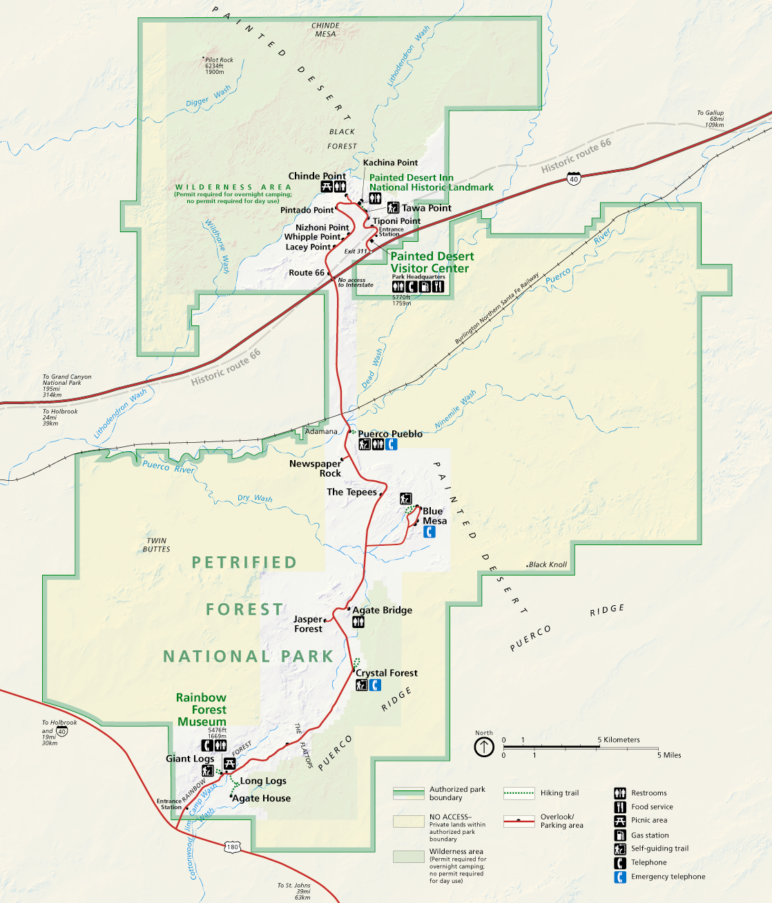

Petrified Forest National Park

DRIVING DIRECTIONS

Entering at the SOUTH side

The park road is 28 miles long one way and takes about 45 minutes to drive with no stops.

Enter the park off I-40, using Exit 311.

Enter the park off of Hwy 180

Enter Petrified Forest National Park from Hwy 180 through Holbrook or St. Johns. If you have an approved Educational Fee Waiver, present it at the entrance station. Each vehicle in your group must have a copy of the fee waiver.

Stop at the Rainbow Forest Museum, 1.5 miles north of the entrance station, for restrooms, to fill water bottles, and watch the 18 minute park film Timeless Impressions.

You can continue North through the park returning to I-40 at Exit 311 from the north entrance.
Enter the park off Hwy 180, coming from Holbrook or St. John’s.

