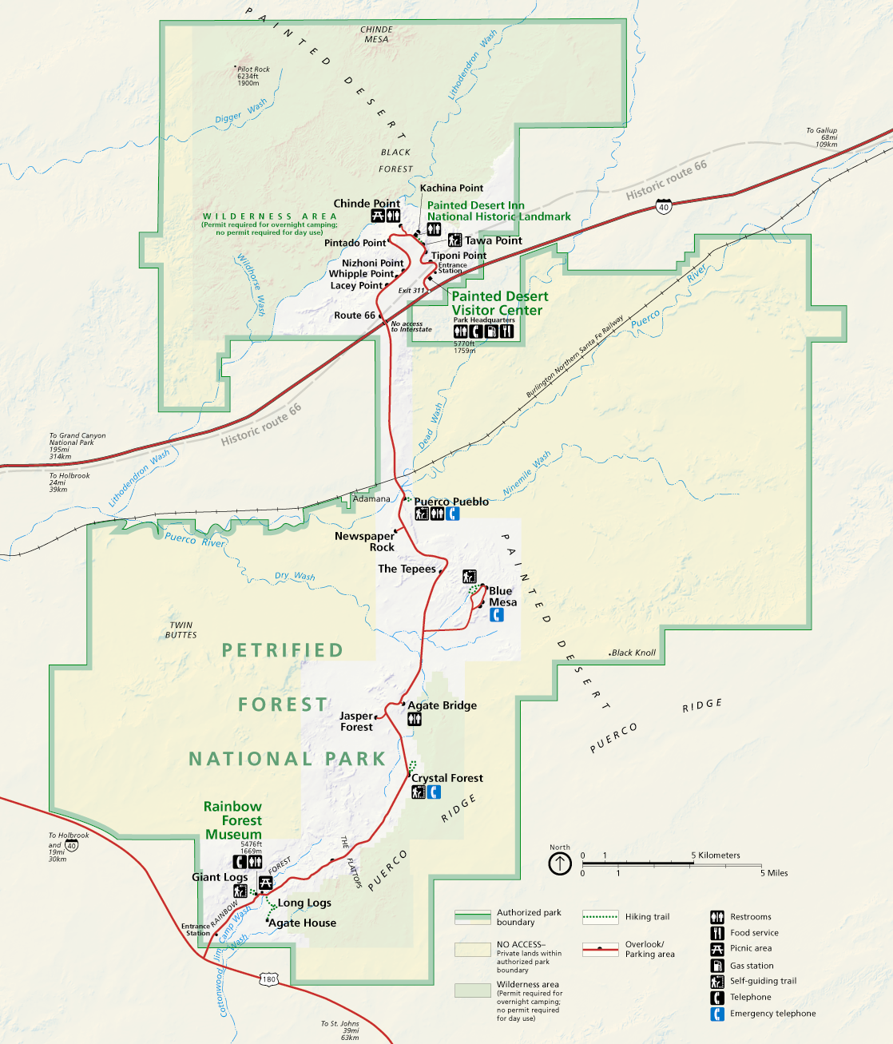


Petrified Forest National Park

DRIVING DIRECTIONS

Entering at the NORTH side
Enter the park off I-40, using Exit 311.
The park road is 28 miles long one way and takes about 45 minutes to drive with no stops.

Enter Petrified Forest National Park from I-40, using Exit 311. Stop at the Painted Desert Visitor Center for restrooms, to fill water bottles, and to watch the 18-minute orientation movie, Timeless Impressions.

If you have an approved Educational Fee Waiver, present it at the entrance station just past the Visitor Center. *Each vehicle in your group must have a copy of the fee waiver.

You can continue through the park, exiting at the south end onto Hwy 180 and returning to I-40 through Holbrook.

