**Museum Detectives**

**Field Trip Program**

*Revised December, 2014*

**Petrified Forest Focus:** Paleontology

**School Subjects:** Science

**Grade Levels: 3rd – 8th**

**Duration:** 60 minutes

**AZ Science Standards**

* **SC01-S1C1**: compare common objects using multiple senses
* **SC01-S1C2**: Ask questions based on experiences with objects, organisms, and events in the environment.
* **SC01-S1C4**, **SC02-S1C4, SC03-S1C4, SC04-S1C4, SC05-S1C4**: Communication; communicate results of investigations
* **SC01-S1C2, SC02-S2C2, SC03-S2C2, SC04-S2C2, SC05-S2C2**: Nature of scientific knowledge; Understand how science is a process for generating knowledge.
* **SC01 – S3C2-02**: Describe how suitable tools (e.g. magnifiers, thermometers) help make better observations.
* **SC01-S1C2-01, SC02-S1C2-01, SC03-S1C2-01, SC04-S1C2-01, SC05-S1C2-01**: Demonstrate safe behavior and appropriate procedures.
* **SC02-S1C1, SC03-S2C1-02, SC04-S1C1**: Observations, Questions, and Hypotheses: Observe, ask questions, and make predictions.
* **SC02-S2C1-02, SC03-S2C1-02, SC04-S2C1-02**: Identify science related career opportunities
* **SC03-S1C2-05, SC04-S1C2-05, SC05-S1C2-05**: Record data in an organized and appropriate format.
* **SC03-S1C4-03, SC04-S1C4-03, SC05-S1C4-03**: Communicate with other groups or individuals to compare the results of a common investigation.
* SC03-S4C1-01: Identify animal structures that serve different functions
* **SC01-S5C1-01:** Classify objects using the following observable properties; shape, texture, size, color, weight

**AZCCR Standards**

* (3.MP.7) Look for and make use of pattern.
* For Informational Text:
  + (3.RL.1) Ask and answer questions to demonstrate understanding of a text, referring explicitly to the text as the basis for the answers.
  + (3.RI.7) Use information gained from illustrations (e.g., maps, photographs) and the words in a text to demonstrate understanding of the text
  + (3.SL.3)Ask and answer questions about information from a speaker, offering appropriate elaboration and detail.
  + (3.SL.1)Engage effectively in a range of collaborative discussions (one-on-one, in groups, and teacher-led) with diverse partners on grade 3 topics and texts, building on others’ ideas and expressing their own clearly.
  + (3.SL.6)Speak in complete sentences when appropriate to task and situation in order to provide requested detail or clarification.
  + (4.RL.1) Refer to details and examples in a text when explaining what the text says explicitly and when drawing inferences from the text.
  + (4.RI.7)Interpret information presented visually, orally, or quantitatively (e.g., in charts, graphs, diagrams, time lines, animations, or interactive elements on Web pages) and explain how the information contributes to an understanding of the text in which it appears.
  + (5.RI.7) Draw on information from multiple print or digital sources, demonstrating the ability to locate an answer to a question quickly or to solve a problem efficiently.
  + (5.RL.1) Quote accurately from a text when explaining what the text says explicitly and when drawing inferences from the text.

**Lesson Overview**

Students will participate in a guided learning activity inside of the Rainbow Forest Museum identifying and matching replica fossil bones of Late Triassic animals to the museum exhibits. Students will work in groups or pairs to answer questions about the animals and present their answers to the whole class. Maximum group size - 30

**Background Knowledge** (for teachers and students)

Petrified Forest National Park contains a wealth of fossils from the Late Triassic epoch that are over 200 million years old. These fossils are contained in the layers of the Chinle Formation, also known as The Painted Desert. The process of science and field work is very important to telling the story of Petrified Forest NP because the first paleontological research began in the early 1900’s and continues today. Both the geology and paleontology within the park have been and continue to be extensively studied. The park strives to foster public appreciation for the new information that is learned as part of a larger appreciation for protecting and learning in public lands.

Paleontology is a science that investigates the remains of ancient life and the changing forms of life through time. Paleontologists must have an understanding of geology, biology, and ecology to interpret the clues of the ancient past. They piece together information from rocks - how rocks form, how they change over time, and what environments they represent - in order to know which layers of rock might contain fossils. They must understand animal and plant anatomy, physiology, and behavior in order to interpret the fossils they find. With an understanding of the relationships between organisms and their environment, paleontologists become paleo-ecologists and can create images of entire ancient ecosystems. Because the past can never be recreated, paleontological resources are considered nonrenewable and are in need of protection and preservation.

Studying the fossil bones of animals from the Triassic enables paleontologists to discover what the animals ate, how they moved, their size etc. and develop a bigger picture of life on Earth over 200 million years ago.

**Animals of the Triassic:**

Archosauriformes are a specialized group of reptiles that includes birds and crocodiles. In the Triassic, archosauriformes were represented by aetosaurs, phytosaurs, rauisuchians, and dinosaurs.

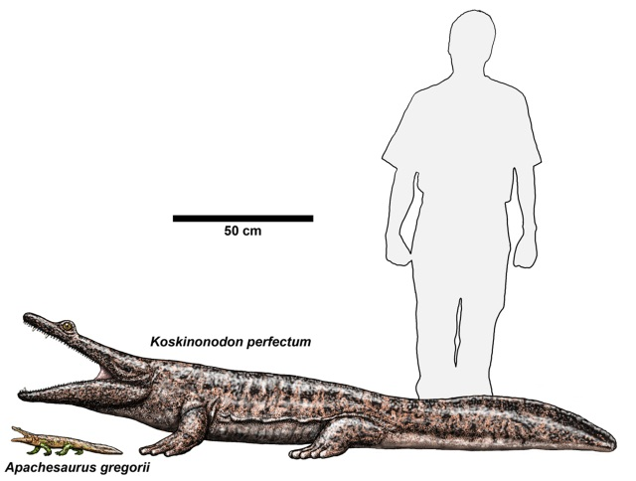**Metoposaurs** (meh-toe-poe-sores) were giant amphibians. A common fossil animal found in the lower portion of the park is the large flat-headed amphibian *Koskinonodon perfectus*, 10 feet (3 m) long and weighing up to half a ton. These animals were most likely voracious predators feeding on fish and smaller animals. With their flat heads and upward directed eyes, *Koskinonodon* probably settled in the muddy bottom of ponds and ambushed prey from below. *Koskinonodon* rarely occurs in the northern section of the park, which contains sediments younger than the Blue Mesa and Rainbow Forest. Giant amphibians are represented in these layers by a smaller yet similar animal named *Apachesaurus gregorii*.

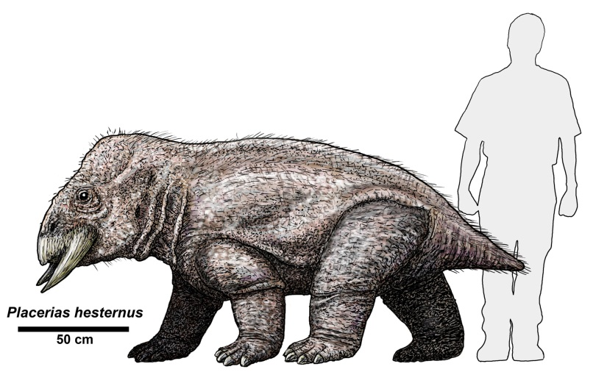Therapsids were large reptiles that possessed mammalian characteristics including a “cheek” bone, enlarged canine teeth, pelvis, and a specialized attachment of the skull to the spine. *Placerias hesternus* (pla-seer-ee-us) was a dicynodont therapsid. This massive plant eater was up to 9 feet (2.7 m) long and might have weighed as much as two tons. Placerias had a short neck, barrel-shaped body, small tail, and a beak-like skull with large tusk-like bones protruding from its upper jaw. The beak-like jaws helped them pull up and tear tough plants and roots. While Placerias is represented in the park by isolated elements, it is common near St. Johns, just southeast of the park, where large numbers of Placerias were found in a single quarry.

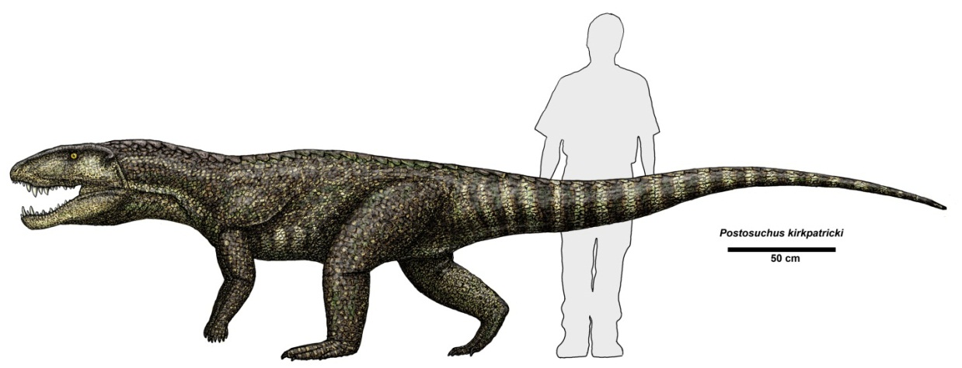

Rauisuchians (rau-i-su-key-ans) were the top terrestrial predators of the Late Triassic, thanks to huge skulls armed with powerful biting jaws and 3 inch (7.6 cm) long serrated teeth. Species of rauisuchians found in the park include *Postosuchus kirkpatricki* and *Poposaurus gracilis*. Some rauisuchians could grow up to 20 feet (6 m) in length.

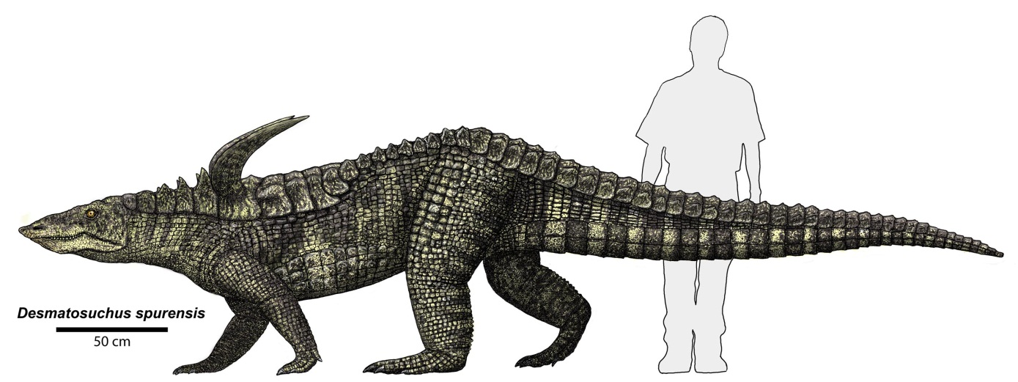

Aetosaurs (a-ee-toe-sores) were 3-18 feet (1-6m) long, herbivorous reptiles with broad flat bodies protected by plate-like scutes. Some species had large spikes on their sides or back that were possibly used for defense. Aetosaurs had short limbs and small skulls with a pig-like snout for rooting in soil for plants and roots. *Desmatosuchus spurensis* (above) and *Calyptosuchus wellesi* are two of the aetosaurs found in Petrified Forest National Park.

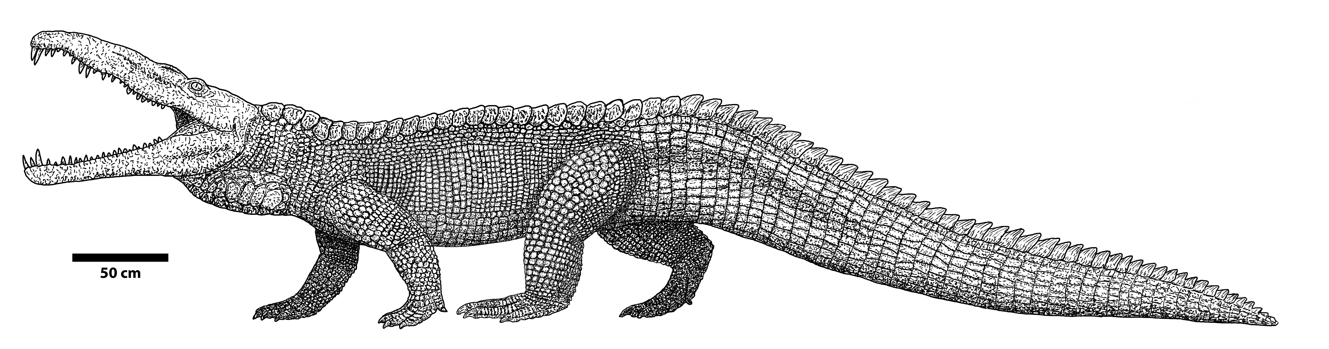

Phytosaurs (fie-toe-sores) were crocodile-like reptiles, some species reaching lengths possibly exceeding 20 feet (6.1 meters). Distantly related, phytosaurs probably filled similar ecological niches as crocodiles, feeding mainly on fish and any other animals that came too near. Phytosaurs are the most common fossil animal found in the park, species including *Smilosuchus gregorii* and *Machaeroprosopus pristinus*.

*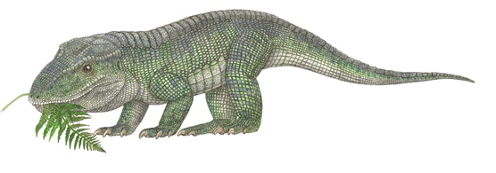Revuetosaurus callenderi* is a small, about 3feet (1 m) long, herbivorous reptile that until recently was quite an enigma. Known only from distinctive leaf-shaped teeth it was thought to be a primitive plant eating dinosaur. Discovery of the skeleton of this animal in Petrified Forest in 2004 showed that it was not a dinosaur and instead more closely related to aetosaurs and rauisuchians.

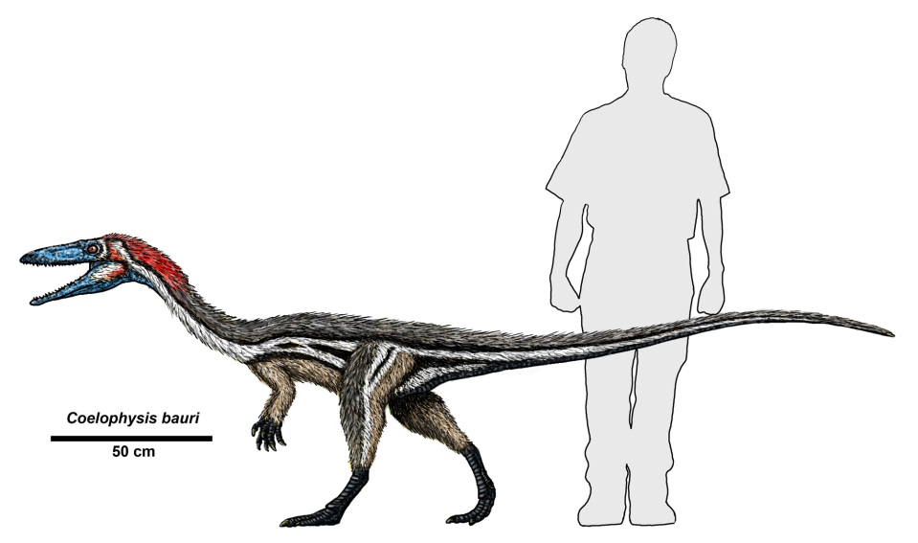**Dinosaurs**- Most visitors to the park are surprised to learn that dinosaurs are a relatively rare and minor component of the Triassic fauna preserved at the park. Separated from the other archosaurs by characteristics of the pelvis and ankle, Late Triassic dinosaurs were mainly small, bipedal carnivorous predators including *Chindesaurus* and *Coelophysis*. *Coelophysis* (sealo-fie-sis) was an early carnivorous dinosaur that probably walked on two legs. It was about 8 feet (2.4 m) long and could weigh 50 pounds (23 kg).

**Lesson Goals**

* develop an understanding of the science of paleontology by learning the skills and concepts involved
* be introduced to basic anatomy of animals by matching individual fossils to compete skeletons.
* Be introduced to the three types of consumer groups in nature
* Practice reading (binomial nomenclature) scientific names
* explore an aspect of paleontology through participation in an investigation activity.
* become aware of the importance of preservation of paleontological resources
* understand the role of the National Park Service in the preservation and protection of natural and cultural resources.

**Learning Objectives**

Students will be able to:

* describe paleontology as the study of ancient life on earth through fossils
* list geological time periods represented at the park
* recognize basic animal anatomy from fossil bones
* describe how an animal’s teeth can help determine what type of food they ate.
* recognize that paleontological resources are nonrenewable
* describe at least one thing they learned about Petrified Forest National Park and/or the National Park Service.

**Related Vocabulary**

* **Anatomy**: the branch of science concerned with the structure of living organisms’ bodies and bones
* **Ankle –** the joint that connects the foot to the leg
* **Bipedal**: characteristic of an animal using only two legs to walk; includes humans
* **Carnivore –** an animal that feeds on meat; typically has teeth that are long and pointed or serrated for tearing and separating flesh
* **Chinle Formation** - rock formation within Petrified Forest National Park and the larger area of the Painted Desert, containing several distinct rock layers, dating to over 200 million years ago; represents the Late Triassic Period
* **Erosion** - the movement of earth material from one place to another due to forces such as water, wind, gravity, or ice movements
* **Femur** – the thigh bone in humans and other animals
* **Fossil** - any record of past life found preserved in rock; can be plant materials such as stems, seeds, or cones, and pollen, or animal parts such as bone, shells, or teeth; can be trace impressions, such as tracks, footprints, trails, burrows, leaves, etc.
* **Fossilization** - a process by which plant and animal remains or their impressions are preserved in rock *(evidence of life preserved by a geologic process)*
* **Geology** - a science that concentrates on the origin, history, and structure of the earth including the study of rocks and the forces acting upon the earth
* **Herbivore –** an animal that feeds on plants; typically has teeth that are flat or have triangle shaped tips for chewing and grinding
* **Omnivore –** an animal that feeds no both plants and meat; Typically has a combination of flat and pointy teeth
* **Organic material** - dead plant and animal matter in various stages of decomposition or fossilization
* **Pelvis**: the large bony structure near the base of the spine to which the hind limbs or legs are attached in humans and many other vertebrates.
* **Permineralization** - fossilization through in-filling of pore spaces in organic material by minerals; organic material is encased within the mineral (scientific term for petrification)
* **Scapula** – technical term for the shoulder blade.
* **Sedimentary** - rock formed from the deposition, accumulation, and cementation of sediments, usually forming layers, often including fossils
* **Skull -** a framework of bone or cartilage enclosing the brain of a vertebrate; the skeleton of a person's or animal's head.
* **Tetrapod:** a four-footed animal, especially a member of a group that includes all vertebrates higher than fish.
* **Triassic Period** - the first geologic timespan within the Mesozoic Era, dating from 248-206 million years ago; the Late Triassic Period is well represented at Petrified Forest National Park
* **Vertebra** - each of the series of small bones forming the backbone, having several projections for articulation and muscle attachment, and a hole through which the spinal cord passes.

**Materials** - All materials will be provided by the park

**Student Assessment Questions**

Use the following questions to help your students prepare for their trip and to assess what they learned after visiting the park.

1. Can you think of two facts you know about Petrified Forest or the National Park Service?
2. What is a fossil? Give an example of a fossil found at Petrified Forest National Park.
3. It is important to protect our natural resources. Fossils are an example of resources that are in danger of being destroyed. Can you list two reasons for why fossils are being destroyed?
4. What is one way you might be able to tell a herbivore from a carnivore based on the animal’s skeleton?
5. How can paleontologists use fossil bones to find out how animals moved or stood?
6. National parks were created to protect natural and cultural resources for future generations. Can you explain why this is important?

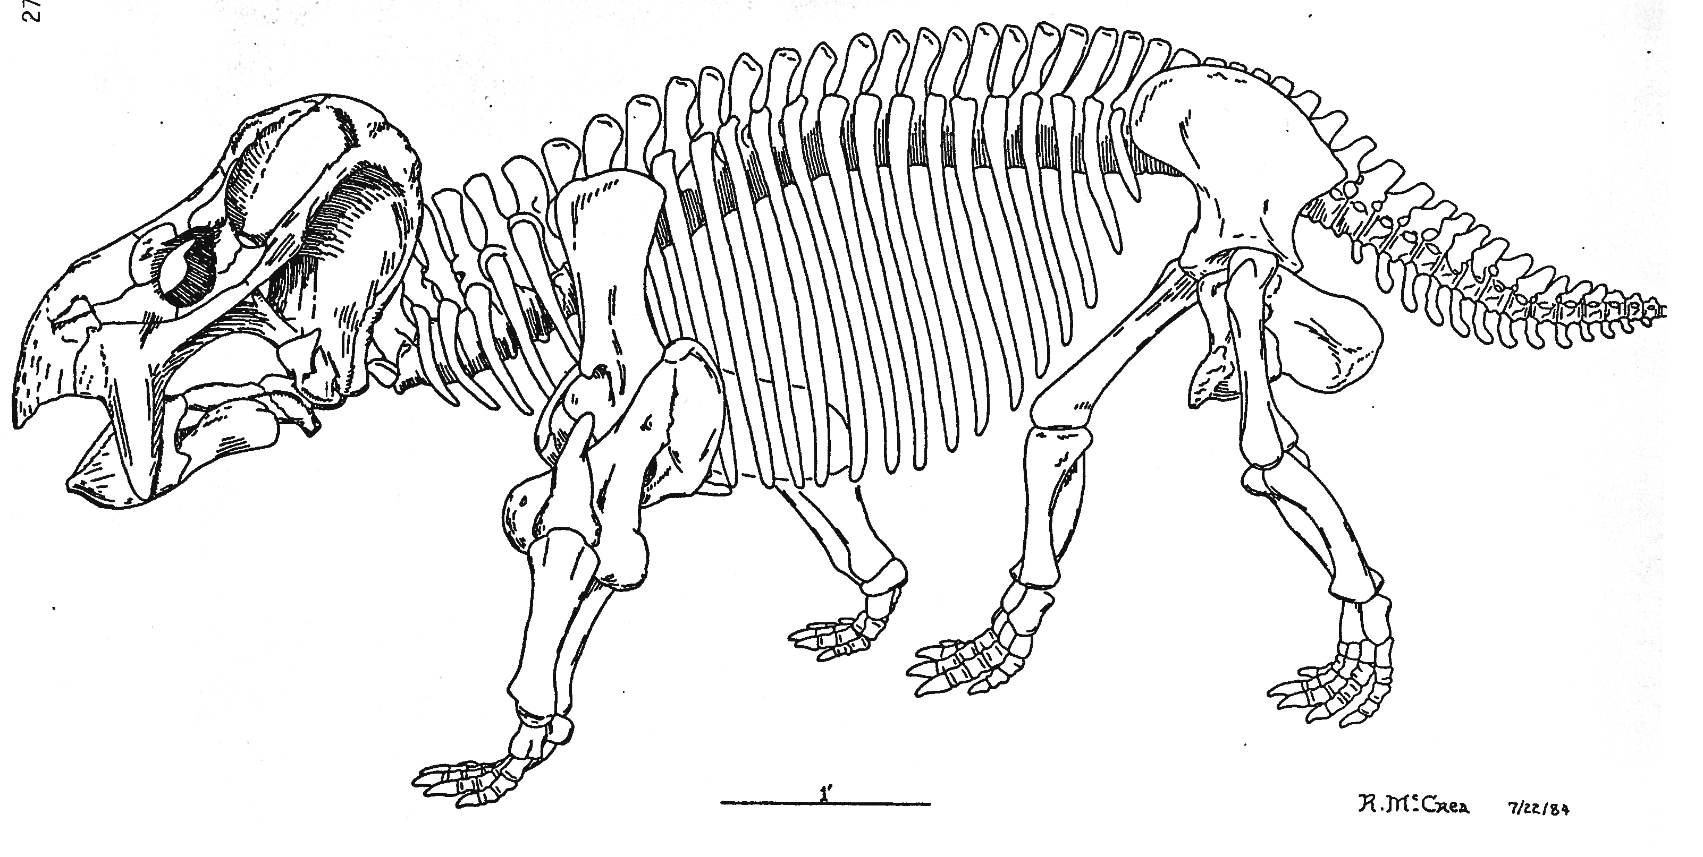Museum Detectives at Petrified Forest National Park

Making observations and looking for clues is an important part of doing paleontology (the study of ancient non-human life). With your group or partner, look closely at your fossil. Try to match it with one of the fossils on display. Answer the questions below and be ready to share what you have learned with your classmates and the ranger.

1. What part of the animal’s body is your fossil? (leg bone, skull, etc.)
2. What is the name of your animal and when did it live?
3. What kind of animal is it and what did it eat? (reptile, dinosaur, amphibian?)
4. What part of the body can be used to determine what this animal ate?
5. What is one other thing you learned or observed about your fossil?

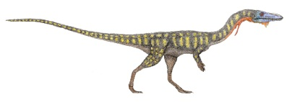

Names: _____________________ and _____________________