  - Environmental Factors Influencing Fire Behavior in the Olympic Mountains

Table of Contents

Introduction: Pgs. 2-6
Scope: Pg. 6
Decision Maker’s Problem: Pgs. 6-7
Management Goal: Pg. 7
Project Objective: Pgs. 7-8
Methods: Pgs. 8-9
Assumptions: Pgs. 9-14
Case Studies: Pgs. 14-60
The Hopper Fire (2010): Pgs. 14-20
The Heatwave Complex (2009): Pgs. 21-40
The 10 Mile Fire: Pgs. 21-27
The Constance Fire: Pgs. 27-34
The Knife and Buckinghorse Fires Pgs. 34-40
The Olympic Complex (2008): Pgs. 40-46
The Bear Gulch II Fire (2006): Pgs. 47-53
The Griff Fire (2003): Pgs. 54-60
Results: Pgs. 61-68
Recommendations: Pgs. 68-69
References: Pg. 70

Introduction
Olympic National Park is a lush and diverse landscape punctuated by steep, rugged peaks and deep glaciated valleys. Mount Olympus at 7,959 ft., located slightly north and west of the center of the park, receives more precipitation than anywhere else in the U.S.—roughly 200 inches per year. Deeply furrowed river drainages influencing local weather patterns, extend radially from the center of the park toward the Pacific Ocean. The climate here is temperate rainforest, and the Pacific Ocean’s marine influences moderate temperatures on the Olympic Peninsula, with summer time highs in the 70s and occasionally in the 80s and winter time lows in the 40s and lower 50s. A significant rain-shadow exists on the northeast side of the Park, and some areas there receive less than 20 inches of rain per year. The majority of fires in the park have burned on the rain-shadow side of the park, and a fire occurrence map for the area showing size and locations of fires 1938-2001 nicely illustrates this phenomenon (fig .1).
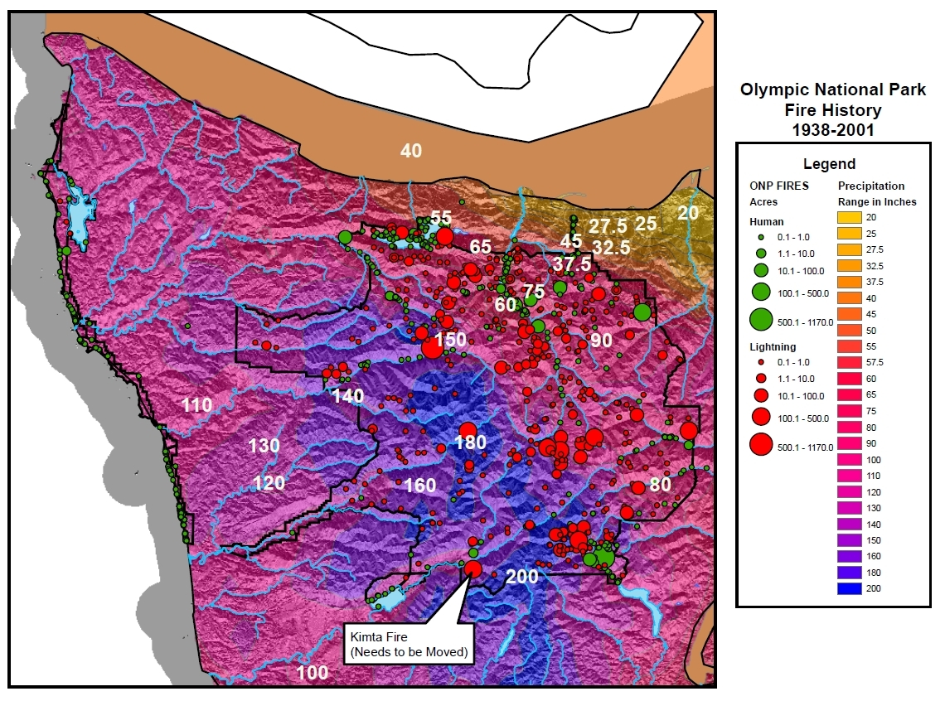

The vast majority (85 percent) of precipitation in the Olympic Mountains falls between October and April, and precipitation between July and August totals only 5 percent of the yearly amount.
“In the Olympics, vegetation patterns and fire regimes reflect environmental gradients of moisture and temperature. Moisture increases from east to west and from lower to higher elevations” (ONP FMP 2005). For the purpose of an analysis of vegetation done in the park’s FMP 20 shrub/heather types and 17 tree types are lumped into six vegetation zones: The Sitka Spruce Zone—typically below 600 ft.; the Western Hemlock Zone—between 500-200ft. on the west side of ONP and from sea level to 4,000 ft. on the east side; the Douglas-fir Zone—in middle elevations in the Dungeness River drainage; the Silver Fir Zone—throughout the interior of the park, generally at middle elevations; the Mountain-Hemlock Zone—generally above 3,500 ft. ; and the Subalpine Fir Zone—generally above 4,000 ft. A study on vegetation on the lands around Olympic National Forest by Henderson, et al. (1989) shows that vegetation zones relate interdependently to patterns of previous fire events. They state, “In the cooler moister associations, fires appear to have been much less frequent than on drier or warmer types. An analysis of the reconstructed fire patterns showed that Sitka Spruce, Silver Fir and Mountain Hemlock Zones had much less acres burned than the Western Hemlock, Subalpine Fir od Douglas-fir Zones…The fire return period for the Sitka Spruce, Mountain Hemlock and Silver Fir Zones for the last 800 years were 900, 844, and 629 respectively for the Western Hemlock, Subalpine Fir and Douglas-fir Zones they were 234, 208, and 138 years respectively…” One study in the Morse Creek drainage calculated a fire return interval as short as 24 years (Wezell and Fonda, 2000) (it should be noted, however, that the assumptions and methodology of this study differed from earlier studies.) “Disturbance maps for the peninsula presented by Henderson et al., 1989; and Agee, 1994…indicate that there is a gradient of fire regimes across the park” (ONP FMP 2005 pg. 17).
The relatively short fire season extends from July through September with some fires occurring in late June and early October. “Since 1916, a total of 2,984 ha [7373 ac.] burned in Olympic National Park. Eighty-three percent of the total were burned by lightning fires. Most natural fires in Olympic National Park are less that 0.1 ha [.25 ac] in size (Pickford et al. 1977); infrequent, but large lightning fires, such as the 1978 Hoh Fire which burned 492 ha [1215 ac], account for most of the burned area (Agee and Huff 1980).
Spread rates and intensities of fires in the Olympic Mountains are determined by the interplay of fuels, weather and topography. Steep, narrow river drainages often exhibit powerful, tumultuous diurnal winds in excess of 20 miles per hour during summer afternoons. Most fires in the Olympics occur on craggy, exposed south-facing slopes. Lightning caused fires often ignite on ridge tops or the upper 1/3 of slopes. Unlike the wind-driven fires of other locations, fires in the Olympics tend to be topography driven. The incredibly dense forest canopy shields fires from most winds, and the very steep landscape (slopes greater than 100% are common) causes burning debris to roll-out downhill and ignite fuels below which in turn generates enough heat to produce small, up-slope runs. Fuel loadings are incredibly high. Fire managers often use TL5 “High Load Conifer Litter” to model fire behavior here, but this fuel model does not take into account the very deep duff layers and thick moss component regularly found on tree boles, in the canopy and on the forest floor. This deep duff and moss enables fires to continue to smolder in a somewhat dormant state during periods of cool, wet weather that would quickly extinguish fires in lighter fuel types. Hold-overs or sleeper fires are often revealed sometimes weeks after the orographic storms that ignited them have passed. Most of these thunderstorms are accompanied by rain, putting the newly started fires into dormancy until extended periods or warm, dry weather, usually in conjunction with east winds, bring them back to life. Large, well established fires can smolder for weeks and even months in cool, moist conditions until several days of unusually warm, dry conditions enable them to make a few major runs.
Jim Agee in his paper, “Characteristics of Large Lighting Fires in the Olympic Mountains, Washington”, says that while, “peak thunderstorm activity occurred in 1946, 1949, 1953, and 1958…no significant fires ensued even though a high frequency of ignition was present” (Agee and Huff 1980). And he speculates, “fire occurrence may be determined by fuel moisture as a function of time since last significant precipitation” (Pickford et al. 1977). He concludes that, “long periods of below normal precipitation could strongly influence large lightning fire occurrence in Olympic National Park. In another paper entitled, “A Fire Cycle Model Based on Climate”, Agee says that, “Large (>1 ha) lightning fires were associated with several months of drought before the fire, short term dry spells before the ignition, thunderstorm activity that served as the ignition source, and an east wind synoptic weather type, associated with low relative humidity and in some locations strong winds” (Agee and Flewelling 1983). In this paper he uses a model to measure frequency of natural fire in this moist fire environment. He concludes that the model runs for increased drought produce what appear to be the most reasonable fire cycles for the park in terms of ground evidence of past fires. However, he says, “drought of such magnitude over long periods of time does not seem to be likely, and several major events appear to be responsible for much of the past burned area. Unusually high short-term increases in two or more fire climate factors may be responsible” (Agee and Flewelling 1983).
In the last decade there has been a noteworthy increase of both fire occurrence and acres burned in the northeastern, rain-shadow portion of the Olympic Mountains. Between 2003 and 2010 nearly 4000 acres burned in and adjacent to Olympic National Park—that is more than half of the number of acres burned in the 64 year period of 1916-1980. A handful of significant large fire events account for these acres burned: the Griff Fire in 2003 burned 820 acres; the Bear Gulch 2 Fire in 2006 burned 1050 acres; the Heatwave Complex in 2009 burned 1616 acres; and the Hopper Fire in 2010 burned 381 acres. Considering this increase in fire activity in the Olympics in the light of Agee’s studies on the characteristics of large fires in the Olympics, it may be interesting and helpful to investigate which weather related factors contributed most to large fire growth. If drought alone does not explain the occurrence of these recent large fires, which combination of variables is responsible?
Scope:
Due to the fact that there is a gradient of fire regimes across the park and that we can expect fire to behave very differently on the wet west side than on the drier east side, this project will focus only on the dry/ rain-shadow side of the park. The west side of the park is a true example of a high severity/ low frequency fire regime, and the east side of the park is a mixed frequency and mixed severity regime. Additionally, because weather data at the Hurricane RAWS station becomes infrequent prior to 1993, this study will focus on fire weather at Olympic National Park from 1993-2010. Quality data is available at the Jefferson and Cougar RAWS stations back to 1985, but for consistency and comparison purposes, this study will confine analysis to 18 years of weather data between the three RAWS stations from 1993-2010. It is reasonable to base this study on less than 20 years of weather data because Fire Program Analysis models used for planning, budgeting and resource allocation are based on only the most recent 10 years of weather data.
Decision Maker’s Problem:
The ONP Fire Management Plan addresses the importance of maintaining fire as a natural disturbance in the ecosystem, and fire managers at Olympic manage naturally ignited wildfires as a natural process within forest ecosystems whenever it is possible to do so. Having a better understanding of what key factors influence large fire growth at ONP and how often they occur could help decision makers manage wildfire for resource benefit at ONP with greater confidence. It could also change our understanding of how much fire we can expect in coming years. The current FMP limits fire for resource benefit acres to 1600 acres every five years, and a study like this may encourage policy makers to expand upon current limits to better reflect the amount of fire we are seeing on the ground.
Management Goal:
The vegetative composition, structure and fuels across the park are considered to be in a Condition Class I, with little departure from the historical or natural range of variability. However, some of the natural fires that were suppressed at a small size might otherwise have grown large, creating forest openings and diverse habitats. It may be hundreds of years before fires occur again at those sites. In the meantime, the diversity of habitat is reduced in these localities. If suppression were continued park-wide indefinitely, it would eventually affect stand structure and composition, the abundance of subalpine meadows (Agee, 1993), and habitat available for wildlife species (Huff, 1984). For this reason, and because, “the historic role of fire in determining past and present forest conditions is only beginning to be fully recognized.” (National Park Service Master Plan 1976), Park Fire Managers allow fire to play its natural role in the ecosystem any time it is not a threat to physical developments, private lands, lands outside the park and human life. Understanding the average number of days in any given season that would have the requisite combination of environmental factors to support large fire growth could help Park Fire staff manage fire for resource benefit with greater confidence.

Project Objective:
This project will use case studies of five significant fire events on the rain-shadow side of Olympic National Park in the last 10 years to explore the relationship between climatic variables and large fire growth. It will explore the relationship between these five key climate factors and large fire growth in the Olympic Mountains (1000 hr. fuel moisture, ERC, precipitation, relative humidity and temperature). Studies show that 1000 hr. fuel moistures and ERCs, drought levels and time since last precipitation are highly correlated to large fire growth in the Olympics. Other studies suggest that in addition to these factors a “weather trigger” of hot, dry conditions may be required to facilitate large fire growth in this area.
This study explores the relationship between these five key climate factors and large fire growth in the Olympic Mountains (1000 hr. fuel moisture, ERC, precipitation, relative humidity and temperature).
This project seeks to address the following questions: How often do these factors come into alignment to create conditions favorable for large fire growth? Is there an upward trend in the number of potential large fire growth days in the recent decade? Can this upward trend be explained by climate change? And what can local fire managers expect in the future?

Methods:
Fire records were examined for all of the five case study fire events. Information was gathered about the fires in order to create a context illustrating causes and conditions that resulted in active fire behavior during each event. Records of on-site observations were used to chart the growth of each event, noting days and groups of days when the fire grew most actively. After these dates were identified for each event the data sets were examined to find out which weather related factors had the most influence on fire behavior for each event. Using records of on-site weather observations, relevant RAWS data, and archived fire weather discussions from the Seattle Weather service, weather patterns were charted over the period of most active growth for each event. After charts were created for each fire event indicating dates of most active fire behavior and corresponding charts were created illustrating key weather variables for those dates, a conclusion was drawn about which key weather variables need to be in what range in order for large fire growth to be possible. Lastly, the event locator in firefamily plus was used to determine how frequently the alignment of these several key weather factors occurred in the past at the RAWS stations that were used in this study.

Assumptions:
This project will consider ERC’s 1000hr fuel moisture contents, precipitation, temperatures and relative humidity in relation to each of the fire events examined in these case studies. Two indices that are particularly useful in the Olympics are the Energy Release Component (ERC) and the 1000-Hr Fuel Moisture Content. The ERC is a number related to the 24-hr, potential worst case, total energy released per unit area within the flaming front of the fire. It is directly related to the available energy (BTU) per unit area (square foot) within the flaming front at the head of a fire. The 1000-Hr Fuel Moisture Content represents the modeled moisture content in the dead fuels in the 3 to 8 inch diameter class and the layer of the forest floor about four inches below the surface. Values can range from 1 to 40 percent (ONP FMP). These two indices have been good indicators for predicting active fire behavior in this area in the past so they will be used in this study. As Agee indicated in previous studies, precipitation before and after fire ignition and drought before fire ignition is highly correlated to large fire growth in the Olympic Mountains. So, this study will also consider precipitation and drought in relation to each of the case study fire events. Finally, this study assumes that very low relative humidity and very high temperatures often associated with East wind events serve as the weather trigger that, coupled with low 1000 hr. fuel moisture, high ERC’s and minimal precipitation, make large fire growth in the Olympic Mountains likely. So relative humidity and temperatures will also be examined in relation to the case study fire events.
There could be no more accurate data for this study than on-site weather observations, but because that data was not recorded consistently and because that data does not extent back in time, this study must rely on weather data from nearby RAWS stations. RAWS stations were picked to best represent the elevation, slope, aspect, fuel type and exposure for each individual fire location. When on-site weather observations differ from RAWS data and archived weather discussions, all data was checked for accuracy and if differences persist, an investigation of the causes for these differences was conducted.
Jefferson Creek RAWS is located approximately 8.5 miles west of the town of Eldon in NE Mason County. This mid-slope site is situated on the southeast aspect of Jefferson Ridge. Steep, fractured terrain in the area favors diurnal slope and valley winds in the Jefferson Creek drainage. Light winds and good overnight humidity recovery are the rule of thumb. While open to the marine influences of Puget Sound, it also is influenced by frontal intrusions with moderate to heavy rainfall when low level flow ahead of the front is from the east to southeast (ONP FMP). This RAWS station was chosen to represent the weather on the 10-Mile and Bear-Gulch fires due to its proximity to the fire locations, its similar elevation, and its representation of the diurnal wind patterns that were observed on the fires. The following chart indicates the months and years data is available at this RAWS station.

Jefferson Creek Washington
BOLD, Red indicates some data available for month and year.
2011 | Jan | Feb | Mar | Apr | May | Jun | Jul | Aug | Sep | Oct | Nov | Dec
2010 | Jan | Feb | Mar | Apr | May | Jun | Jul | Aug | Sep | Oct | Nov | Dec
2009 | Jan | Feb | Mar | Apr | May | Jun | Jul | Aug | Sep | Oct | Nov | Dec
2008 | Jan | Feb | Mar | Apr | May | Jun | Jul | Aug | Sep | Oct | Nov | Dec
2007 | Jan | Feb | Mar | Apr | May | Jun | Jul | Aug | Sep | Oct | Nov | Dec
2006 | Jan | Feb | Mar | Apr | May | Jun | Jul | Aug | Sep | Oct | Nov | Dec
2005 | Jan | Feb | Mar | Apr | May | Jun | Jul | Aug | Sep | Oct | Nov | Dec
2004 | Jan | Feb | Mar | Apr | May | Jun | Jul | Aug | Sep | Oct | Nov | Dec
2003 | Jan | Feb | Mar | Apr | May | Jun | Jul | Aug | Sep | Oct | Nov | Dec
2002 | Jan | Feb | Mar | Apr | May | Jun | Jul | Aug | Sep | Oct | Nov | Dec
2001 | Jan | Feb | Mar | Apr | May | Jun | Jul | Aug | Sep | Oct | Nov | Dec
2000 | Jan | Feb | Mar | Apr | May | Jun | Jul | Aug | Sep | Oct | Nov | Dec
1999 | Jan | Feb | Mar | Apr | May | Jun | Jul | Aug | Sep | Oct | Nov | Dec
1998 | Jan | Feb | Mar | Apr | May | Jun | Jul | Aug | Sep | Oct | Nov | Dec
1997 | Jan | Feb | Mar | Apr | May | Jun | Jul | Aug | Sep | Oct | Nov | Dec
1996 | Jan | Feb | Mar | Apr | May | Jun | Jul | Aug | Sep | Oct | Nov | Dec
1995 | Jan | Feb | Mar | Apr | May | Jun | Jul | Aug | Sep | Oct | Nov | Dec
1994 | Jan | Feb | Mar | Apr | May | Jun | Jul | Aug | Sep | Oct | Nov | Dec
1993 | Jan | Feb | Mar | Apr | May | Jun | Jul | Aug | Sep | Oct | Nov | Dec
1992 | Jan | Feb | Mar | Apr | May | Jun | Jul | Aug | Sep | Oct | Nov | Dec
1991 | Jan | Feb | Mar | Apr | May | Jun | Jul | Aug | Sep | Oct | Nov | Dec
1990 | Jan | Feb | Mar | Apr | May | Jun | Jul | Aug | Sep | Oct | Nov | Dec
1989 | Jan | Feb | Mar | Apr | May | Jun | Jul | Aug | Sep | Oct | Nov | Dec
1988 | Jan | Feb | Mar | Apr | May | Jun | Jul | Aug | Sep | Oct | Nov | Dec
1987 | Jan | Feb | Mar | Apr | May | Jun | Jul | Aug | Sep | Oct | Nov | Dec
1986 | Jan | Feb | Mar | Apr | May | Jun | Jul | Aug | Sep | Oct | Nov | Dec
1985 | Jan | Feb | Mar | Apr | May | Jun | Jul | Aug | Sep | Oct | Nov | Dec

Hurricane Ridge RAWS is located 10 miles south of Port Angeles in the northeast portion of Clallam county. It is the highest-elevation, fire weather site in western Washington with excellent exposure to free-air winds at 5,000 ft msl. Hurricane Ridge often remains warm and dry on days when marine air encircles the lower elevations of the Olympic Mountains. Frontal systems moving inland from the west to northwest will usually bring cloudy, cool, rainy weather to Hurricane Ridge. However, this is less likely to happen when the front moves in from the south or southwest. In late summer and early fall, dry, westerly flow aloft - especially behind a sharp, upper level, short-wave trough - can result in extremely low humidity readings in the single digits (ONP FMP). This RAWS station was chosen for weather data collection for the Knife, Buckinghorse, Olympic Complex, and Griff fire case studies because all of these fires occurred at high elevations (ca 5000 ft.) and were exposed to upper level winds. The following chart indicates the months and years data is available at this RAWS station.

Hurricane Washington
BOLD, Red indicates some data available for month and year.
2010 | Jan | Feb | Mar | Apr | May | Jun | Jul | Aug | Sep | Oct | Nov | Dec
2009 | Jan | Feb | Mar | Apr | May | Jun | Jul | Aug | Sep | Oct | Nov | Dec
2008 | Jan | Feb | Mar | Apr | May | Jun | Jul | Aug | Sep | Oct | Nov | Dec
2007 | Jan | Feb | Mar | Apr | May | Jun | Jul | Aug | Sep | Oct | Nov | Dec
2006 | Jan | Feb | Mar | Apr | May | Jun | Jul | Aug | Sep | Oct | Nov | Dec
2005 | Jan | Feb | Mar | Apr | May | Jun | Jul | Aug | Sep | Oct | Nov | Dec
2004 | Jan | Feb | Mar | Apr | May | Jun | Jul | Aug | Sep | Oct | Nov | Dec
2003 | Jan | Feb | Mar | Apr | May | Jun | Jul | Aug | Sep | Oct | Nov | Dec
2002 | Jan | Feb | Mar | Apr | May | Jun | Jul | Aug | Sep | Oct | Nov | Dec
2001 | Jan | Feb | Mar | Apr | May | Jun | Jul | Aug | Sep | Oct | Nov | Dec
2000 | Jan | Feb | Mar | Apr | May | Jun | Jul | Aug | Sep | Oct | Nov | Dec
1999 | Jan | Feb | Mar | Apr | May | Jun | Jul | Aug | Sep | Oct | Nov | Dec
1998 | Jan | Feb | Mar | Apr | May | Jun | Jul | Aug | Sep | Oct | Nov | Dec
1997 | Jan | Feb | Mar | Apr | May | Jun | Jul | Aug | Sep | Oct | Nov | Dec
1996 | Jan | Feb | Mar | Apr | May | Jun | Jul | Aug | Sep | Oct | Nov | Dec
1995 | Jan | Feb | Mar | Apr | May | Jun | Jul | Aug | Sep | Oct | Nov | Dec
1994 | Jan | Feb | Mar | Apr | May | Jun | Jul | Aug | Sep | Oct | Nov | Dec
1993 | Jan | Feb | Mar | Apr | May | Jun | Jul | Aug | Sep | Oct | Nov | Dec
1992 | Jan | Feb | Mar | Apr | May | Jun | Jul | Aug | Sep | Oct | Nov | Dec

Cougar RAWS is a mid-slope site on Gold Creek in the Dungeness River drainage. During east wind episodes, Cougar experiences moderate wind speeds, lower humidity, and very poor overnight humidity recovery. Located within the Olympic Mountain rain shadow, this site is dry, often exhibiting the highest fire danger of any fire weather station on the Olympic Peninsula. However, Cougar's proximity to the Strait of Juan de Fuca helps moderate fine fuel moisture (and therefore fire danger) by keeping afternoon relative humidity above 30%. This typically occurs when winds are from the northwest to northeast (ONP FMP). This RAWS station was chosen to represent the weather on the Constance fire due to its proximity to the fire location, it’s similar elevation, and its representation of the very dry conditions that were observed at the fire location. The following chart indicates the months and years data is available at this RAWS station.

Cougar Mountain Washington
BOLD, Red indicates some data available for month and year.
2011 | Jan | Feb | Mar | Apr | May | Jun | Jul | Aug | Sep | Oct | Nov | Dec
2010 | Jan | Feb | Mar | Apr | May | Jun | Jul | Aug | Sep | Oct | Nov | Dec
2009 | Jan | Feb | Mar | Apr | May | Jun | Jul | Aug | Sep | Oct | Nov | Dec
2008 | Jan | Feb | Mar | Apr | May | Jun | Jul | Aug | Sep | Oct | Nov | Dec
2007 | Jan | Feb | Mar | Apr | May | Jun | Jul | Aug | Sep | Oct | Nov | Dec
2006 | Jan | Feb | Mar | Apr | May | Jun | Jul | Aug | Sep | Oct | Nov | Dec
2005 | Jan | Feb | Mar | Apr | May | Jun | Jul | Aug | Sep | Oct | Nov | Dec
2004 | Jan | Feb | Mar | Apr | May | Jun | Jul | Aug | Sep | Oct | Nov | Dec
2003 | Jan | Feb | Mar | Apr | May | Jun | Jul | Aug | Sep | Oct | Nov | Dec
2002 | Jan | Feb | Mar | Apr | May | Jun | Jul | Aug | Sep | Oct | Nov | Dec
2001 | Jan | Feb | Mar | Apr | May | Jun | Jul | Aug | Sep | Oct | Nov | Dec
2000 | Jan | Feb | Mar | Apr | May | Jun | Jul | Aug | Sep | Oct | Nov | Dec
1999 | Jan | Feb | Mar | Apr | May | Jun | Jul | Aug | Sep | Oct | Nov | Dec
1998 | Jan | Feb | Mar | Apr | May | Jun | Jul | Aug | Sep | Oct | Nov | Dec
1997 | Jan | Feb | Mar | Apr | May | Jun | Jul | Aug | Sep | Oct | Nov | Dec
1996 | Jan | Feb | Mar | Apr | May | Jun | Jul | Aug | Sep | Oct | Nov | Dec
1995 | Jan | Feb | Mar | Apr | May | Jun | Jul | Aug | Sep | Oct | Nov | Dec
1994 | Jan | Feb | Mar | Apr | May | Jun | Jul | Aug | Sep | Oct | Nov | Dec
1993 | Jan | Feb | Mar | Apr | May | Jun | Jul | Aug | Sep | Oct | Nov | Dec
1992 | Jan | Feb | Mar | Apr | May | Jun | Jul | Aug | Sep | Oct | Nov | Dec
1991 | Jan | Feb | Mar | Apr | May | Jun | Jul | Aug | Sep | Oct | Nov | Dec
1990 | Jan | Feb | Mar | Apr | May | Jun | Jul | Aug | Sep | Oct | Nov | Dec
1989 | Jan | Feb | Mar | Apr | May | Jun | Jul | Aug | Sep | Oct | Nov | Dec
1988 | Jan | Feb | Mar | Apr | May | Jun | Jul | Aug | Sep | Oct | Nov | Dec
1987 | Jan | Feb | Mar | Apr | May | Jun | Jul | Aug | Sep | Oct | Nov | Dec
1986 | Jan | Feb | Mar | Apr | May | Jun | Jul | Aug | Sep | Oct | Nov | Dec
1985 | Jan | Feb | Mar | Apr | May | Jun | Jul | Aug | Sep | Oct | Nov | Dec

Case Studies:
The Hopper Fire
The Hopper Fire of 2010 was first reported on August 6th 2010. It was ignited by lightening on the upper 1/3 of a remote ridge on the south side of Mt. Hopper 10 miles up the North Fork of the Skokomish River from the Staircase Ranger Station. The new start was established in an old fire scar from a previous blaze (also called the Hopper Fire). The lightning storm that ignited the fire also produced a fair amount of precipitation and the fire remained small (less than 1/10 ac) for many days after it began. On August 9th, local resources reported very little sign of fire activity and foggy, wet weather. On August 11th the Olympic National Park fuels specialist Todd Rankin was advised by an IMET (incident meteorologist) at the Northwest Coordination Center that a thermal trough would be setting up over the fire area resulting in a critical fire weather pattern that could increase fire activity. On August 13th, a ranger reported a visible and growing smoke column from Lena Lake, 5 miles due east from the fire location. Later that day an aerial recon reported the fire had grown to 120 acres. It was burning actively, making short runs in sub-alpine fir and doing some short range spotting. Staff from engine 701 hiked in to the site to monitor fire behavior. On August 14th resources on the ground reported minimal fire behavior and cool, mild weather in the morning and then fire behavior increasing significantly after 1330 with limited crown runs and rates of spread of 25 chains/hour. The fire continued to burn quite actively through August 15th and had grown to 300 acres by this time. When the thermal trough broke down after August 16th and more seasonable weather returned, fire behavior slowed significantly. The Hopper Fire continued to burn much less actively, smoldering and creeping for weeks until significant precipitation late in the season put it out. The Hurricane RAWS station was used to collect weather data for this fire.
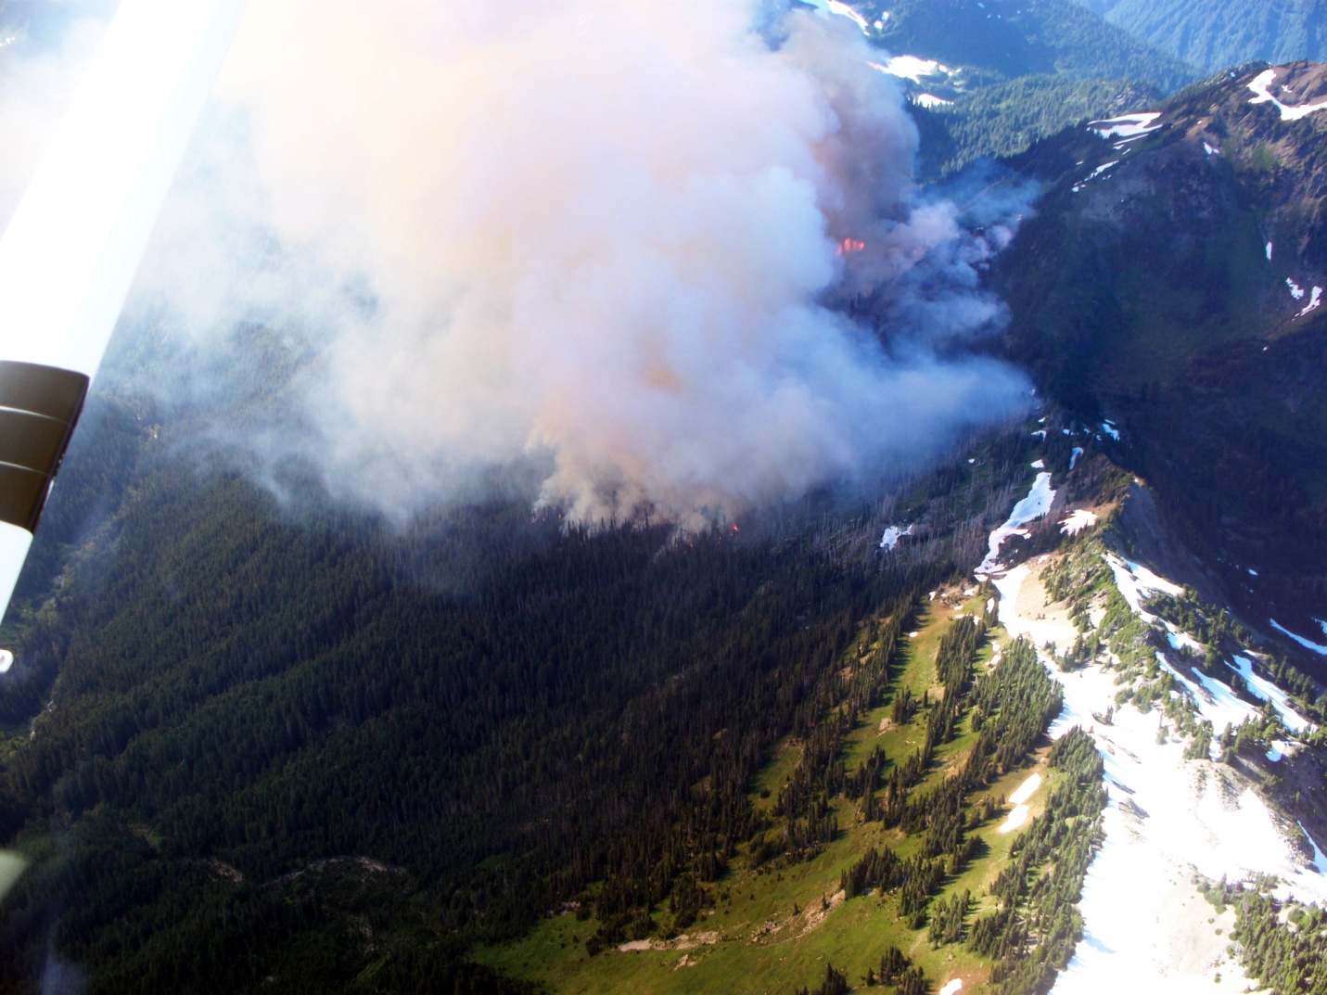
The Hopper Fire August 13th, 2010

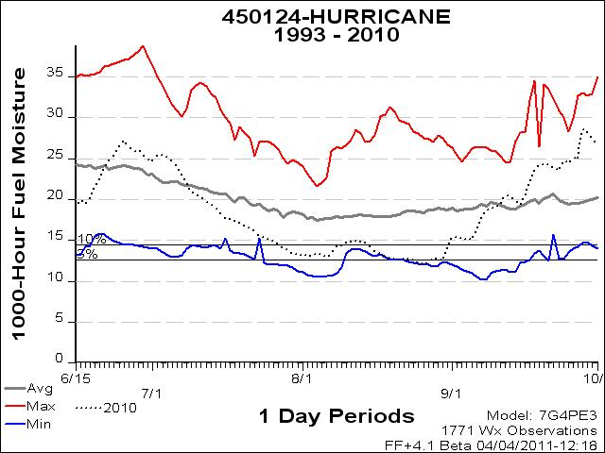
1000 hr fuel moistures were above average in 2010 before and after the most active period of the Hopper fire. In late June and late September these figures ranged upwards of 25%. During and just after the active growth period (August 13th-25th) figures dropped into the 10th and 5th percentiles hovering between 12 and 14%. These were historically low readings.

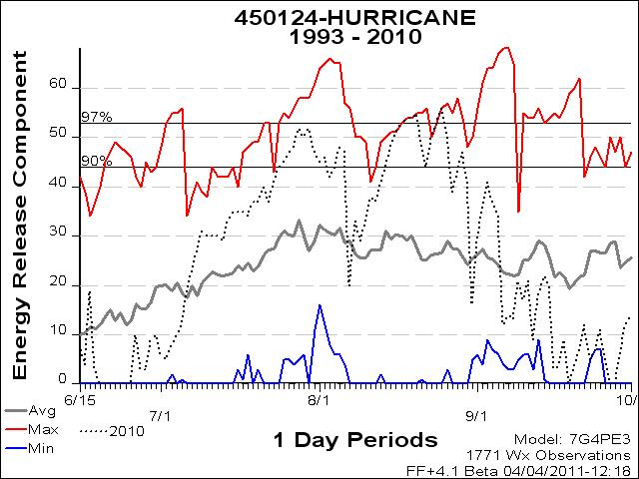
Here we see a similar pattern: ERC’s in June and September plummet to below 20 (that is below this 18 year average), and during the period of active growth reach 18 year highs above the 90th percentile at 44, 48, 51, 53, 54, 54, 54 for the dates 8/13-8/20.
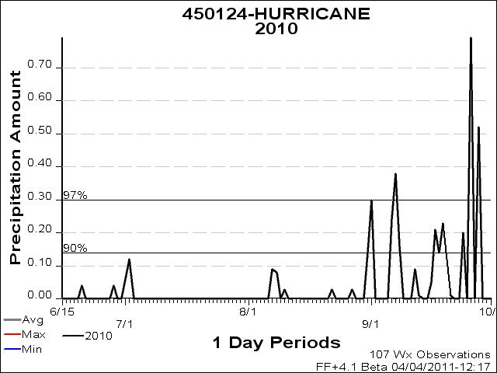
This graph show what seems to be a very typical precipitation pattern for fire season on the east side of the park: Some rain in June, a mostly dry July, some thunderstorm related rain in August and heavier rain setting in in September and October.
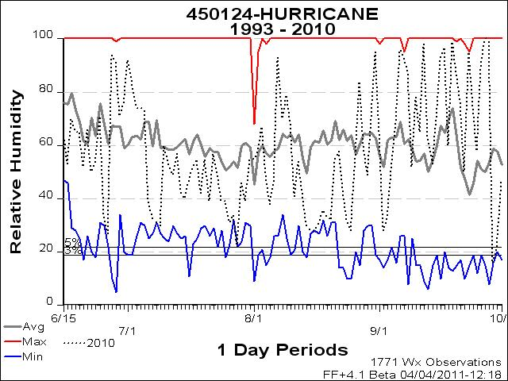
Although RH’s during the period of active growth had not dipped into the 5th and 3rd percentiles, they were hovering around 30% which is very close to the 18 year low.

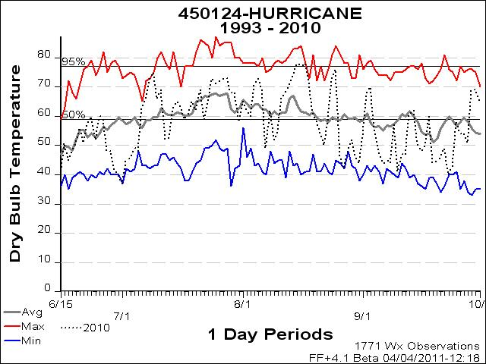
Although temperatures during this time (8/13-16) were not at 18 year highs, they were above the 95th percentile at 74, 77, and 78 degrees.

The Heatwave Complex
The Heatwave Complex of 2009 consisted of four significant fires (10 Mile, Constance, Knife and Buckinghorse) ignited by several discrete orographic storms over the course of a month. An additional fire the Sol Duc fire was ignited up near the seven lakes basin and was grouped in with the complex, but this fire, unlike the others was on the west side of the rain shadow and only grew to 5 acres.
The 10 Mile Fire
The 10 Mile fire was discovered on June 23rd, 2009. It was determined to have been started by a lightning strike near the edge of the Duckabush river at the bottom of a 1000 ft slope on a south facing aspect. This fire was pinned in by a hiking trail that effectively acted as a containment line, and it smoldered on the moist flat valley floor for nearly a month before it crossed the trail and began to grow. The fire remained at less than .5 acres until July 29th when it grew to 2 acres. Beginning on this day and lasting for nearly a week, temperatures increased dramatically and RHs fell sharply across western Washington in what the National Weather Service referred to as the 2009 Heatwave. The fire grew exponentially during this period: On the 30th it grew to 4 acres, on the 1st it grew to 250 acres, and by the 4th it was at 450 acres. On August 1st, the fire had established itself at the base of the south aspect of the drainage and was making large runs upslope with spotting occurring ½ mile out. The fire’s pace moderated after the week long heatwave. It continued to grow steadily reaching 650 acres by August 26th and topping out at 817 acres by the time 17 inches of rain snuffed it out in a season ending event in mid-October. The Jefferson RAWS station was used to collect weather data for this fire.

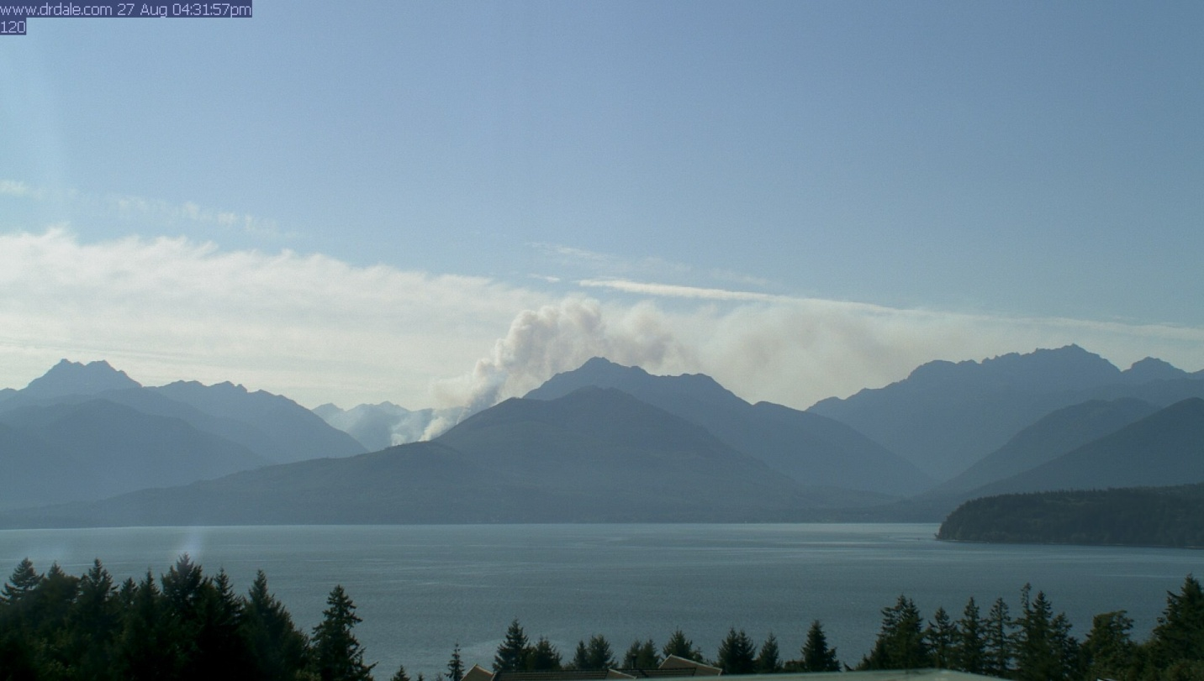

The 10 Mile Fire seen from across the Hood Canal on July 29th, 2009
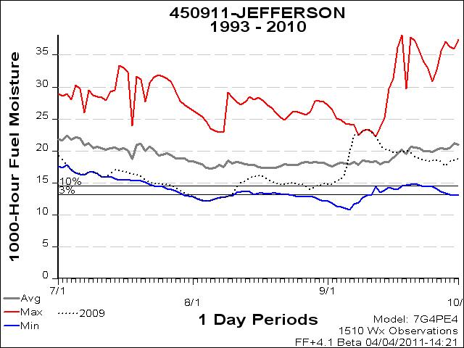
1000 hr fuel moistures at this RAWS station hovered near 18 year lows from early July until mid-August. Beginning in early September these values rocketed up to 18 year highs, but during the period of most active fire growth, July 29th-August 4th, values dipped into the 3rd percentile at 13.8, 13.4, 13, 12.8, 12.5, 12.3 and 12.2.

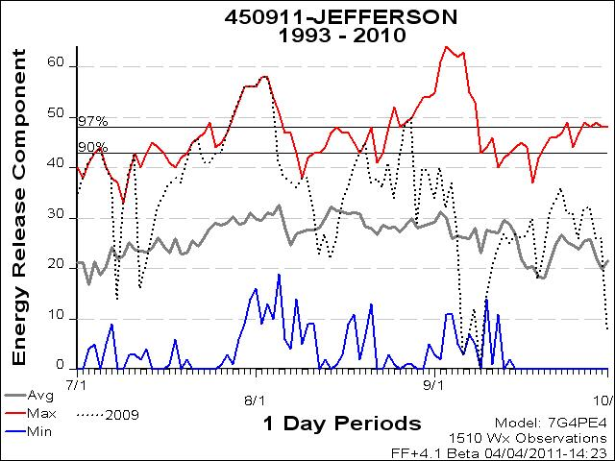
Again, ERC’s mirror 1000hr fuels in that on the days of most active growth values were in critical ranges—well above the 97th percentile at 53, 56, 56, 56, 58, 58 54 from 7/29-8/4.
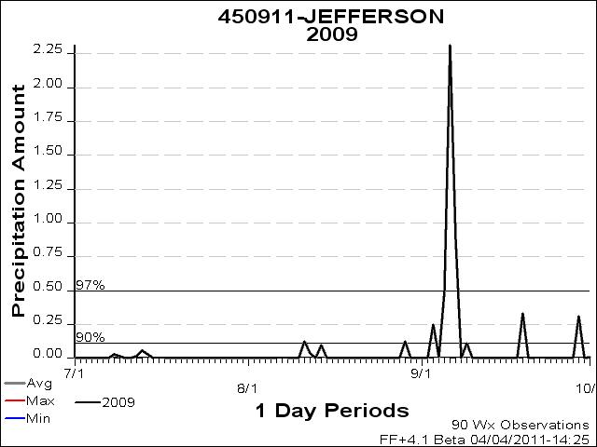
Only trace amounts of rain were received at this station from early July until early September. The two days of rain in August (8/11 .13” and 814, .1”) did slow fire growth significantly. But the fire was able to continue growing steadily until August 29th when it had dried out sufficiently to make one more significant upslope run before heavy rain (9/6 2.3”) knocked it down.
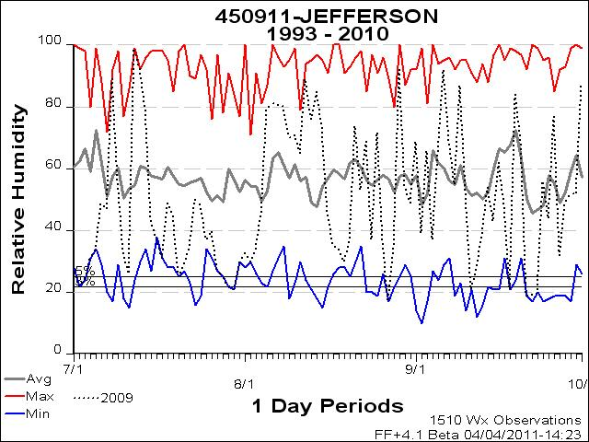
RH’s at this station dropped to 18 year lows during the period of most active fire growth. Values fell into the 5th and 3rd percentiles at 25, 22, 21, 30, 33, 30, 34, and 46 during this eight day period.
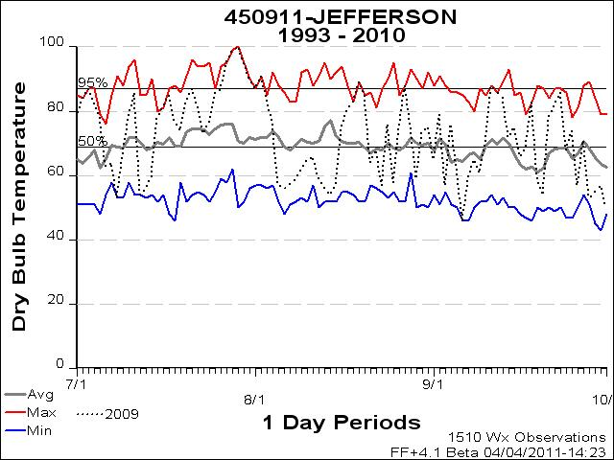
Temperatures were at 18 year highs and were well above the 95th percentile during the period of most active growth. From July 29th-August 4th temperatures were: 100, 95, 90, 87, 91, 84, 76.
The Constance Fire
The Constance fire was discovered on July 11th, 2009 just below the top of a south facing ridge near Mt Constance. This area is up the Dosewallips River drainage which is the next river drainage to the north from the Duckabush River drainage where the 10 Mile Fire was burning. The fire elevation was around 2500 ft and the slope 75-100%. This fire, also started by lightning grew slowly at first. It was 2 acres at the time of discovery and had only grown to 5 acres in nearly two weeks. During this time the fire grew primarily from burning debris rolling out over steep terrain and igniting fire below. Beginning on July 21st and continuing until August 4th, the fire grew rapidly, and during the week long heatwave episode July 26th-August 2nd, firefighters observed ¼-1/2 mile spotting, significant runs, and some sustained crown fires. Strong downdrafts produced by nearby thunderstorms caused increased fire activity and spread rates on July 29th and created considerable smoke issues for the community of Brinnon about 9 miles down-drainage from the fire. The fire grew to nearly 400 acres during this time and then continued to grow at a moderated pace with little growth from August 7th through October 12th. The fire did make one small, late season up-slope run at night in early October that was called into Park Dispatch from an airline pilot. At 443 acres, like the 10 mile fire, it was put out by heavy rain in October. The Cougar RAWS station was used to collect weather data for this fire.
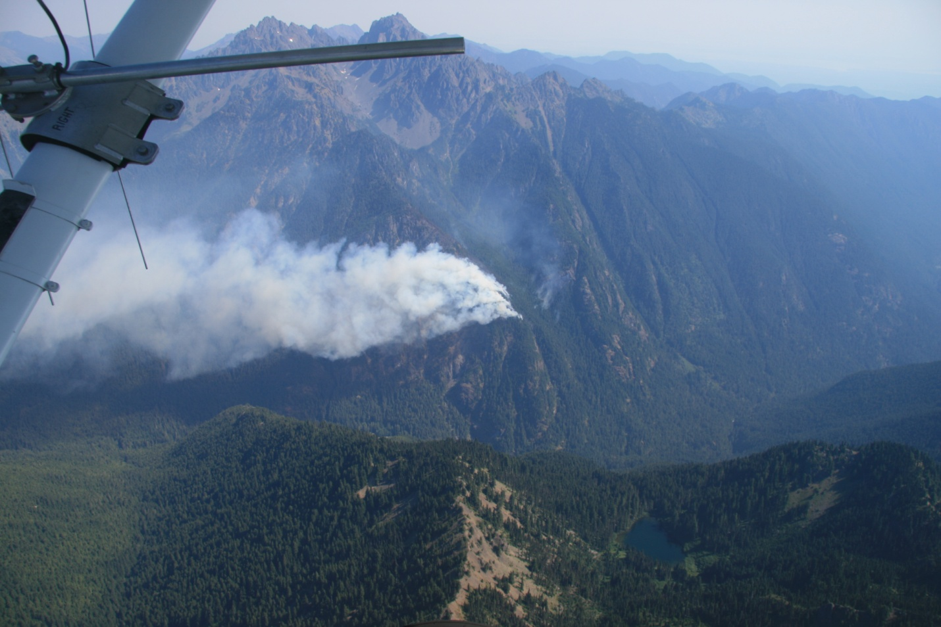
The Constance Fire July 25th, 2009
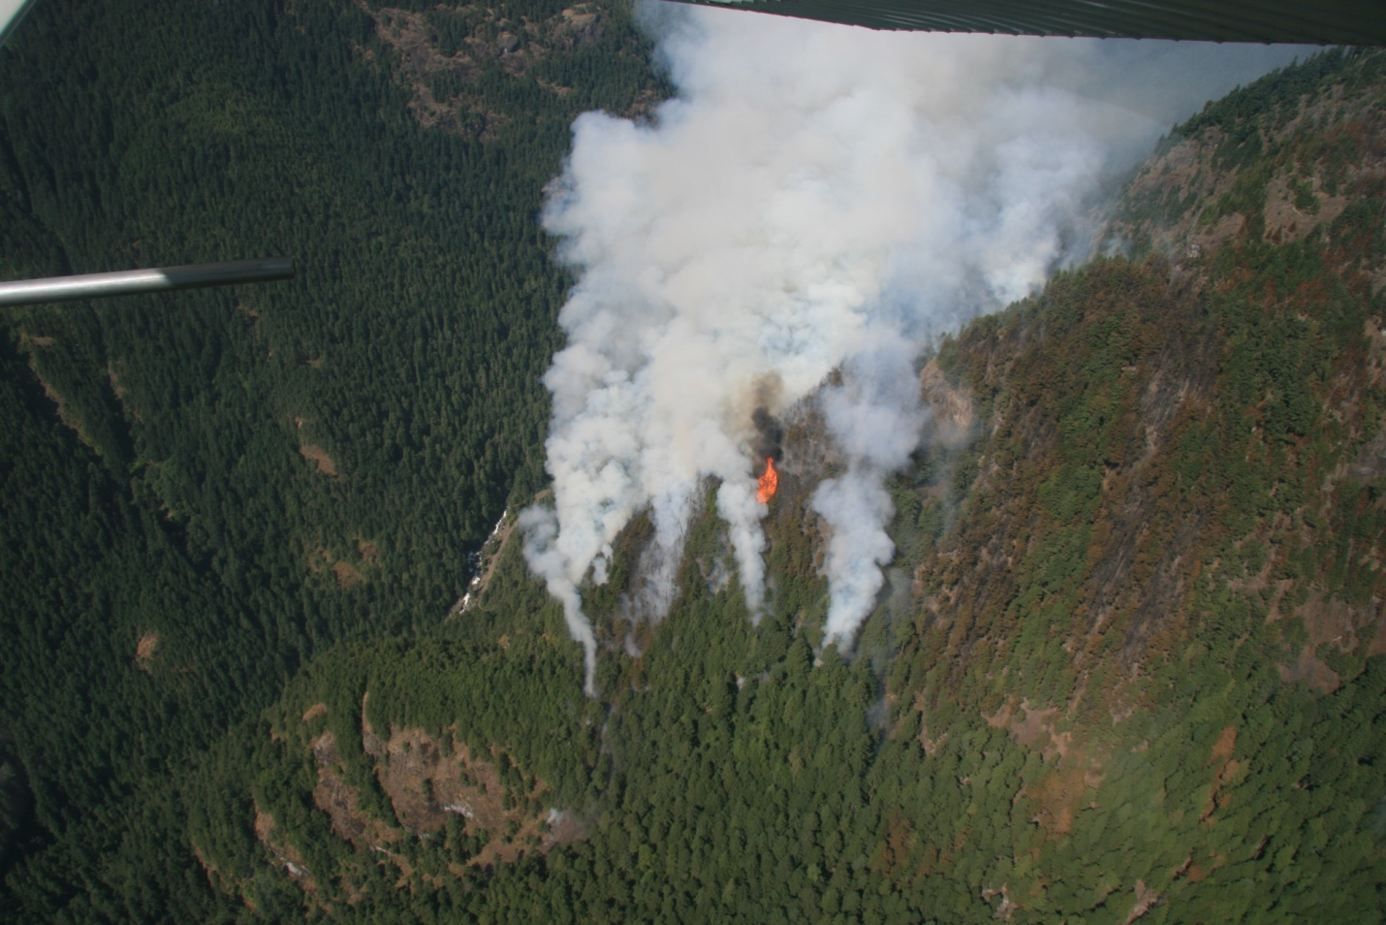
The Constance Fire July 25th, 2009
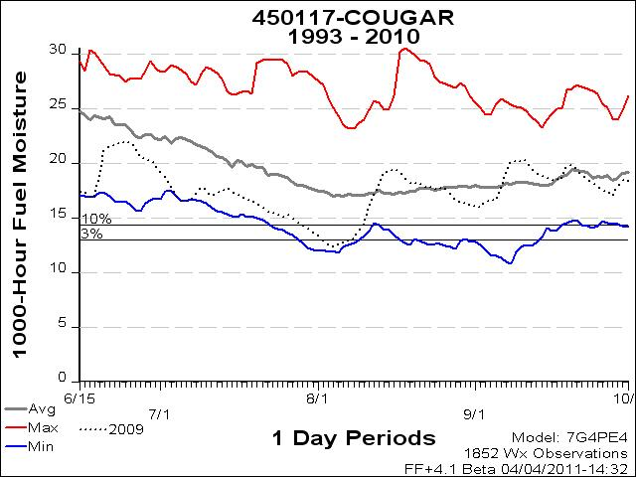
1000 hr fuels during the period of most active growth on the Constance fire were in the 10th and 3rd percentiles and were near 18 year lows. From July 26th-August 2nd they were: 15.3, 14.9, 14.6, 14.3, 14, 13.6, 13.4, and 12.9.
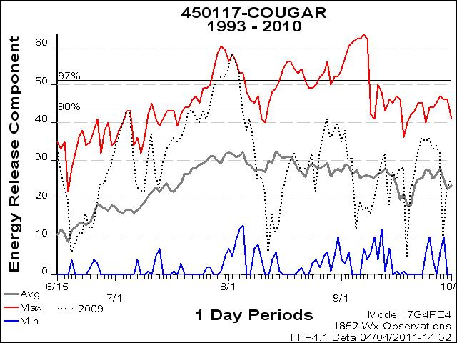
ERC’s from 7/26-8/2 were in the 90th and 95th percentiles and some were at 18 year highs. ERC’s for this time were: 41, 44, 49, 51, 52, 52, 54, 58.
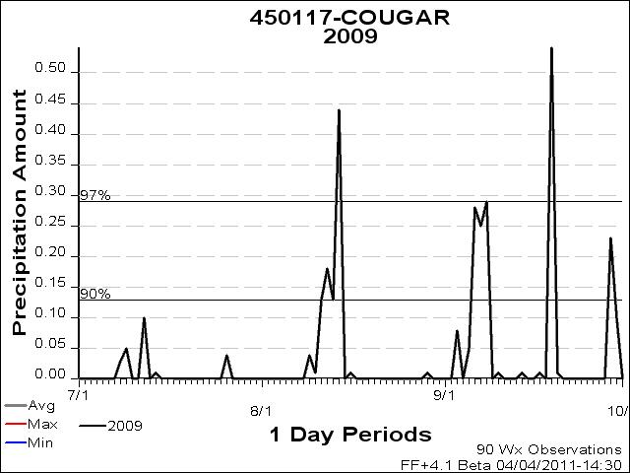
At this station there were trace amounts of precipitation recorded just before and after the discovery date of 7/11 (7/8 .03”, 7/9 .05”, 7/12 .1”) and then, with the exception of a slightly wetter week in August (8/9 .04”, 8/10 .01”, 8/11 .13”, 8/12 .18”, 8/13 .13”, 8/14 .44”) no precipitation was recorded again until early September. The Cougar RAWS station had some considerably higher precipitation readings during August than the Jefferson station had.
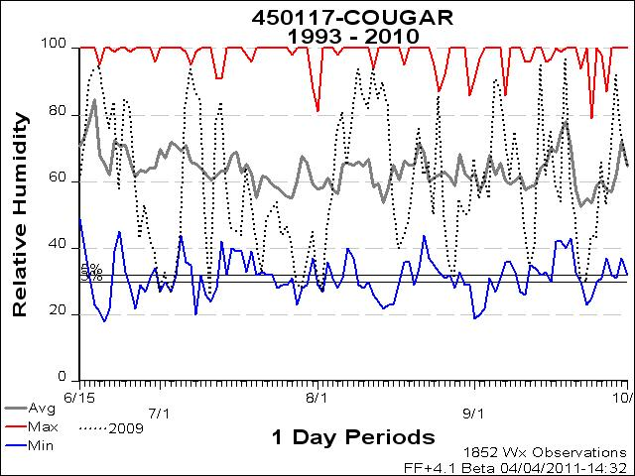
RH’s during the period of active fire growth was, with the exception of a wetter days on 7/26, 7/27 and 7/31 (47, 41 and 45%) in the 5th and 3rd percentiles and at or near 18 year lows. 29, 28, 36-32, 27.
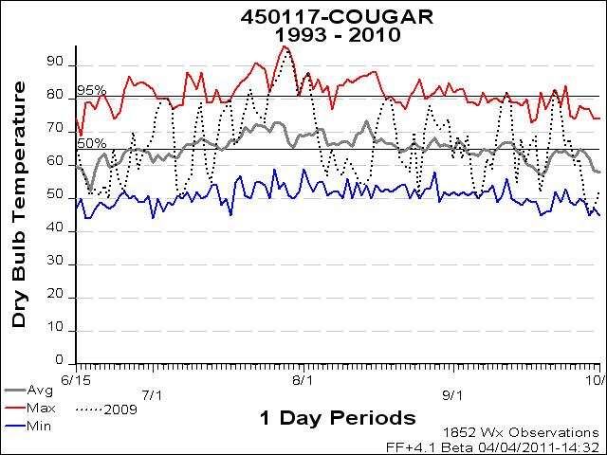
Temperatures during this time were all above the 95th percentile and were at or near 18 year highs: 85, 87, 91, 95, 91, 81, 86, 88.
The Knife and Buckinghorse Fires
The Knife and Buckinghorse fires were both discovered on July 24th 2009. Both fires were started by the same lightning storm that caused the increased fire activity and smoke problems in Brinnon that were seen on the Constance Fire. They occurred near the ridgetops across a river drainage from eachother some 10 miles NW from the 10 mile fire but still on the East (rain-shadow) side of the park. Both of these were high elevation fires (4500-5500ft) and occurred on very steep 75-100% slopes. Unlike the 10 Mile and Constance fires which smoldered for some time before becoming active, the Knife and Buckinghorse fires quickly put up significant smoke columns shortly after ignition. In the middle of the Olympic Heatwave and pushed by winds from nearby thunder cells, the Buckinghorse fire exhibited running crown fire behavior and grew to over 100 acres in a short time. The Knife fire grew less quickly that the Buckinghorse because it started in a burn scar from the 1981 Chimney Peak fire and lacked the heavy fuel loading seen at the Buckinghorse site. Both of these fires spread from the ridgetops downslope, where rolling debris ignited fuels below and generated enough heat to make some upslope runs. These fires grew most quickly within the 1st 10 days of ignition and then continued to grow more slowly until heavy rain in October and snow in November put them out. The Knife fire had grown to 127 acres and the Buckinghorse to 299. The Hurricane RAWS station was used to collect weather data for these fires.
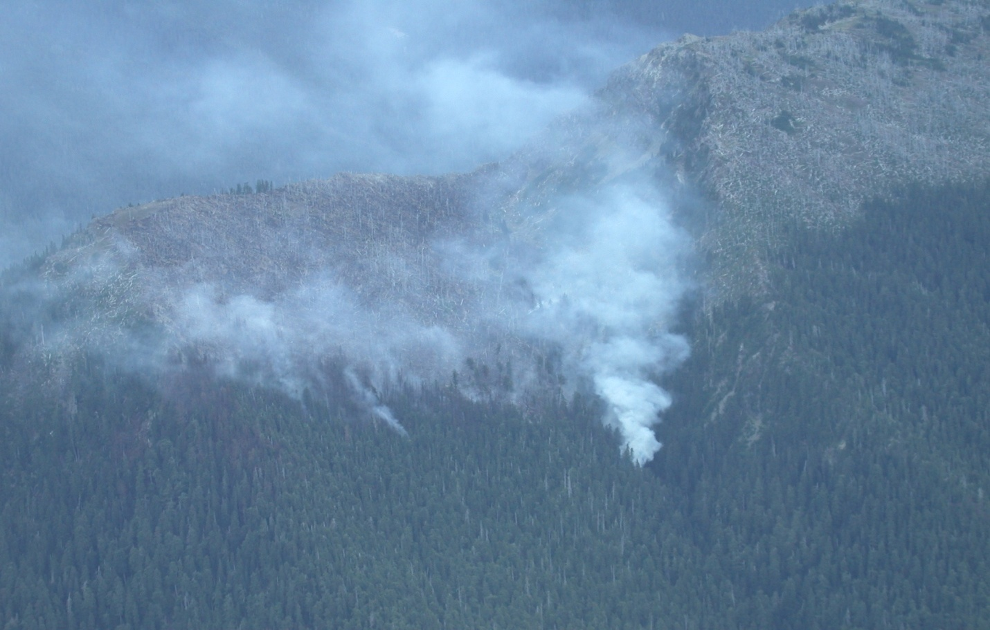
The Knife Fire on July 24th, 2009

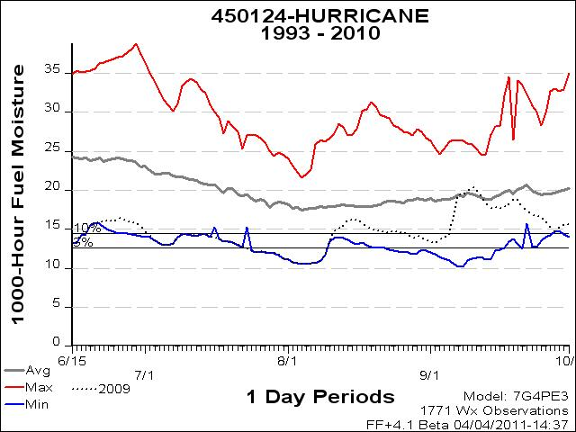
During the most active periods of these fires, 7/24-8/2, 1000hr fuel moistures dropped below the 5th percentile and to 18 year lows. 1000 hr. fuels during this time were: 11.9, 11.7, 11.3, 11.1, 10.7, 10.6, 10.5, 10.5, 10.6.
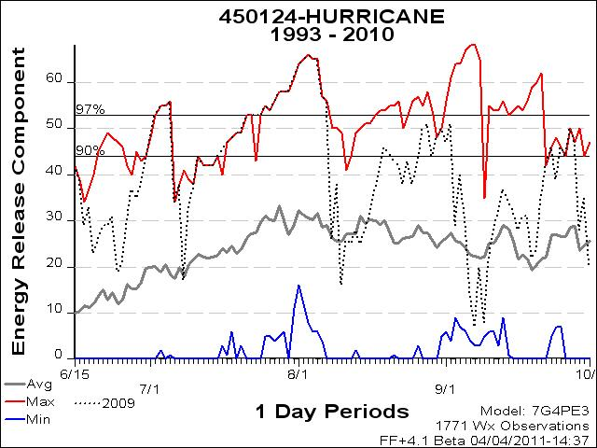
During the most active periods of growth on these two fires ERC’s were correspondingly at 18 year highs and above the 97th percentile. ERC’s were: 58, 58, 61, 64, 65, 66, 65, 57, and 56. These are record highs for the park.
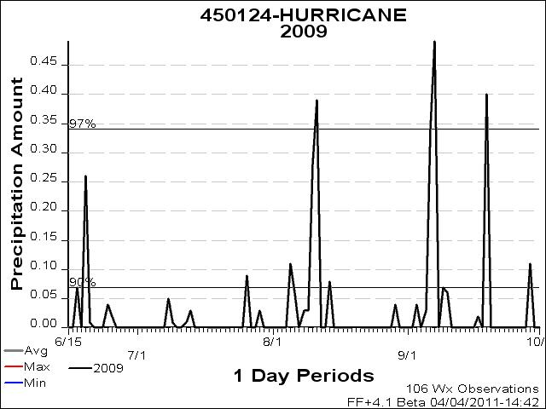
In spite of the record high ERC’s there was some precipitation recorded at this station during this period of active fire growth. At this station there were trace amounts of precipitation recorded just after the start dates of 7/24 (7/26 .09”, 7/29 .03”) and then, with the exception of a slightly wetter week in August (8/5 .11”, 8/6 .06”, 8/8 .03”, 8/9 .03”, 8/10 .28”, 8/11 .39”) no precipitation was recorded again until early September. Two days in mid-August were particularly wet: 8/10 and 8/11 .28” and .39”, and this moisture did retard fire growth on both Knife and Buckinghorse.
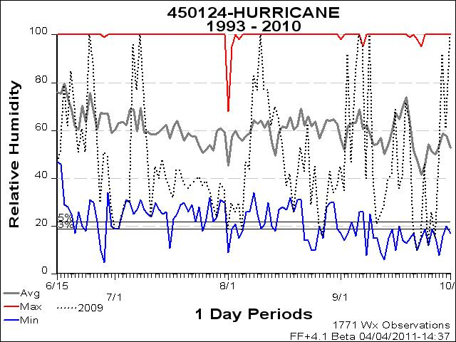
From 7/24-8/2 RH’s varied quite a bit, but for the most part they were at or near 18 year lows and had dropped into the 5th and 3rd percentiles. During these dates RH’s were: 24, 38, 35, 19, 30, 26, 30, 18, and 47.
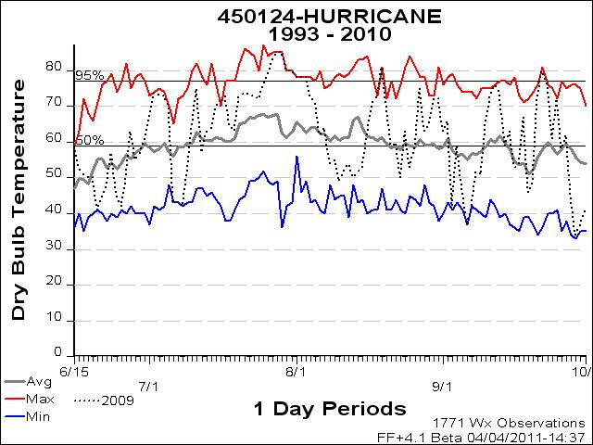
From 7/24- 8/2 temperatures were above the 95th percentile and were at 18 year highs. During this time temperatures were: 85, 80, 80, 78, 78, 78, 72, 71, and 62.
The Olympic Complex
The Olympic Complex of 2008, unlike the other 4 case studies which serve as examples of large fire growth in the Olympics, serves as an example of what happens when multiple ignitions occur but lack the fuel and weather conditions to encourage large fire growth. On August 17th 2008, a significant lighting storm produced 35 fires. Not all of the 35 fires were staffed and monitored, but of those that were, resources on scene reported seeing steady upslope growth with isolated torching. These fires continued to torch trees and make small upslope runs for the remainder of the afternoon of 8/17 until a thunderstorm moved across the area and moderated fire activity. The fires continued to creep and smolder for the next few days until 8/23 when activity picked up again. On 8/25 rain activity returned and dampened fire activity and on 8/28 heavy rains arrived and put a halt to fire growth. Park Fire Managers had decided to manage these naturally caused wildfires for resource benefit, but none of the fires grew to over 5 acres before going out naturally. The Hurricane RAWS station was used to collect weather data for these fires.
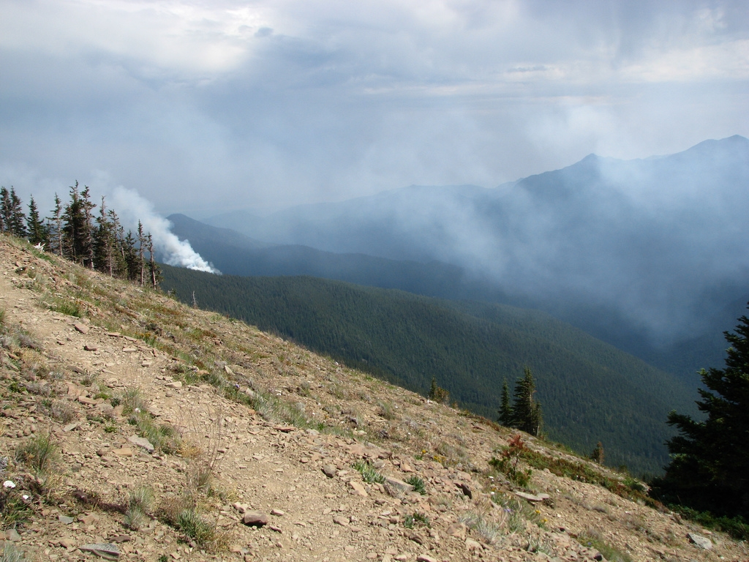
The Green Fire on August 17th, 2008
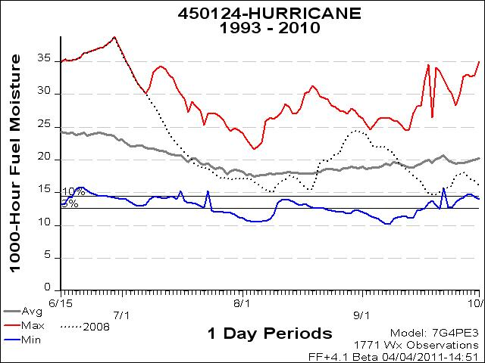
Fuel moisture contents in June and July of 2008 were at historic highs, they dropped down below average from late July until mid-August with 1000hrs fuels ranging from 15-17%. Values consistently stayed above the 10th percentile even at their lowest, and then they rose again to near historic highs in late August and early September.
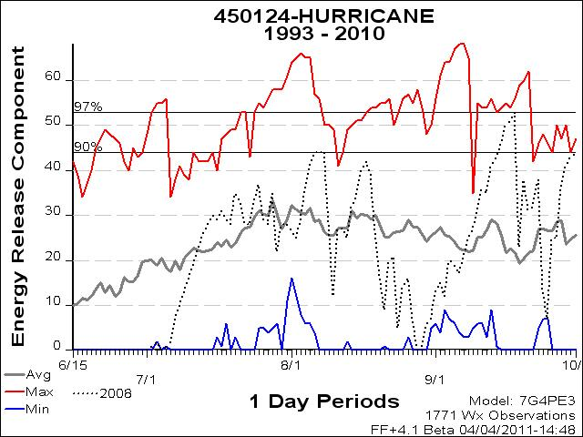
ERC’s right around August 17th ,the first and most active day of fire behavior in the Olympic Complex, hovered above the 18 year average, but they remained below the 90th percentile (8/16 40, 8/17 42, 8/18 39). However, before and after these several days, ERC’s dropped off precipitously to values well below average (8/10 12, 8/11 27, 8/12 27, 8/13 25, 8/14 32, 8/15 35) (8/19 26, 8/20 16, 8/21 9, 8/22 20, 8/23 21, 8/24 5…). In late August, values dropped to 18 year lows before climbing back into the 90th percentile late in the season around the middle of September.
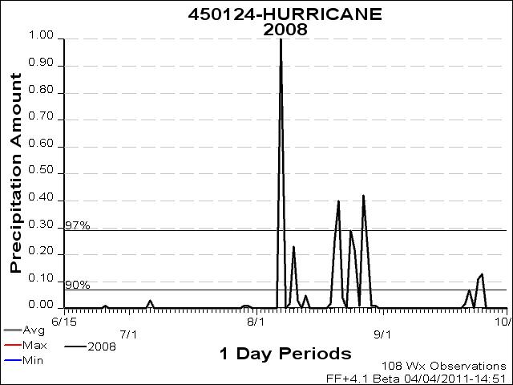
It had been a relatively dry season until August that year, however, just prior to and shortly after the multiple ignitions generated from the lightning storm, the area received significant rainfall (before ignitions: 8/7 1”, 8/9 .02”, 8/10 .23”, 8/11 .03”, 8/13 .05” and then after ignitions: 8/19 .02”, .25”, .4” 8/24 .29”, 8/25 .22”, 8/27 .42”).
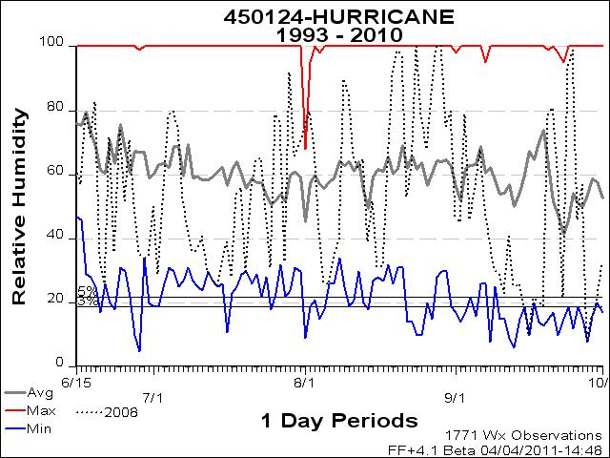
Relative humidity had been high for the week preceding ignitions, but then dropped to below average values on the day before ignitions and the day of ignitions (8/16 31%, 8/17 32%). Although these RH’s were below average, they were still above the 5th percentile and above 18 year lows. The day after ignitions RH’s crept back up well above average and into 18 year highs (8/18 63%, 8/19 92%, 8/20 99%, 8/21 97%).
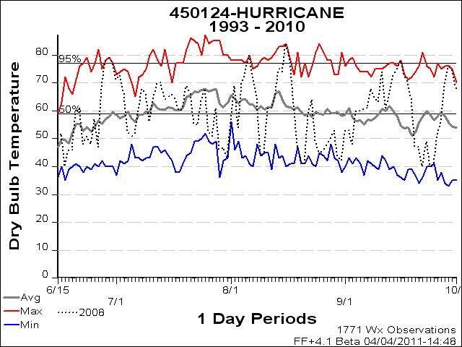
Temperatures bracketing the day of ignitions were fairly high. Values during this time were above average (8/14 75, 8/15 74, 8/16 84, 8/17 78, 8/18 62). The day before ignitions temperatures were at 18 year highs, and the day of ignitions temperatures were lower but were still in the 95th percentile. In the week leading up to ignitions and during the week following, however, temperatures dropped well below average to 18 year lows (8/9 44, 8/10 45, 8/11 61, 8/12 61, 8/13 65) (8/19 48, 8/20 41, 8/21 41, 8/22 59). Cooler weather persisted for weeks following ignitions with temperatures hovering around the mid 40’s and only creeping above 60 degrees once until higher than average temperatures returned later in September.

The Bear Gulch II Fire
The Bear Gulch II Fire of 2006 occurred on Forest Service land, adjacent to the SE corner Olympic National Park near Lake Cushman. Even though the fire did not actually occur on Olympic National Park land, I am choosing to include it in this study because of its proximity to the Park and its similarities in fuels, weather and topography. The Bear Gulch II fire was a human caused fire ignited by some burn piles that got out of control and slopped over onto USFS land sometime around July 23rd or 24th 2006. Because the fire was human caused and near many residences in the Lake Cushman area the decision was made to implement a full-suppression strategy on USFS land and to monitor the fire as it entered the Park. Due to very dry conditions, steep terrain and high winds, the fire quickly exceeded the capabilities of initial attack resources. The fire was very active on this day with isolated torching and some upslope runs. The fire continued to grow slowly and persistently on the days immediately following July 26th. It moved mostly as a surface fire with very little torching, crowning and spotting, and a major mechanism of spread was rolling material igniting areas down-slope. A pattern of marine cloud layer development occurred most evening and resulted in an inversion in the morning with good humidity recovery on July 30th and 30st. The days of most active fire spread were preceded by several days of poor nighttime recovery. From July 26th-August 5th, the fire spread east an average of 1 ½ chains/day. Daily spread rates accelerated to three chains per day until the August 19-21 spread event, when the fire moved about ¾ mile in three days or about 20 chains per day. In late September, the fire spread had essentially stopped due to rain. By the time heavy rain and snow began falling over the area in late October the fire was 1050 acres. The Jefferson RAWS station was used to collect weather data for this fire.

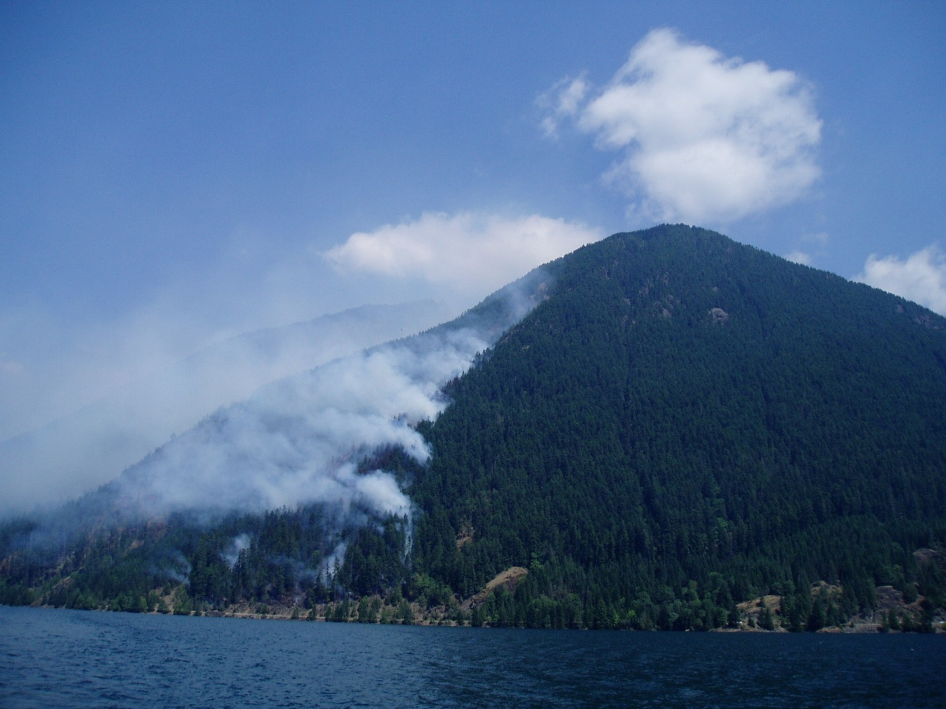
The Bear Gulch II Fire July 26th, 2006
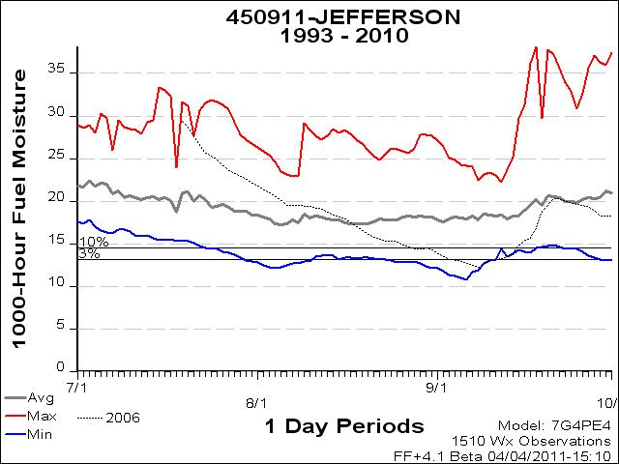
1000 hr. fuel moistures in mid-July were well above average at 18 year highs near 30%. These values dropped steadily until bottoming out below the 3rd percentile at 18 year lows in early September. At the time of most active fire behavior, August 19th-21st, 1000 hr fuels were below average, but not yet below the 10th percentile and 2-3% above 18 year lows.

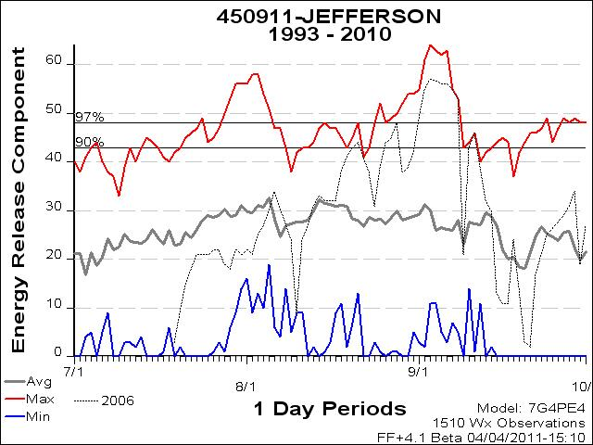
ERC’s on August 10th had dropped from just above average to well below average at an 18 year low of 9. These values then climbed steadily and during the period of most active fire behavior had reached into the 90th percentile, just below 18 year highs (8/19 41, 8/20 43, 8/21 44). Following these three most active days ERC’s dipped down to near average for a day or two before climbing back into the 90th and 97th percentiles and for a couple of days in early September, reaching 18 year highs.
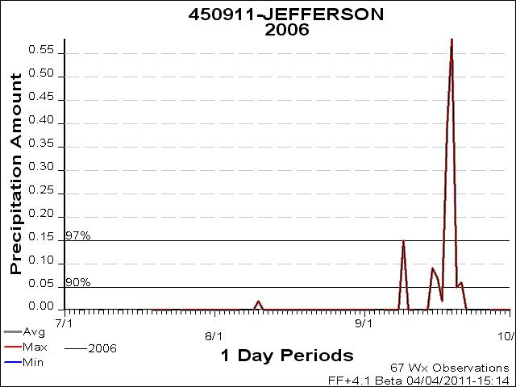
At this station only trace no rain was recorded in July prior to ignition 7/23, and only trace amounts occurred (8/10 .02”, 9/9 .15”) until late September when the area received more significant precipitation.
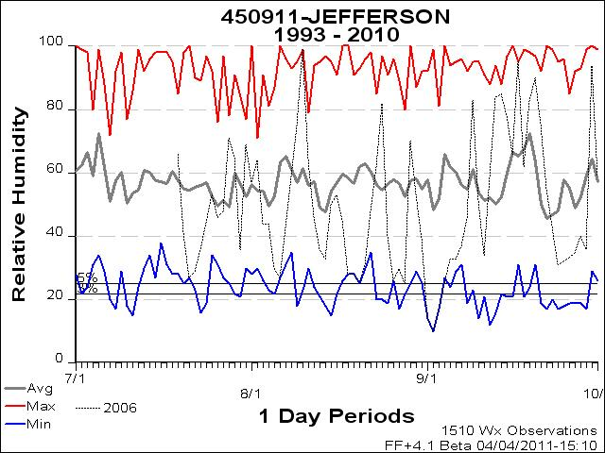
Relative humidity during the period of most active fire growth was well below average and near the 5th percentile and 18 year lows (8/19 28%, 8/20 25%, 8/21 31%). RH’s shortly after this period rose sharply for several days and then sank back to 18 year lows well into the 3rd percentile in early September (9/1 14%, 9/2 10 %, 9/3 17%).
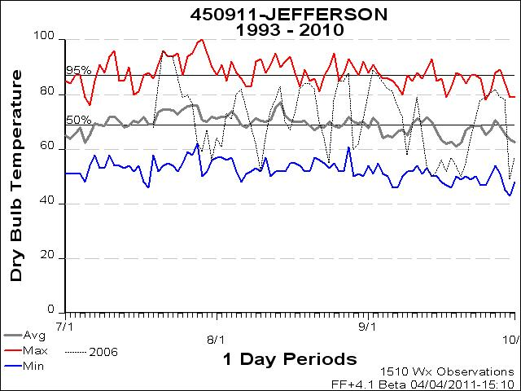
With the exception of a couple of unusually cold days that fell near 18 year lows (8/10 52, 8/24 55), August 2006 temperatures were mostly above average and many days were near 18 year highs. During the period of most active fire growth temperatures were just below the 95th percentile and just below 18 year highs (8/19 84, 8/20 84, 8/21 82). Temps cooled off a bit just after this timeframe for several days before climbing back into the 95th percentile near 18 year highs in late August and early September.

The Griff Fire
The Griff Fire of 2003 was discovered on September 6th, significantly later than any of the other case study fires in this project and near what many consider to be the end of fire season in the Olympics. It was ignited by a late season lightning storm near the top of Griff Peak. This fire was on a NE aspect only three air-miles from town of Port Angeles. It was in the NE portion (still well over on the dry/ rainshadow side) of the park and was highly visible from town. Full suppression strategies were considered due to the fire’s proximity to this community, however, due to the incredibly steep terrain (75-100% slopes) concern about firefighter safety, and the fact that it was already late in the season with cool, moist conditions, Park Fire Managers opted for a confine/contain strategy that would keep the fire away from residences and herd it back toward the park’s interior. The fire grew only minimally for the first 14 days after ignition due to cool, moist weather. However, dry conditions returned to the area towards the end of September which triggered an increase in fire activity and spread. An offshore flow had produced very low RH’s and poor nighttime humidity recovery. Fire activity at this time was increasing by 0500 and historically high ERC’s along with 1000 hour fuels in the low teens allowed the fire to grow 100-150 acres a day. Confinement efforts were effective and the fire grew to 820 acres but never threatened the community. Precipitation that started on October 6th and continued through much of October hampered fire spread and ultimately extinguished the fire. The Hurricane RAWs station was used to collect weather data for this fire. 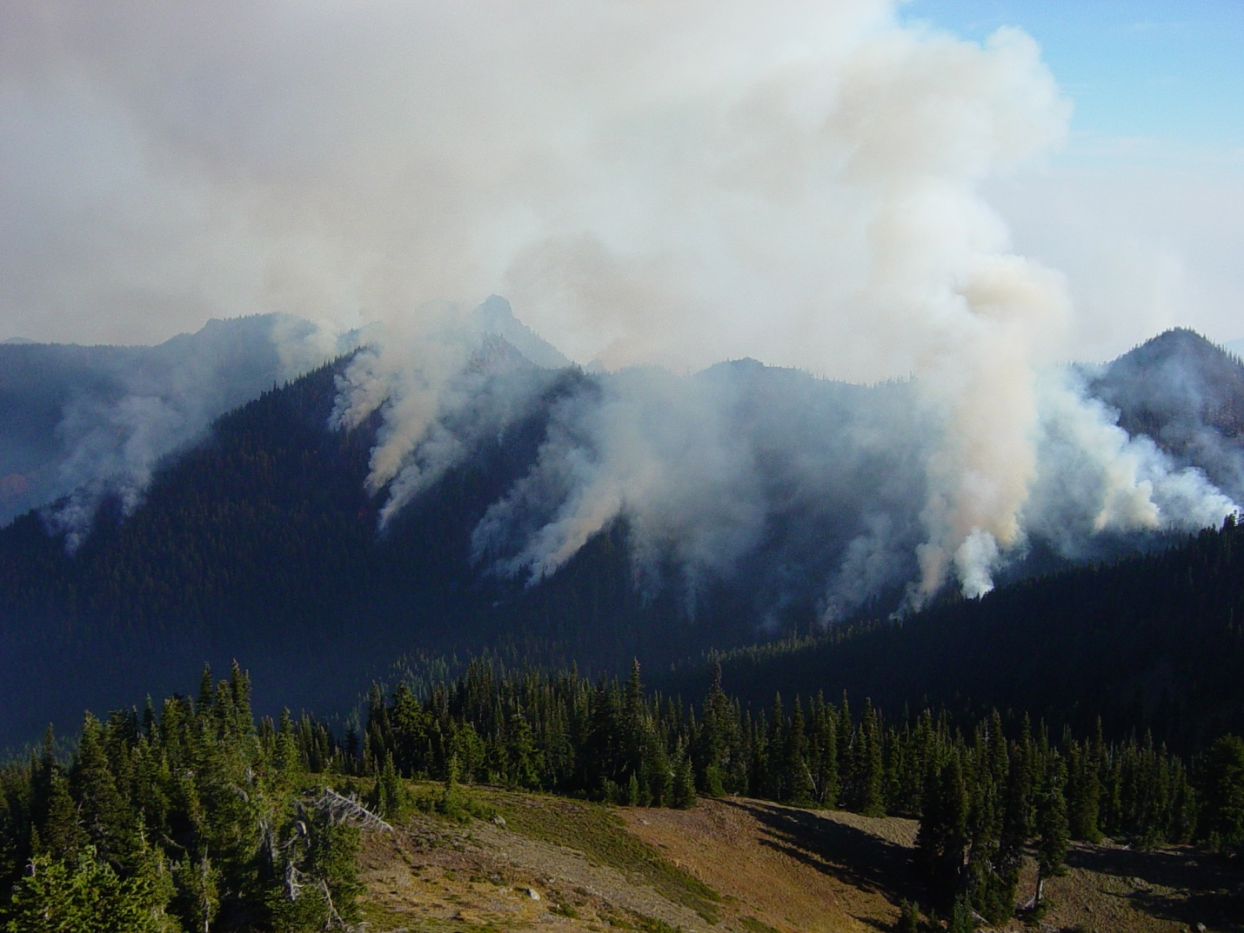
The Griff Fire September 29th, 2003
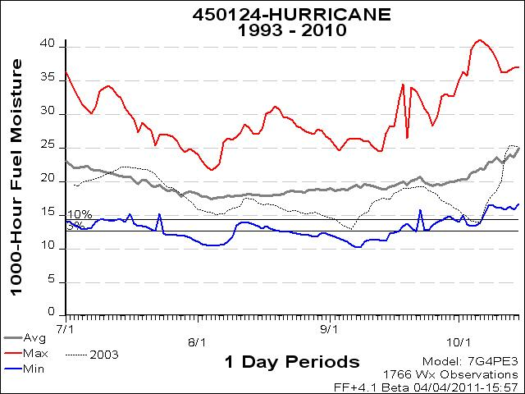
With the exception of a week or so in mid-July when values were slightly higher than average, 1000 hr. fuel moistures for the fire season of 2003 stayed below average. 1000 hr. fuel moistures dipped below the 10th percentile in early September (9/5 13.2%, 9/6 12.9%) and then during the period of most active fire growth, September 29th-October 5th, they dropped below the 10th percentile again to near 18 year lows (9/29 16.5%, 9/30 16.1%, 10/1 15.7%, 10/2 15.1%, 10/3 14.7%, 10/4 14.1%, 10/5 14%).
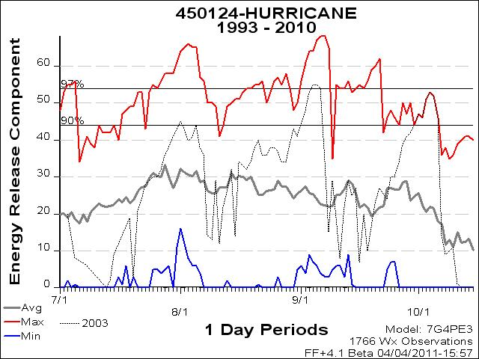
ERC’s started climbing above average in mid-August, and by early September they were up into the 97% percentile for several days before falling back down below average in mid-September. Then, in late September/ early October during the period of most active fire growth, ERC’s rose again into the 90th percentile, far above average and at 18 year highs (9/29 42, 9/30 44, 10/1 47, 10/2 46, 10/3 51, 10/4 53, 10/5 52).
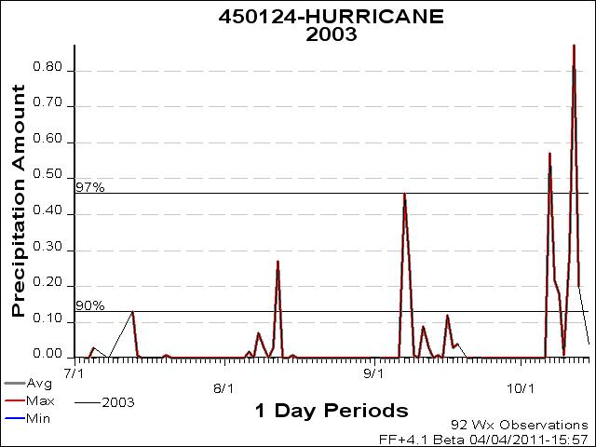
At this station there was some precipitation recorded just after the start date of 9/6 (9/7 .46”, 9/8 .27”) and then, only trace amounts were recorded until October 6th when significant rainfall occurred in a season ending event.
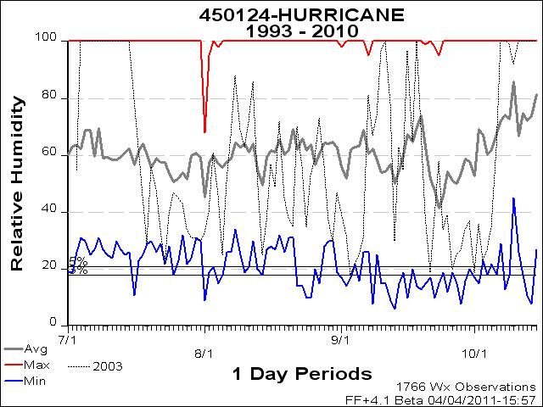
Relative humidity in late September and early October was considerably lower than average for an extended period of time. Values during this time dipped into the 5th percentile several times and reached 18 year lows on October 1st at 19%.
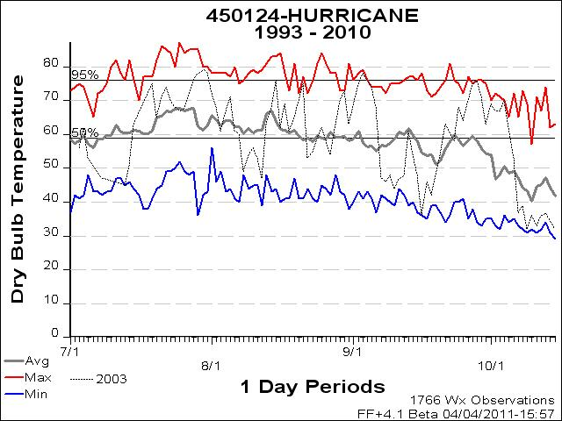
Temperatures before and after the most active period of fire growth were well below average down in the low 50’s and high 40’s and near 18 year lows. However, for a 12 day period coinciding with the period of active growth, temperatures rose above average (9/24 68, 9/25 68, 9/26 70, 9/27 75, 9/28 76, 9/29 71, 9/30 63, 10/1 69, 10/2 67, 10/3 67, 10/4 70, 10/5 62). Two days during this stretch saw temps at 18 year highs.

Results:
Hurricane RAWS Data Dates of Greatest Fire Activity:
Hopper Fire
Date | 1000 hr |  | ERC |  | Precip |  |  | RH |  |  | Temp
12-Aug | 14.9 |  | 37 |  | 0 |  |  | 54 |  |  | 68
13-Aug
14-Aug | 14.7 |  | 44 |  | 0 |  |  | 30 |  |  | 74
15-Aug | 14.3 |  | 48 |  | 0 |  |  | 28 |  |  | 78
16-Aug | 13.7 |  | 51 |  | 0 |  |  | 28 |  |  | 77
averages | 14.24 |  | 45.66 |  | 0 |  |  | 35.62 |  |  | 72.58
Knife and Buckinghorse Fires
Date |  | 1000 hr |  | ERC |  | Precip |  |  | RH |  |  | Temp
7/24/2009 |  | 12.3 |  | 53 |  | 0 |  |  | 41 |  |  | 72
7/25/2009 |  | 12 |  | 55 |  | 0 |  |  | 37 |  |  | 76
7/26/2009 |  | 12.2 |  | 54 |  | 0 |  |  | 39 |  |  | 79
7/27/2009 |  | 12.1 |  | 56 |  | 0 |  |  | 35 |  |  | 83
7/28/2009 |  | 12 |  | 58 |  | 0 |  |  | 29 |  |  | 85
7/29/2009 |  | 11.9 |  | 58 |  | 0.03 |  |  | 24 |  |  | 85
7/30/2009 |  | 11.7 |  | 58 |  | 0 |  |  | 38 |  |  | 80
7/31/2009 |  | 11.3 |  | 61 |  | 0 |  |  | 35 |  |  | 80
8/1/2009 |  | 11.1 |  | 64 |  | 0 |  |  | 19 |  |  | 78
8/2/2009 |  | 10.7 |  | 65 |  | 0 |  |  | 30 |  |  | 78
averages |  | 11.7 |  | 57.9 |  | 0.003 |  |  | 32.87 |  |  | 79.11

Olympic Complex
Date | 1000 hr | ERC | Precip | RH | Temp
8/2/2008 | 17.1 | 25 | 0 | 80 | 69
8/3/2008 | 17 | 29 | 0 | 68 | 54
8/4/2008 | 16.6 | 36 | 0 | 42 | 70
8/5/2008 | 16.2 | 41 | 0 | 26 | 74
8/6/2008 | 15.7 | 44 | 0 | 26 | 80
8/7/2008 | 15.4 | 44 | 1 | 34 | 73
8/8/2008 | 15.1 | 44 | 0 | 40 | 64
8/9/2008 | 15.3 | 28 | 0.02 | 90 | 44
8/10/2008 | 16.4 | 12 | 0.23 | 85 | 45
8/11/2008 | 16.8 | 27 | 0.03 | 66 | 61
8/12/2008 | 17 | 27 | 0 | 62 | 61
8/13/2008 | 17.6 | 25 | 0.05 | 65 | 65
8/14/2008 | 17.3 | 32 | 0 | 39 | 75
8/15/2008 | 17.1 | 34 | 0 | 53 | 74
8/16/2008 | 16.7 | 40 | 0 | 31 | 84
8/17/2008 | 15.8 | 42 | 0 | 32 | 78
8/18/2008 | 15.4 | 39 | 0 | 63 | 62
8/19/2008 | 15.6 | 26 | 0.02 | 92 | 48
8/20/2008 | 17.1 | 16 | 0.25 | 99 | 41
averages | 16.3 | 32 | 0.08 | 57.5 | 64.3

Griff Fire
Date |  | 1000 hr |  | ERC |  | Precip |  | RH |  | Temp
9/29/2003 |  | 16.5 |  | 42 |  | 0 |  | 34 |  | 71
9/30/2003 |  | 16.1 |  | 44 |  | 0 |  | 37 |  | 63
10/1/2003 |  | 15.7 |  | 47 |  | 0 |  | 19 |  | 69
10/2/2003 |  | 15.1 |  | 46 |  | 0 |  | 36 |  | 67
10/3/2003 |  | 14.7 |  | 51 |  | 0 |  | 23 |  | 67
10/4/2003 |  | 14.1 |  | 53 |  | 0 |  | 27 |  | 70
10/5/2003 |  | 14 |  | 52 |  | 0 |  | 35 |  | 62
averages |  | 15.33 |  | 47 |  | 0 |  | 30.35 |  | 67.08
Jefferson RAWS Data Dates of Greatest Fire Activity:
10 Mile Fire
Date | 1000 hr |  | ERC |  | Precip |  | RH |  | Temp
7/29/2009 | 13.8 |  | 53 |  | 0 |  | 22 |  | 100
7/30/2009 | 13.4 |  | 56 |  | 0 |  | 21 |  | 95
7/31/2009 | 13 |  | 56 |  | 0 |  | 30 |  | 90
8/1/2009 | 12.8 |  | 56 |  | 0 |  | 33 |  | 87
8/2/2009 | 12.5 |  | 58 |  | 0 |  | 30 |  | 91
8/3/2009 | 12.3 |  | 58 |  | 0 |  | 34 |  | 84
8/4/2009 | 12.2 |  | 54 |  | 0 |  | 46 |  | 76
averages | 12.98 |  | 54.81 |  | 0 |  | 31.85 |  | 88.25

Bear Gulch II Fire
Date | 1000 hr | ERC | Precip | RH | Temp
8/19/2006 | 16.5 | 41 | 0 | 28 | 84
8/20/2006 | 16.1 | 43 | 0 | 25 | 84
8/21/2006 | 15.7 | 44 | 0 | 31 | 82
averages | 16.75 | 39.5 | 0 | 33.3 | 80.2

Cougar RAWS Data Dates of Greatest Fire Activity:
Constance Fire
Date | 1000 hr | ERC | Precip | RH | Temp
7/19/2009 | 16.5 | 36 | 0 | 55 | 69
7/20/2009 | 16.2 | 38 | 0 | 43 | 76
7/21/2009 | 15.9 | 43 | 0 | 33 | 83
7/22/2009 | 15.5 | 43 | 0 | 49 | 77
7/23/2009 |  |  | 0
7/26/2009 | 15.3 | 41 | 0.04 | 47 | 85
7/27/2009 | 14.9 | 44 | 0 | 41 | 87
7/28/2009 | 14.6 | 49 | 0 | 29 | 91
7/29/2009 | 14.3 | 51 | 0 | 28 | 95
7/30/2009 | 14 | 52 | 0 | 36 | 91
7/31/2009 | 13.6 | 52 | 0 | 45 | 81
8/1/2009 | 13.4 | 54 | 0 | 32 | 86
8/2/2009 | 12.9 | 58 | 0 | 27 | 88
averages | 14.71 | 46.69 | 0.0028 | 39.35 | 84.08

For each RAWS station used in this project, the event locator tool in firefamily plus was used to identify how often the alignment of these five weather factors has occurred in the last 18 years. Data from the case studies was used to arrive at values for 1000 hr. fuel moistures, ERC’s, precipitation, relative humidity and temperature that occurred during periods of large fire growth. Tables were generated to show values for each of these five variables for every case study fire over the course of active fire behavior (3-13 days). Values for each variable (1000 hr., ERC, precipitation, RH, and temperature) were averaged for each case study fire, and then those values were averaged for each RAWS station.
The averages for 1000 hr. fuel moisture, ERC, precipitation, relative humidity and temperature during the most active 4 days on the Hopper fire were: 14.2, 46, 0, 36 and 73. Averages for the most active 10 days of the Knife and Buckinghorse Fires were: 11.7, 58, 0, 33, 79. Averages for the most active 7 days of the Griff Fire were: 15.3, 47, 0, 30, 67. All three of these case study fires were analyzed using data from the Hurricane RAWS, so the averages from these three fires were: 13.7, 50, 0, 33, 73. The Olympic Complex case study was also done using data from the Hurricane RAWS, but because this particular case study was intended to serve as an example of inactive fire behavior, averages from the Olympic Complex were not included in the Hurricane RAWS averages.
The averages for 1000 hr. fuel moisture, ERC, precipitation, relative humidity and temperature during the most active 7 days on the 10 Mile Fire were: 12.98, 55, 0, 32, 88. Averages for the most active 3 days of the Bear Gulch II Fire were: 16.75, 40, 0, 33, 80. Both of these case study fires were analyzed using data from the Jefferson RAWS, so the averages from these three fires were: 14.87, 47.5, 0, 32.5, and 84.
The averages for 1000 hr. fuel moisture, ERC, precipitation, relative humidity and temperature during the most active 13 days on the Constance Fire were: 14.7, 47, 0, 39, and 84. Because the Constance Fire was the only case study fire analyzed using data from the Cougar RAWS, these numbers represent the Cougar RAWS averages.
Once averages for 1000 hr. fuel moisture, ERC, precipitation, relative humidity and temperature were identified for each of the three RAWS stations used in the case studies, percentiles representing those numbers were used in the event locator in firefamily plus to determine how often these factors occurred in conjunction. When percentiles based on averages for the RAWS stations generated outputs that did not capture the days of greatest fire activity, the percentiles were modified to capture those dates, with care taken to avoid capturing dates that were not likely large fire growth dates.
At the Hurricane station, the alignment of factors required for large fire growth occurred 63 times in the last 18 fire seasons. 53 of those days occurred after 2000, only 10 occurred in the 1990’s. At the Cougar station, the alignment of weather factors required for large fire growth occurred 45 times in the last 18 fire seasons. 37 of those days occurred after 2000, only 8 occurred in the 1990’s. At the Jefferson station, the alignment of weather factors required for large fire growth occurred 63 times in the last 18 fire seasons. 47 of those days occurred after 2000, only 16 occurred in the 1990’s.
Analysis of weather data from RAWS stations in each of the case studies in this project supports the assumption that large fire growth at in the Olympic Mountains is possible when the following weather factors come into alignment: 1000hr fuel moistures are low (15-20th percentile or below 16.3%), ERC’s are high (85-90th percentile or above 40), no precipitation occurs for the duration of the event, relative humidity is low (15th percentile or below 40%), and temperatures are high (75th percentile or above 68 degrees). Low 1000 hr. fuel moistures, high ERC’s and lack of precipitation, and an ignition source set the stage for these large fire events, and then a weather trigger of very low relative humidity and high temperatures is required to initiate active fire behavior leading to large fire growth.
According to the data gathered in these case studies, only when all five of these fire climate factors (1000 hr. fuel moisture, ERC, precipitation, temperature and relative humidity) are at or near peak values do large fires occur. As the results above show, the occurrence of all five factors occurring near peak levels simultaneously in the past is relatively rare. This fact is mirrored by the short, episodic fire seasons one finds in the Olympic Mountains. The duration of all five fire climate factors occurring at peak levels in unison has not lasted more than nine days in this study area. Fires here can smolder in deep duff during periods of inclement weather for months before springing to life when fire climate factors allow. However, there is no historic precedent for active large fire growth persisting at rapid rates of spread (100 acres/ day or more) for much more than a week. Significantly more days with the presence of all five factors near peak levels have occurred between 2003-2010 than in the previous decade. Large fire occurrence in the Olympics mirrors this trend, as we also see significantly more large fires burned here between 2003-2010 than in the previous decade. In spite of this upward trend in fire climate factors occurring near peak levels and large fire occurrence, every fire examined in these case studies has remained within the historic range of variability with spread rates limited to less than 150 acres/day and with total size limited to less than 1500 acres.
Hurricane RAWS
FireFamily Plus Event Locator Report
Listing of Selected Events
printed on: 04/07/2011 at 03:20:58 PM (from run # 1)
using database: C:\Documents and Settings\lburwell\Desktop\capstone FOR 479\Burwell_capstone_weather_files\LB401_weather_data_03312011

------------------------------------------------------
Active Working Set:
Station: 450124 - HURRICANE
Data years: 1993 - 2010
Analysis Period Length: 1 days
Annual filter dates: July 1 thru October 15
------------------------------------------------------
Station Details:
450124 HURRICANE Fuel model: G (Use 88?: N)

Slope class: 4 Climate class: 3 Greenup: 03/05 Freeze: 12/31
Start KBDI: 100 Start FM1000:25 Avg. Precip: 74.00
FM1 = FM10? N Herb Annual? N Deciduous? N
Aspect: 0 Slope posit.: U Elevation: 5200
Latitude: 47.97 Longitude: -123.50
Weighed Stick Moistures Used: Yes
------------------------------------------------------

Event Definition:
Daily(Dry Bulb Temperature) >= 75.00 Percentile (68.00)
AND Daily(Relative Humidity) <= 15.00 Percentile (32.00)
AND Daily(Precipitation Amount) = 0.00
AND Daily(Energy Release Component) >= 90.00 Percentile (44.00)
AND Daily(1000-Hour Fuel Moisture) <= 15.00 Percentile (15.13)

1-Day Periods

DATE Temp RH Rain ERC 1000
-----------------------------------------------
10/04/1993 TRUE TRUE TRUE TRUE TRUE
08/24/1996 TRUE TRUE TRUE TRUE TRUE
08/25/1996 TRUE TRUE TRUE TRUE TRUE
08/26/1996 TRUE TRUE TRUE TRUE TRUE
09/15/1999 TRUE TRUE TRUE TRUE TRUE
09/17/1999 TRUE TRUE TRUE TRUE TRUE
09/18/1999 TRUE TRUE TRUE TRUE TRUE
09/19/1999 TRUE TRUE TRUE TRUE TRUE
09/20/1999 TRUE TRUE TRUE TRUE TRUE
09/21/1999 TRUE TRUE TRUE TRUE TRUE
08/07/2000 TRUE TRUE TRUE TRUE TRUE
08/23/2002 TRUE TRUE TRUE TRUE TRUE
08/28/2002 TRUE TRUE TRUE TRUE TRUE
08/05/2003 TRUE TRUE TRUE TRUE TRUE
09/02/2003 TRUE TRUE TRUE TRUE TRUE
09/03/2003 TRUE TRUE TRUE TRUE TRUE
09/04/2003 TRUE TRUE TRUE TRUE TRUE
09/05/2003 TRUE TRUE TRUE TRUE TRUE
09/06/2003 TRUE TRUE TRUE TRUE TRUE
10/04/2003 TRUE TRUE TRUE TRUE TRUE
08/07/2005 TRUE TRUE TRUE TRUE TRUE
08/13/2005 TRUE TRUE TRUE TRUE TRUE
08/14/2005 TRUE TRUE TRUE TRUE TRUE
08/21/2005 TRUE TRUE TRUE TRUE TRUE
08/25/2005 TRUE TRUE TRUE TRUE TRUE
08/26/2005 TRUE TRUE TRUE TRUE TRUE
08/07/2006 TRUE TRUE TRUE TRUE TRUE
08/17/2006 TRUE TRUE TRUE TRUE TRUE
08/19/2006 TRUE TRUE TRUE TRUE TRUE
08/20/2006 TRUE TRUE TRUE TRUE TRUE
08/21/2006 TRUE TRUE TRUE TRUE TRUE
08/27/2006 TRUE TRUE TRUE TRUE TRUE
08/28/2006 TRUE TRUE TRUE TRUE TRUE
09/01/2006 TRUE TRUE TRUE TRUE TRUE
09/02/2006 TRUE TRUE TRUE TRUE TRUE
09/03/2006 TRUE TRUE TRUE TRUE TRUE
09/04/2006 TRUE TRUE TRUE TRUE TRUE
09/05/2006 TRUE TRUE TRUE TRUE TRUE
09/06/2006 TRUE TRUE TRUE TRUE TRUE
09/07/2006 TRUE TRUE TRUE TRUE TRUE
09/29/2006 TRUE TRUE TRUE TRUE TRUE
09/18/2008 TRUE TRUE TRUE TRUE TRUE
07/02/2009 TRUE TRUE TRUE TRUE TRUE
07/03/2009 TRUE TRUE TRUE TRUE TRUE
07/04/2009 TRUE TRUE TRUE TRUE TRUE
07/05/2009 TRUE TRUE TRUE TRUE TRUE
07/11/2009 TRUE TRUE TRUE TRUE TRUE
07/17/2009 TRUE TRUE TRUE TRUE TRUE
07/28/2009 TRUE TRUE TRUE TRUE TRUE
08/01/2009 TRUE TRUE TRUE TRUE TRUE
08/02/2009 TRUE TRUE TRUE TRUE TRUE
08/03/2009 TRUE TRUE TRUE TRUE TRUE
08/04/2009 TRUE TRUE TRUE TRUE TRUE
08/19/2009 TRUE TRUE TRUE TRUE TRUE
08/27/2009 TRUE TRUE TRUE TRUE TRUE
07/26/2010 TRUE TRUE TRUE TRUE TRUE
07/28/2010 TRUE TRUE TRUE TRUE TRUE
08/14/2010 TRUE TRUE TRUE TRUE TRUE
08/15/2010 TRUE TRUE TRUE TRUE TRUE
08/16/2010 TRUE TRUE TRUE TRUE TRUE
08/17/2010 TRUE TRUE TRUE TRUE TRUE
08/24/2010 TRUE TRUE TRUE TRUE TRUE
08/25/2010 TRUE TRUE TRUE TRUE TRUE

63 hits out of 1926
160 rejects for no/missing observations

FF+4.1 Beta 04/07/2011-15:20
At the Hurricane station
Cougar RAWS

FireFamily Plus Event Locator Report
Listing of Selected Events
printed on: 04/07/2011 at 03:34:17 PM (from run # 1)
using database: C:\Documents and Settings\lburwell\Desktop\capstone FOR 479\Burwell_capstone_weather_files\LB401_weather_data_03312011

------------------------------------------------------
Active Working Set:
Station: 450117 - COUGAR
Data years: 1993 - 2010
Analysis Period Length: 1 days
Annual filter dates: July 1 thru October 15
------------------------------------------------------
Station Details:
450117 COUGAR Fuel model: G (Use 88?: N)

Slope class: 4 Climate class: 4 Greenup: 06/04 Freeze: 12/31
Start KBDI: 100 Start FM1000:30 Avg. Precip: 50.00
FM1 = FM10? N Herb Annual? N Deciduous? N
Aspect: 2 Slope posit.: M Elevation: 3000
Latitude: 47.92 Longitude: -123.12
Weighed Stick Moistures Used: Yes
------------------------------------------------------

Event Definition:
Daily(Dry Bulb Temperature) >= 90.00 Percentile (78.00)
AND Daily(Relative Humidity) <= 15.00 Percentile (41.00)
AND Daily(Precipitation Amount) = 0.00
AND Daily(Energy Release Component) >= 90.00 Percentile (43.00)
AND Daily(1000-Hour Fuel Moisture) <= 15.00 Percentile (15.03)

1-Day Periods

DATE Temp RH Rain ERC 1000
-----------------------------------------------
08/12/1998 TRUE TRUE TRUE TRUE TRUE
08/13/1998 TRUE TRUE TRUE TRUE TRUE
08/29/1998 TRUE TRUE TRUE TRUE TRUE
08/30/1998 TRUE TRUE TRUE TRUE TRUE
08/31/1998 TRUE TRUE TRUE TRUE TRUE
09/01/1998 TRUE TRUE TRUE TRUE TRUE
09/03/1998 TRUE TRUE TRUE TRUE TRUE
09/06/1998 TRUE TRUE TRUE TRUE TRUE
08/12/2002 TRUE TRUE TRUE TRUE TRUE
08/13/2002 TRUE TRUE TRUE TRUE TRUE
08/23/2002 TRUE TRUE TRUE TRUE TRUE
08/28/2002 TRUE TRUE TRUE TRUE TRUE
07/28/2003 TRUE TRUE TRUE TRUE TRUE
07/29/2003 TRUE TRUE TRUE TRUE TRUE
07/30/2003 TRUE TRUE TRUE TRUE TRUE
08/15/2003 TRUE TRUE TRUE TRUE TRUE
08/21/2003 TRUE TRUE TRUE TRUE TRUE
08/30/2003 TRUE TRUE TRUE TRUE TRUE
09/02/2003 TRUE TRUE TRUE TRUE TRUE
09/03/2003 TRUE TRUE TRUE TRUE TRUE
09/04/2003 TRUE TRUE TRUE TRUE TRUE
09/05/2003 TRUE TRUE TRUE TRUE TRUE
08/14/2005 TRUE TRUE TRUE TRUE TRUE
08/15/2005 TRUE TRUE TRUE TRUE TRUE
08/06/2006 TRUE TRUE TRUE TRUE TRUE
08/19/2006 TRUE TRUE TRUE TRUE TRUE
08/20/2006 TRUE TRUE TRUE TRUE TRUE
08/26/2006 TRUE TRUE TRUE TRUE TRUE
08/27/2006 TRUE TRUE TRUE TRUE TRUE
09/02/2006 TRUE TRUE TRUE TRUE TRUE
09/03/2006 TRUE TRUE TRUE TRUE TRUE
09/04/2006 TRUE TRUE TRUE TRUE TRUE
09/05/2006 TRUE TRUE TRUE TRUE TRUE
07/27/2009 TRUE TRUE TRUE TRUE TRUE
07/28/2009 TRUE TRUE TRUE TRUE TRUE
07/29/2009 TRUE TRUE TRUE TRUE TRUE
07/30/2009 TRUE TRUE TRUE TRUE TRUE
08/01/2009 TRUE TRUE TRUE TRUE TRUE
08/02/2009 TRUE TRUE TRUE TRUE TRUE
07/26/2010 TRUE TRUE TRUE TRUE TRUE
08/14/2010 TRUE TRUE TRUE TRUE TRUE
08/15/2010 TRUE TRUE TRUE TRUE TRUE
08/16/2010 TRUE TRUE TRUE TRUE TRUE
08/17/2010 TRUE TRUE TRUE TRUE TRUE
08/25/2010 TRUE TRUE TRUE TRUE TRUE

45 hits out of 1926
99 rejects for no/missing observations

FF+4.1 Beta 04/07/2011-15:34

Jefferson RAWS
FireFamily Plus Event Locator Report
Listing of Selected Events
printed on: 04/07/2011 at 03:50:01 PM (from run # 1)
using database: C:\Documents and Settings\lburwell\Desktop\capstone FOR 479\Burwell_capstone_weather_files\LB401_weather_data_03312011

------------------------------------------------------
Active Working Set:
Station: 450911 - JEFFERSON
Data years: 1993 - 2010
Analysis Period Length: 1 days
Annual filter dates: July 1 thru October 15
------------------------------------------------------
Station Details:
450911 JEFFERSON Fuel model: G (Use 88?: N)

Slope class: 4 Climate class: 4 Greenup: 06/23 Freeze: 12/31
Start KBDI: 100 Start FM1000:30 Avg. Precip: 90.00
FM1 = FM10? N Herb Annual? N Deciduous? N
Aspect: 2 Slope posit.: M Elevation: 2200
Latitude: 47.55 Longitude: -123.17
Weighed Stick Moistures Used: Yes
------------------------------------------------------

Event Definition:
Daily(Dry Bulb Temperature) >= 85.00 Percentile (81.00)
AND Daily(Relative Humidity) <= 15.00 Percentile (34.00)
AND Daily(Precipitation Amount) = 0.00
AND Daily(Energy Release Component) >= 85.00 Percentile (40.00)
AND Daily(1000-Hour Fuel Moisture) <= 25.00 Percentile (16.31)

1-Day Periods

DATE Temp RH Rain ERC 1000
-----------------------------------------------
09/07/1993 TRUE TRUE TRUE TRUE TRUE
09/29/1993 TRUE TRUE TRUE TRUE TRUE
07/20/1994 TRUE TRUE TRUE TRUE TRUE
07/22/1994 TRUE TRUE TRUE TRUE TRUE
09/22/1995 TRUE TRUE TRUE TRUE TRUE
07/14/1996 TRUE TRUE TRUE TRUE TRUE
08/10/1996 TRUE TRUE TRUE TRUE TRUE
08/23/1996 TRUE TRUE TRUE TRUE TRUE
08/24/1996 TRUE TRUE TRUE TRUE TRUE
08/25/1996 TRUE TRUE TRUE TRUE TRUE
08/29/1996 TRUE TRUE TRUE TRUE TRUE
08/16/1997 TRUE TRUE TRUE TRUE TRUE
09/06/1998 TRUE TRUE TRUE TRUE TRUE
09/15/1998 TRUE TRUE TRUE TRUE TRUE
09/20/1999 TRUE TRUE TRUE TRUE TRUE
09/21/1999 TRUE TRUE TRUE TRUE TRUE
08/17/2002 TRUE TRUE TRUE TRUE TRUE
08/24/2002 TRUE TRUE TRUE TRUE TRUE
08/28/2002 TRUE TRUE TRUE TRUE TRUE
07/19/2003 TRUE TRUE TRUE TRUE TRUE
07/29/2003 TRUE TRUE TRUE TRUE TRUE
07/30/2003 TRUE TRUE TRUE TRUE TRUE
08/14/2003 TRUE TRUE TRUE TRUE TRUE
08/21/2003 TRUE TRUE TRUE TRUE TRUE
08/25/2003 TRUE TRUE TRUE TRUE TRUE
08/29/2003 TRUE TRUE TRUE TRUE TRUE
08/30/2003 TRUE TRUE TRUE TRUE TRUE
09/02/2003 TRUE TRUE TRUE TRUE TRUE
09/03/2003 TRUE TRUE TRUE TRUE TRUE
09/04/2003 TRUE TRUE TRUE TRUE TRUE
09/05/2003 TRUE TRUE TRUE TRUE TRUE
10/03/2003 TRUE TRUE TRUE TRUE TRUE
07/23/2004 TRUE TRUE TRUE TRUE TRUE
07/24/2004 TRUE TRUE TRUE TRUE TRUE
08/13/2004 TRUE TRUE TRUE TRUE TRUE
08/20/2006 TRUE TRUE TRUE TRUE TRUE
08/21/2006 TRUE TRUE TRUE TRUE TRUE
08/26/2006 TRUE TRUE TRUE TRUE TRUE
08/27/2006 TRUE TRUE TRUE TRUE TRUE
08/28/2006 TRUE TRUE TRUE TRUE TRUE
09/02/2006 TRUE TRUE TRUE TRUE TRUE
09/03/2006 TRUE TRUE TRUE TRUE TRUE
09/05/2006 TRUE TRUE TRUE TRUE TRUE
09/06/2006 TRUE TRUE TRUE TRUE TRUE
08/07/2008 TRUE TRUE TRUE TRUE TRUE
08/16/2008 TRUE TRUE TRUE TRUE TRUE
07/11/2009 TRUE TRUE TRUE TRUE TRUE
07/20/2009 TRUE TRUE TRUE TRUE TRUE
07/21/2009 TRUE TRUE TRUE TRUE TRUE
07/27/2009 TRUE TRUE TRUE TRUE TRUE
07/28/2009 TRUE TRUE TRUE TRUE TRUE
07/29/2009 TRUE TRUE TRUE TRUE TRUE
07/30/2009 TRUE TRUE TRUE TRUE TRUE
07/31/2009 TRUE TRUE TRUE TRUE TRUE
08/01/2009 TRUE TRUE TRUE TRUE TRUE
08/02/2009 TRUE TRUE TRUE TRUE TRUE
08/03/2009 TRUE TRUE TRUE TRUE TRUE
08/18/2009 TRUE TRUE TRUE TRUE TRUE
08/19/2009 TRUE TRUE TRUE TRUE TRUE
08/27/2009 TRUE TRUE TRUE TRUE TRUE
08/17/2010 TRUE TRUE TRUE TRUE TRUE
08/24/2010 TRUE TRUE TRUE TRUE TRUE
08/25/2010 TRUE TRUE TRUE TRUE TRUE

63 hits out of 1926
205 rejects for no/missing observations

FF+4.1 Beta 04/07/2011-15:50
Recommendations:
These results show that there were more days with the required alignment of weather factors for large fire growth in this decade than in the 1990’s. There were also more large fires and more acres burned between 2003 and 2010 than there have been in any other decade in the history of the park. This information would suggest that it is getting hotter and drier in the Olympic Mountains. It is tempting to suppose that climate change may be responsible for the increases in large fires and acres burned in the recent decade. Unfortunately, it may be impossible to determine whether or not this is so by using RAWS station data only because quality data goes back to 1993 at the Hurricane RAWS station and to 1985 at the Cougar and Jefferson RAWS stations. 18 years of weather data may not be sufficient to track such large scale fluctuations as climate change. Additionally, Andy Haner, Incident Meteorologist at the National Weather Service in Seattle, claims that, “while global warming appears to be a current reality, computer modeling done at the University of Washington shows that the Pacific Northwest would be among the last places on Earth to actually feel the impacts of warming temperatures, partly because warmer temperatures over the continent would increase cool onshore flow in the PNW’s coastal regime”.
If climate change does not account for the recent increase in frequency of hot, dry days in the Olympic Mountains, it is possible that the Pacific Decadal Oscillation or PDO may be a contributing factor. The PDO is a pattern of Pacific climate variability that shifts phases on an inter-decadal time scale, usually about 20-30 years. During a warm or positive phase, the west Pacific becomes cool and part of the eastern ocean warms; during a cool or negative phase, the opposite pattern occurs. Haner says that after spending the last 20 years in a warm phase of PDO which was marked by increased fire activity, we have entered into a cool phase in the last few years, similar to the 1950’s and 60’s. During those decades, the Pacific Northwest saw more winter snow and generally unremarkable fire seasons. Many climatologists believe that we have already entered into a 20-30 year phase that will entail snowier winters and cooler summers. The effects of PDO on large fire growth is still not well understood, and it is likely that a number of other unnamed factors affect these fluctuations as well. While it is easy to blame global warming for the recent uptick in fire activity in the Olympic Mountains, it appears that other factors are at play and that a linear increase in temperatures and fire activity is not necessarily what is in store.
A possible and even likely explanation for the increase in large fires and acres burned at Olympic National Park is a shift in fire management policy. Until 2003 Olympic National Park was operating under a full suppression strategy for all fires. Most fires in this area burn in a very dense fuel type that lends itself to creeping and smoldering fire behavior, unless spurred on by the unique alignment of conditions studied in this project (low 1000 hr fuel moisture, high ERC’s, no precipitation and a weather trigger—very low relative humidity and high temperatures). When these conditions are present and in alignment fires in the Olympics tend to grow actively. However, most fires in the Olympics start small and smolder, lingering in often very inhospitable conditions until the alignment of conditions makes large fire growth possible. Because this is so, new fires in the Olympics are particularly vulnerable to suppression—they remain small and slow moving long enough for crews to easily access and extinguish them. The most common exception to this is when terrain prohibits crew access, but even then, aggressive initial attack with aerial resources alone often proves effective for suppressing these fires. Without suppression, fires are likely to smolder and creep in a semi-dormant stage for very long periods of time, dramatically increasing the odds that they will come into alignment with conditions required for large fire growth. The unique fuel type at Olympic with its incredibly deep duff that allows fires to persist for months in very cool and moist weather conditions, combined with a management policy that allows fires to burn for months (long enough to enter into a window of potential large fire growth) work together to create a dynamic in which large fire growth (usually for a brief period of time—most often less than one week) in any given fire season is likely.
Yet another finding in this study was that even though there have been more potential large fire growth days in the last decade, these kinds of days happen relatively infrequently. Even in the hottest and driest seasons there were still fewer than 20 total potential large fire growth days, and the longest stretch of consecutive large fire growth days was just over one week. In Agee’s paper, “Characteristics of Large Lightning Fires in the Olympic Mountains”, he stated that fire seasons in the Olympics tend to be more episodic than cyclic. In a correspondence from Andy Haner, Seattle National Weather Service Incident Meteorologist, he joked that we don’t have fire seasons in the Olympics, we have fire episodes. What does this mean for fire managers in the Olympic Mountains? What can fire managers in the Olympic Mountains expect in the future? One likely and obvious answer is that with the shift in policy away from full suppression to managing fires for multiple objectives fire managers will continue to see more fire on the landscape. Even though the number of potential large fire growth days have increased in the last decade, fires sizes and growth rates are not departing from historic norms. This is good news for fire managers who are interested in allowing fire to play its natural role in the ecosystem. While the potential for fire occurring in small patches across the landscape is reasonably high, the potential for fires here to exceed the organizational ability to manage them successfully are low. These fires do create positive fire effects during their active periods, but their active periods rarely last long enough to create many problems for managers regarding cost or resource allocation. Because much of the public is unfamiliar with seeing fire in this ecosystem, there will be potential for upset and concern, and opportunities for public education and outreach abound. It would seem that until fire spread rates and sizes begin to exceed the historic range of variability, fire managers in the Olympics can continue to confidently manage wildfires for multiple objectives. Continuing to monitor the number of potential large fire growth days during fire season in the Olympics is recommended. Is this number continuing to rise? Does it fluctuate? Are patterns arising? It would be helpful to continue research on the effects that large scale weather and climatic patterns like the PDO may have on large fire growth in the Olympics. Lastly, continuing to maintain high quality weather data into the future may provide invaluable information for the coming generations of fire managers.

References:
Agee, J.K. and R. Flewelling. 1983. A Fire Cycle Model Based on Climate For The Olympic Mountains, Washington. Fire and Forest Meteorology Conf. 7:32-37. (American Meteorological Society. Boston, MA)
Agee, J.K. and M.H. Huff. 1980. Characteristics of Large Lightning Fires in The Olympic Mountains, Washington. Wildlife Science Group, NPS. Reprinted from the Proceedings of the Sixth Meteorology Conference April 22-24, 1980, Seattle, WA.
Olympic National Park Fire Management Plan, U.S. Department of the Interior, National Park Service, Final Version November 2005

Pickford, S.G., Agee, J.K., and Rauw, D.M. (1980). Interpreting the Natural Role of Fire: Implications for Fire Management Policy Acceptance in Olympic National Park. Final Report for National Park Service Contract CX-9000-9-0057. Cooperative Park Studies Unit, College of Forest Resources, University of Washington. Seattle, Washington. 26 p.

Pickford, S. G., Fahnestock, G. R., and Ottmar, R. (1977). Fuels, Weather, and Lightning Fires in the Olympic National Park. Final Report to National Park Service, contract CX-9000-6-0116. College of Forest Resources, University of Washington. Seattle, Washington. 97 p.

Taylor, K.L. (1988). Fuel structure and fire in subalpine fir forests, Olympic National Park, Washington. Thesis (M.S.), Western Washington University. Bellingham, Washington.

Wetzel, S.A. and R.W. Fonda. (2000). Fire History of Douglas-fir Forests in the Morse Creek Drainage of Olympic National Park, Washington. Northwest Science, 74(4), 263-279.

Pickford, S.G., Fahnestock, G.R. and Ottmar, R. (1980). Weather, Fuel, and Lightning Fires in Olympic National Park. Northwest Science 54(2), 92-105.

Andy Haner, Seattle National Weather Service, Incident Meteorologist.
Karen Kopper, North Cascades National Park, Fire Ecologist.
Todd Rankin, Olympic National Park, Fuels Specialist.

