Nicodemus National Historic Site

510 Washington Ave., Apt. B

Nicodemus, Kansas 67625

785-839-4321 phone

785-839-4325 fax

Nicodemus NHS News Release

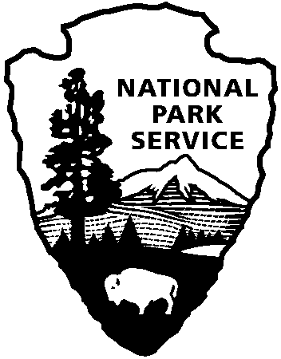

National Park Service

U.S. Department of the Interior

For Immediate Release: March 31, 2015

Contact Phyllis Howard, Park Ranger, 785-839-4233, Phyllis_Howard@nps.gov

Nicodemus NHS Joins National Find Your Park Movement

*National Park Week 2015 Encourages Everyone To Find Your Park*

Nicodemus – Nicodemus NHS joins parks, programs and partners across the country to encourage everyone to find their park and share their stories online at [FindYourPark.com](http://www.findyourpark.com). Launched yesterday by the [National Park Service](http://www.nps.gov) and the [National Park Foundation](http://www.nationalparks.org/), [Find Your Park](http://www.findyourpark.com/) is a public awareness and education campaign celebrating the milestone centennial anniversary of the National Park Service in 2016 and setting the stage for its second century of service.

Find Your Park invites the public to see that a national park can be more than a place -- it can be a feeling, a state of mind, or a sense of American pride. Beyond vast landscapes, the campaign highlights historical, urban, and cultural parks, as well as the National Park Service programs that protect, preserve and share nature, culture, and history in communities nationwide.

“Find Your Park” is also being the theme for this year’s [National Park Week](http://www.nationalparkweek.org), April 18 – 26. Join the fun at Nicodemus National Historic Site, on Saturday April 25 for National Junior Ranger Day from 10-3. There will be all kinds of fun and educational activities to introduce your kids to the history of Nicodemus and to the National Park Service as a whole. For more information, please contact Education Technician Jonathan Winskie at (785) 839-4321 or jonathan_winskie@nps.gov.

"This is an exciting time for the National Park Service as it enters its second century in 2016. In celebration of National Park Week, I encourage everyone to bring their children to Junior Ranger Day on April 25. Come experience the history in your backyard and "Find Your Park" at Nicodemus National Historic Site." Angela Wetz, Superintendent.

Visit [www.NationalParkWeek.org](http://www.NationalParkWeek.org) to learn more about how you can join parks, programs, and partners in celebrating National Park Week across the country.

[**www.nps.gov**](http://www.nps.gov)

*About the National Park Service. More than 20,000 National Park Service employees care for America’s 407 national parks and work with communities across the nation to help preserve local history and create close-to-home recreational opportunities. Learn more at* [*www.nps.gov*](http://www.nps.gov)*.*