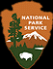
Ranger Led-Activities for March through May 2011
National Park Service
U.S. Department of the Interior

Morristown National
Historical Park

Third line, if necessary
Morristown

March Activities
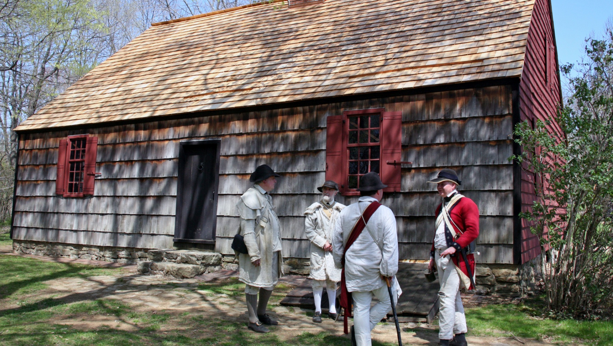
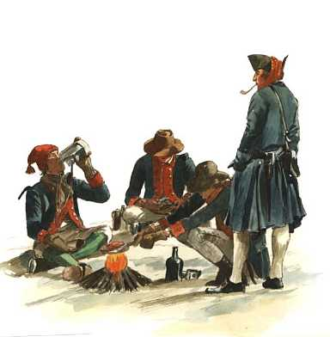

Jockey Hollow Visitor Center: Open daily from 9:00am to 5:00pm and admission is free. A recreated soldier’s hut is on display as well as a 15 minute park movie. Trail Guides to 27 miles of hiking trails are available for free. Call 973-543-4030 for information.
Wick House: Open daily from 9:30am to 4:30pm and admission is free. Step back into time while exploring the 18th Century farmhouse of the Wick Family which also served as the headquarters of General Arthur St. Clair during the winter encampment of 1779 to 1780. Call 973-543-4030 for information.
Washington’s Headquarters Museum:The museum is open daily from 9:00am to 5:00pm. The museum features three exhibit galleries and a 30 minute park movie about Morristown during the Revolutionary War. The museum also includes an Eastern National bookstore. The fee for the museum is $4.00 for adults (age 16 and Up) and also includes a tour of the Ford Mansion. Call 973-539-2016 ext 210 for information.
Ford Mansion: Tours are offered daily and begin at the Washington’s Headquarters Museum. Call 973-539-2016 ext 210 for availability.
Daily

This is a main head, Labeled "Head A"
in the styles menu

March

Sunday, March 6th: Tempe Wick: Truth & Legend – Did Tempe Wick really hide a horse in the Wick House? Hear the legend and find out the truth as you explore the Wick House and look for potential hiding spots. 1:30pm, 2:30pm & 3:30pm at the Wick House
Sunday, March 13th: Ladies of the Camp Meet one of Washington’s Aides during a Ford Manison tour and learn about the role of women, both upper and lower classes, in the armies of the Revolutionary War. 1:00pm, 2:00pm & 3:00pm at the Ford Mansion
Saturday, March 19th: Our Revolution: The meaning of Liberty from the Perspective of an African American Soldier. This unique theatrical experience will be offered by the troupe Living Voices. 2:00 pm at the Washington’s Headquarter’s Museum

Sunday, March 20th: Sons of St. Patrick Discover the role of the Irish in the American Revolution as you encounter one of Washington’s Aides on a Ford Manison tour. Learn why St. Patrick’s Day was the only holiday celebrated by the soldiers during the winter of 1779-1780. 1:00pm, 2:00pm & 3:00pm at the Ford Mansion
Saturday, March 26th: Women of the House Look into the roles of Martha Washington, Theodosia Ford, Mrs. Thompson and Peggy Lee while touring the Ford Manison. Learn how these women helped make General Washington’s Headquarters feel more like home. 1:00pm, 2:00pm, 3:00pm & 4:00pm at the Ford Mansion
Sunday, March 27th: Myth-Informed: Debunking Myths of 18th Century Life Over time, guides at historic sites have told all sorts of interesting stories that turn out to be false. Join the Park Historian and discover the truth behind many popular old-house myths. 1:00pm, 2:00pm, 3:00pm at the Ford Mansion

April
Saturday, April 2nd: Spring at the Huts The last snow storm of the winter has passed. The Continental Army will soon return to the campaign trail. Meet a Ranger at the huts of the Pennsylvania line to learn about the soldiers lives and what waits them during the summer. 1:00pm to 4:00pm at the Soldier Huts, call Jockey Hollow Visitor Center for details.
Sunday, April 3rd: Morristown’s Other Army During the Great Depression of the 1930’s another army camped in Morristown. Join a Ranger at the Washington’s Headquarters Museum for a 45 minute PowerPoint presentation to discover the work of the Civilian Conservation Corps and how these “Soil Soldiers” transformed Morristown NHP and other public lands. 1:15pm & 3:15pm at the Washington’s Headquarters Museum
Sunday April 10th: Stark’s Bridgade Hike Join the Park Historian on a 3 mile round trip hike to Stark’s Bridgade. Learn about the New England soldiers who camped there and their life during the winter.This can be a strenous hike. Wear appropriate clothing and bring along your own water. In the event of rain the hike will be canceled. Call 973-543-4030 for more information. 10:00am at the NY Bridgade Parking Area.
Friday April 15th to Sunday April 17th: Revolutionary Times Weekend - Join us for this special event with activities throughout the weekend. Call 973-543-4030 or visit www.nps.gov/morr for further details. All weekend long at Jockey Hollow.
Sunday April 24th: A Great Diversity of Faiths Presbyterians, Baptists, Anglicans, Quakers, Catholics and Jews were just part of the religious mosaic of 18th century America. Learn about the role played by different faiths as you meet one of Washington’s Aides during a Ford Mansion tour. 1:00pm, 2:00pm & 3:00pm at the Ford Mansion
Saturday, April 30th: Tools of the Farmer 18th Century Farmers, like Henry Wick did not have the modern machinery of today. Farming involved a lot of manual labor. Come see the ‘power tools’ of the day as well as demonstrations of a flax brake and shaving bench. 1:00pm to 4:00pm at the Wick House.

May
Sunday May 1st: The East Indies in the American Revolution – Celebrate Asian-Pacific Islander Heritage Month and explore the role of Asia and the Pacific Islands during the Revolution as you encounter one of Washington’s Aides on a Ford Mansion tour. Learn about the China trade, war in India and the on-going explorations of the Pacific by Captain Cook. 1:00pm, 2:00pm & 3:00pm at the Ford Mansion.
Saturday May 7th: History Connections; Ford & Dey Mansion – Visit the Washington’s Headquarters Museum to learn where General Washington travelled to after his winter at the Ford Manison. Learn why Washington headed north, when the southern campaign was just heating up and where he stayed after leaving Morristown. 1:30pm to 4:30pm at the Washington’s Headquarters Museum
Sunday May 8th: Kid’s Discovery Hike Experience life of a soldier as you join in a 2½ mile round trip hike from the Visitor Center to the Soldier Huts. While at the huts you’ll try your hand at musket drill and marching. When you return to the Wick House you can play some 18th Century games played by the soldiers in camp. This will be an active program that is designed for kids at the 5th grade level and above. All children must be accompanied by an adult. In the event of rain the hike will be canceled. Call 973-543-4030 for further information. 1:00pm at the Jockey Hollow Visitor Center
Saturday May 14th: Money of Early America Morristown National Historical Park will have part of the parks collection on display for the general public. View money and coins of the 18th and early 19th Century. Learn about the unstable history of finance during the colonial period and how this complicated the troubles that the army faced. 1:30pm to 4:30pm at the Washington’s Headquarters Museum
Sunday May 15th: What’s Up with the Weather? – Learn about the role of weather in the American Revolution as you meet one of Washington’s Aides on a Ford Manison tour. Learn how bad weather sometimes saved Washington’s Army as well as how horrible the “Hard Winter of 1780” really was. 1:00pm, 2:00pm & 3:00pm at the Ford Mansion
Saturday May 21st: Was it Really Nonsense? Though his soldiers thought so, General Washington considered Morristown’s Fort Nonsense a real necessity. Come find out the curious history of this often forgotten fort of Morristown NHP. 1:00pm to 4:00pm at Fort Nonsense, Call Jockey Hollow Visitor Center for information.
Sunday May 22nd: Camp Rounds Hike Visit every bridgade site in Jockey Hollow and learn about life in the winter encampment on a 5½ mile hike. This is a strenuous hike over uneven terrain. Please wear appropriate clothing and bring along your own water. The hike starts and ends at the Jockey Hollow Visitor Center. In the event of rain the hike will be canceled. 1:00pm at the Jockey Hollow Visitor Center.
Sunday May 29th: Soldier’s Viewpoint Step back in time to June 1780; and hear a soldier’s viewpoint on the army and the winter encampment. A Park Ranger will take on the character of a soldier and answer your questions. 1:30pm to 4:00pm at the Wick House

EXPERIENCE YOUR AMERICA™

