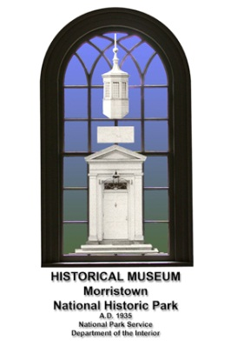
The museum and archival collections of the Morristown NHP are a rich source of exciting information dealing with a truly wide sweep of Western history. In all, nearly 350,000 items comprise the total collections, which include archeology, fine and decorative arts, paintings and prints, textiles, archival, and biological representations.
In addition, the research library of nearly 20,000 volumes is available by appointment. The collections contain items dating from the fifteenth century through the twentieth century. Naturally, the collection is anchored by colonial and revolutionary era artifacts and documents, which speak to the persistence and unique abilities of the founding generation.
Beyond the core collection though, the park has good fortune to be able to expand these core themes to include representations of chapters in Western history which impact to founding of the United States and also contribute to the rich cultural heritage we all are beneficiaries of. Over the past eighty years the park has received several generous donations of private collections, which have enabled the park to expand its historical program offerings to our visitors. This on-line exhibit is one example of the types of programs we will offer from time-to-time which will look at some of the less exhibited items in the park collections.
If you have any questions or comments about this collection, please contact the Division of Cultural Resources at 973-539-2016 ext. 204 or www.nps.gov/morr./
Thank you.

Acknowledgements
Morristown National Historical Park gratefully acknowledgements the contributions of the following individuals and institutions in the development of this on-line collection.
Morristown National Historical Park: Division of Cultural Resources
Jude M. Pfister & Joni Rowe
Division of Interpretation:
Anne DeGraaf & Thomas Winslow.
Pensacola Junior College-Randall Broxton, Professor of History.
The Papers of John Marshall-Joan Lovelace, Managing Editor.
The Papers of George Washington-Theodore Crackel, Editor-in-Chief.

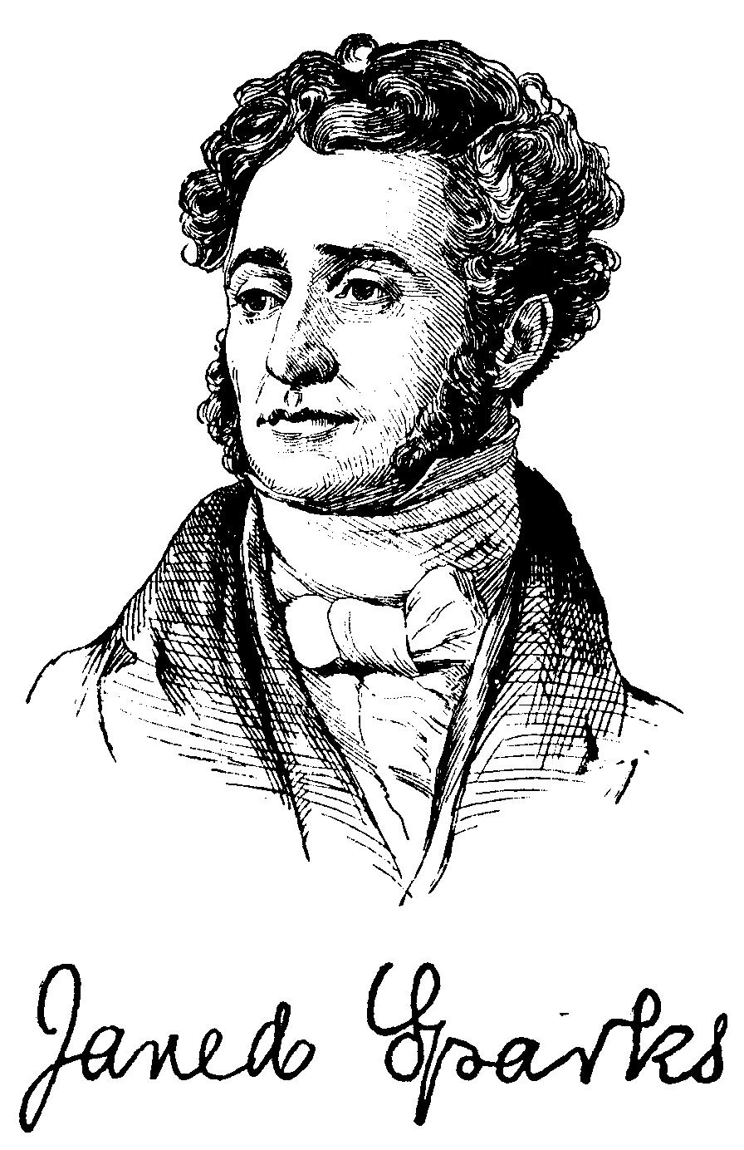
JARED SPARKS 1789-1866

Jared Sparks is an excellent introduction to learning historical research and preservation. Sparks tirelessly collected the papers of our founding fathers including the signers of the Declaration of Independence. He realized the importance of American history for future generations. His inspiring research included the beginnings of American biography with his collection of biographical information on the leaders of America. His works included: The Writings of George Washington (1834-1838), The Library of American Biography (1834-1838), The Works of Benjamin Franklin (1836-1840), and as editor of the North American Review (1824-1831).

Because of his dedication to scholarly research the history club at Pensacola Junior College (Pensacola, Florida) decided to honor his memory by naming our organization the Jared Sparks Historical Society of Pensacola Junior College in 1994. I am honored to introduce this exciting opportunity to view some of Jared Sparks letters. This collection provides more insight and reflection on our early American history and Jared Sparks’ role in its preservation.

Professor Randall Broxton
History Professor
Pensacola Junior College
Pensacola, Florida

Jared Sparks and the Washington Papers

Jared Sparks was an American Historian who produced the first set of the collected papers of George Washington. Sparks worked for ten years, from 1827-1837, to gather and edit every letter or piece of correspondence to/from Washington that he could find.

He traveled throughout the United States and to Europe in a tireless effort to provide the most accurate and full literary portrait that he could. Naturally, numerous individuals aided him. Among the more famous were Bushrod Washington (nephew of the President), John Marshall, and Joseph Story.

All three of these men were Supreme Court justices (Marshall was Chief) and much correspondence went through these channels. Marshall, it should be noted, also wrote a biography of President Washington early in the nineteenth century.

Sparks’s work is important from many viewpoints. He developed the concept of research in the sense that multiple sources should be studied to produce a viable picture.

He traveled and consulted repositories on both sides of the Atlantic before that was an established practice. He pioneered the discipline of historical study in the United States and established the first department of history in America at Harvard in 1838.

During the time he worked on this project he lived at the Craige House in Cambridge, which was Washington’s headquarters during the siege of Boston in 1775-76 and later was purchased by Henry Longfellow in 1842. Today it is the Longfellow NHS.

Included here is the first letter sent by Sparks to Justice Washington where he outlines his grand plan for the papers project. Also included is the reply by Justice Washington to Sparks, and the subsequent agreement between Sparks, Justice Washington, and John Marshall. All letters have been transcribed and the transcriptions are included.

A Thread of History

The Jared Sparks-Bushrod Washington letters

The correspondence between Bushrod Washington (nephew of President Washington) and Jared Sparks (1789-1866) is unique in American historical literature. Sparks, a historian, had set himself the goal of publishing the collected works of President Washington and corresponded with innumerable people in America and Europe (he researched as well in Europe and throughout America himself) to obtain copies of the President’s correspondence. The letters Sparks produced himself during his ten year project on George Washington are nearly as important as the papers of

President Washington which he sought to collect. Sparks’s written letters with the Washington family, not to mention the innumerable letters he sent to archival repositories in America and Europe, gather to over two hundred pages.

This collection of Sparks’s letters chronicles one of the earliest attempts to gather, through primary sources, the literary remains of a major historical figure. As Sparks himself wrote in the preface to his one volume biography of President Washington, “Whoever would understand the character of Washington, in all its compass and grandeur, must learn it from his own writings and from a complete history of his country during the long period in which he was the most prominent actor.”

In his efforts concerning the Washington papers, Sparks wrote significantly to Bushrod Washington (1762-1829), the President’s nephew and Associate Justice of the Supreme Court. Although Justice Washington initially declined to give Sparks the help he requested, he eventually consented to allowing Sparks access to his uncle’s materials. (Justice Washington had inherited from his uncle the Mt. Vernon estate along with all of the President’s writings and personal property.)

The correspondence with Justice Washington represents Sparks’s attempt to logically take his search to one of the relatives of the President. Justice Washington only consented to help after Sparks had already traveled throughout the original thirteen Colonies (and to Europe) collecting copies of the President’s writings and had proven he was serious in his effort.

Justice Washington also felt more comfortable with the project once John Marshall was involved.

Over twenty years earlier Justice Washington had urged Marshall to write a biography shortly after the President’s death and provided Marshall with considerable access to the President’s writings. Marshall’s five volumes became the first major biography written and a one volume abridgement, which went through twenty editions by 1849, is still in print and available through Eastern National.

Justice Washington may have felt that he and John Marshall had fulfilled the obligation to write the “definitive” biography, and therefore rejected Sparks’ initial overture. Nonetheless, Justice Washington, as mentioned, did consent to assist Sparks and Sparks published his twelve volumes Life and Writings of General Washington in 1834-37, after almost ten years of work. Justice Washington did not live to see the publication, which represented the first scholarly attempt at collecting a historical figures works for public

consumption. Sparks went on to become a professor of ancient and modern history at Harvard (and a colleague of Henry W. Longfellow, a professor of modern languages) and ultimately president of Harvard from 1849-1853.

Jared Sparks is clearly not a household name as far as American history is concerned. However, he lived and worked with other Boston literary luminaries such as contemporaries and near contemporaries as George Bancroft (1800-1891, a lifelong friend he met while a student at Philips Exeter Academy) and William Prescott (1796-1859,) among many others. As a professor, he taught and influenced a generation of later historians, including Francis Parkman (1823-1893.) However, during his life, and throughout the “heroic model” (or great man) period of historical writing in the United States, Sparks cut a wide swath.

His desire to see historical research and writing improved in the United States was evident in his correspondence. After researching at the British Museum in 1840 (when the British Library was still housed there) he wrote “when shall we see the like in the Athenaeum” in comparing the number of researchers in London to the number of researchers to the private Boston library and research center.

Sparks was in the vanguard of American historians and to a certain extent set standards which others where to follow and refine into the modern discipline of history. In fact, Sparks became, in 1838, the first Professor of History at an American college—Harvard. His work is often criticized as being clouded with gushing patriotism and of editing controversial life episodes into more generous scenes.

This aside, he did render a tremendous service to historical writing by producing nearly seventy volumes during his career and selling nearly 600,000 copies of his works. These works included not only the twelve volumes of President Washington’s papers, but also ten volumes of Benjamin Franklin’s papers. He also published separately a one-volume Life of George Washington and edited the Library of American Biography. This latter work earned Sparks the appellation “the American Plutarch.”

The associated images depicted here show a series of letters and one contract (agreement) which were collected and bound together probably in the latter half of the nineteenth century, and purchased (as a bound set) by Lloyd W. Smith sometime after 1920 but no later than 1955.

Smith gifted the set, along with his entire archival and artifact collection to Morristown NHP through his will after his death in 1955.

The first letter (nearly ten pages,) from Jared Sparks to Bushrod Washington, spells out in grand detail the ambitious plan he has arrived at “after very mature reflection” for the publishing of President Washington’s collected papers. He meticulously outlines the plan which will consist of three parts:
1) Official Letters;
2) State Papers, & other official documents;
3) Private Correspondence.

As Sparks’s states, his ambition is to “make every statement & allusion clearly understood and exhibit, in connexion (sic) with the letters, a thread of history as continuous and perfect as the nature of the subject will admit.” Near the end of his letter, Sparks writes that it is his desire that his project will serve “both as a tribute due to the name of Washington, and a repository for the perpetuating the most valuable treasures of American history.” Sparks vows to “engage resolutely” in his project and will “spare neither industry nor expense” to produce a work which is “creditable to the fame of Washington, to our literature, and our national history.”

The second letter from Bushrod Washington to Jared Sparks, spells out, in ambiguous terms, the fact that Justice Washington and Chief Justice Marshall have, “for some years past” been engaged in a similar, albeit less encompassing, project. Justice Washington states “it is our intention to publish many of the letters” relating to the affairs which President Washington involved himself in as a military commander and as a statesman.

The final letter is the contract or agreement signed by Jared Sparks, Bushrod Washington, and John Marshall. In the agreement, Justice Washington (and Chief Justice Marshall) agrees that Sparks will “have free access to the said papers of the said General Washington at Mount Vernon, with full permission to examine and to take copies…” Sparks however, cannot remove letters from Mount Vernon without written permission.

Sparks agrees to “take upon himself the charge and responsibility of the literary part of the said work,” and to basically engage fully in the enterprise completely. Sparks will pay up front the cost associated with the research and publishing. These costs will be reimbursed to Sparks from proceeds from the sale of the work. Justice Washington and Chief Justice Marshall will share in the profits once Sparks is reimbursed.

The copyright is to be shared two ways between Sparks on one side, and Justice Washington and Chief Justice Marshall on the other.

An interesting note concerning Justice Washington is that he served on the Supreme Court during much of the period when John Marshall was Chief Justice. Marshall is known as one of the first serious (although not necessarily scholarly) biographies of the President Washington. Although knowledgeable and qualified, Justice Washington was, as one biographer puts it, “not a distinguished justice.” He seems never to have been able to remove himself from his uncle’s fame.

One final note: During 1833-35, while Sparks was working on the Washington papers project, he boarded at the Craige house in Cambridge, MA.
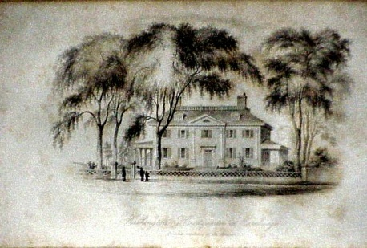
Today, this house is known as the Longfellow National Historical Site. It became the home of Henry Longfellow and his family several years after Sparks had left and after Mrs. Craige died. Longfellow and Sparks worked as colleagues at Harvard. Coincidently, the Craige home, before the Craige’s owned it, was also the headquarters of General Washington after he was appointed Commander-in-Chief of the Continental Army in 1775.

Below is the first letter sent by Sparks to Justice Washington.

Boston, January 26, 1826

To the
Hon Bushrod Washington,
Sir

You may recollect, that nearly two years ago I wrote you concerning a design, which a friend of mine then had, of publishing an edition of “General Washington’s Works.” As he did not carry his purpose into execution, I was myself led to examine the subject, and have read with great attention such of the writings of General Washington, as I have been able to obtain. I have also made numerous inquiries, respecting his official letters to the Governors of the states, during the revolution, and to the

principal officers of the army. The result of my investigation has been, that there is in existence a vast number of unpublished letters written by him, which are of the highest importance as containing materials for a correct history of the country, and as exhibiting in a still more imposing light, than has yet been done, the extraordinary resources and powers of the author’s mind, and the controlling influence of his opinions and character, in gaining the independence, and establishing the free governments which are now the glory and happiness of his countrymen, and the admiration of the world.

Under this conviction, and after very mature reflection and extensive enquiry, I have resolved, should such a project meet your approbation, to collect and publish all the works of General Washington, both such as have already appeared in print, and such as are to be found in manuscript.

My plan is to accompany the whole with a full body of notes and historical illustrations, and to arrange the material under the following divisions,

Part 1 Official Letters

This division will embrace all General Washington’s correspondence which may be strictly call official; that is, his letters to the Governor of Virginia, while engaged in the French War; his letters to the President of Congress, and the committee on the army during the revolution; his letters to the governors of the states and committees appointed to correspond with him by different legislatures; his letters to the officers of the army, and the other individuals engaged in public affairs; and such of his letters, while president of the United States, as may be deemed of an official character.

The two volumes of “Washington’s Official Letters,” first published in London, in the year 1795, embrace those only which were addressed to the president of Congress from the time he took command of the army in June, 1775, to the end of the year 1778, about three years and a half. These were copied in the Secretary’s office at Philadelphia, by a person who took them to London, and published them, with the apparent design of continuing the series. But the sale did not probably encourage him to fulfill his intentions as he is still living in London, and nothing in addition to the above two volumes has appeared. These letters were doubtful correctly copied, but they are printed with many omissions, which were thought necessary to accommodate them to the state of public feeling at the time. I do not find, that any of the letters to Congress, after the year 1778, have been printed; nor any of the vast numbers, which he wrote to the governors of the states; nor any of those sent to officers of the army, except in a few instances, where memoirs of the general officers have been written.

I have learnt from the secretaries of several states, that many letters from General Washington are on file among the public papers, copies of which can be obtained without difficulty. The same thing I have also ascertained, in regard to the papers left by some of the leading officers of the army. Many letters from the Commander in Chief are found among them. In the library of the Massachusetts Historical Society, is a volume of [?] letters by General Washington, collected from the papers of Governor Hancock, & deposited there by his widow.

In the same library is also a series of volumes of manuscripts, which belonged to Governor Trumbull, & which contain all General Washington’s correspondence with him & gentlemen in New Hampshire has a full copy of the proceedings of the committee of Congress, which visited the army in 1780, to consult with the commander in chief on important affairs. In this manuscript volume are contained fifteen letters from General Washington, unpublished letters of his are also deposited in the library of the New York Historical Society.

In short, it would not be easy to calculate the number which may be gathered from different sources, by a thorough & persevering examination.

When these are collected, my purpose is to arrange them in chronological order and to add such explanations by way of notes, as will make every statement & allusion clearly understood and exhibit, in connexion with the letters, a thread of history as continuous and perfect as the nature of the subject will admit. In constructing the notes, many valuable material may be drawn from the letters written in reply to those of General Washington very few of which have ever been published. To what extent these may be obtained, can be known only by future enquiry. Copies of these written by the Governor, & other authorities of the states, are unquestionably preserved. All other sources of information will likewise be resorted to, on which premise in any way to aid the execution of my plan.

Part II State Papers, & other official documents

In this division will be brought together his messages to Congress, addresses, general orders to the army, and whatever other papers there may be of a public nature, which cannot be properly ranked under the division of official letters.

The notes and illustrations here will principally relate to the political state of the times; to the opinions, views, and purposes of the author, to his wisdom in devising measures of the most salutary kind, and his influence and the weight of his character in carrying them into effect, to his agency in directing the progress of events, and leading them to the best ends in establishing the new

government on a solid foundation; and, indeed, to whatever may elucidate the history of his political life.

Part III Private Correspondence

In this department much discretion must of course be exercised. It is not to be supposed, that all his private letters, nor all that can be collected, are suited to publication. There is much even here, however, that is not only curious, but valuable.

His agricultural correspondence with Sir John Sinclair, & Mr. Anderson, which was published in England, will come under the head; and many letters, which here appeared from time to time in public papers and journals; as well as numerous others in manuscript, known to be in the hands of individuals. Of this description of letters, I should not be disposed to print any, except such as you, & other judicious persons, may deem in accordance with the dignity of the work, as containing interesting facts, or developing traits of the author’s mind and character.

The notes under this division will be few & short, explaining such parts of the letters as may require it, & detailing such particulars and incidents, as may come to my knowledge, respecting the private pursuits, and the characteristic habits & opinions of the writer.

I have thus, Sir, in a few words as possible, disclosed to you my plan. In making to you this frank and explicit exposition, I have two objects in view. First, as it is a thing in which you, as an individual, are more deeply interested than any other person, it is highly proper for me to ascertain, whether you approve my undertaking, and are willing to promote it by your counsel & aid, before I take any public measures for prosecuting it. And secondly, it is of the utmost importance for me to know whether you will consent that access may be had to the papers of General Washington in your possession.

I am aware, that there is some delicacy in the second point, nor should I venture to make the inquiry were I not encouraged to do it by many gentlemen, to whom I have explained my designs, on whose judgment I can rely, & to whom the fame of no man is dearer, than that of Washington’s. These have professed, one and all, to regard my project as one of a magnitude and importance which justify me in making even such an application; and whatever may be your view, as to the expediency of allowing the papers to be examined, I cannot doubt you will duly appreciate my motives, & freely excuse any thing that may to you have the appearance of impropriety in the liberty I take.

It was the habit of General Washington to preserve copies of his correspondence. While in the army he kept regular letter books for this purpose; and from many circumstance I infer that the same was done in respect to most of his private letters. In his correspondence with Mr. Anderson, for instance, he sent a duplicate of a letter which he found had not reached its destination.

Now, as it is to be presumed, that General Washington’s letters have been preserved with great care, by the persons into whose possession they may have fallen, it can hardly be doubted, that a public advertisement would bring nearly all of them to light, and those in the archives of the legislatures of the states may be had by direct application; yet, after every effort is made, there must be deficiencies, particularly in regard to letters among the papers of the general officers of the army, whose descendants may desire to retain them for a first

publication in a future biographical notice of the person to whom they were written. And some will also necessarily be overlooked; that are in the offices of the secretaries of the States, by reason of the masses of papers with which they will be connected. The only possible mode of supplying such deficiencies, is by examining the copies of correspondence left by General Washington. If you agree with me, therefore, as you most certainly will, that if such a work is to be executed, it should be done in as complete and perfect a manner as possible, I think you will not fail to see, in a clear and convincing light, the force of these hints.

Again, there are other documents of the highest value among the papers of General Washington, many of which cannot be supposed to exist any where else, and these are the letters received by him during his whole public life.

It would seem that he was as remarkable for retaining the original of all letters sent to him as for preserving copies of his own. In almost every letter to Congress he mentions copies of letters enclosed, which he had received from public person, and the originals of which were kept by himself. In some cases, it is not likely the writers of these preserved copies in others, where copies were taken at the time, they have doubtly been lost in the vicissitudes through which they have passed, so that at the day it is probable, that the only copies in being are the single ones among the papers at Mount Vernon. Yet these letters unfold many of the leading principle and moving stirrings of the revolution; they afford the very best materials of history, and, in a work, are absolutely essential to illustrate the work of General Washington.

With these views of the subject, I shall leave it to your better judgement to decide in what light it is proper for you to regard my proposed undertaking. As to myself, it only needs be added, that I have been chiefly influenced by a deep conviction of the importance of such work, both as a tribute due to the name of

Washington, and a repository for perpetuating the most valuable treasures of American history, which, in their present scattered state are subject to be swept into oblivion by every wind that blows, exposed to the mercy of accident, & the consuming power of the elements. My thoughts have been more or less occupied with the plan for the last two years, as a literary enterprise it falls in with my inclination and pursuits; but the labor of collecting materials so widely diffused, & of preparing them in the way I propose for the press, is one of which no adequate conception can be formed by and person who has not had some experience in work of a similar kind. But I have resolved to engage resolutely in the task, if I undertake it at all, and to spare neither industry nor expense in endeavoring to execute it, as far as my ability will allow, in a manner creditable to the fame of Washington, to our literature, and our national history.

For further information, as to my purposes and qualifications, permit me Sir, to refer you to Judge Story with whom I have conversed on the subject, and who manifests a lively interest in the plan of collecting into one body all the writings of General Washington. With Mr. Webster and Mr. Wheaton I am also acquainted, and I doubt not they will readily answer any inquiries, you may wish to make respecting my character and pursuits.

I shall write to Judge Marshall, and I hope you will do me the favor to show him this letter, that he may fully understand my views and motives.

I have the honor to be, Sir
With great respect,
Your Ot. Servant----

Jared Sparks

The reply to Jared Sparks from Justice Washington

Washington March 13th 1826.
Sir
Your letter of the 26th January was handed me by Mr. Justice Story, and I owe you an apology for the delay which has taken place in answering it. The truth is that, although living under the same roof, the important cases which the Judges have had to examine and discuss in conference diverted the attention of the C. Justice & myself from the subject, insomuch, that it is but lately that we had an opportunity of conversing upon it.

The only answer which it is now in my power to give to your proposal will be contained in the following statement of facts. – A part of the work which you contemplate writing has for some years past engaged the attention, & commanded the labour, of the C. Justice & myself. It is now completed, and we expect in the course of the next summer to put to press about three volumes of what we judge to be the most interesting of Genl. Washington’s letters, written during the war of the revolution, and subsequent to its termination. It is further our intention to publish many of the letters addressed to him by the governors of the several states, foreign officers & others during those periods.
The letters written by him prior to and during the French war, are, many of them, copied, and will be published at some future period.
I am Sir very respectfully Your mo. Ob. Servt.
Bushrod Washington

The Articles of Agreement

Articles of agreement entered into this seventh day of March in the year eighteen hundred and twenty seven between Jared Sparks of the state of Massachusetts of the first part, and John Marshall of the city of Richmond and Bushrod Washington of Mount Vernon, both of the state of Virginia witness, that whereas the party of the first part proposes to prepare for publication and to publish an edition of the Works of General Washington according to a plan proposed by the party of the first part in a letter from him bearing date the 26th day of January in the year eighteen hundred and twenty six addressed to the said Bushrod Washington one of the parties of the second part, which work the said party of the first part now engages to execute according to the plan proposed in the said letter (reference whereto is here made as part of these articles) the said party of the first part taking upon himself the charge and responsibility of the literary part of said work and the business of finding a publisher and of superintending the publication, it is hereby covenanted and agreed by and between the aforesaid parties in manner and form following, that is to say;
- First, the said party of the first part covenants and agrees in consideration of having access to all the papers in possession of the said Bushrod Washington, which were devised to him by his uncle the said General Washington, and permission to take copies on extracts from the same, subject to the

qualification herein after mentioned, to prepare for publication and to publish an edition of General Washington’s Words, according to the plan proposed by the said party of the first part in the letter before mentioned, (which letter is now distinguished by the name’s of the parties to this agreement being endorsed thereon) and to execute the said work according to the said plan, and to take upon himself the charge and responsibility of the literary part of the said work, and the business of finding a publisher, and of superintending the publication thereof and to secure the copyright thereof.
—Second, the said Bushrod Washington covenants and agrees, that the said party of the first part shall have free access to the said papers of the said General Washington at Mount Vernon, with full permission to examine and to take copies or extracts of the same at Mount Vernon, but not to remove the said papers, or any or either of them to any other place without the leave of the said Bushrod Washington first obtained in writing, or, in case of his death, of the person to whom or to whose care they shall and may be committed by the said Bushrod Washington by his will or otherwise, it being fully understood and agreed by the parties to this agreement, that any paper may be withheld which the parties of the second part both or either of them, do not deem suited or proper for publication,; and the parties of the second part further covenant and agree to deliver to the party of the first part, with a view to facilitate his labors, the copies of letters from and to the said General Washington, which they have caused to be made, free of any change.
—Third, the said Jared Sparks or his part covenants and agrees, that the parties of the second part shall be equally interested with himself in the property of the copyright of copyrights to the said work, and in the profits of the sales, after the expenses of the said Sparks, the said party of the first part, which have been or shall hereafter be incurred in procuring materials for the historical illustrations of the said work, shall be deducted from the said profits of the sales; that is to say, the said Sparks of the first part is to be entitled to a moiety of the property in the said copyright or copyrights, and to a moiety of the profits of sales of the said work, after the said deduction is made, and the said parties of the second part to the other moiety of the said copyright or copyrights, and of the said profits of sales after the said deduction is made.
Bushrod Washington
[seal]
John Marshall
[seal]
Jared Sparks
[seal]

Jared Sparks to Bushrod Washington-- January 26, 1826.
Jared Sparks, The Life of George Washington, 1839.
Brooks, Van Wyck. The Flowering of New England.
Brooks, Van Wyck. The Flowering of New England.
Spiller, Robert E. Ed. Literary History of the United States
Brooks, Van Wyck. The Flowering of New England.
Website Oyez. U.S. Supreme Court multimedia history and current affairs.

