American Pika

The American Pika is a small mammal closely related to the rabbit. Pikas depend on cool temperatures and thrive on rocky, alpine slopes of Mount Rainier. Pikas build haystacks of grasses that are consumed during the winter months. They whistle when strangers approach their territory.

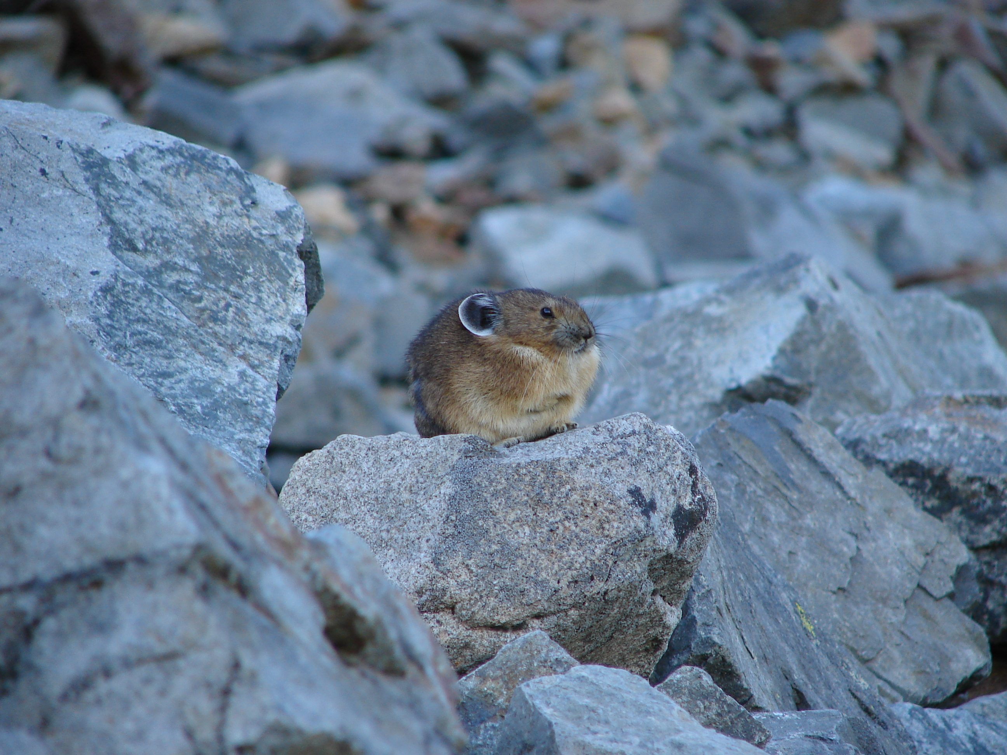

A pika at home among the rocks of an alpine meadow.
Photo: Mount Rainier National Park

Impact:
Warmer temperatures cause the pika’s alpine habitat to move to higher elevations because of forest encroachment. In
some places, pika have moved as far as 2,000 feet higher than their historic habitat. Eventually, their habitat could be pushed off the mountain or ridge top. Pikas cannot easily migrate laterally in response to climate change. Their thick fur does not dissipate heat, thus restricting their ability to cross lower-elevation valleys to reach more desirable alpine slopes.

Impact:
Longer frost free seasons allow for subalpine fir displacement of wildflower and grass meadows which supply the pika with food. As meadows decrease there is less food for pikas and greater competition for fewer resources, leading to a decline in population and genetic diversity.

Impact:
Declining pika populations further impact predators, such as hawks and other raptors, which consume the pika as part of
their diet.

Impact:
Pika are not well-adapted to temperature increases. They must move to higher elevations because they can only leave their
burrows to forage when the temperatures are cool enough. As temperatures increase, they can spend less and less of the
day out of their burrow foraging and therefore are less able to store up reserves for the winter months. Since pikas do not
hibernate, they are dependent upon the food that they store in the summer to feed them through the winter.

Impact:
Warmer temperatures may also cause a mismatch between the timing of when the pikas breed in May and June and
when the grasses that they consume are melted out of the snow. Less food availability stresses already waning pika
populations.

Impact:
Conversely, some plant species, such as grasses, are dependent upon on animal transport and dispersal of seeds. The loss
of the seed dispersal that occurs as pikas gather, pile and cure “hay” may result in slower or overall less plant colonization
of disturbed ground.

Impact:
Non-native plant species are often more tolerant of higher temperatures and changes in precipitation than native species.
When they outcompete the native species it lessens the food and shelter available to animals such as pika.

