Nisqually Glacier

Glaciers are important sources of fresh water for human, plant and animal components of downstream communities. Glacier-fed streams traditionally have less variable stream flow than other streams. Summer melting makes up for less precipitation during summer. In the winter, when precipitation increases, melting decreases due to colder temperatures. Ecosystems that form along glacier-fed streams are reliant on a steady, consistent supply of cold water. The Nisqually glacier has been studied by scientists since 1918 and provides the longest continuous record for any glacier in the Western Hemisphere. Today, the Nisqually Glacier terminus lies more than 2,500 meters upstream from its furthest known extent down valley dating to some time in the mid-1820’s.

Impact:
More precipitation falling as rain and less as snow leads to fewer sources of the snow and ice needed for glacier formation. With less snow during the winter, warmer temperatures in the summer and longer snow-free seasons causing more melting, glaciers are getting smaller and thinner. At sites in the Olympic and Cascade mountain ranges, there have been decreases in April 1st snowpack measurements of between 30-60%; glaciers on Mount Rainier lost 21% of their surface area between 1913 and 1994.

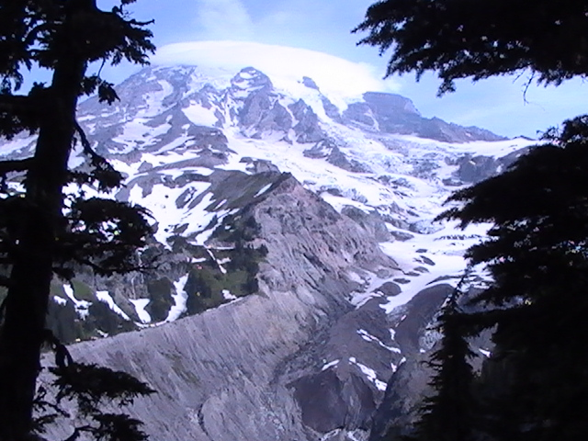

The terminus of the Nisqually Glacier (bottom center of picture) is covered by rocks and debris that have eroded off the surrounding cliffs and moraines. This debris can eventually be washed downstream by floodwaters.
Photo: Mount Rainier National Park

Impact:
Retreating glaciers uncover sediments. With more precipitation falling as rain and increases in the
frequency of extreme storms, loose sediments lead to debris flows and stream aggradation. For example,
the retreating Van Trump glacier produced four debris flows between 2001 and 2006. These flows filled the Nisqually River with sediment and raised the river bed at least six feet. Debris flows can destroy downstream ecosystems and require hundreds of years of succession to return to their original state.

Impact:
In contrast, retreating glaciers also uncover space that can then be colonized by pioneer plants and animals.

Impact:
Higher stream beds, due to stream aggradation, increase the risk of floods. Flooding can damage roads, homes and other
infrastructure and bury fertile farmland in inches of sand and gravel. In 2006, Mount Rainier National Park was
devastated by flooding, resulting in a six-month closure of a park that is normally accessible year-round. The cost to
repair damage was more than $28 million. The Carbon River Road is permanently closed to vehicle traffic, and repairs are still needed at Sunshine Point Campground. This figure excludes the impact to local businesses reliant on tourism and the multitudes of downstream communities who were also impacted by the flooding.

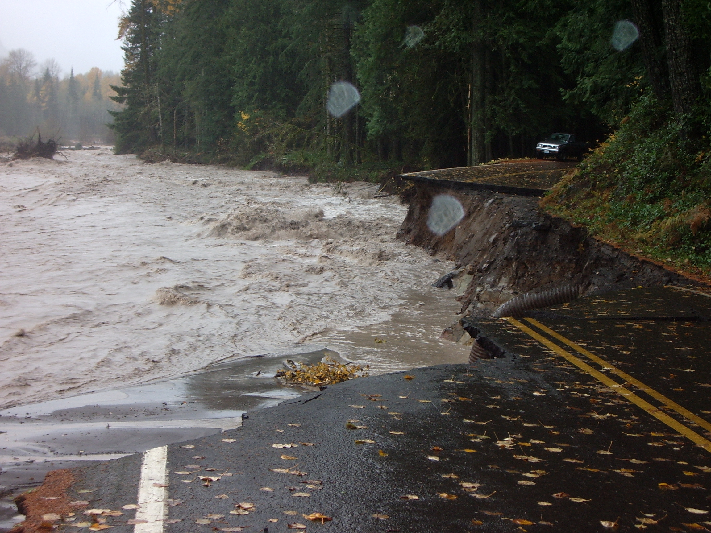

In 2006, flood waters from the Nisqually River eroded part of the park’s main road and most of the Sunshine Point campground.
Photo: Mount Rainier National Park

Impact:
Flooding and increased sediment also negatively impact native fish populations such as salmon species.

Impact:
Late summer stream flow is predominantly fed by glaciers. More winter precipitation and less summer precipitation,
combined with less snow and glacial melt-off, reduces stream flow, especially in the late summer when temperatures
are at their highest. Lower stream flow and higher air temperature together raise stream temperatures, impacting fish and
amphibian species

Impact:
Hotter summer months require increased use of irrigation for farming, leading to extraction of water from already low
stream flow. This impacts the water quality and availability to downstream populations and ecosystems, placing farmers
in conflict with other stakeholders such as fisheries, power suppliers, Native Americans, environmental protection
organizations, community water supply and regulators.

Impact:
Hydroelectric dams are often placed on glacially-fed streams due to their year-round water supply. As stream flow
diminishes, water is diverted around power generating turbines, rather than pooled behind dams for power generation,
therefore reducing the amount of electricity available for human use. Less availability of hydroelectric power increases the
dependence upon other possibly less-desirable sources of energy such as coal power. In addition, empty power generation
reservoirs are not as appealing for recreational activities such as water sports, fishing, boating or camping.

