KINDERHOOK COMMUNITY TRAILS KINDERHOOK. NEW YORK

Dutch Farming Heritage Trail

COMMUNITY TRAILS

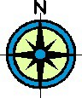

TRAIL ROUTE

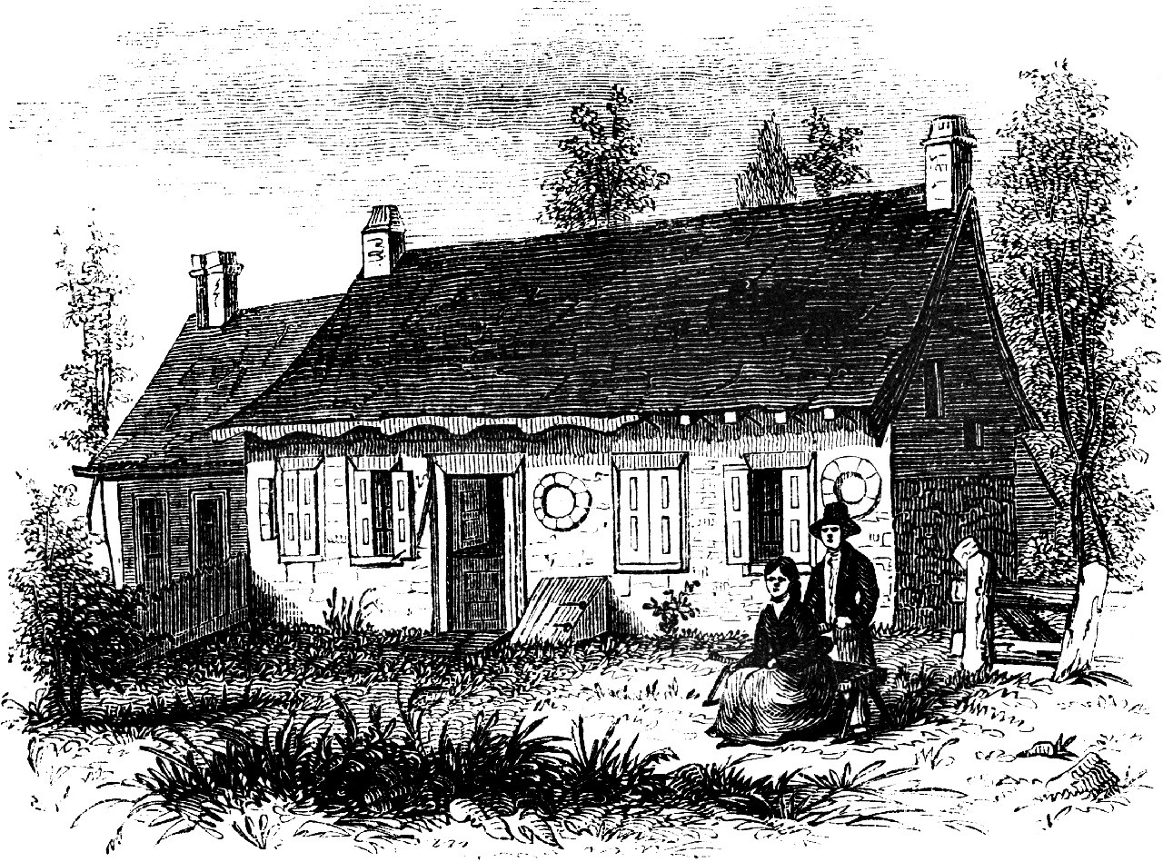

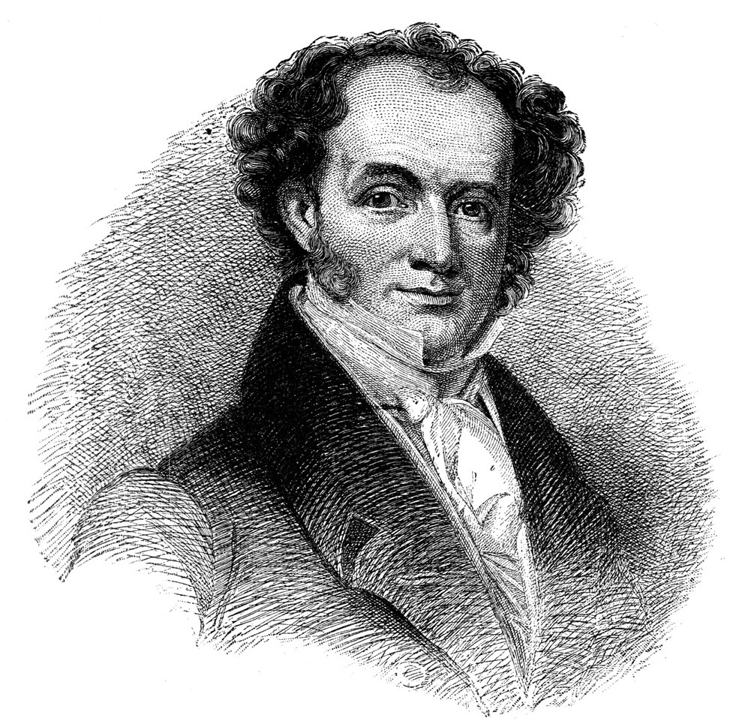
Community members in the towns of Kinderhook, Stuyvesant, and Stockport have been busy establishing recreational trails within their towns.
Together, they created a longer inter-municipal trail linking the three communities. Thanks to a grant from the Hudson River Valley Greenway, the development and completion of the Dutch Farming Heritage Trail has occurred. It’s hoped that this trail will serve as a catalyst and a model for a web of multiple-use trails linking the three towns.
Please use the trail regularly and enjoy it responsibly. Always respect the rights of property owners and abutters.

The trail runs from the back of the Van Alen House property, owned by Columbia County Historical Society, through areas of Roxbury Farm, down a historic portion of Old Post Road, and to the parking lot of the Martin Van Buren National Historic Site. Hikers can enjoy forest, farm, and stream views, while hiking along rolling hills.
Not only does the trail connect the two National Historic Landmarks, but it also provides the opportunity to tie together the evolution of Dutch farming across four centuries. The story begins in the 1700’s, with the Van Alen family farming the land. Gone are the farm structures that likely dotted the landscape, which might well have included a Dutch barn and hay barracks. Where there is now early successional forest, there once were fields of crops, including hay and flax. Also present were a variety of farm animals. The landscape would have been inhabited by a diversity of people, including the Van Alen family, and workers both slave and free.
Heading south on the trail, you leave CCHS property and enter Roxbury Farm, which brings the story of Dutch farming on Kinderhook land to the present day. Roxbury farm is a community supported farm, run by Jean-Paul Courtens and Jody Bolluyt. Jean-Paul immigrated to the United States after completing a four year training school for biodynamic agriculture in the Netherlands. On Roxbury Farm you see modern organic farming. Flax is no longer a crop of choice; instead, a variety of vegetables, fruits, and livestock are raised there.
Continuing south, hikers will walk on a portion of Old Post Road (part of the original Albany Post Road). This road, built in the 18th century, allowed people and goods to travel between Albany and New York City. The road was certainly important for farmers in the area, including the Van Alens and Martin Van Buren. It remains so for Roxbury Farm as a means to move between the northern and southern sections of their farm.
The trail ends at Lindenwald, where it connects to the existing “Wayside Loop Trail,” beginning in the visitor parking lot. It also provides access to the trails in the Martin Van Buren Nature Area located across route 9H. The Wayside Loop Trail is a three-quarter

mile loop trail around the grounds. There are ten outdoor interpretive markers - waysides - which contain information about Martin Van Buren and his Lindenwald farm. While in the White House, Van Buren purchased the farm that he named Lindenwald, which eventually grew to 226 acres. Van Buren was interested in new agricultural techniques and technology to make his farm profitable. Van Buren’s Will begins with a testament to his deep interest in agriculture: "I Martin Van Buren...heretofore Governor of the State, and more recently President of the United States, but for the last and happiest years of my life, a Farmer in my native Town. "

NATIONAL HISTORIC LANDMARKS
A National Historic Landmark (NHL) is a building, site, structure, object, or district, that is officially recognized by the United States government for its historical significance. Out of more than 80,000 places on the National Register of Historic Places only about 2,430 are NHL’s. NHL’s are exceptional places. They form a common bond between all Americans. While there are many historic places across the nation, only a small number have meaning to all Americans--these we call our National Historic Landmarks. Both Lindenwald and the Luykas Van Alen House are National Historic Landmarks.

TRAIL REGULATIONS

The trail may be used for walking, jogging, running, snowshoeing, and cross-country skiing. Other activities permitted include picnicking and nature observation. The trail is open seven days a week, 365 days a year from 7:00am to sundown.
The following activities are NOT permitted on the trail without the explicit permission of the partner on whose property the activity takes place. Trail use guidelines are posted at both trail head kiosks:
- Motorized vehicles are not permitted except for emergency, maintenance and law enforcement vehicles
- No pets, with the exception of service animals, are permitted
- Horseback riding is not permitted
- Bicycling is not permitted
- No alcoholic beverages are allowed
- Camping is not permitted.
- Fires of any sort are not permitted
- Hunting is not permitted on any point on the trail

TRAIL HEADS & MAP

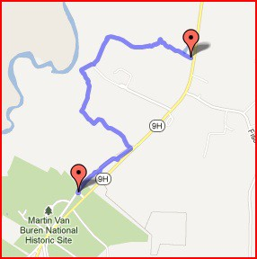
Trail heads are found at the Luykas Van Alen House and on the south end at Martin Van Buren National Historic Site. Both sites are located on Route 9H, just south of the Village of Kinderhook, New York. Contact either site for information.

The Columbia County Historical Society, which operates the Van Alen House, can be contacted at 518-758-9265; e-mail is cchs@cchsny.org or visit www.cchsny.org.

Martin Van Buren National Historic Site can be
reached at 518-758-9689, email is MAVA_info@nps.gov; the web site is www.nps.gov/mava.

