Mussel species found in Manassas National Battlefield Park

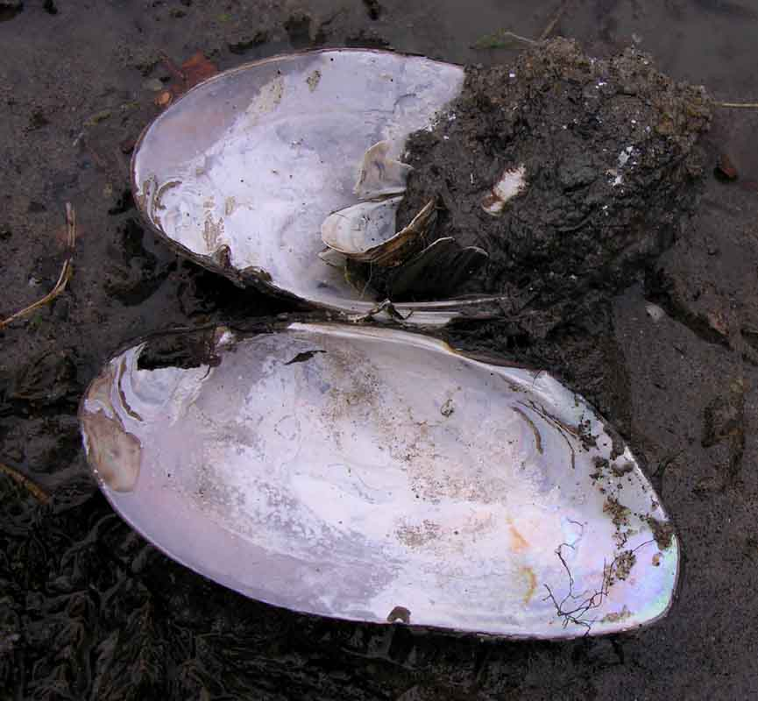

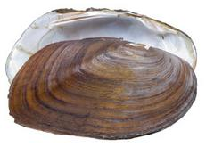

Bull Run

Elliptio complanata
Elliptio fisheriana
http://www.dnr.sc.gov/cwcs/pdf/NorthernLance.pdf
Alasmidonta undulata (watchlisted by DCR-DNH)
http://www.eol.org/pages/401079
Pyganadon cataracta
Strophitus undulatus (watchlisted by DCR-DNH)
Corbicula fluminea (exotic)

There is a record of Alasmidonta varicosa from 1939. This is a state endangered mussel. It has not been found in Bull Run in any recent surveys and may be extirpated from this location.

Young's Branch

Elliptio complanta
Pyganadon cataracta
Corbicula fluminea (exotic)

Holkum's Branch (note: these records were incidental to an Odonate survey being conducted)

