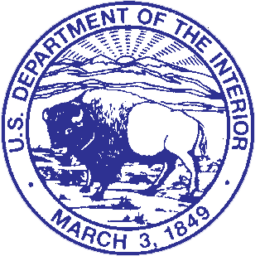
United States Department of the Interior

National Capital Parks-East
NATIONAL PARK SERVICE
Interior Region 1- National Capital Region
1900 Anacostia Drive, S.E.
Washington, D.C. 20020

In Reply Refer to:

Mary McLeod Bethune Federal Advisory Commission Meeting
January 24-25, 2024

January 24th
Location: National Capital Parks- East (NACE) Headquarters
1900 Anacostia Drive, S.E. Washington, DC

11:00-11:45am Welcome and Introductions

11:45am-12:30pm Lunch

12:30 –1:15pm History of the Commission and Review of the Act

1:15 –2:30pm Site Update and Improvements

2:30- 3:30pm How an Advisory Commission Functions
Election of Chair and Vice Chair

3:30-4:30pm NPS Expectations and Priorities

January 25th

1:45 –2:00pm Recap NPS Priorities

2:00pm-3:00pm Advisory Commission Expectations

