Designated Public Use Areas

Appendix 4 - Site Map, 36 CFR 2.51 & 2.52 Designated Areas

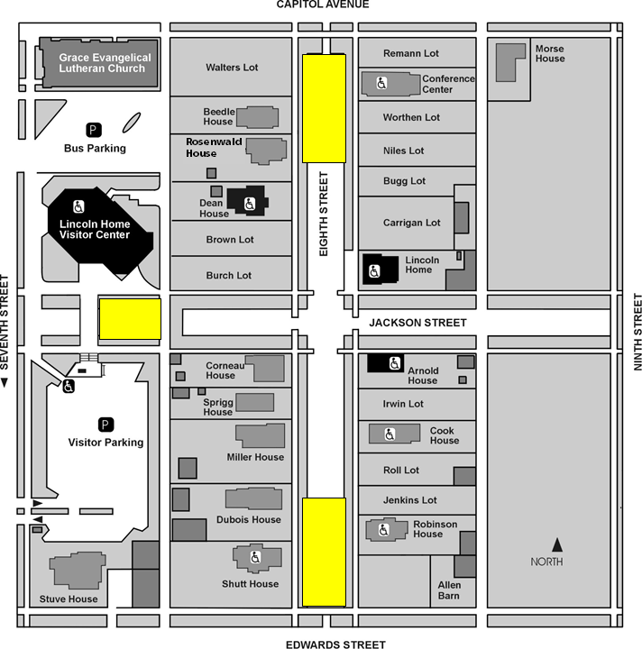

= Designated Public Use Areas

The Designated Public Use Areas are restricted to the street only, and do not include use of the walkways (brick or boardwalks), grassy parkway areas, or the alley adjacent to the areas

