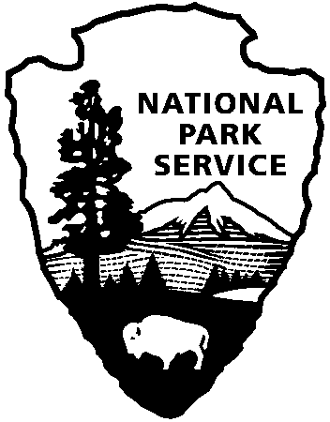
9800 Black Rock Canyon Rd.
Yucca Valley, CA 92284

For questions:
760-367-3012
jotr_education@nps.gov
Joshua Tree National Park
Education Office
National Park Service
U.S. Department of the Interior

Guest Speaker Reservation Request

Directions:

download document, complete and save, email the completed copy to: jotr_education@nps.gov

Teacher Contact: teacher name Email: teacher email

School Name: school name
School Address: school address School Phone: phone number

Program(s) Requested: Program Title(s), select from updated list on website
*Please coordinate with other teachers so that at least three classes are being served during the ranger’s visit. Two different program titles can be offered for the day.

Date: 1st Choice: mm/dd/yy 2nd Choice: mm/dd/yy 3rd Choice: mm/dd/yy

Room # | Grade | Teacher | # of Students | Time Range
room | # | teacher | students | start and end time
room | # | teacher | students | start and end time
room | # | teacher | student | start and end time
room | # | teacher | students | start and end time

Please check one (click on the box):
Each classroom will have a laptop and projector available for the ranger to use.
OFFICIAL USE ONLY
Date Received
Added to Calendar
Confirmation Created
Confirmation Emailed
Notified Staff
Our classrooms do not all have laptops or projectors. The ranger should bring these items.

Additional info/comments: add comments

