Number 1, Summer 2006
Hot Springs National Park
The Natural Systems in Hot Springs National Park or “Follow the Water”

Natural system” is used as another name for “environment” because it communicates the important idea that the environment is made up of a system of interrelated components: time, climate, geology, soils, plants, animals, and the most important for hot springs — water. We will follow the water to understand the relationships of all the other components.

Grades 5—10

Arkansas Science Curriculum Frameworks
LS.4.6.1; LS.4.5.5; ESS.9.8.1; ESS.9.8.2;
PD.1.ES.2; PD.1.ES.4; PD.1.ES.10; MC.2.B.2; CDL.7.B.1; CDL.7.B.3; CDL.7.B.5
Arkansas History Curriculum Frameworks
PPE.2.3; PPE.2.4

National Science Foundation Standards
Life Science, Content Standard C
Earth and Space Science, Content Standard D

Objectives:
- to understand how the hydrothermal springs of Hot Springs National Park formed and the natural systems functioning in the park today
- to compare and contrast this information with other springs and ecological systems
- to identify and describe the unique plant and animal life associated with the hot springs

Introduction—What is a “hot spring?”

A hot spring or a hydrothermal spring is a place where warm or hot groundwater issues from the earth on a regular basis for at least a predictable part of the year, and is significantly above the ambient ground temperature (which is usually around 55–57 °F or 13–14 °C in the eastern United States).

The water issuing from a hot spring is heated by geothermal heat, essentially heat from the Earth's interior. In general, the temperature of rocks within the Earth increases with depth. The rate of temperature increase with depth is known as the “geothermal gradient”. If water percolates deeply enough into the crust, it will be heated as it comes into contact with hot rocks. The water from hot springs in non-volcanic areas is heated in this manner.
Hot Springs National Park
101 Reserve Street Hot Springs, Arkansas 71901
501-620-6701

www.nps.gov/hosp

In volcanic zones, such as Yellowstone National Park, water may be heated by coming into contact with magma (molten rock). The high temperature gradient near magma may cause water to be heated enough

Page

that it boils or becomes superheated. If the water becomes so hot that it builds steam pressure and erupts in a jet above the surface of the earth, it is called a geyser; if the water only reaches the surface in the form of steam, it is called a fumarole; and if the water is mixed with mud and clay, it is called a mud pot. There are no geysers, fumaroles, or mud pots at Hot Springs National Park.
Connections
The countries most famous for hot springs are Iceland, New Zealand and Ikaria-Greece. The “onsen” (a Japanese word for "hot spring") plays a notable role in Japanese culture and is one of the most popular tourism industries there. Examples of national parks in the United State with hot springs include:

- Hot Springs National Park, Arkansas
- Death Valley National Park and Lassen Volcanic National Park, California
- Big Bend National Park, Texas
- Olympic National Park, Washington
- Yellowstone National Park

Warm springs are sometimes the result of hot and cold springs mixing but may also occur outside of geothermal areas, such as Warm Springs, Georgia (frequented for its therapeutic effects by paraplegic
U.S. President Franklin D. Roosevelt, who built the Little White House there). Because heated water can hold more dissolved solids, warm and especially hot springs also often have a very high mineral content, containing everything from simple calcium to lithium, and even radium. Because of both the folklore and the proven medical value some of these springs have, they are often popular tourist destinations and locations for rehabilitation clinics for those with disabilities.

The map below illustrates Hot Springs National Park in relation to major features in the area and to the city of Hot Springs. Additional maps are available from Hot Springs National Park and a variety of sources both directly and on-line, including the Arkansas Highway and Transportation Department, the Arkansas Department of Parks and Tourism, and the city of Hot Springs.
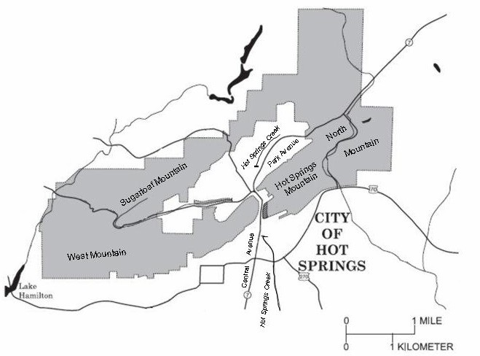
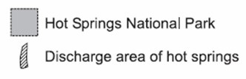
Features to note:

- the discharge area of the springs

- the covered portion of Hot Springs Creek
2
1

2
Page 2

How did hot springs develop in Arkansas?

To understand how the hot springs located in Hot Springs National Park, Arkansas, developed, we must go back to the Paleozoic era (about 400 million years ago) on the land mass that would become North America. The entire area that would be Arkansas was under the ocean.

Arkansas under the ocean
In the northern part of the state, the waters were clear and full of marine plants and animals. Farther south, in what would become west-central Arkansas, including Garland County, there was a deep ocean basin (Ouachita Basin or Embayment) with run-off from a large continental mass to the south. The run-off created sediment in the water which consisted of sand
(becomes sandstone) and mud (becomes shale). Few living things could survive in these deep, sediment-filled waters, but
the little creatures that did manage to live there are very important to the geology of the HSNP area because the fossils of these little creatures helped to form chert, including Arkansas novaculite (see next page).

Radiolarians & graptolites
Radiolarian and graptolite fossils are often found in shales where sea-bed fossils are rare. This type of rock formed from sediment deposited in relatively deep water that had poor bottom circulation, was deficient in oxygen, and had no scavengers.
Radiolarians are amoeboid protozoa that produce siliceous skeletons that are generally organized around spines which are sharp, dense projections from the main skeletal mass. These
spines fuse to form an outer shell. The outer shell is connected by bars or beams to the many concentrically organized inner shells which also serve to strengthen and support the entire structure. The single cell of the organism lives in the inner chambers.
The word 'graptolite' means 'writing in rock', and that is what the fossils of these extinct animals look like. Each graptolite consisted of a stick- or twig-like colony of tiny animals that either floated in the sea or was attached to the sea floor like a tiny, up-right shrub. The graptolite colony consisted of one or many branches that were straight, curved or spiral. The individual animals lived in a series of tiny, cup-like structures organized along the length of the graptolite skeleton.
The skeletons of radiolarians and graptolites, deposited over millions of years, formed a type of cryptocrystalline quartz called chert. It is similar to flint, but probably best known to Arkansans as novaculite or Arkansas whetstone.
Connections
Extensive run-off or erosion and sediment still impact life in our oceans today. One of the most visible examples is the “Dead Zone” in the Gulf of Mexico.

More information and images can be found on the NASA website: http://www.nasa.gov/vision/

Or the US Geological Survey site at:
http://landsat.usgs.gov/ gallery/detail/377/

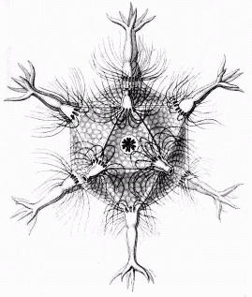
radiolarian

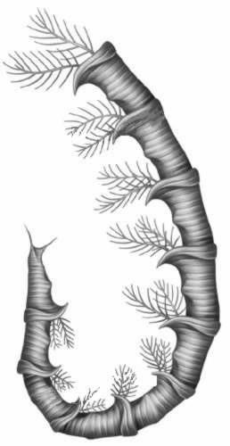
graptolite

Arkansas novaculite is a re-crystallized variety of chert and is widely distributed in the Ouachita Mountains of Arkansas. It is a sedimentary rock composed mostly of microcrystalline quartz. Arkansas novaculite is dense, hard, and most commonly white to grayish-black in color, although some specimens have colors such as red or yellow (see photo at right). It typically breaks with a smooth conchoidal (shell- like) fracture.
Early American Indians in Arkansas gathered novaculite boulders and quarried the stone to make weapons and tools. Arkansas novaculite is recognized worldwide for its use as whetstones and oilstones, which are used for sharpening knives, surgical instruments, and wood-carving tools. It contains numerous pores that give the stone’s surface edges which grip or bite into a steel blade to sharpen it quickly.

The Ocean and the Ouachita Basin go away
In addition to the skeletons and spicules of radiolarians and graptolites (which will become chert/novaculite) the Ouachita Basin is also filling up with layers of
- sand (which will become sandstone—very hard, does not erode easily)
- mud (which will become shale—softer and washes away more easily)
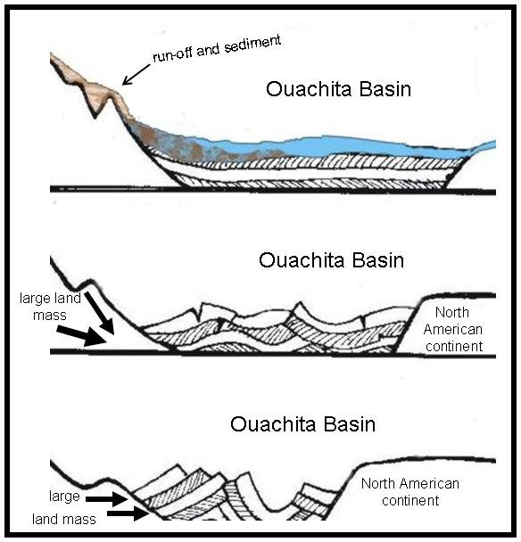
A continent or very large land mass moved up from the south and began pushing on what we call North America. This action happened over millions of years, with periods of much land shifting and therefore, much run-off and sediment washing into the Ouachita Basin. There were also periods of quiet and more stability where debris accumulated more slowly. But when the continents finally collided, the layers of debris and rock were squeezed together, the land “wrinkled up” or folded, and the Ouachita Basin was closed. Sediments piled up in the basin were shoved up against the North American continent and great faults or breaks occurred. Huge sheet-like blocks of crumpled sediment were thrust forward on top of one another and the folded land became the Ouachita Mountains we see today.

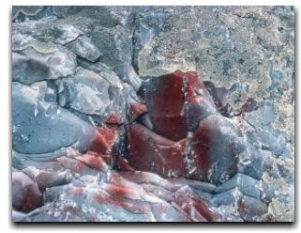
Arkansas novaculite
NPS photo

Connections
Additional information on novaculite is available from the Arkansas Geology Commission http://www.state.ar.us/agc/novaculi.html such as mining information (Arkansas 1st in the nation) and economic impacts.

Encourage students to bring in examples of whetstones.

But, remember, follow the water—what happened to the rest of the water in the Ouachita Basin when it closed?
Connections
Quartz Facts
- Quartz, or silica (SiO2), is a hard, brittle, usually colorless or white, nonmetallic mineral that exhibits considerable resistance to weathering.
- Quartz is composed of the two most abundant elements (silicon and oxygen) in the earth's crust. Hydrothermal quartz crystals and milky "bull" quartz veins are a common and striking geologic feature of the Ouachita Mountain region of Arkansas.
- The mineralogical profession has recognized Arkansas quartz crystal as some of the best and purest in the world. Because of this, and the popularity of quartz with many tourists who visit Arkansas each year, the Arkansas General Assembly designated quartz crystal as the official State Mineral.
- Arkansas quartz is available from several sources, including the Arkansas Geology Commission. Many students may also have personal samples. Encourage them to bring samples to school for comparison and discussion and/or research.

Water helps make quartz
Water was trapped in the sediment and between the sheets of rock as they folded violently in on one another. This water was warmed, partly by the tremendous energy as these huge sheets of rocks were forced together. The warm water was forced up through the masses of rock as they crushed together and it dissolved silica in the rock as it washed through. As the water cooled and rose to the surface, the cooler water could no longer hold the silica in suspension and it was deposited as quartz along the open fractures and cracks in the wrinkled sediment. In some areas, these cracks were very large and great amounts of silica-laden water deposited the spectacular quartz crystals for which Arkansas is famous.

How do you make a hot spring?
At this point, the Ouachita Mountains exist as an east/ west belt of folded and stacked rocks with cracks. But parts of these folded mountains extend 1300 miles between eastern Mississippi to western Texas; what happened in the area of the city of Hot Springs to make the hot springs?
A spring is defined as a place where a concentrated discharge of ground water flows at the ground’s surface. They range in size from intermittent seeps, which flow only after much rain, to huge pools flowing hundreds of millions of gallons daily. Some hot springs or
hydrothermal springs occur in regions of recent volcanic activity and are fed by water heated by contact with hot rocks and magma far below the surface. Even where there has been no recent volcanic action, rock layers deeper in the earth are warmer than rock layers nearer the surface.
As noted in the Introduction, the deeper one descends into the Earth's crust, the higher the temperature becomes. This rise in temperature with depth is called the geothermal gradient. Although the exact heating up differs from place to place, in general the average increase world-wide is 3 to 5 degrees F for every 300 feet of additional depth.
There are several reasons why the Earth’s internal temperature is hot. One is pressure from the overlying layers. In other words, the energy from the compaction of the Earth due to gravity is converted to heat energy. Other reasons include energy from the accretion (growth by accumulation) of material when the Earth formed and the decay of radioactive materials inside the Earth. The compaction of the Earth due to gravity and the energy from the accretion of the Earth are considered “left-over heating” from Earth’s formation, while radioactive decay is a constant (although diminishing) source of heat.
Therefore, if rain water soaks down into the Earth deep enough, it can become very hot. And if that water finds a crack or another way to rise to the surface so quickly it does not have time to cool, then it will emerge as a “hot” spring.
Page 5

How is the water in Hot Spring National Park (HSNP) heated and how do we know?
shale
The flow system that yields thermal water to the springs of HSNP is not fully understood. By measuring the abundance of hydrogen and oxygen isotopes in the water and comparing the results to spring water from all over the world, geochemists conclude that the water flowing from the hot springs in HSNP was not heated by coming in contact with magma – it fell as rainwater. Based on radioactive isotope dating, they estimate that much of the water is approximately 4,400 years old.
The “recharge areas” for the springs which adds more water (or “recharges” the system) where rain water falls and begins its journey underground are chert and novaculite outcrops in a broad valley that runs north and northeast of the springs.

Water that goes down must come up
The thermal springs at Hot Springs are heated rain water that originally falls in a broad valley to the north. This recharge area is at a slightly higher elevation than the location of the springs. The hard, brittle chert of the recharge area cracked and fractured many times as the mountain ridges folded together during their formation. These cracks funnel the water downward and it warms as it slowly descends through rocks deep in the Earth.
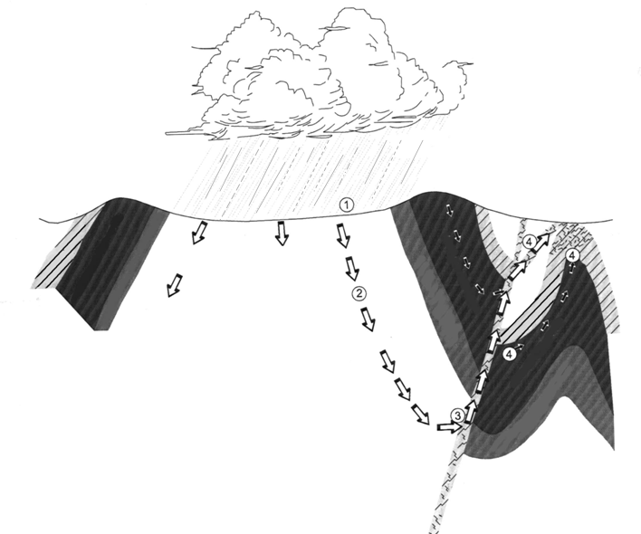
Water in the ground always seeks the easiest way to flow down hill (or down gradient since there are technically no “hills” underground). The shape of the valley in Hot Springs acts like a natural funnel and collects the hot, underground water and gives it only one, narrow escape route. When the water reaches a large crevice that offers a path of less resistance, it rises much more quickly than it descended. It does not have time to cool before it emerges and comes out as “hot springs”.
Sugarloaf Mountain
North Mountain- West Mountain
hot springs
chert
- Precipitation falls in recharge area
- Water moves slowly to depths of at least 4,500 to 7,500 feet, picking up heat from surrounding rocks
- Water reaches a large crevice and begins to rise quickly to the surface
4 . Faults, joints and fissures in the chert, sandstone, shale and novaculite provide conduits for the final movement of the thermal water to the springs
Fault zone
Page 6

Hot water and chemistry
As the rainwater falls in the recharge area, it first passes down through leaves, soil and other debris on the surface. The living animals in this debris and soil give off carbon dioxide and this is dissolved in the water (H₂O plus CO₂ ) and forms a weak carbonic acid H₂CO₃.
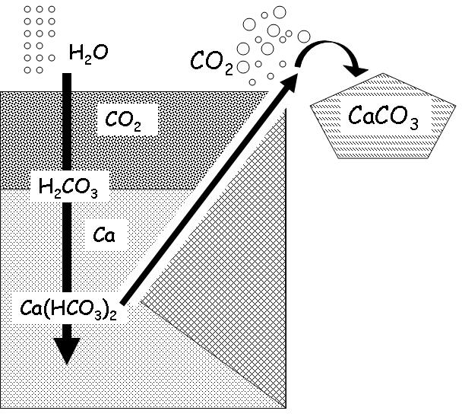
This acidic water now moves farther down in the Earth, through the different layers of chert, including the thick layers of novaculite. The novaculite and chert include the skeletons and spicules of radiolarians and graptolites, which are made of calcium. This calcium along with the rock exists in a form called calcium carbonate CaCO₃.
As the water passes through the chert formations, it dissolves some of the calcium carbonate. The carbonic acid in the water reacts with the calcium carbonate to form soluble calcium bicarbonate Ca(HCO₃)₂. In this process, the carbonic acid is partially neutralized and the solution gradually becomes more alkaline. Calcium bicarbonate only exists as a solution.
As this solution moves deeper into the earth, it heats up and dissolves some silica from the surrounding rock layers. The amount of dissolved silica found in the Hot Springs water is one clue for geochemists to help determine the maximum temperatures the water reached underground.
The underground heat helps to make the calcium bicarbonate solution (water) more buoyant, and the broad cracks and faults across the face of Hot Springs mountain give this solution just the escape route it is looking for. When the solution Ca(HCO₃)₂ reaches the surface, the dissolved carbon dioxide CO₂ quickly escapes, just like the fizz in a soda bottle. Taking the CO₂ out of the Ca(HCO₃)₂ leaves the remaining CaCO₃, which is calcium carbonate. It is important to note that calcium carbonate is formed from the release of the carbon dioxide, not from the change in temperature from rising to the surface. Calcium carbonate is actually more soluble in cool water

Tufa (not to be confused with the bean curd—tofu)
The calcium carbonate deposits from the springs are called “tufa” (pronounced (too’-fah). When early explorers first came to
the valley of the Hot Springs, the side of the mountain was covered
Page 7

with massive blankets of tufa. Tufa does not continue to form in significant amounts on the mountain today, since the springs are diverted; however, vestiges of it can be seen at the display springs in the park. Tufa also forms the cliff in back of Bathhouse Row. A tufa rock across from the Arlington Hotel is part of a tufa layer which has broken off and fallen down. Another interesting exposure of tufa can be seen off the Promenade. Ral Hole is located at spring # 14 on the Tufa Terrace Trail.
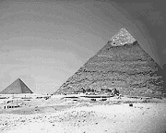
Tufa exists at other spring sites and in other parts of the world, such as Mono Lake in California which has towers of tufa rising from the lake. In the ancient world, tufa's relative softness meant that it was used for construction where it was available. Tufa is common in Italy, and the Romans used it for many buildings and bridges. The Servian Wall, built to defend the city of Rome in the 4th century BC, is built almost entirely from tufa.
Connections
If the water used today in Hot Springs fell as rain around 4,400 years ago, what was happening around that time (2,000 BCE)? Have students research the answer to this question and/or create a timeline. Some suggested topics include:
- Bronze Age
- Great Pyramids at Giza
- Earliest Egyptian mummies
- Sphinx
- Papyrus

Hot Springs water and the numbers
The water used today fell as rain approximately 4,400 years ago.
The temperature of earth’s crust increases with depth, average—3 to 5 degrees F for every 300 feet down.
The water collected at a maximum depth of somewhere between 4,500 to 6,500 feet
The water temperature averages 143 degrees F.

The total amount of water discharged by the springs as a group is several hundred thousand gallons each day, although there are seasonal variations.

Take it to the extreme
Beginning in the early 1990s, scientific knowledge of the environmental limits of microbial life on Earth expanded dramatically as microbiologists applied new methods of molecular biology over a broad range of environmental extremes. Microbial species are now known to occupy a vast range of environments that previously were unimagined. New discoveries have revolutionized scientific understanding of Earth's biosphere, opened up new views of the history of terrestrial (land-based) life, and increased the possibilities that life could develop elsewhere in the cosmos.
The name applied to this new research area of biology is extremophiles research. Extremophiles (literally "extreme-loving") are defined as organisms that occupy environments judged by human standards as harsh. These encompass both physical and chemical extremes.
Page 8

Extension - see Activity 3

Different classes of extremophiles have been defined based on the nature of the environments where they are found. For example,
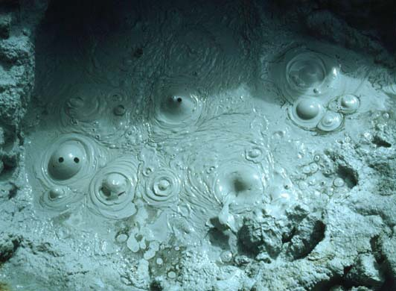
extremophiles that have adapted to high temperatures are called thermophiles. Those that require cold temperatures for growth and reproduction are called psychrophiles.
Those that love acidic environments (with low pH) are called acidophiles, whereas those found in highly alkaline conditions (high pH) are alkaliphiles. Organisms that live under high pressure are called piezophiles, and those found in high-radiation environments are as yet unnamed. Some organisms occupy more than one environmental extreme simultaneously, and are known as polyextremophiles. An example is the archaebacterial species, Sulfolobus acidocalderius, which thrives in boiling mudpots at temperatures exceeding 80°C (176°F) and at acidities less than pH 3. Although mostly microbial, extremophiles
include a few species of multicellular organisms such as worms, amphibians, mollusks, and crustaceans.
Cellular enzymes extracted from extremophiles have spawned a multibillion dollar biotechnology industry. The enzymes are used in industrial and medical applications, ranging from the production of stone- washed jeans, to creating artificial sweeteners, to genetic fingerprinting. One thermophile that lives in hot springs is the source of the heat-stable deoxyribonucleic acid (DNA) polymerase enzyme used in polymerase chain reaction (PCR). PCR forms part of the foundation of much of the biotechnology industry. Proteins produced by psychrophilic organisms may one day prove useful in coldfood preparation and in detergents for washing in cold water.

Life at high temperatures
One thermophile, Pyrolobus fumarii, has been found at temperatures of 113° C /235° F — that's hotter than the boiling point of water (100° C / 212° F)! Most thermophiles live at temperatures between 60 and 80 ° C (140 to 176 ° F). These organisms are capable of growing, carrying out metabolic processes, and reproducing at these extreme temperatures.
Thermophiles have special enzymes — protein molecules that conduct functions like photosynthesis and digestion within a cell — that can work at these extreme temperatures. Enzymes are tightly packed, 3-D structures held together by chemical links. They commonly unfold and the links break apart at temperatures above 47° C/116° F. But the enzymes in thermophiles are packed very tightly and held by especially strong links.
The DNA of thermophiles is adapted to life at high temperatures as well.
This attribute has allowed the food, clothing, and paper industries — to name a few — to create better, safer, and/or more environmentally friendly products. Industries are using thermophilic enzymes in processes that used to be limited by temperature at which they could occur. Food

Boiling mud in a mud pot

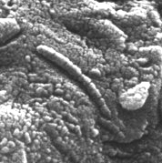
preparation can occur at higher temperatures, reducing the risk of contamination. Thermophilic enzymes have helped in DNA fingerprinting; Taq polymerase can operate at high temperatures without breaking down, replicating DNA pieces rapidly and allowing crime labs to process trace amounts of DNA quickly. Taq polymerase was first obtained from thermophile Thermus aquaticus which lives in the hot springs of another national park - Yellowstone National Park. How might the thermophiles at Hot Springs National Park be used some day?

Hot Springs National Park thermophiles Nanobes and meteorites from Mars
The ability of some extremophiles to survive harsh conditions similar to those found on other planets has raised the possibility that life might exist beyond Earth. NASA scientists began looking for very small extremophiles after they found what they thought might be fossilized bacteria on a meteorite from Mars found in Antarctica in 1984 – the famous ALH84001 meteorite.
Research conducted by NASA scientists on water from HSNP detected the presence of very small

microbes or “nanobes” similar to the fossilized structures on the Martian meteorite. Although nanobes are sometimes called “nanobacteria,” it
Structures on meteorite fragment ALH84001

has not yet been confirmed that they could, in fact, be considered such. Nanobacteria are said to be cell walled microorganisms with a diameter well below the generally accepted lower limit (about 200 nanometers) for bacteria. Reports of them being living organisms are controversial. If they are living, there is even speculation that they may be a newly discovered form of life, rather than bacteria. The term “calcifying
nanoparticles” (CNPs) has also been used, side-stepping the question of their formal status as a life form. The nanobes found in the HSNP water were described as spherical (150-200 nanometers in diameter) and rod-shaped (50-150 nanometers in width and less than 1 micrometer in length). Some of the nanobes appeared to have flagella and other appeared to be dividing.
The whole debate regarding nannobacteria started with their discovery in 1990 during the high magnification study of carbonates from a variety of hot springs around the world.
Because of the general resemblance between these objects and known bacteria such as Bacilli, Streptococci, and Staphylococci, and because of their tendency to occur in chains or clusters, it was initially proposed that the objects were "dwarf forms," about one-tenth the diameter of ordinary of bacteria, or "nannobacteria.”
The genuine existence and biological nature of nanometer-scale objects has been severely challenged in the scientific community, including the fact that a cell at the small end of the size range of purported nanobacteria (<50 nm) is thought too small to contain all the nucleic acids and ribosomes necessary for independent life. In 1998 the debate took a different twist when scientists in Finland claimed to have found nanobacteria, surrounded by a calcium-rich mineral called apatite, in human kidney stones.
Regardless of the eventual outcome of these scientific debates, the microbes at HSNP will have a role in this new branch of science.

Ostracods

ostracod
Another very small resident of the hot springs that has adapted to life in hot water is definitely an animal, but its species has not yet been determined. This little animal is an ostracod (or ostracode) and it is not much larger than the period at the end of this sentence. Ostracods belong to the class of animals known as crustaceans, and the animal living at HSNP has been identified as being in genus Darwinula, but its species has not been determined, so the little animal is taxonomically written as “Darwinula sp.”
Crustaceans (Crustacea) are a large group of arthropods (55,000 species), and include various familiar animals, such as lobsters, crabs, shrimp and barnacles. The majority are aquatic, living in either fresh water or marine environments, but a few groups have adapted to terrestrial life, such as terrestrial hermit crabs. Ostracods are sometimes known as “seed shrimp” and can survive temperatures up to 120 degrees F (49 degrees C).
They have 5 to 7 pairs of appendages which are specialized for different tasks. The animal lives inside a shell or carapace made of two valves.
They shed the carapace several times during life, growing a new larger one each time. They are sexually dimorphic - males and females are different shapes. There are approximately 5,000 known, living ostracods and they are found today in almost all aquatic environments, including hot springs.

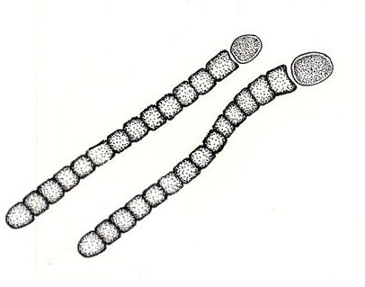
When is a plant not a plant?

Blue-green algae or cyanobacteria
Another very unique organism that is adapted to living in the hot springs is a species of blue-green algae called Phormidium treleasei. Blue green algae are another type of thermophile and are adapted to live in temperatures even hotter than the ostracods.
Approximately 13 to 17 species of blue green algae thrive in various temperature gradients of the hot springs, but one type, Phormidium treleasei, is so rare, it has only been recorded from five other places in the world.
Blue-green algae or cyanobacteria is sometimes
considered part plant and part animal. Algae are the simplest members of the plant kingdom, and the blue-green algae are the simplest of the algae; however, blue-greens are not true algae. They have no nucleus, the structure that encloses the DNA, and no chloroplast, the structure that encloses the photosynthetic membranes and the structures that are evident in photosynthetic true algae. In fact blue-greens are more akin to bacteria which have similar biochemical and structural characteristics.
The blue-greens are widely distributed over land and water, often in environments where no other vegetation can exist. They can tolerate temperatures in the range of 158 to 163 degrees F (70 to 73 degrees C).
Page 11

Their fossils have been identified as over three billion years old. They were probably the chief primary producers of organic matter and the first organisms to release elemental oxygen, O₂, into the primitive atmosphere, which was until then free from O₂. Thus blue- greens were probably responsible for a major evolutionary transformation leading to the development of aerobic metabolism and to the subsequent rise of higher plant and animal forms.
The blue-green color of the cells of cyanobacteria (cyan means blue-green) is due to the combination of green chlorophyll pigment and a unique blue pigment (phycocyanin).
However, not all blue-green algae are actually are blue-green. Their pigmentation includes yellow-green, green, grey-green, grey-black, and even red specimens. The Red Sea derives its name from occasional blooms of a species of Oscillatoria that produces large quantities of a unique pigment called phycoerythrin. In the arid regions of Central and East Africa, flamingos consume vast quantities of Spirulina, and their feathers derive their pink color from carotene pigments in filaments of Spirulina.
The blue-greens are microscopic life forms that exhibit several different types of organization. Some grow as single cells enclosed in a sheath of slime-like material, or mucilage. The cells of others, including Phormidium treleasei aggregate into colonies. Phormidium usually forms flat, slimy mats of tangled filaments attached deep under water which can detach and float to the surface.

Special plants
The interconnected components that make up the natural system of the hot springs sometimes create unique “mirco-habitats” that allow very different species to live side by side. For example, a rare acidophilic (acid-loving) plant and one that depends on an alkaline environment have both been documented growing in the area around the hot springs.

Arkansas bedstraw (Galium arkansanum var.pubiflorum) is a rare variety of the more common bestraws that is restricted to portions of the Ouachita Mountains, including the springs area at HSNP. It thrives in the acid soils of the chert and novaculite outcrops. “Bedstraw” is short for the longer name “Our Lady’s Bedstraw” which refers to fact that these plants have a sweet fragrance which actually gets stronger when they are dried, so they were used to stuff mattresses in medieval times. The varieties in North America are related to the European herb called sweet woodruff. Most of the plants have hairy or prickly stems and small white flowers.
The calcareous tufa deposited around the springs provides the alkaline environment needed by the rare woodland stonecrop (Sedum ternatum). Woodland stone crop is a member of the sedum family which includes succulents, such as the Jade Tree, that are grown as ornamentals. This rock-loving perennial usually sends up a single

flowering branch and several shorter, leafier, non-flowering branches. Sometimes little plantlets grow along these leaves and drop to the ground to root and form new plants.

Page 12

Novaculite outcrops on ridges and mountain tops above the springs are home to three unusual spleenworts: a lobed spleenwort (Asplenium pinnatifidum) and the rare Graves hybrid spleenwort (Asplenium gravesi) and Scott’s hybrid spleenwort (Asplenium ebenoides). Spleenworts are a type of fern which means they are flowerless and seedless vascular plants which have true roots growing from a rhizome, fronds that uncurl upward, and they reproduce by spores. Spleenworts get their name from the old belief, based on the doctrine of signatures, that the fern was useful for ailments of the spleen, due to the spleen-shaped sori on the backs of the fern fronds (see illustration).
The hybrid spleenworts are rare in part because they are sterile and do not reproduce. Hybrids are the offspring of two different species or parents of the same species that have very different characteristics they are able to pass on to the next generation. Hybrids between species are often sterile because they fail to produce viable reproductive cells. The cells they might produce do not develop properly because the chromosomes from one species do not pair up correctly with the chromosomes from the other species.

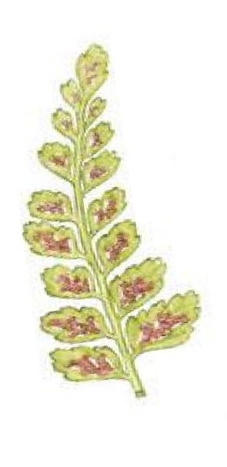
sori

Page 13

Extension - see Activity 4

Vocabulary words
aquifer - a water-bearing stratum of permeable rock, sand, or gravel
calcareous - resembling calcite or calcium carbonate especially in hardness; consisting of or containing calcium
chert - rock resembling flint and consisting of quartz and amorphous silica
fault - a fracture in the crust of the Earth accompanied by a displacement of one side of the fracture with respect to the other, usually in a direction parallel to the fracture
fissure - a narrow opening or crack of considerable length and depth usually occurring from some breaking or parting
gradient - change in the value of a quantity (as temperature, pressure, or concentration) with change in a given variable and especially per unit distance in a specified direction
hybrid - an offspring of two animals or plants of different races, breeds, varieties, species, or genera
hydrothermal - of or relating to hot water
isotope - any of two or more atoms of a chemical element with the same atomic number and nearly identical chemical behavior but with differing atomic mass or mass number and different physical properties
magma - molten rock material within the Earth from which igneous rock results by cooling
meteorite - any of the small particles of matter in the solar system that are directly observable only by their incandescence from frictional heating on entry into the atmosphere
novaculite - a very hard fine-grained siliceous chert used for whetstones
percolate - to ooze or trickle through a permeable substance
protozoa - any of a phylum or subkingdom (Protozoa) of chiefly motile and heterotrophic unicellular protists (as amoebas, trypanosomes, sporozoans, and paramecia) that are represented in almost every kind of habitat
pseudopod - temporary protrusion or retractile process of the cytoplasm of a cell that functions (as in an amoeba) especially in a locomotor or food gathering capacity
seismic - of, subject to, or caused by an earthquake; or relating to an earth vibration
siliceous - of, relating to, or containing silica
suspension - the state of a substance when its particles are mixed with but undissolved in a fluid or solid
tufa - a porous rock formed as a deposit from springs or streams

Page 14

Extension Activity 1

Romantic Radiolarians

- Use images from: Art Forms from the Ocean: The Radiolarian Atlas of 1862, by Ernst Haeckel, Prestel Verlag, 2005 ISBN 3791333275, and modern-day photographs to compare and contrast representations of radiolarians.
- Explain that German biologist Ernst Haeckel produced exquisite (and perhaps somewhat exaggerated) drawings of radiolaria, helping to popularize these protists among Victorian parlor microscopists.
- Compare his drawings to other Victorian art such as botanical illustrations and discuss the “romantic” representation.
- Give students an opportunity to research radiolarians and create their own drawings.

Ernst Haeckel’s drawings Modern microscopic
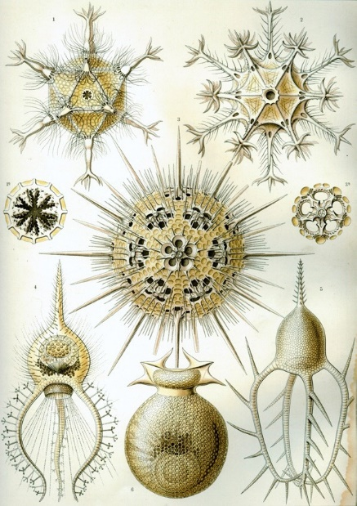
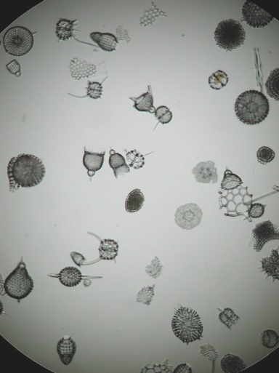
photographs Examples of botanical prints
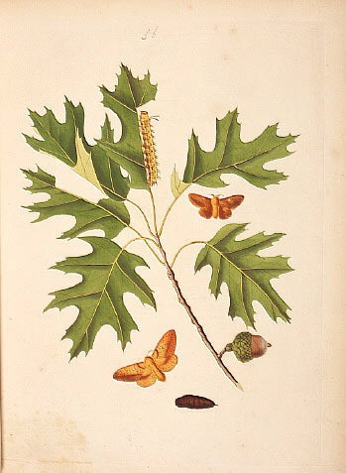
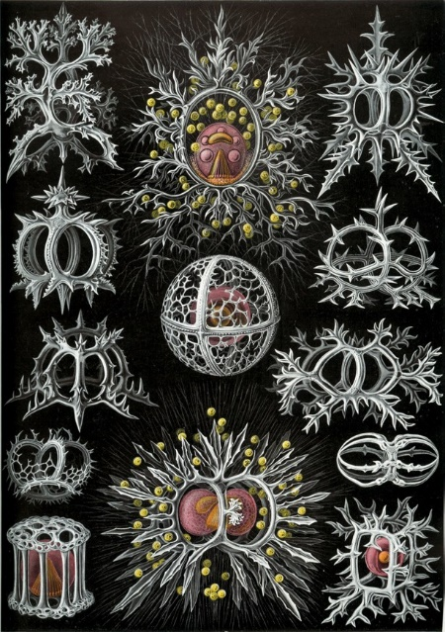
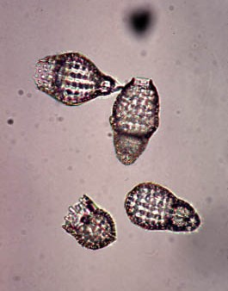
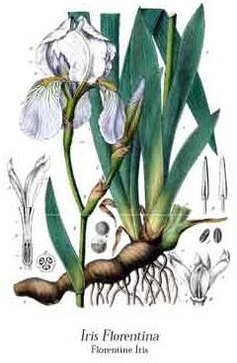
Page 15

Extension Activity 2

Folding Playdoh to Make the Ouachita Mountains

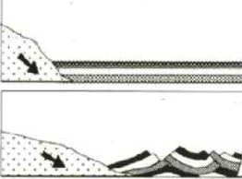
- Flatten several different colors of playdoh/clay, and layer the strips in a stack.
Explain that the layers represent
- sand—which became sandstone
- mud—which became shale
- skeleton and spicules of radiolarians and graptolites—which became chert/novaculite
that slowly built up and eventually formed the Ouachita Basin or Embayment

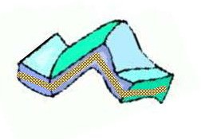
- Discuss how landmasses shifted, pushed and squeezed the rock layers together.

- Push the clay together so that the layers buckle and curve.

- Compare the folds in the clay model to the dramatic folds and twists that are apparent in many parts of the Ouachita Mountains (see Ouachita road cut below). Visit an actual road cut if possible.

- Use a pencil or other small, pointed tool to make holes in the clay model. Discuss how water moving up or down the hole would come into contact with different layers.

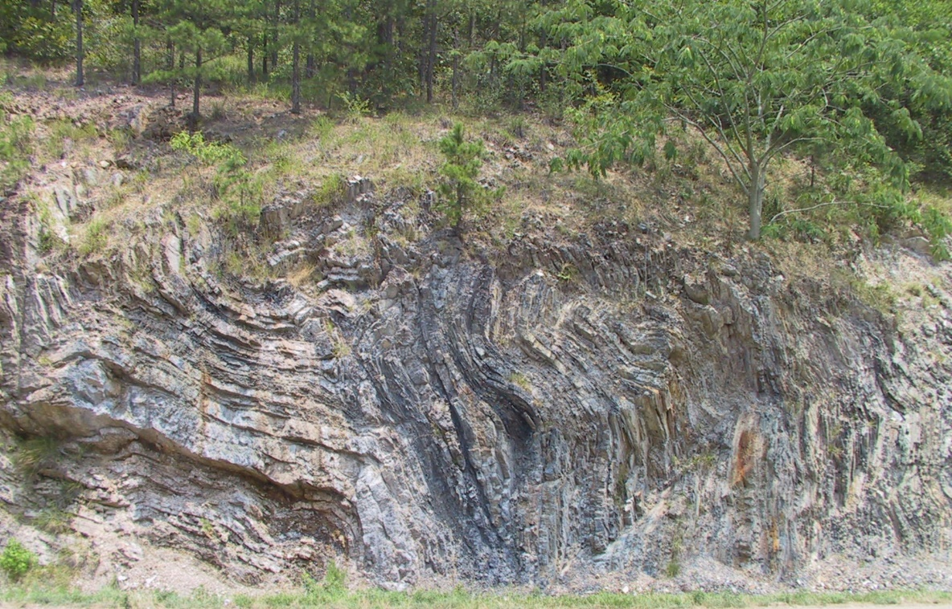
Page 16

Extension Activity 3

Make A Mineral Deposit

This activity will illustrate how water can deposit minerals to create formations, such as the tufa formations at Hot Springs National Park.

Materials:
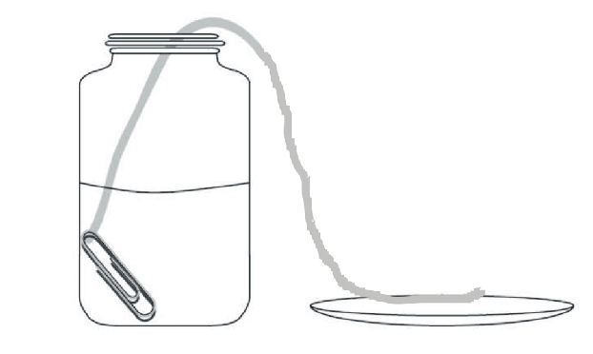
- 10 to 12 inch piece of cotton yarn or string (cotton wicks liquid much better than acrylic)
- Small container—jar, cup or small glass
- Saucer or small plate
- Mineral powder—washing soda (sodium carbonate), or baking soda (sodium bicarbonate) or Epsom salts (magnesium sulfate heptahydrate)
- Warm water and mixing container
- Optional: magnifying glass

Procedure:
- Dissolve as much of the mineral powder as you can in very warm water and pour into the small container. Fill at least half full.
- Tie a weight (such as a paperclip) to the end of the piece of string.
- Soak the string in the solution and then lift one end out and place it on the small plate, as illustrated.
- Put a small amount of your chosen mineral powder on the small plate with the string.
- Leave the jar and plate for several days in a dry, well ventilated, sunny location.

The solution in the small container will wick along the string and deposit at the end, onto the small plate. Deposits should building up after several days. Be sure that sufficient solution remains the jar with the string.

Students might choose to observe the effects on the deposition process by manipulating some of the variables, such as varying the concentration of the solution or by changing the environment (warm or cool location, light or dark). Consider the additional questions: Which conditions were the most favorable for growth?
What do these conditions have in common?

Page 17

Extension Activity 4

Doctrine of Signatures

Use the information below to assist students in conducting more in-depth research on the Doctrine of Signatures and the roots of plant names.
Find pictures of plants or go on a collecting trip for plants around the school, and have students develop names and “cures” for plants, based on their appearance.

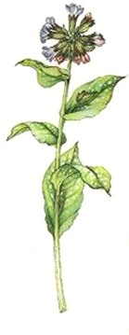
The "Doctrine of Signatures" has been an idea of herbalists for centuries, but it did not become part of the medical thinking until the middle of the seventeenth century. In simple terms, the "Doctrine of Signatures" is the idea that God has marked everything He created with a sign (signature). The Doctrine states that, by observation, one can determine from the color of the flowers or roots, the shape of the leaves, the place of growing, or other signatures, what the plant's purpose was in God's plan
lungwort

Signature plants were probably first recognized in ancient China, where there was a classification that correlated plant features to human organs:
yellow and sweet = spleen red and bitter = heart green and sour = liver black and salty = lungs

The most famous advocate of signature plants was Philippus Aureolus Theophrastus Bombastus von Hohenheim. This Swiss citizen later adopted the Latin name Paracelsus and published the literary theory entitled Doctrine of Signatures. During the first half of the 16th century, Paracelsus traveled throughout Europe and to Asia and Egypt, curing people with his concoctions. He experimented with new plants in search of more treatment and solutions.

Many vernacular names of plants tell us how plants were once used to cure human ailments. In general, long-lived plants were used to lengthen a person’s life, and plants with rough stems and leaves were believed effective to heal diseases that destroy the smoothness of the skin. Plants with yellow sap were cures for jaundice, and roots with jointed appearance were the antidote for scorpion bites. Many plants still carry the word root "wort", an Anglo-Saxon word meaning herb, as part of their modern name:
−liverwort = relieve liver trouble
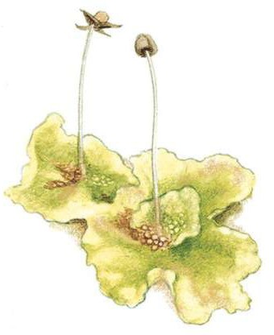
−snakeroot = antidote for snake venom
liverwort
−adder’s tongue = cure for inflammation from snakebite
−lungwort = cure pulmonary diseases
−toothwort = relieve toothache
−gravelwort = dissolve stones in the urinary tract
−wormwood = expel intestinal parasites
−black-eye root = remove bruise discoloration
−maidenhair fern = cure for baldness

Page 18

Resources

Books

Arkansas and the Land
By Thomas Foti and Gerald Hanson

Art Forms From The Ocean: The Radiolarian Atlas Of 1862 by Ernst Haeckel, Olaf Breidbach

Discover Nature in the Rocks: Things to Know and Things to Do (Discover Nature Series)
by Rebecca Lawton, Diana Lawton, Susan Panttaja,

Graptolites: Writing in the Rocks (Fossils Illustrated) by Douglas Palmer (Editor)

Geology Rocks!: 50 Hands-On Activities to Explore the Earth (Kaleidoscope Kids)
by Cindy Blobaum, Michael Kline

Geology: The Active Earth (Ranger Rick's NatureScope) by National Wildlife Association

Guide to Microlife
by Kenneth G. Rainis, Bruce J. Russell

Life At High Temperatures by Thomas D. Brock
Preserving Nature in the National Parks: A History by Richard West Sellars

Websites

Hot Springs National Park http://www.nps.gov/hosp

National Park Service—Connecting Learners to Their National Parks http://www.nps.gov/learn/home.htm

Arkansas Natural Heritage Commission http://www.naturalheritage.com

Arkansas Geology Commission http://www.arkansas.gov/agc/agc.htm

Page 19

Websites continued

Details on Servian Walls of Rome http://www.geocities.com/mp_pollett/walls.htm

geothermal map of the US http://map.ngdc.noaa.gov/website/seg/hot_springs/viewer.htm

geothermal energy http://www.ngdc.noaa.gov/seg/geotherm.shtml

ostracods http://www.ucmp.berkeley.edu/arthropoda/crustacea/maxillopoda/ostracoda.html

nanobacteria http://www.newscientist.com/article.ns?id=dn5009 http://naturalscience.com/ns/cover/cover14.html

blue-green algae - Cyanobacteria http://www.ucmp.berkeley.edu/bacteria/cyanointro.html

The Doctrine of Signatures http://www.botgard.ucla.edu/html/botanytextbooks/economicbotany/Doctrine/index.html

Animal Diversity Web—research animal names http://animaldiversity.umich.edu/site/index.html

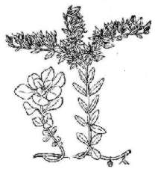
An A-Z of plant names quiz http://pss.uvm.edu/ppp/rootquiz.htm

woodland stonecrop (Sedum ternatum)

Please note: This lesson plan was developed by Jane Jones-Schulz in consultation with staff of Hot Springs National Park, summer, 2006. The photographs on pages 8,9,and 10 are used by permission of Wikipedia Commons. The diagram on page 6 is adapted from the Hot Springs National Park Water Resources Scoping Report by James C. Peterson and David N. Mott, Technical Report NPS/NRWRD/NRTR-2002/301. The color fern drawing on page 13 is adapted from Kirsten Tind of the Hardy Fern Library. The plant pictured above is adapted from Nearartica.com wildflowers. The drawings on pages 3,4,11, and 12 are by Nicholas Jones. The images used in Extension Activity 1 are public domain.
Page 20

Hot Springs Crossword Puzzle
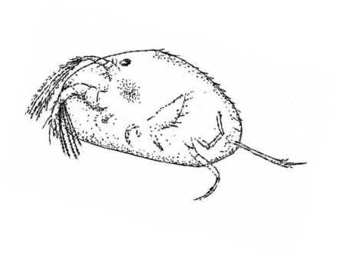
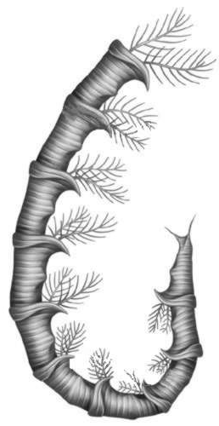
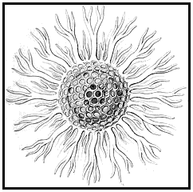

Across
  - Arkansas novaculite is a recrystallized variety of .
- The plant that gets its common name because it was once stuffed into mattresses to make them smell better is called .
- The hot water in Hot Springs entered the ground many years ago as .
7. are sometimes known as "seed shrimp" and can live at temperatures as high as 120 degrees F.
- As you go deeper into the Earth, the temperature .
- The name means “writing in rock.”

Down
- Two of the spleenworts found at Hot Springs National Park do not reproduce because they are sterile .
- A protozoa that lived in the muddy sediment of the Ouachita Basin is called .
6. Blue-green were the probably the first organisms to release oxygen into the primitive atmosphere.
8. The calcium carbonate deposits from the hot springs water are called .

Page 21

How well do you know your hot water words?

Unscramble each word below.
Then use the letters from each numbered box to solve the second puzzle below.

Page 22

