Native American Indian Legends

Post-Visit Activity:

Goal: To assist students in gaining an understanding of the spiritual relationship of Native American Indians to the living environment by examining their myths and legends

Objectives: After completing the lesson, students will be able to:
1. describe ways in which Native American Indians used
myths of origin and animal spirit legends to explain natural phenomena
2. identify Native American Indian lessons about and traditions of environmental conservation in their myths and legends
3. write a myth of origin or spirit legend about an element of the natural environment, incorporating Native American Indian views and values

Introduction: During the long winter nights when wind and snow blew outside the longhouses, native people gathered around the fires to listen to the great storytellers. These oral historians were the guardians of traditional values and the teachers of lessons about the natural world. They told stories of creation, spiritual metamorphosis, and the mysteries of the animal kingdom. Embedded in these stories is the theme of conservation and preservation of the environment, a constant reminder to the people that they belong to the earth and must be good stewards.

Many of the stories explain natural phenomena, how the raven made the tides or how thunder and earthquake made the ocean. Others are great adventure stories, recounting supernatural encounters or transformations: stories of turtle who makes war on man and the owl-man giant and the monster elk. Still others reveal secrets of the animal kingdom, how the birds got their feathers and how grandmother spider stole the sun.

Today we will explore some of these themes as we read and discuss several Native American Indian stories. Remember that legends, handed by many generations, are especially important in cultures where there is no written language. Myths are defined as stories dealing with supernatural beings, ancestors, or heroes. They have the power to shape the world view of a people and to define their customs.

Procedure: The class may sit in a circle, a traditional arrangement for storytelling, as the teacher reads or tells two or more of the accompanying stories. After reading the stories, the teacher will lead a discussion by asking the students to respond orally to the following questions.
Duration: 60 to 90 minutes

For “The Never-Ending Bear Hunt”:
- Who are the main characters in the story and what do they represent?
- How does the action of the characters relate to the seasons and the “movement” of stars in the night sky?
- How is the natural cycle renewed?
Note: students may create “star maps” to demonstrate these changes in the night sky.

For the “Niagra Falls” and “Great Smokies” stories:
- Why was the young woman saved by the thunder beings?
- What moral or lesson is taught by the Seneca story?
- How were the Great Smoky Mountains and valleys created?
- How would you describe the relationship between the Cherokee and the Great Smokies?
Note: students may tell stories about the “smoke” which mingles with the peaks of the Smokies. What is its source? When and by what means did it first appear? Why are the mountains still enshrouded by “smoke”?

For “Awi Usdi, the Little Deer”:
- How did the trouble between man and animals begin?
- Why are ceremonies necessary to the hunt for food?
- Which is the superior being – man or animal? Give evidence from the story to support your view.
Note: students may reflect on today’s public policy related to conservation and preservation of resources. What are we doing to protect endangered species? How are we protecting natural resources? Why do we have national parks? What is our responsibility to the natural environment? What can we do as individuals?
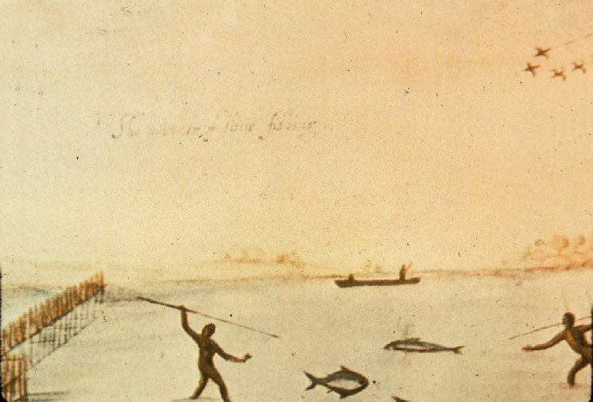
Assignment: Ask students to reflect on their visit to Great Falls Park, focusing on some of the elements of the natural environment. Assign the writing of a myth which explains the origin of one of these phenomena, involves spiritual transformation, or teaches a lesson about the natural environment. Students may complete their story in class or for homework and share their stories with the whole class at the next class meeting. As part of their work the students may be asked to illustrate their myth or story.

Native American Indian stories

“The Never-Ending Bear Hunt”

The stars in the sky seem to revolve around the North Star, also called Polaris, during the night. The sky appears to change as the night moves on, but it also changes throughout the year. The two constellations of Bootes and Corona Borealis seem to sink so low in the night sky that they disappear below the horizon and are not seen for several months of the year. At the same time, the Big Dipper is visible all year long but looks like it is standing upright during some months and upside down in others. Stars don’t really move, but they appear to because the earth spins on its axis. The Micmac Indians of Nova Scotia told a story to fit the changing look of the starry sky.

Far away in the sky country, a bear woke up from a long winter sleep. She left her rocky den on the hill and lumbered off to search for berries. A sharp-eyed chickadee, flitting around the bushes, saw the bear and flew off to call his friends around him.
“It has been a long winter and I am hungry,” said Chickadee. “I am going bear hunting. Who will come with me?”
Six of his friends agreed to join Chickadee, and at once they set out to find the bear.
Chickadee was the smallest hunter, but he was also the wisest. He carried along a pot for boiling his dinner. Robin, who was larger, was called upon to lead the hunting party. Moose-bird was impatient and took his place behind Chickadee. He intended to help himself to Chickadee’s pot. Pigeon, Blue Jay, Horned Owl and Saw-whet all fell into place behind Moose-bird as the party started out.
Since food had been scarce through the winter, the hunters hurried to track their dinner. They found, though, that large and awkward as she seemed, Bear could move quite fast. The hunters were not catching up with her.
All summer the bear moved across the land of the stars while the hungry hunters followed. As autumn approached, some of them grew too weary to continue.
“I’m too far behind to catch up,” said Saw-whet at the very end of the line. He was a clumsy owl and heavier than the others. Saw-whet dropped out of the chase first.
“Where’s that lazy Saw-whet?” fretted Horned Owl, and he left to find his cousin.
Blue Jay tried to stay in the hunt, but by-and-by he and Pigeon lost their way and fell out of sight. That left only Robin, Chickadee with his pot, and Moose-bird to follow the trail of the bear.
At last, deep into autumn, the hunters overtook their prey. The cornered bear reared up on her hind legs and tried to defend herself. Growling and clawing she stood, but Robin shot her with his arrow. The bear fell over on her back, her blood coloring the leaves of autumn and staining Robin’s breast a brilliant red.
All during the winter the dead bear lay on her back in the sky country. But that was not the end of the story. Her life spirit had entered another bear who had found its way to the den and was fast asleep. When spring awakens the sleeping earth, the den will reappear. A new star bear will come out of the den to search for berries in the sky, and Chickadee will begin the hunt again, as he does every year.

From the Seneca comes a story about Niagra Falls

To the North live the Longhouse People, near the edge of the falls called Ne-ah-ga. They sometimes spoke of the Thunder Beings who lived in a cave beneath the falls. When a child wanted to give thanks to the Thunderers for the gift of rain, he would place an offering in a canoe and put it in the river to float over the falls.
One day a young woman, alone in her canoe, was crossing the river far up from the falls when she lost her paddle. The current was swift and she found herself swept away. This young woman had always been a friend of the Thunderers, giving them gifts with each new season. So, as she fell, she did not scream or cry. In trust, she asked for help.
The Thunder beings saved her life, catching her safely in their blanket. Then the chief of the Thunderers asked the young woman to be his wife. She agreed, and to this day, the Seneca say that when the rumbling voices of the Thunder Beings roll across the sky, the brave young woman is keeping watch, reminding us that every gift we give gives us back a blessing.

From the Cherokee comes a story about the Great Smokies

If we travel far to the South, there in the land of mountains and mist, we might hear the story of how Earth was first shaped.
Water Beetle came out to see if it was ready, but the ground was still as wet as a swamp, too soft for anyone to stand. Great Buzzard said, “I will help dry the land.” He began to fly close above the new Earth. Where his wings came down, valleys were formed, and where his wings lifted, hills rose up through the mist.
So the many rolling valleys and hills of that place called the Great Smokies came into being there. And so it is that the Cherokee people, aware of how this land was given, know that the Earth is a sacred gift which must be respected and shared.

Awi Usdi, the Little Deer

Back when the world was young, the humans and the animal people could speak to each other. At first they lived in peace. The humans hunted the animals only when they needed food or skins to make clothing. Then when the humans discovered the bow and arrow, they began to kill animals with ease, even when they did not need them for food or clothing. It seemed as if all the animals in the world would soon be exterminated.
The various animals began to meet in council to discuss the problem. The bears decided they would have to fight back. “The humans will shoot us with their arrows before we come close to them,” said one of the bear warriors.
Old Bear, their chief, agreed. “We must learn how to use the same weapons they use.”
They made a very strong bow and fashioned arrows for it. But when they tried to use the bow, their long claws got in the way.
“I will cut off my claws,” said one of the bear warriors. He did so and was able to use the bow arrow. His aim was good and he hit his mark every time.
“That is good,” said Old Bear. “Now, can you climb this tree?”
The bear without claws tried to climb the tree, but he failed.
Old Bear shook his head. “This will not do. Without our claws we cannot climb trees. Without our claws we will not be able to hunt or dig for food. We must give up this idea of using the same weapons that the humans use.”
One by one each of the animal groups met. One by one they came to no conclusion. It seemed there was no way to fight back. The last group to meet was the deer.
When all were gathered together, their leader, Awi Usdi, spoke. “We cannot stop the humans from hunting animals. That is the way it was meant to be. If they do not respect us and hunt us only when there is real need, they may kill us all. I shall go and tell the hunters that whenever they wish to kill a deer, they must prepare in a ceremonial way. They must ask me for permission and after they kill a deer, they must show respect to its spirit and ask for pardon. If they do not do this, I shall track them down. With my magic I will make their limbs crippled. Then they will no longer be able to walk or shoot a bow and arrow.”
At night Awi Usdi, Little Deer, whispered into the ears of the hunters, telling them what they must do. When they awoke, some of the hunters thought that they had been dreaming. Others, realized that Awi Usdi had truly spoken to them. They hunted for deer and other animals only when they needed food and clothing. They remembered to prepare in a ceremonial way, to ask permission before killing an animal, and to ask pardon when an animal was killed. Some of the hunters, though, paid no attention. They continued to kill animals for no reason. Awi Usdi came to them and, using his magic, crippled them with rheumatism. Before long, all of the hunters began to treat the animals with respect and to follow Awi Usdi’s teachings.
So it is that the animals have survived to this day. To this day, even though the animals and people no longer can speak to each other as in the old days, the people still show respect and give thanks to the animals they must hunt.

Bibliography

Bruchac, Joseph. Between Earth and Sky: Legends of Native
American Sacred Places. New York: Harcourt Brace and Company, 1996.

Bruchac, Joseph. The Boy Who Lived With The Bears and other
Iroquois Stories. New York: Harper Collins Publishers, 1995.

Caduto, Michael J. & Joseph Bruchac. Keepers of the Earth:
Native American Stories and Environmental Activities for Children. Golden, Colorado: Fulcrum, Inc., 1989.

Erdoes, Richard & Alfonso Ortiz, ed. American Indian Myths and
Legends. New York: Panteon Books, 1984.

