Glacier Bay Wilderness Questionnaire For ResearchersAH_small_BW_b

# Glacier Bay

National Park and Preserve

National Park Service

U.S. Department of the Interior

**Scientific Research in Glacier Bay National Park’s Wilderness**

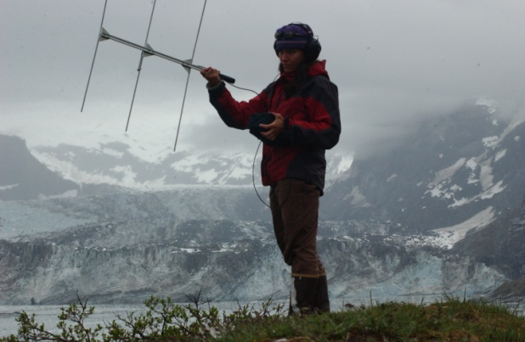This questionnaire gathers information needed to review proposed research activities in and adjacent to Glacier Bay Wilderness Area.

Eighty-five percent of Glacier Bay National Park and Preserve lands and some of its marine waters are officially designated as wilderness ([MAP](https://www.nps.gov/glba/learn/management/upload/W-map-GLBA.jpg)) under the [Wilderness Act of 1964](https://wilderness.net/learn-about-wilderness/key-laws/wilderness-act/default.php). Wilderness designation provides the highest level of protection to public lands and provides guidance for use and management of these unique areas. As defined by the Wilderness Act, “*a wilderness, in contrast with those areas where man and his own works dominate the landscape, is hereby recognized as an area where the earth and its community of life are untrammeled by man. . . .*” Wilderness provides outstanding opportunities for research in a natural landscape, however wilderness preservation requires additional considerations in order to preserve wilderness character.

There are four equally important qualities identified in the Wilderness Act that define wilderness character:

* ***Untrammeled*** -Wilderness is free from overt human control, constraint, and manipulation.
* ***Natural*** - Ecological systems in wilderness are largely unaffected by modern civilization.
* ***Undeveloped*** - Wilderness is essentially without permanent improvements, installations, or modern human occupation.
* ***Solitude or primitive and unconfined type of recreation*** - Wilderness provides outstanding opportunities for solitude or primitive and unconfined recreation.

Research in Glacier Bay’s wilderness is allowed when the benefits of the investigation outweigh potential negative impacts to other wilderness values. One of the reasons Glacier Bay National Monument was created in 1925 was to conduct scientific research! The best opportunities for finding a balance between the benefits of science and impacts to wilderness emerge when managers and scientists collaborate well in advance of projects to identify outcomes that are beneficial to both scientific inquiry and wilderness values. When reviewing proposals, a Glacier Bay management team will consider the benefits to wilderness stewardship and science that the research will provide in relationship to the impacts the research activities may have on wilderness character and visitor enjoyment.

A research proposal will be evaluated using a set of criteria developed nationally and modified specifically for Glacier Bay’s unique wilderness environment. The more information provided regarding potential benefits and impacts of the research, the more effectively and efficiently the Glacier Bay team will be able to properly evaluate the proposal. The information needed is captured by the questions below. To obtain a research permit in Glacier Bay National Park and Preserve, answers must be provided to all questions, even if the proposed research will be not conducted in wilderness we still need to evaluate the impacts to the surrounding wilderness. For more information see [Guide to Conducting Wilderness Research in Alaska’s National Parks](https://www.nps.gov/articles/researchakwilderness.htm) and [Wilderness Toolbox for Practitioner’s](https://wilderness.net/practitioners/toolboxes/research-and-science/default.php).

We appreciate your time in providing this needed information. We look forward to working with you!

For questions or further information, contact:

***Martin Hutten, Research Coordinator, Glacier Bay National Park***

***(907) 697-2659***

***glba\_research\_permitting@nps.gov***

**Glacier Bay Wilderness Research PermiT Questionnaire**

***Please provide brief (1-3 sentences) answers to each of the following:***

**Benefits to Stewardship and Science**

1. Will the research be conducted in GLBA Wilderness ([MAP](https://www.nps.gov/glba/learn/management/upload/W-map-GLBA.jpg))? If so, why is it essential that the research be conducted within wilderness rather than in non-wilderness areas?

***Wilderness Stewardship***

1. Does the research address a current wilderness stewardship issue(s)? If so, describe why the issue is important and/or urgent.
2. Do the research results allow effective action by park management on a wilderness stewardship issue? If so, describe how park managers will use results to improve current or future stewardship of Glacier Bay wilderness?
3. Who else could benefit from the results (other scientists, park visitors, general public, other management agencies)?

***Benefits to Science***

1. Describe the importance of the research to the scientific field of study.
2. What is the breadth of scientific inquiry - is research conducted on single or multiple components of ecosystem?
3. How broadly will the results benefit science - the park, the State of Alaska, the region, the nation, or the world?
4. Who will benefit from results and for how long into the future?
5. How will your research results be disseminated?

**Impacts to Wilderness Character and Cultural Resources**

***Untrammeled Quality***

1. 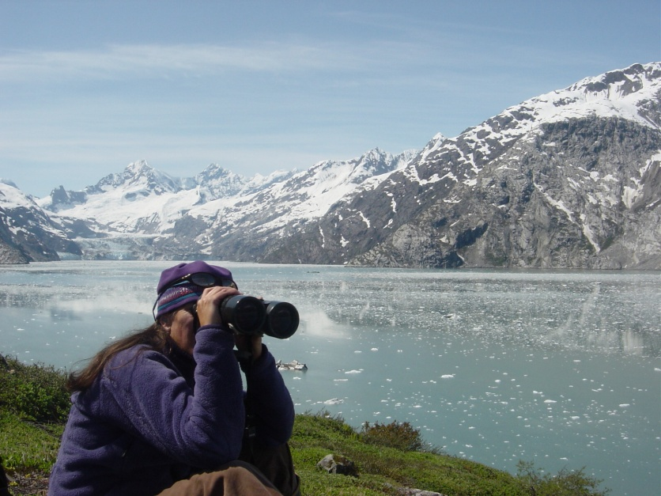Will the research manipulate any processes or conditions of the environment? Examples include herbicide use, collecting animals or plants, installing fish weir or exclosures, etc. If so, describe manipulation in detail.

***Natural Quality***

1. Will the research disturb (manipulate) plants or animals? Examples include feeding, trapping, marking, collecting or changing behavior. If so, describe in detail.
2. Will the research involve ground disturbance? Ground disturbance can trigger the need for [Section 106](https://www.nps.gov/history/tribes/Documents/106.pdf) compliance with the National Historic Preservation Act of 1966. If so, describe what kind of ground disturbance will occur and in what locations? For example, how many holes, depth and width of holes? Would the soil or top layer be replaced? How will impacts be mitigated? Monitoring or prior archaeological survey may be necessary.
3. Will the research include collection of specimens, samples, or objects? If so, why is collection necessary? What alternatives to new collections were considered (could reference specimens from somewhere else be used? Where, when, how will specimens be collected? How many? Will there be any disturbance (e.g., scarring) as a result of sample removal and if so, what mitigation measures will be implemented? Will collected items be destroyed in analysis or preserved/archived? If items will be retained, please identify a permanent repository for the collection by submitting [Appendix A](https://irma.nps.gov/DataStore/DownloadFile/601663).

***Undeveloped Quality***

1. Will helicopters, off-road vehicles or snow machines be used? If so, provide details about why this transportation is the minimum means necessary to accomplish the research objectives. Outline the details on the type of motorized transport, number of travel hours, proposed flight/travel paths and altitude, and number and location of landings.
2. Will fixed-wing aircraft be used? If so, provide details on type of airplane, number of flight hours, proposed flight paths and altitude, and number and location of landings.
3. Will Unmanned Aerial Systems (UAS, aka drones) be used? If so, please contact the Research Coordinator.
4. Will motor vessels be used? If so, provide details on type of vessel, number of days and hours per day, proposed travel paths, and number and location of shore landings.
5. Will waters seasonally closed to motorized vessels be accessed with motor vessels ([MAP](https://www.nps.gov/glba/planyourvisit/upload/Guide-to-park-waters-map.jpg))? If so, provide details on why motorized access in non-motorized waters is necessary.
6. Will there be and other requests for exceptions from any park regulations ([MAP](https://www.nps.gov/glba/planyourvisit/upload/Guide-to-park-waters-map.jpg))? If so, why are exceptions to park regulations necessary?
7. Will motorized tools be used in wilderness? If so provide details on why motorized tools are the minimum means necessary to accomplish the research objectives and type, duration, timing and location of use.
8. Will there be any installations (gear or equipment left in the field)? If so, describe what other alternatives were considered and why alternatives are not acceptable. Describe in detail the number, size and placement of the installations and the distance at which they will be visible – include maps, photos, and tables if necessary. What design features and other measures would be taken to minimize visual, audible, and maintenance impacts of the installation? How long will installations be out for and how often would they be maintained or serviced? When, how, and by whom would installations be removed? GPS coordinates will be required for every installation within the park.
9. Will there be temporary or permanent tags, marks or collars on animals with VHF, satellite, sonic, archival, or other type of telemetry device? If so, describe what other alternatives were considered and why alternatives are not acceptable. Describe in detail the number, size and placement of the tags and the distance at which they will be visible – maps and photos are valuable. What design features and other measures would be taken to minimize visual, audible, and maintenance impacts of the tags? How long will tags be out for and how often would they be maintained or serviced? When, how, and by whom would tags be removed? GPS coordinates will be required for every tags/markings/collars within the park.

***Solitude or Primitive and Unconfined Quality***

1. Describe the group size, and the number of days in the field per year. If there will be nights spent in the field, describe sleeping location (boat, tent, etc.) and for how many nights per year.
2. Describe the dates of field work and who will be conducting your field work.
3. Provide a detailed map of the intended study sites in Glacier Bay National Park and Preserve. KMZ and GIS files welcome.

***Homeland and Cultural Resources***

In addition to the Wilderness Act of 1964, all historic preservation laws also apply to this research. Additionally, the connection between the Tlingit people and much of the Wilderness of Glacier Bay is an important Park specific Wilderness Character so each research proposal will go through consultation with the Huna Indian Association (HIA) and/or Yakutat Tribe. In the event your proposal is seen as deleterious to the homeland of the Tlingit, mitigations will need to be implemented. The presence of known cultural resources within your proposed project area will impact research proposals so avoiding these sites is recommended. If you cannot avoid these sites, mitigations such as prior or concurrent archaeological survey will need to be implemented. Lastly, cultural site locations shall not be divulged through the publication and distribution of your findings/research unless explicitly allowed.

1. Are you proposing research in areas which have been previously identified or have a high probability for cultural resources? If you do not know, your detailed map of the intended study sites will be utilized here, so please be as specific as possible.

***Other***

1. Will you be filming during your project, what is the intended use of the footage? Filming or photography for commercial use will require a separate NPS permit.
2. Will you be asking for any type of Park support? If so, what type?