Geology, ………it’s not just for scenery anymore.

By Tim Connors, Tom Clark, Bruce Heise, Bob Higgins and Anne Poole (all National Park Service)
Stephanie O’Meara, Trista Thornberry, Victor deWolfe, John Graham (Colorado State University)

SUMMARY
Bedrock and surficial geologic maps and supporting information provide the foundation for studies of ecosystems, earth history, groundwater, geomorphology, soils, and environmental hazards such as fire history, landslide and rockfall potential, etc. Geologic maps describe the underlying physical conditions of many natural systems and are an integral component of the physical science inventories stipulated by the National Park Service (NPS) in its Natural Resources Inventory and Monitoring Guideline. The NPS has identified GIS and digital cartographic products as fundamental resource management tools. There are few geologists employed at parks, thus these tools are particularly important to the National Park Service to aid resource managers in using geologic data for park management decisions. At Capitol Reef National Park in Utah, resource manager Tom Clark has found numerous uses of digital geologic maps for predicting habitat for threatened and endangered species

Why Digital?
Digital geologic maps have several advantages over paper geologic maps. Digital geologic maps can be used in a digital GIS environment where they can be integrated with other geospatial (soils, vegetation, hydrology, etc.) data to provide analysis of spatial relationships. A digital GIS provides quick, reproducible, precise analysis results. Digital data are also more easily shared and transferred between users. With digital attribute capability a digital geologic map becomes a powerful database!

The Odyssey from paper to digital
One of the unresolved issues facing developers of digital geologic maps models is how to include map unit descriptions, supplemental explanatory text (references and map notes), geologic cross sections, and the variety of other printed information that occur on published maps. The overarching development goal of the NPS Inventory and Monitoring program is to produce digital products that are immediately useful to anyone familiar with their analog counterparts. For geologic maps, this means that the map unit legend must be sorted and shaded appropriately by geologic age and that all textual, graphical, and other information from the published maps must be available interactively to the user. In short, the digital product must "look and feel" like its published source.

The NPS is developing most digital products in ESRI (Environmental Systems Research Institute) ArcView GIS. ArcView interfaces effectively with other software running on the Microsoft Windows operating system. Also, integrating a variety of tools including the NPS GIS Theme Manager, Windows Help software, a Microsoft Visual Basic graphics viewer program, and the ArcView legend editor has allowed users to display geologic map information in a digital GIS.

Completing the Odyssey
This article details the steps entailed in transforming a paper geologic map to a user-friendly digital geologic map and database. In short the paper geologic map is scanned and the resulting image is georeferenced, providing a background for the digitization (capture) of geologic features. In accordance with the NPS Geology-GIS Data Model, the spatial and geologic feature types present (i.e. polygon, line, point and fault, fold, unit, etc.) are captured into appropriate GIS coverages and attributed as per the Data Model. These data are then incorporated into the NPS GIS Theme Manager that facilitates (in ArcView 3.2) the presentation of the various map coverages along with any FGDC metadata and accompanying help files that display map notes, unit descriptions and other ancillary data from the original paper source map. Any map graphics (e.g. geologic cross sections) are scanned from the original paper map and hotlinked to a coverage (e.g. in this case the cross section line coverage) on the digital geologic map. These data are then posted on the NPS I&M GIS Clearinghouse website for user access and download.

Geologists use two types of maps to convey various geologic features: bedrock and surficial geologic maps.
Bedrock geologic maps aid in the following:

- Conveys information about the geologic history, including the origin of features and the processes that created them

- Used to identify scope and type of geologic hazards (rockfall, faulting, flooding, etc.)

- Used to identify location and type of resources (coal, ore deposits, ground-water, oil & gas, etc.)

- Provides basis for sound land use planning (hazards, engineering considerations, etc.)

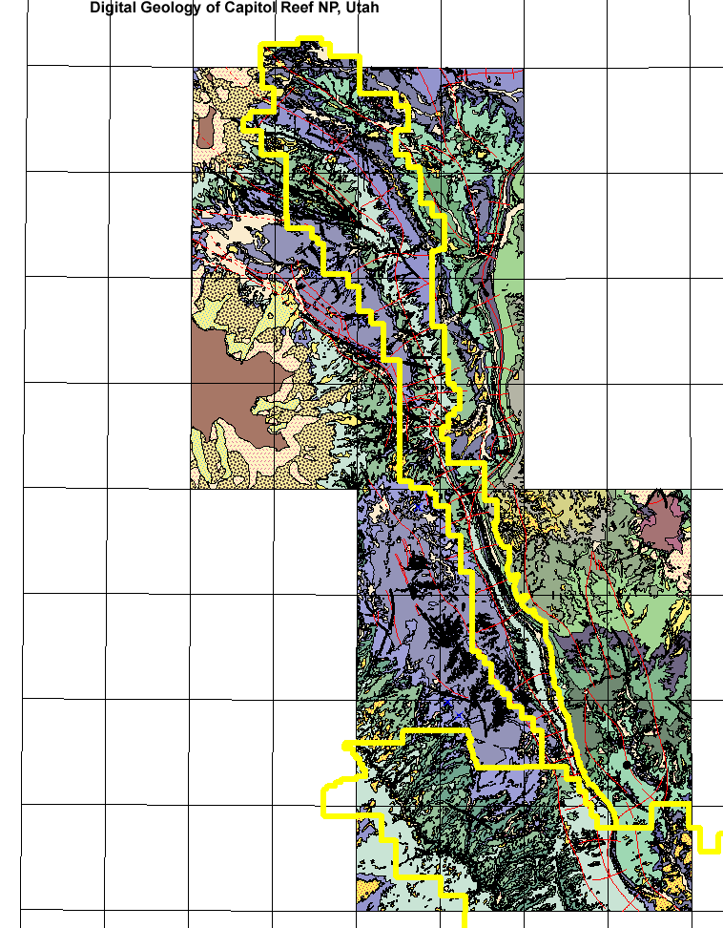

Surficial geologic maps:

- Convey information about recent geologic processes and resultant features

- Are key to understanding surface hydrology, near-surface groundwater, & watershed response

- Can be used to understand patterns of soil development and infer occurrences of flora, fauna, fire prone areas, archeological sites, etc. (other resources of concern)

- Be used to identify erosional susceptibility

USING DIGITAL GEOLOGY AT CAPITOL REEF NATIONAL PARK
NPS resource management professionals are beginning to see the importance of using digital datasets to respond to issues in parks. Geology, often scoffed at as merely being attributable only to the “scenery”, plays a much more diverse role in the total ecosystem than it is usually given credit for. The importance of geology to our everyday activities is obvious to the geologist: it ranges from shaping the earth’s surface (the actual topographic expression of a landform) to direct relationships with soil development from “parent material” to the species of plants and animals that grow on the land, to controlling where humans eventually settle in communities. With GIS, now the geologist can illustrate the importance of the science of geology to other natural resource enthusiasts, such as soil scientists, botanists vegetation specialists, and ecologists.

Therefore, through integrated efforts a few important uses of geology and geologic maps have found some interesting correlations to other natural resource disciplines. Here are a few quick examples:

At Capitol Reef, Tom Clark (Chief of Natural Resources) has been using the parks digital geology layer, along with soils and aspect data to predict habitats for species listed as threatened or endangered. He has found direct connections with geologic substrate and successful habitat prediction of three known endangered species.
- Habitat for Winkler’s cactus seems to be confined to geologic outcrops and expressions of the Jurassic Morrison Formation’s Salt Wash Member within Capitol Reef NP. To the south of the park there is a correlation with the Cretaceous Dakota Formation, and to the north of the park it is found in the Curtis Formation
- Barneby reed-mustard is confined to north-facing, cliff exposures in the Triassic Moenkopi Formation and likely has additional ties to moisture levels.
- Jones cycladenia is only found in the uppermost member of the Triassic Chinle Formation

Additionally, he has found correlations of species specific only to exposures of the Navajo Sandstone for the following:
- Beck’s Spring Parsley seems to only occur in north facing narrow canyons within the Jurassic Navajo Sandstone
- Harrison’s milkvetch
- Maguire’s daisy
- Rabbit Valley gilia
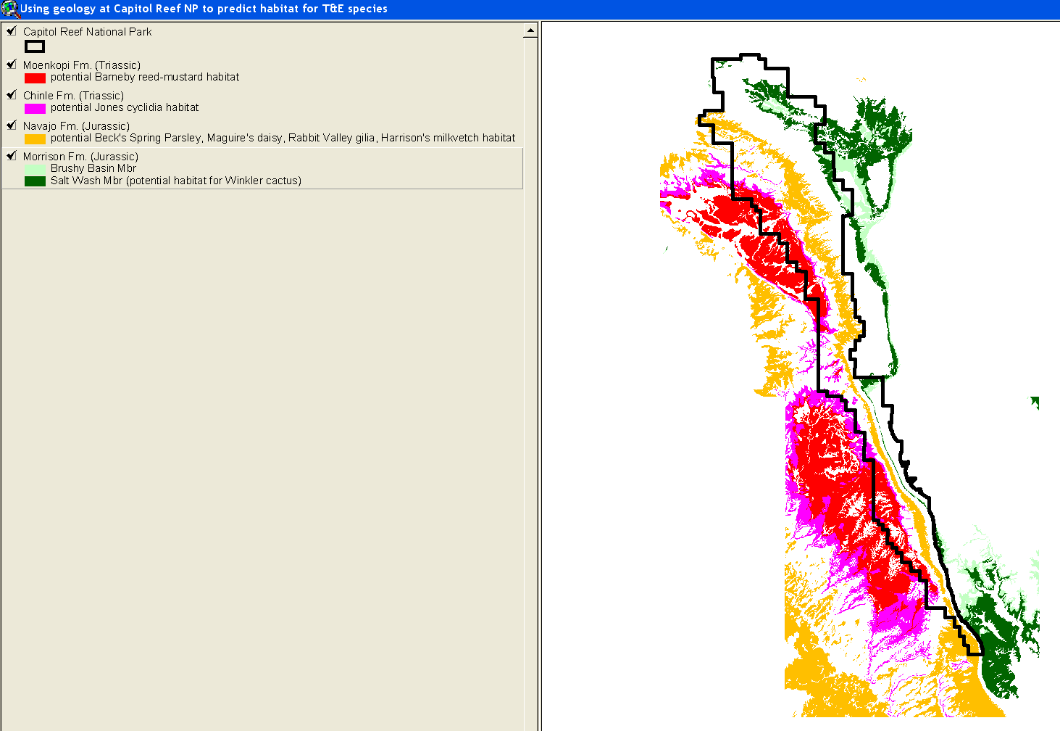

For a more detailed paper on this matter, please see Park Science (Volume 19, Number 2, December 1999, p. 27-29) The article is attached below for simplicity.

For more information on the NPS Geologic Resources Inventory Program, please see Ranger (Volume XVIII, number 2, Spring 2002, p. 2-4 (http://www.anpr.org/geology.htm) and http://www2.nature.nps.gov/grd/geology/gri .
It is also attached below for simplicity.

Rare plant survey at Capitol Reef National Park
By Deborah Clark and Thomas O. Clark
In 1997 and 1998, Capitol Reef National Park received a research and inventory grant from the National Park Foundation and Canon U.S.A., Inc., through their "Expedition into the Parks" program. This grant enabled National Park Service staff, researchers, and volunteers to collect critical data on several of the rarest plants occurring in the park.
Capitol Reef National Park is located in south-central Utah (figure 1), in the Colorado Plateau region, 72 km (45 mi) west of Hanksville on U.S. Highway 24. It was established to protect the longest exposed monocline in North America and is approximately 97,000 ha (241,903 acres) in size. This wrinkle in the earth's crust runs about 160 km (100 mi) north to south and is named the Waterpocket Fold. Unique geological conditions within the fold have created microhabitats that support over 40 rare and endemic plant species.
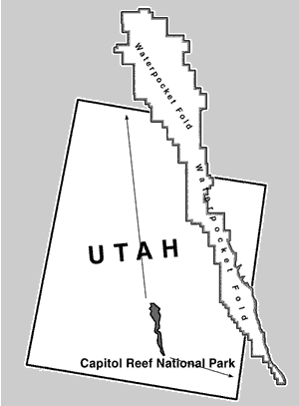
Figure 1. Capitol Reef National Park is located in south-central Utah and encompasses the Waterpocket Fold, a 100-mile-long geologic formation known as a monocline that provides numerous microhabitats for rare plants.
The six plant species selected for this study were ones most likely to be impacted by increased park visitation around the headquarters or Fruita area. Capitol Reef is primarily a backcountry park and receives about three-quarters of a million visitors each year. Many of these visitors hike the trails within the Fruita area and many of these trails have rare plant populations adjacent to them. Therefore, information on the whereabouts of rare plants in these high use areas and whether they are being affected by visitation is essential for park management.
Three of the six species are federally listed as endangered or threatened: Barneby reed-mustard (Schoencrambe barnebyi-endangered), Maguire's daisy (Erigeron maguirei-threatened), and Wright's fishhook cactus (Sclerocactus wrightiae-endangered). One species, Rabbit Valley gilia (Gilia caespitosa-figure 2), was a candidate for federal listing, but is now being managed under a conservation agreement and strategy that precludes the need to list it¹. The remaining two species are NPS sensitive: Harrison's milkvetch (Astragalus harrisonii), occurring only within Capitol Reef National Park, and pinnate spring-parsley (Cymopterus beckii).
¹The conservation agreement and strategy was written by BLM, FWS, USFS, and NPS staff in 1996. This agreement addresses protection measures designed to achieve long-term conservation of the species so that listing under the Endangered Species Act would not be necessary.
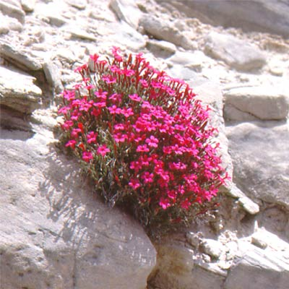
Figure 2. Rabbit Valley gilia, a candidate for federal listing, is now being managed under a conservation agreement and strategy.
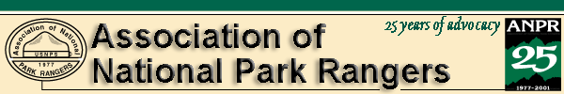
back to main Communications page

GEOLOGY
It's not just another pretty picture

The National Park Service Geologic Resources Inventory
By Tim Connors and Bruce Heise
NPS Geologic Resources Division
Many units of the National Park Service were set aside because of their unique geologic features and processes. Examples that come readily to mind are Yellowstone, Arches, Grand Canyon, Badlands, Mammoth Cave and Mount Rainier.
However, often a park's basic geology is overlooked as a significant natural resource and regarded as a static feature responsible only for the scenery. Aficionados of geology in the NPS and the Geologic Resources Division are making strides to change this perception - and to promote the concept that geology is indeed the "bedrock of the ecosystem."
When geology is viewed as both science and as a natural resource rather than just scenery, it can serve as the basis for understanding the relationship of geology to soil development, topographic expression and landscape, microclimates, vegetation and species distribution, paleontological resource locations and fire history. Geologic processes such as earthquakes, floods and mass wasting, and features such as volcanoes and glaciers are present in many NPS units. They provide opportunities for the NPS interpretive staff and concessioners alike to educate the public. They also are subjects of concern to resource managers, planners and park managers dealing with public safety, hazards and facility siting.
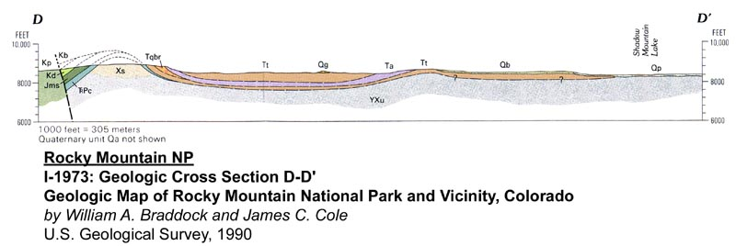
With the Inventory and Monitoring Program, initiated in fiscal year 1998, the NPS has undertaken a major step toward assessing the natural resources we are charged with protecting.
Twelve themes were originally identified for inventories: geology, species lists, bibliographies, base cartography, vegetation, water quality, water body information, soils, species surveys and distribution, air quality, air quality-related values and long-term climatic data. The main product stemming from most inventories is a digital spatial layer that can be used in a park's Geographic Information System to address resource management issues and interpretation, for both educational and scientific value, to better manage the natural geologic resources of the park.
The concept of a Geologic Resource Inventory was unprecedented. There were 272 NPS "natural resource" units targeted, but no guidelines existed that laid out exactly what constituted an inventory of a park's geology. To determine that, the Geologic Resources Division conducted a workshop in November 1997 in Denver with geologists from individual parks, the U.S. Geological Survey and academia, and state geologists from Colorado, Utah and North Carolina. The workshop identified four necessary components for the inventory to provide meaningful information to resource management staffs. These components are:
• a scoping meeting held at each park for the purpose of bringing together local experts on a specific park's geology.
• a geologic bibliography generated for each park and posted on a website.
• a digital geologic map for use in a park's GIS.
• a comprehensive geologic report covering multiple facets of the parks' geologic features and processes.
With no similar inventories from which to base the program on, workshop participants decided to conduct a three-year pilot project inventorying every park in three states to establish a methodology to use for the rest of the parks. Coincidentally, Colorado, Utah and North Carolina were selected as the pilot states, and the program commenced in 1998. The three pilot states offered a wide variety of park management units (parks, monuments, seashores, historic sites) and a broad spectrum of geologic features.
While there were some initial "teething" problems, the program has since taken off to the point where there now is a waiting list of parks requesting an inventory. On-site scoping meetings are particularly popular with park staff. So far dozens of geologists from the USGS, academic institutions, state offices and interested locals have participated in these one-day field trips along with park interpretation and resource staff, providing detailed discussions of the park's geologic features, processes and potential hazards. This is typically followed by a day in the office assessing the quality and extent of existing map coverage and publications and, where dated or inadequate, plans to acquire new or missing data.
While initiating new parkwide mapping projects are generally beyond the scope of the GRI, leveraging inventory and monitoring funds and other in-kind contributions with other federal, state or academic projects has proven to be an effective way of obtaining new geologic data. GRI funds have been used to partner with ongoing projects with the USGS in Death Valley, the Utah Geological Survey in Glen Canyon and Stanford University at Great Basin, just to name a few. In each case, the sole goal has been to provide quality geologic maps in a digital format to park management. Once the digital data is obtained, NPS Natural Resource Program Center staff strive to format it in such a way that park managers need not be geologists to understand what is being presented.
Inventory funds have also been used in more innovative ways, such as paying for a Utah Geological Association publication that provides detailed geologic reports for every park unit in the state. It was written by the experts in the field, at a fraction of the cost necessary to acquire otherwise. A similar volume is planned for the parks of New Mexico, again in partnership with the state geologic survey.
While using geologic maps to understand and predict geologic phenomena, the scoping meetings have revealed numerous examples of parks using maps for decidedly non-geologic purposes. Some examples are:
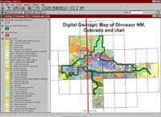
• At Mesa Verde there is a growing awareness that the many alcoves containing cultural resources distributed in the park are usually geologically controlled in their origins. Groundwater moving laterally in the geologic strata carves out alcoves along contacts between geologic units of differing susceptibility to erosion. Studying the nature of these geologic contacts as they are distributed in the park may lead to the discovery of unknown ruins.
• At Dinosaur the main attraction is the large "graveyard" of complete dinosaur skeletons contained at the Dinosaur Quarry site. However, the geology of the park is also responsible for several maintenance headaches, including the actual building over the main dinosaur quarry, which is subject to numerous shifts and shakes because of the nature of the bentonitic (swelling) soils that underlie the structure. Maintenance nightmares include heaving floors, windows popping out of frames and not a square doorjamb in the entire building. The geologic maps also are used to predict the distribution of the endangered spiranthes (orchid) as its habitat is constrained to certain geologic units. Additionally, consultants have used the geology to predict habitat of the endangered Colorado pike minnow based on geologic structures that provide the river bottom morphology critical for spawning.
• At Capitol Reef the distribution of endangered Winkler's cactus is controlled by the underlying geology. The cactus grows only in soils derived from the Morrison, Curtis and Dakota formations. By querying the digital geologic database, these geologic units can be identified and the distribution of Winkler's cactus can be better predicted, and therefore, better protected.
• At Colorado National Monument recent geologic mapping conducted by the USGS has revealed new insight into the fire history of the area. Charcoal horizons found in drainage sediments have been age-dated, and 20,000 years of regional fire activity can be identified. USGS geologists, supported by Inventory funds, also produced a poster showing the geologic map and explaining the relationship among the geology, biology, hydrology and human history. This poster, the "Geologic Map of Colorado National Monument and Adjacent Areas, Mesa County, Colorado," is a popular item at the Natural History Association bookstore and was awarded the "Best Overall Presentation" at the Environmental Systems Research Institute Inc. 2001 GIS User Conference.
• At City of Rocks National Reserve rockfall probability maps were generated by the USGS by combining the mapped geology with topographic and aspect data in a GIS database for park use in facility siting. These maps are useful in determining safe locations for campsites and other park facilities.
• In the Great Smokies cerulean warbler habitat is found only in vegetation growing on acidic soils derived from underlying, one-half-billion-year-old shales. The habitat distribution is mapped on the basis of the geologic map. There are other examples. As parks begin to receive their inventory data, many more uses will probably be discovered. The products of the GRI will assist superintendents, rangers, interpreters/environmental educators, resource managers, scientists and facility management personnel to make better decisions regarding park resources. They also will provide the park visitor a better understanding of the unique geologic features and processes present in the many "geologic" parks in the NPS.
If you are interested in further information on the Geologic Resource Inventory, please contact Tim Connors, tim_connors@nps.gov; 303-969-2093) or Bruce Heise, bruce_heise@nps.gov; 303-969-2017) at the Geologic Resources Division, or consult the GRI website at http://www2.nature.nps.gov/grd/geology/gri/
Tim Connors' interests include geologic mapping, computer uses of geologic data for resource management, inspiring others to see the importance of geology in our everyday lives, and reminding folks that"geology is history, just without the people." Bruce Heise likes to run around looking at rocks. Both are geologists with the NPS Geologic Resources Division in Lakewood, Colorado.

If you enjoyed reading this excerpt from Ranger magazine and want to receive Ranger year-round for a modest price, please join the Association of National Park Rangers.
back to main Communications page

