Gateway National Park Service U.S. Department of the Interior

Gateway National Recreation Area
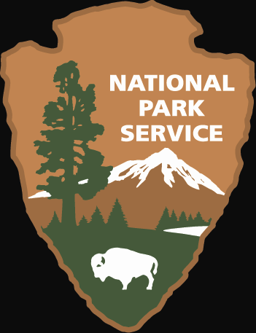
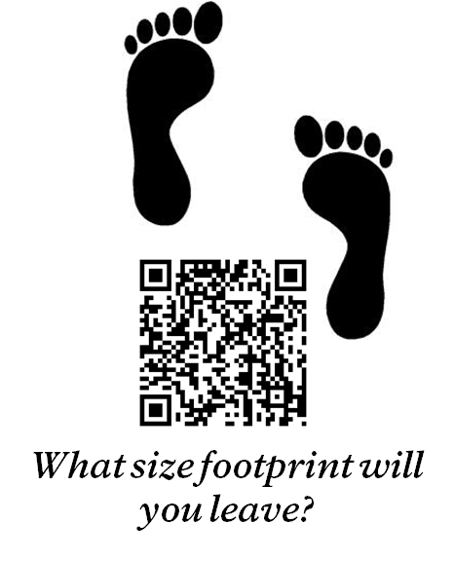

EXPERIENCE YOUR AMERICA™

