National Park Service
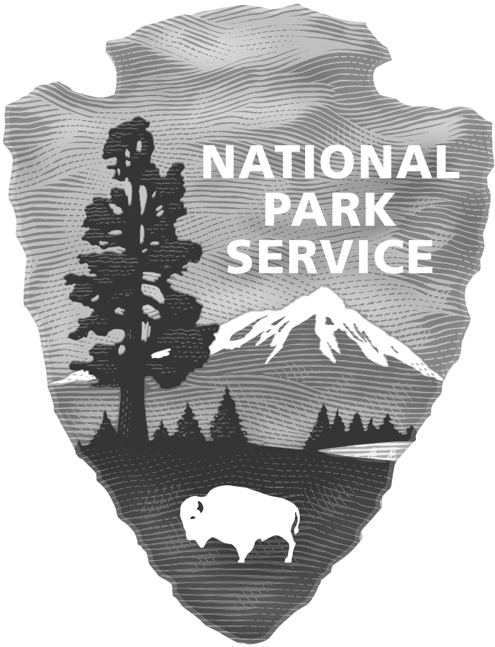
U.S. Department of the Interior

Gateway Research Learning Center
Gateway National Recreation Area

Internship Program
Academic Verification Statement
To be filled out by the Registrar or Councilor

The Gateway Research Learning Center considers part-time and full-time students in good academic standing for internship positions at Gateway National Recreation Area. The purpose of this questionnaire is to ensure that proper consideration is provided to the applicant listed below. Please fill in as much as possible.

Prospective Intern Name:

College/University
or High School:

Major/Minor:

Anticipated graduation:

Academic Standing: Satisfactory Unsatisfactory

Enrollment: Full Time Part Time

Semester: Spring Summer Fall Other (explain)

Registrar Signature Date

Email Phone

Please send completed form in a sealed envelope to:
The GRLC Internship Program, 1 Floyd Bennett Field, Building 69, Brooklyn, NY 11234

EXPERIENCE YOUR AMERICATM
The National Park Service cares for special places saved by the American people so that all may experience our heritage.

