**Lesson Title:**  Habitats by Land and Sea: Restoring Resiliency

**Goals:** The primary goal of this program is to observe and document information about plant and pollinator species at Gateway National Recreation Area. To do so, students will monitor which types of pollinators we currently see at the Jamaica Bay Wildlife Refuge (JBWR), document changes in individual plant species over time, and test various habitats to determine which native plants are suitable to be planted there. The data collected will allow students to discover how to construct restoration projects and design pollinator gardens to increase the biodiversity and resiliency of the park and adjoining areas.

**Objectives:**

* Engage in a scientific process of discovering the physical and chemical parameters of soil in a particular habitat
* Make observations about weather conditions and pollinator activity on native plants
* Make observations about seasonal changes and document evidence of pollinator efficacy by assessing seed quantity and/or viability
* Understand what parameters limit different plants from living in a particular area
* Understand why invasive plant species are well-equipped to dominate an ecosystem
* Discern from data collected and plant requirement information which native plants could survive in a particular location
* Able to define and understand vocabulary terms

**Overview:**  Habitat stressors, (e.g. fragmentation, pollution, and climate change, among others), can leave ecosystems more vulnerable to invasion by exotic species (both plant and animal) and possible collapse. Conserving biodiversity has been shown to increase habitat resiliency. Thus, especially for urban ecosystems to be resilient to effects associated with climate change and other habitat stressors, it is essential to promote greater diversity of native plant populations in critical refuges near dense urban centers.

In this program, students become scientists whose role is to test a specific area for the parameters required by various native plant species. Each class will be divided into three (3) groups and rotate through stations engaged in: 1) pollinator or phenology monitoring and observations (depending on the season), including air temperature, wind speed, and current weather conditions; 2) physical attributes of soil, including texture, sunlight levels, moisture content, and temperature; and 3) chemical attributes of soil, including pH, Nitrogen, Phosphorus, and Potassium.

By exploring the living requirements for plants, students will begin to understand the importance of native plants, pollinators, and associated ecosystem services in various habitats throughout the JBWR. The data produced by the students will help the professional scientists and natural resource managers at Gateway to determine how to design garden areas to attract native pollinator species.

**NYC K-8 Scope and Sequence Connections:**

Grade 3: Unit 1 – Matter, Unit 4 – Plant and Animal Adaptations

Grade 4: Unit 1 – Animals and Plants in their Environment, Unit 4 – Interactions of air, water, and land

Grade 5: Unit 1 – Nature of Science, Unit 2 – Earth Science, Unit 4 – Exploring Ecosystems

Grade 6: Unit 2 – Weather, Unit 3 – Diversity of Life, Unit 4 – Interdependence

Grade 7: Unit 1 – Geology, Unit 4 – Dynamic Equilibrium: Other Organisms

Grade 8: Unit 1 – Reproduction, Heredity, and Evolution; Unit 2 – Humans and their Environment

**Materials:**

* Habitats by Land and Sea step-by-step instructional binders (1/group)
  + A pollinator I.D. chart each
* Clipboard with a pollinator data sheet and a soil data sheet (1/group)
* Station signs (labeled 1, 2, 3) on stakes to indicate where stations are located
  + Milkweed (if single class)
  + Seaside Goldenrod (if double class)
* Group signs (labeled A, B, C) on the binders to indicate how they rotate
  + Monarch Butterfly (if single class)
  + Bumble Bee (if double class)
  + Groups starts at A-1, B-2, C-3; rotate through stations in numerical order
* Backpacks for physical soil station and for chemical soil station
  + 1 of each for a single class; 2 of each for a double class
  + Physical soil station backpacks should each have:
* one set of stacking sieves (lid, #10, #35, #60, #230, & plastic bottom pan)
* one core sampler
* container of dried soil
* 2-4 laminated copies of the soil texture triangle chart
* a light meter (one to share between the two physical stations if double class)
* three graduated cylinders, one large, two medium-sized
  + Chemical back packs should each have:
* soil temperature probe
* at least three soil pH testabs
* at least two Floc-Ex tablets
* at least one Nitrate tablet
* at least one Potassium tablet
* at least one Phosphorus tablet
* bottle of distilled water
* container of dried soil
* silver protective sleeve for nitrogen testing
* a pipet
* N P K color chart
* soil pH color chart
* at least three square test tubes with lids
* one large test tube for “extraction”
* One bag for the pollinator observation stations with:
* two clipboards with pollinator data sheet and soil data sheet
* at least two anemometers or Kestrels (wind meters)
* at least two thermometers for air temperature
* several hand lenses

**Activities (90 mins total):**

(10 mins) What is Resiliency? Activity

(60 mins) Break into groups and walk to stations – Rotate through 3 stations in sequential order

* Station 1: Pollination Monitoring and Weather Observations OR Phenology

(weather dependent)

* Station 2: Physical Soil Testing
* Station 3: Chemical Soil Testing
  + From Station 3, groups rotate to Station 1

(15 mins) What plants will grow here? Discussion of results from testing and what pollinators we would expect to find when those plants are in bloom

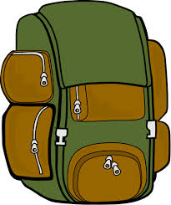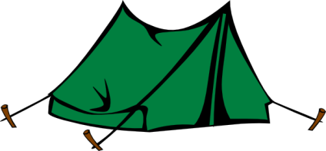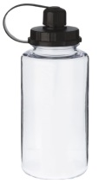

**Activity guide:**

What is Resiliency? Activity (10 mins)

Gather the students in a circle. Introduce the students to the program and let them know that we are at the JBWR.

Have the students imagine we are going on a camping trip for a week and ask what they would need to bring. After naming everything, try picking up the imaginary backpack. If there are unnecessary things, say, “Oof, that’s too heavy. What can we leave out?” Think about the essential things for survival: food, water, and a place to live.

Segue – plants need the same essential things:

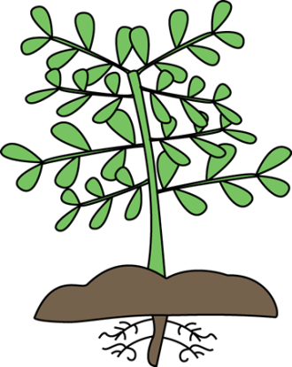

Food = sun (i.e. photosynthesis), nutrients

Water = rain, groundwater

Place to live = soil, trees for support (e.g. for vines), etc.

BUT just like we don’t look the same and have special talents, plants don’t look the same and have special talents, too. Ask the students what kinds of talents they have.

Examples might be:

* Play musical instruments
* Video gaming
* Cooking/baking
* Sports
* Reading
* Art/writing
* Photography
* Theatre

Group the students according to their talents and give them a particular adaptation:

* salt tolerance
* deep root structure
* drought tolerance
* shade tolerance
* fast-growing
* Nitrogen fixation

Have disturbances go through, like strong winds, lots of rain, and another Hurricane Sandy bringing ocean water. Which plants are best adapted for survival after these disturbances?

Have the students think about other types of adaptations that might be important to avert ecosystem collapse. Does it make sense that the greater the diversity of plants with special adaptations, the more resilient that assemblages of plants (and thus the ecosystem) becomes? Thus, biodiversity is important for a healthy ecosystem.

**Stations:**

Students split into 3 or 6 groups to be the scientists and discover for themselves the biodiversity, especially the native vs. invasive species, and specific plant adaptations present in different areas around the Refuge.

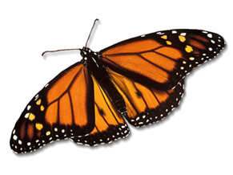

**1 – Pollinator Monitoring Station (20-30 minutes total)**

Students observe pollinator activity on flowering plants and record what type of pollinators they see. They also record air temperature, wind speed, and current weather conditions. Understanding the weather conditions at the same time as making observations of pollinators is important in a scientific study to help explain anomalies in the data (i.e. deviations from what is normal or expected).We are planning to establish more pollinator-friendly gardens, but in order to test whether our goal of getting more pollinators to our park is successful, we need to know what was here in the first place.

***Alternatively, if weather too cold or rainy:***

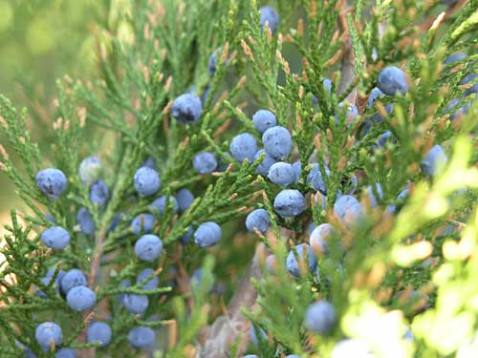

**Eastern Red Cedar berries**

**1 – Phenology Monitoring Station (20-30 minutes total)**

Plants are constantly changing throughout the year, so by observing and documenting when we first see those changes, and comparing those data to large datasets of other people’s observations, we can start to understand how plants are responding to changes in climate and other disturbances. Students will walk through the JBWR documenting the proportions of colors they see and the abundance of berries (i.e. seed production, which is a proxy for the efficacy of pollinators). Notice whether the plants you are seeing are native or invasive and record abundance.

**2 – Soil Physical Station (20-30 min total)**

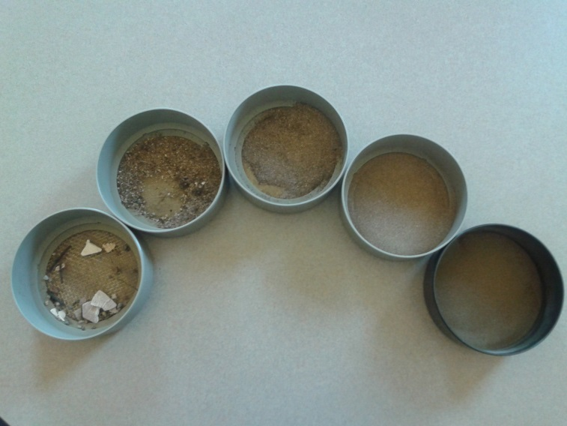Some plants have special adaptations to tolerate shaded habitats, while others prefer high levels of sunlight. Some plants have root systems that can withstand inundated soil, while others have roots that would give way to root rot and die if the soil is too wet. Others are not very picky at all so they are capable of thriving in many more kinds of environments. In this station, students will use the tools of a soil scientist (like the sieves pictured at right) to analyze the sunlight, soil moisture, and soil texture to determine whichplants cannot live in the area being studied. They will compare and contrast the living requirements of select native and invasive plant species. By the end, students should understand why invasive plant species are more able to dominate an ecosystem because they are more adaptable to a wider range of sunlight, soil type, etc. and not as picky as native plants.

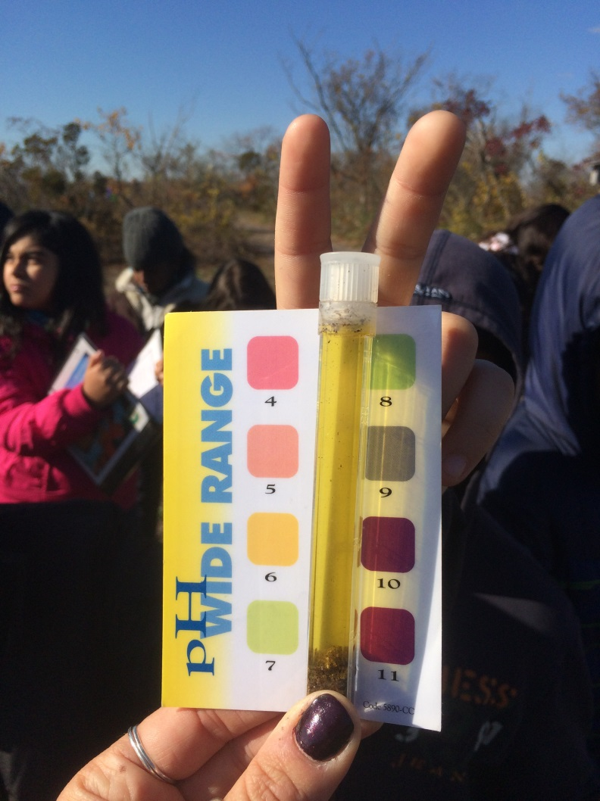**3 – Soil Chemical Station (20-30 minutes total)**

Soil also has chemical properties, like pH (acidic or basic), nutrient content, and salinity, that restrict where plants can grow. Plants need nutrients just like how people need nutrients. Each plant however, needs its own special mix of nutrients to grow and thrive. What is good for one plant is not necessarily good for another plant when it comes to nutrients. In this station, students will perform basic chemical tests to see which plants can live where. By the end of the round, students should be able to determine which plants (native and invasives) can grow in the soil they tested and whether native or invasive plants are more adaptable.

**Wrap-up as a group – What Plants can Grow Here? (5-10 minutes)**

Have the students determine from their charts which native plants could live there. Have them take a plant stake of that species and “plant” it in the future restoration garden.

*Concluding questions:*

* If we put these plants in our garden, what different types of pollinators might we expect to have in our park, then? (note: each plant has some examples pictured on the sign)
* What did you notice about the abundance of native vs. invasive species? Why do you think that is?

If you did pollinator monitoring today:

* Would planting these species increase the diversity of species you saw? Why?
* Why do you think it’s important to monitor pollinators before planting more native species?

If you did phenology monitoring today:

* C:\Users\MLuebke\AppData\Local\Microsoft\Windows\Temporary Internet Files\Content.IE5\2PVJRI1N\MC900088606[1].wmfC:\Users\MLuebke\AppData\Local\Microsoft\Windows\Temporary Internet Files\Content.IE5\NXZXRD2M\MC900437487[1].wmfC:\Users\MLuebke\AppData\Local\Microsoft\Windows\Temporary Internet Files\Content.IE5\BHPUH5J0\MC900437485[1].wmfWould the plants you identified increase the available nectar supply at different times of the year (i.e. are the plants in bloom in different months)? Why might that be important to consider in designing a pollinator garden?

**Appendix A:**

**C:\Users\MLuebke\AppData\Local\Microsoft\Windows\Temporary Internet Files\Content.IE5\2PVJRI1N\MC900355513[1].wmf Vocabulary List**

Accumulate – to gradually gather and increase in number.

Distillation- the boiling of water and then condensing the steam into a clean container.

Distilled water- water that has many of its impurities removed through distillation.

Extraction- the action of taking out something.

Invasive species- an organism that causes ecological or economic harm in a new environment where it is not native.

Inverting- to put upside down or in the opposite direction.

Loam- soil that is made up of about equal parts of clay, sand, and silt where most plants tend to thrive.

Native plants- plants that have developed, occur naturally, or existed for many years in an area (typically for thousands of years or longer).

Native pollinators- pollinator species that have developed, occur naturally, or existed for many years in an area (typically for thousands of years or longer).

Nutrients- ingredients that provide food for growth or development.

pH- a measure of how acidic or basic (alkaline) a substance is.

Phenology- the study of plant and animal life cycle events that are influenced by seasonal and climate changes.

Pipet- a slender tube attached to a bulb for transferring or measuring out small quantities of liquid.

Pollinator- a biotic agent that moves pollen from the male anthers of a flower to the female stigma of a flower to accomplish fertilization.

Resiliency- the ability to bounce back after a disturbance or extreme event.

Sieve- a utensil consisting of a wire or plastic mesh held in a frame, used for separating coarser particles from finer particles.

Soil fertility- a measure of how well the soil supports plant growth.

Soil- loose, weathered material on Earth’s surface in which plants can grow.