War of 1812

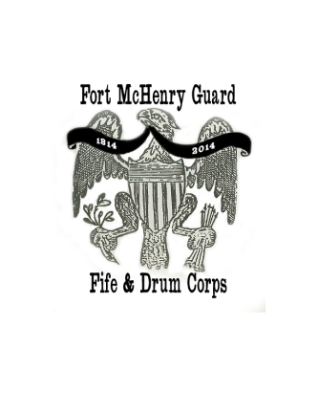
Fife and Drum Camp
June 18-21, 2019

Musicians, Students,
On behalf of the Fort McHenry Guard, we would like to cordially invite you to our War of 1812 Fife and Drum Music Camp, 2019! Over the past few months, we have assembled an array of the most talented and professional instructors from the tri-state region to teach students the art of 19th Century Military Music. Our intention is to hold a Field Music School on the grounds of historic Fort McHenry, to instruct aspiring fifer and drummers in the music and culture of the War of 1812. The approach is entirely hands-on. Participants will experience what it meant to be a musician in our nation’s second war with Great Britain. This includes marching, military formations, musical instruction, flag raising, and much more.
The camp will be held in the morning, from 9 o’clock until 4:00p.m., Tuesday through Friday. Students will rendezvous at a large tent, erected outside of the historic star fort. Students will then engage in an action packed day. They will march into the fort for the morning flag change, roll call and inspection. They will then conduct musical training and workshops, learning and improving with each passing day. Around noon, Dinner Call will be played and they will break for noon meal. At the end of camp, upon completion of all courses, the Fife and Drum school culminates with an 1812 Music Spectacle. The students will form a massive Corps, and display their accomplishments in a performance for the general public. Certificates of completion will then be issued, and students will return home with increased musical and historical knowledge, as well as an official camp shirt, music, and a special memento of their work at the fort. It will be a fun and educational experience that students will long remember.
To participate in the Fort McHenry War of 1812 Fife and Drum School, applications and registration must be completed and mailed/emailed before June 1, 2019. Ages 11 & up. There is no fee required. Acceptance into the school will be acknowledged via e-mail.
Volunteer release forms will be signed by parent and student on the first day.
We look forward to seeing new faces and having a great time learning Fife and Drum! If you have any questions or concerns, feel free to send an email to Ranger Tim Ertel at: timothy_ertel@nps.gov
Thank You,
Ranger Tim Ertel, Music Coordinator
Fort McHenry Guard Fife and Drum Corps
2400 East Fort Ave., Baltimore, Md. 21230

GENERAL INFORMATION
- Students will be provided an official t-shirt to serve as the uniform of the day
- Musicians are also encouraged to wear a hat and/or sunscreen, hydrate before and after sessions, and eat a good breakfast for a long and active day
- Musicians are also encouraged to wear comfortable shoes and shorts
- Volunteers and staff will be available for questions and comments at all times throughout the day
- There will be a large tent to serve as a cooling station. Water will be provided; pack a lunch and snack food.
- Free transportation is available by bus. The Charm City Circulator and #1 bus stop are outside the gates of the park
- Instruments and music will be provided. However, if you have a Fife in Bb or a rope tension snare drum, drum pad with stand, you are welcome to bring them
- Fort McHenry can be reached by phone at 410-962-4290 ext. 250 (Ranger Tim ext. 211)

REGISTRATION
Male _____ Female _____
I wish to learn and/or currently play Fife _____ or Drum _____
Allergies or physical restrictions, medical conditions____________________________________________________________________
Musical Ability Rating________ Shirt Size____
You will be re-evaluated by the music faculty when you arrive at the Camp, but please rate your own ability here:
Beginner _____ Intermediate _____ Advanced _____
Age _____ Grade in School _____ School ____________________________
Student Name _______________________Emergency Contact Name & Cell_______________
Email address ____ ____________ Cell Phone: ____ _
Mailing address _______________________________________________________

