Immediate

Vince Vaise
410-962-4290 Ext. 201
06-06-14

Subject here

Celebrate Independence! Twilight Tattoo! U.S. Army Old Guard! at Fort McHenry on July 5!

Fort McHenry News Release

Fort McHenry National
Monument & Historic Shrine
2400 East Fort Avenue
Baltimore MD 21230

410-962-4290 phone
410-962-2500 fax
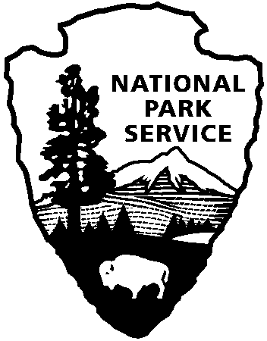
National Park Service
U.S. Department of the Interior

What better way to celebrate the Fourth of July Weekend than to see the U.S. Army Old Guard perform at Fort McHenry National Monument and Historic Shrine?

Come to Fort McHenry National Monument and Historic Shrine on July 5 at 2:00 p.m. for the most musical and colorful afternoon military ceremony of the summer season! The FREE program features patriotic music, military pageantry and living history! The program begins with a concert by the U.S. Army Old Guard Fife and Drum Corps, and Continental Color Guard. Dressed in the uniforms of Washington’s Continental Army, the U.S Army old Guard Fife and Drum Corps plays stirring fife and drum music to audiences worldwide.

The U.S. Army "Old Guard" will be joined by the Fort McHenry Guard. Dressed as the 1814 Defenders of Baltimore, the Fort McHenry Guard will conduct musket drill and stirring fife and drum music.

The highlight of every tattoo is honoring a special individual with the title “Colonel of the Fort McHenry Guard.” Past honorary Colonels have included philanthropists, elected officials and sports heroes. The National Park Service is honored to name Hall Worthington as Honorary Colonel. A recognized civic leader, Hall Worthington has served in the Maryland Army National Guard, 29th Division Association, has lead the Society of the War of 1812, Sons of the American Revolution, serves on the board of the Anne Arundel County Library Association and chairs Fort McHenry's Defenders' Day Committee.

Release date:

Contact(s):
Phone number:
Date:
page 2

The evening program concludes with the audience folding the large 30 x 42-foot Star-Spangled Banner Flag. The evening ceremony is free, and parking is provided on-site.

The tattoo ceremony is FREE and tickets are not required. Visitors attending this ceremony may bring lawn chairs and blankets.

Every ceremony concludes with the folding of the great 30 x 42-foot Star-Spangled Banner flag, playing of “Taps” from the ramparts and the firing of the fort’s cannon.

