Sea Services Ceremony at Fort McHenry!
Celebrate the 100th Anniversary of the United States Coast Guard! U.S. Marine Corps Silent Drill Platoon to Perform!
Fort McHenry News Release

Fort McHenry National
Monument & Historic Shrine
2400 East Fort Avenue
Baltimore MD 21230

410-962-4290 phone
410-962-2500 fax
Immediate

Vince Vaise
410-962-4290 Ext. 250
05-11-15
06-09
Subject here

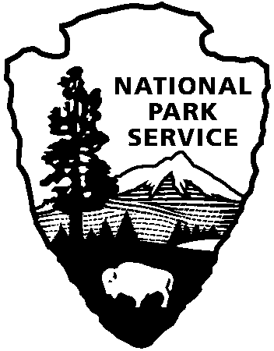
National Park Service
U.S. Department of the Interior

Come to Fort McHenry National Monument and Historic Shrine on August 1 at 2:00 p.m. for a special FREE afternoon tattoo ceremony featuring patriotic music, military pageantry and living history! The program begins with a concert by the Chesapeake Concert Band, precision rifle drill by the United States Marine Corps Silent Drill Platoon, presentation of colors by the Coast Guard Color Guard and demonstration hand-to-hand combat exercises and fife and drum music from the War of 1812 by the Fort McHenry Guard.

The highlight of every twilight tattoo is the designation of the "Honorary Colonel of the Fort McHenry Guard." Rear Admiral Stephen Metruck, head of the Fifth U.S. Coast Guard District, will be honored as "Colonel of the Fort McHenry Guard." Pas t Honorary Colonels have included philanthropists, sports heroes and those who have given to the community. This year marks the Centennial of the U.S. Coast Guard.

During World War II, Fort McHenry served as a U.S. Coast Guard training base. Over 26,000 men and women trained in shipboard firefighting and port security. It is an honor to have the USCG back 70 years later for this special afternoon ceremony.

Following the tattoo, visitors will be invited to fold the great 30 x 42-foot Star-Spangled Banner flag and hear the firing of the fort’s evening gun.

The Fort McHenry Guard offers a unique historical experience at every performance. Dressed in the uniform of the 1814 defenders of Baltimore, the Guard will be doing a cannon drill, musket exercise and a bayonet demonstration. The evening program concludes with the audience folding the large 30 x 42-foot Star-Spangled Banner Flag. The evening ceremony is free, and parking is provided on-site.

With the physical and national legacy of Fort McHenry as the background, Hayward has issued an open invitation to Baltimoreans to come to the fort to be photographed and filmed and to make their marks on the subject of what it means to be a patriot today. .

Fort McHenry is the first stop in Hayward’s Patriot Acts journey to ten historic sites throughout the nation this coming year, where he will continue to create unique, “amazing and enticing portraits.” Richard Merkin, Vanity Fair.

In these public portrait events, subjects, in conversation and collaboration with Hayward, use a bucket of paint, brushes and an unlimited supply of large-scale photo studio background paper to create their own personal setting of text and/or image that reflect their thoughts and beliefs of what it means to be a patriot in America today.

Release date:

Contact(s):
Phone number:
Date:
Release code:

page 2

