♦ Educational Programs ♦

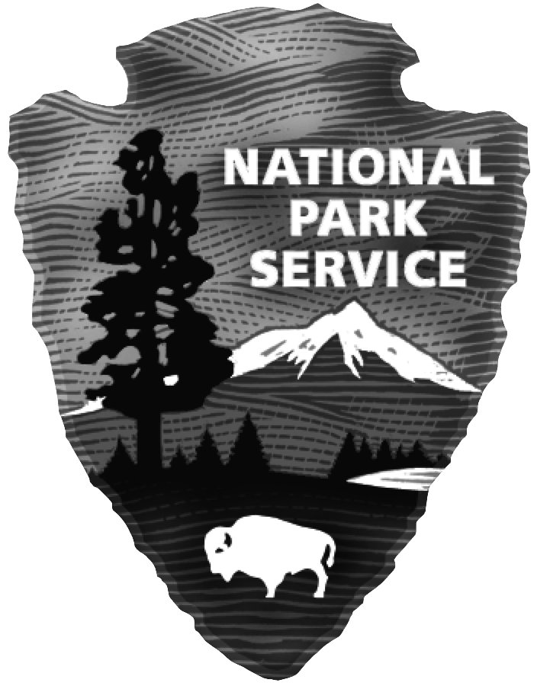



Fort Davis National Historic Site

### P.O. Box 1379

### Fort Davis, Texas 79734

**Phone 432-426-3224 ext.220 FAX 432-426-3122**

**HOURS 8:00 a.m. to 5:00 p.m.**

**→** **TEACHERS! Visit the Fort and have your students do an education program.** **Check out our website at**

[**www.nps.gov/foda**](http://www.nps.gov/foda)**. At the link “For Teachers,” download lessons for the classroom. Find out how to get a**

**fee waiver for your class. Schools visit free! Teachers get a 20% discount in the park bookstore on purchases.**

**All activity-based education programs comply with state standards and promote critical thinking skills.**

**ACTIVITY-BASED EDUCATION PROGRAMS AT THE PARK**

Grades 3-6 **Footsteps Through the Fort** (2 hrs) Students in small groups with sponsors experience an

Grades 6-12 interdisciplinary Social Studies - Math - Science adventure. Emphasizes map reading skills. At each stop, students answer color-coded questions. Can help improve TAKS/STAAR scores

in a fun, hands-on, real-world way! Program for Grades 6-12 has Algebra & more involved

Math, and it includes a “Mystery Photo” that requires clues and deductive reasoning to identify.

Grades 4-12**Tech Trek** (2 hours) Students explore the fort using technology from the past and present.

Basic map-reading skills are reinforced as students navigate with the use of both compass and

GPS unit. A pre-visit CD is available to introduce students to the fort and provide pre/post-visit

activities for the classroom. The park provides 20 compasses and 20 GPS units (or bring your

own). Divide students into small groups, with an adult in each group. Bring batteries (2-AA’s

for each GPS) and a camera for each small group. For advanced high school science students,

*Tech Trek Advanced* uses GPS receivers only (no compasses).

Grades K-5**Touch the Past!** (1½ hours) An Apache cradleboard…a pen that’s a *feather…*a button hook

for shoes? This bag is just *full* of the strangest things! They must be leftovers from olden days at

Fort Davis. Handle an object. Imagine it’s yours. But who did it *really* belong to? Students

are challenged to locate similar objects in the refurbished buildings as they explore the Fort with

a sponsor who carries objects in a haversack like the soldiers used. This multi-disciplinary

program is hands-on learning at its best.

Grades 3-5**Tell Me More—Photo Activity** (1½ hours) Don’t you *love* old family photos? Kids do too!

Let their imagination run wild as they carry photos around the Fort in this challenging & fun

social studies / language arts program. Students make believe the photos are from their own

family history and invent stories of imaginary ancestors to later share with the class. Students

“step back in time” and imagine what life was like without electricity, running water, or an

indoor toilet. Each student should bring notebook & pen.

Grades 6-12**The Fort Davis Bugle: Tell it Like it Was—Publish an Old-Time Newspaper (**2 hours)

Here’s a program for your college-bound students. The *Bugle* “publishes” story features and

advertisements for folks stationed at Fort Davis back when it was an active frontier army post.

Students create a newspaper about people and events at the Fort in the 1880s. Stories can be

shared back at school. This program has a strong emphasis on creative thinking, English

writing & grammar skills, and History in a vibrant context. Each student should bring a

notebook and pen.

**PARK VIDEO**

15-minute video shows in the auditorium every ½ hour or upon special request.

A short history of Fort Davis.

Teachers who prefer to maximize their time at the park can purchase this video at 20%

discount (approx. $20 total) and show it ahead of time to students or on the bus.

**RETREAT PARADE SOUND PROGRAM**

Plays outdoors on loudspeakers at 11:00, 2:00, and 4:00; length 18 minutes.

This audio program is based on a historic ceremony performed at Fort Davis in 1875

to honor former U.S. President, Andrew Johnson, who died that year.

## FOR YOUR CLASSROOM: Traveling Trunks

To bring history into your classroom, the traveling trunks are loaned out for one or two weeks

to schools within 100 miles of the park. The “Buffalo Soldiers in the 19th Century” and

“Frontier Women in the American West” trunks contain lesson plans,

as well as soldiers’ uniforms, military equipment, and period women’s clothes.

The TEKS-compliant trunks for grades 4 – 9 are delivered and picked up by the park.

