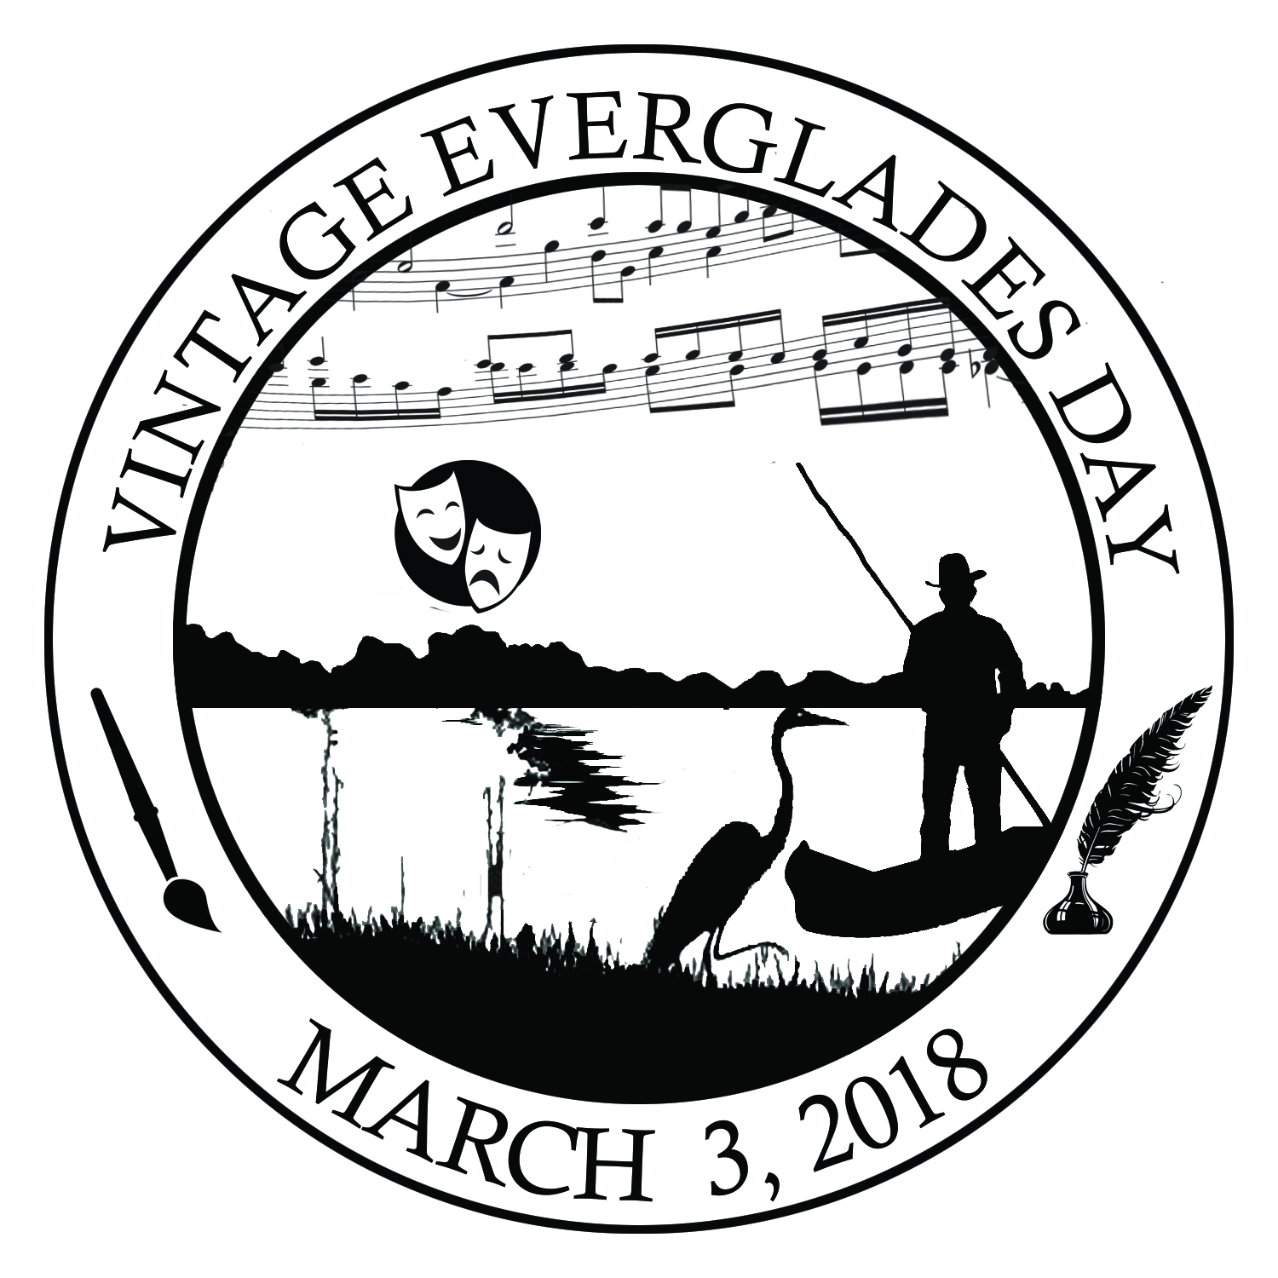 | Vintage Everglades Day  Saturday, March 3, 2018  Program Schedule

Time | Event | Meet At
10 am-2pm | Portrayals of People from the Past | Royal Palm Lawn
10 am-2pm | Create Your Own Music, Poetry, and Watercolor | Royal Palm Lawn
10:00 | Flag Ceremony: Troop #361 | Royal Palm Flag
10:05 | River of Song: A Musical Tribute to the Everglades by Mary Adelyn Kauffman | Royal Palm Benches
10:30 | Guided Walk: Anhinga Amble with a Dredgeman | Royal Palm Benches
10:45 | Alberta Godfrey: A Reading from the classic novel of Zora Neale Hurston, Their Eyes Were Watching God | Royal Palm Benches
11:00 | Tonya Howington: The Vintage Poets of the Everglades | Royal Palm Benches
11:15 | Alyssa Boge: Telling the Seminole Story: Ah-Tah-Thi-Ki Museum | Royal Palm Benches
11:30 | Cesar Becerra: Listening to the Glades | Royal Palm Benches
Noon | History in Song: Grant Livingston Performs | Royal Palm Benches
12:45 | Deborah Mitchell: Artists in Residence in Everglades | Royal Palm Benches
1:00 | Audrey Peterman: How National Parks Inspired the Artist in Me | Royal Palm Benches
2:00 | Guided Walk: Nike Missile Site Tour with Leon Howell | Daniel Beard Center
2:30 | A dramatic reading of Footprints: Mary Barr & Kirk Munroe’s Love Letter to Florida, a play by Sandra Riley | Ernest F. Coe Visitor Center Theater

