United States Department of the Interior

NATIONAL PARK SERVICE
National Trails Intermountain Region
P.O. Box 728
Santa Fe, New Mexico, 87504

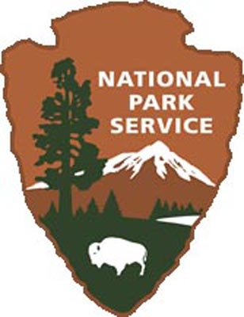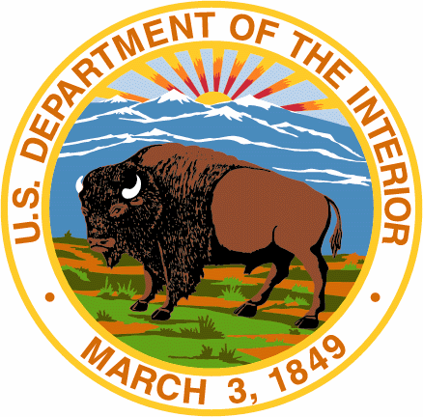

In reply refer to:

INSTALLATION OF OFFICIAL NATIONAL HISTORIC TRAIL SIGNS FOR THE _______________________ NATIONAL HISTORIC TRAIL

[The county, city, other right of way (ROW) jurisdiction] has authorized the __________ Association through its agent [project manager] to identify and erect official national historic trail signs on roads along the [name of trail] within its jurisdiction.

______ [number] signs shall be erected in [the county, city, other jurisdiction] in the locations identified on the attached sign plan [Attachment 1]. The signs shall measure ______x______ in size. Lettering on the signs shall measure ______. The signs shall include the logo for the national historic trail and directional arrows as appropriate. The signs shall be provided to __________ Association by the National Trails Intermountain Region office of the National Park Service (NPS).

Specifications for sign posts and hardware, installation procedures, and distance from the road edge of pavement shall be mutually determined by the [road ROW jurisdiction] and the [project manager]. The signs shall be installed by _______________ in accordance with all [road ROW jurisdiction] requirements and with oversight by the [road ROW jurisdiction]. Fabrication of the signs will be completed by NPS through the Utah Correctional Industries, Draper, Utah sign shop unless otherwise noted.

The [road ROW jurisdiction] hereby agrees to indemnify, save, and hold harmless the United States against all fines, claims, damages, losses, judgments, and expenses arising out of, or from, any omission or activity of such person organization, its representatives, or employees.

____________________________________ _______________________
Authorized road right of way Representative Date

