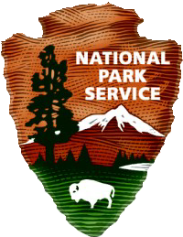

National Park Service
U.S. Department of the Interior
211 Main Street
West Orange , New Jersey

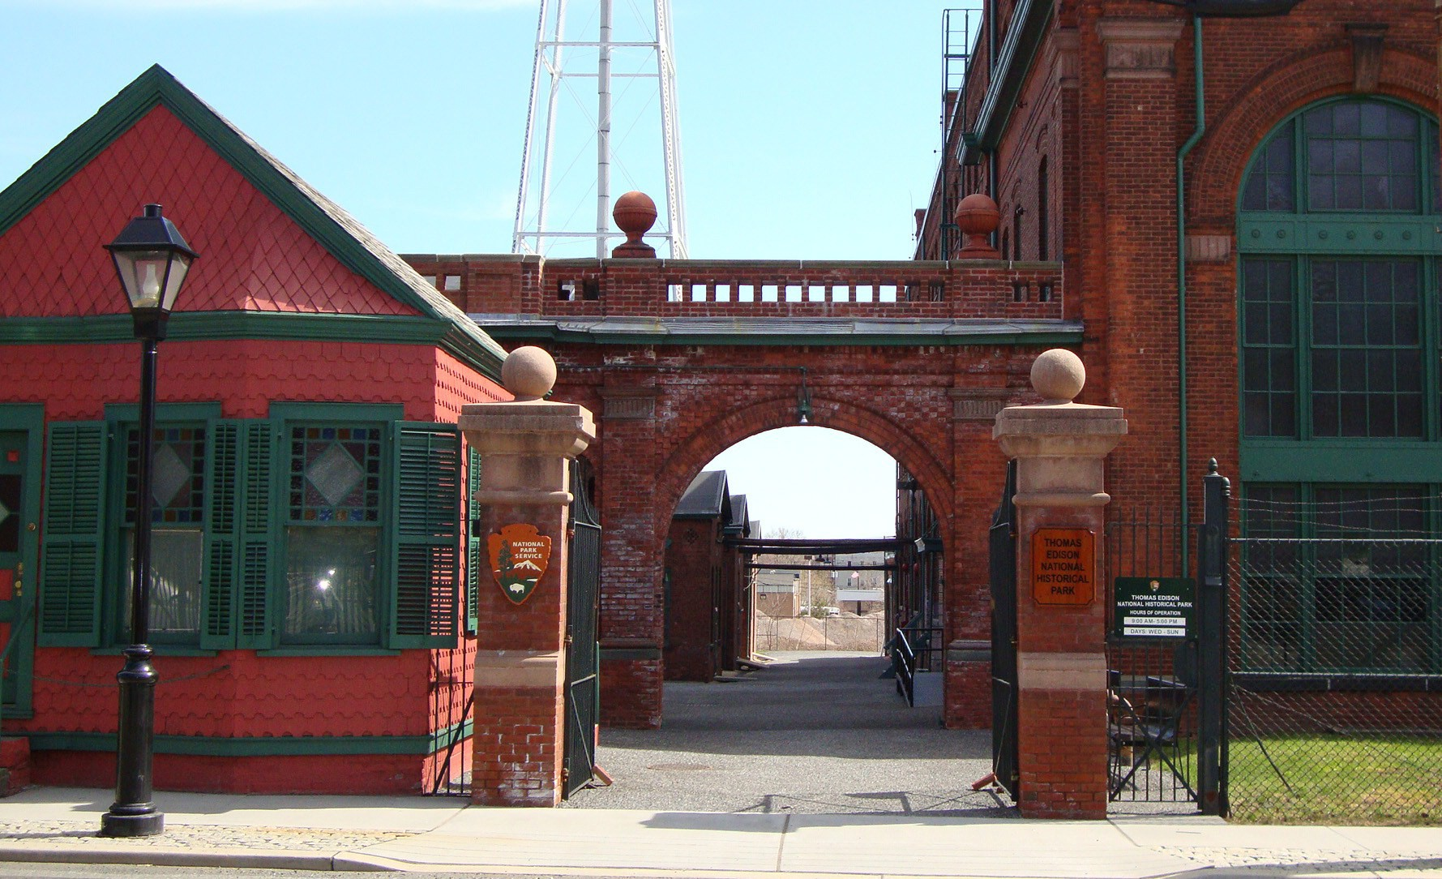

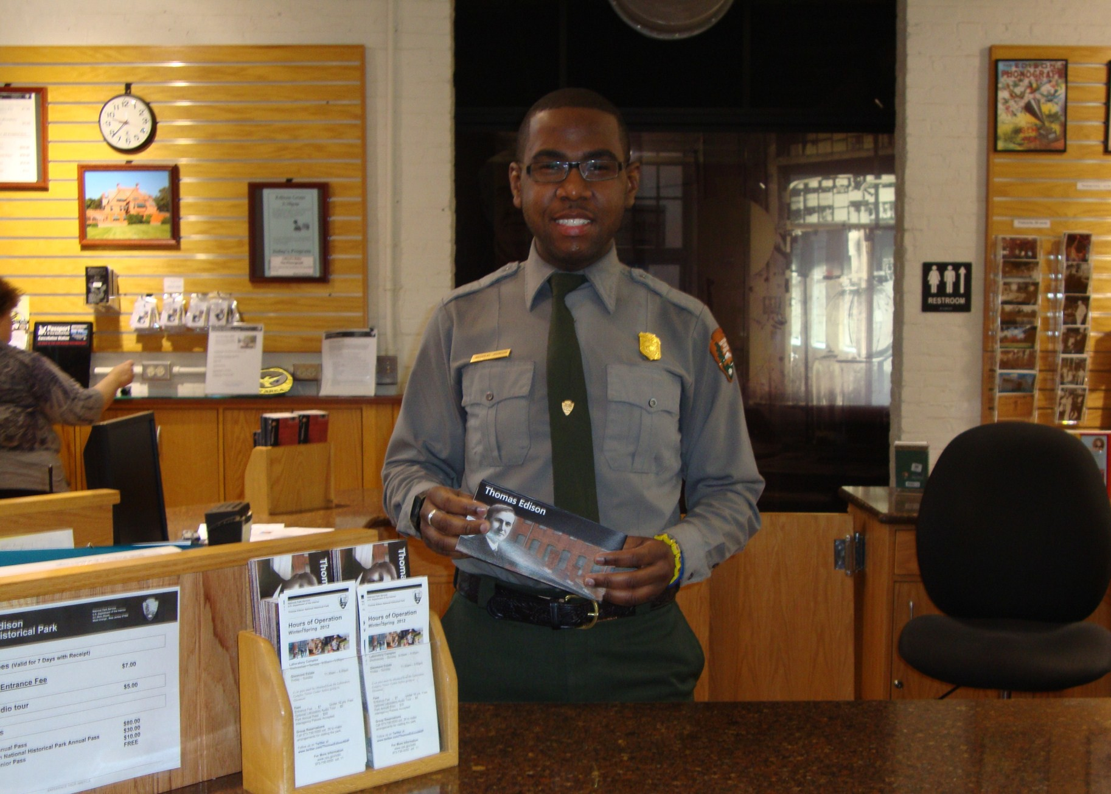
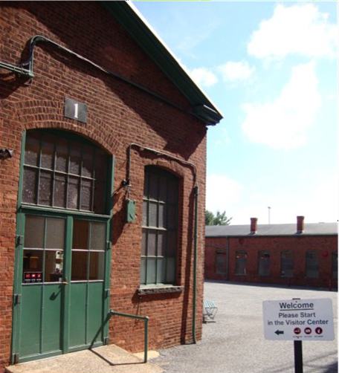

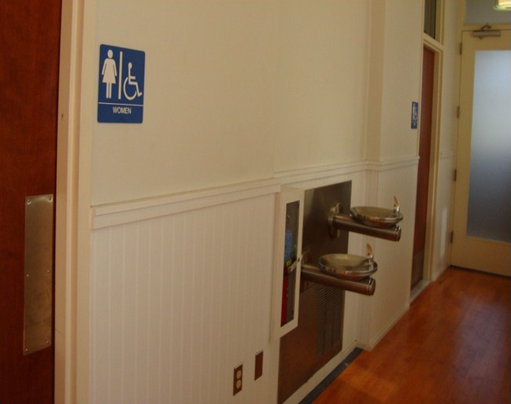
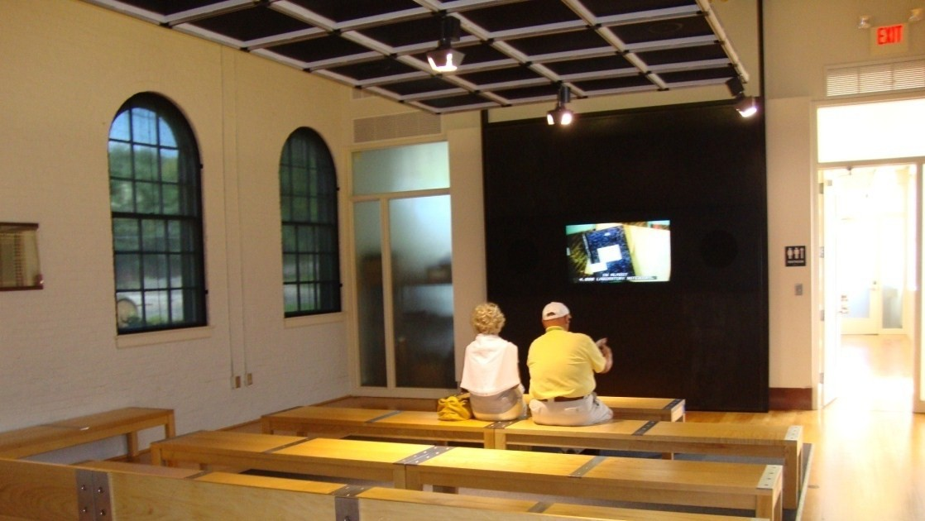

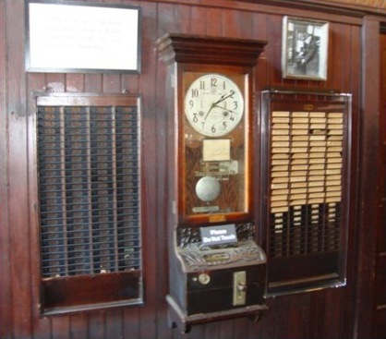
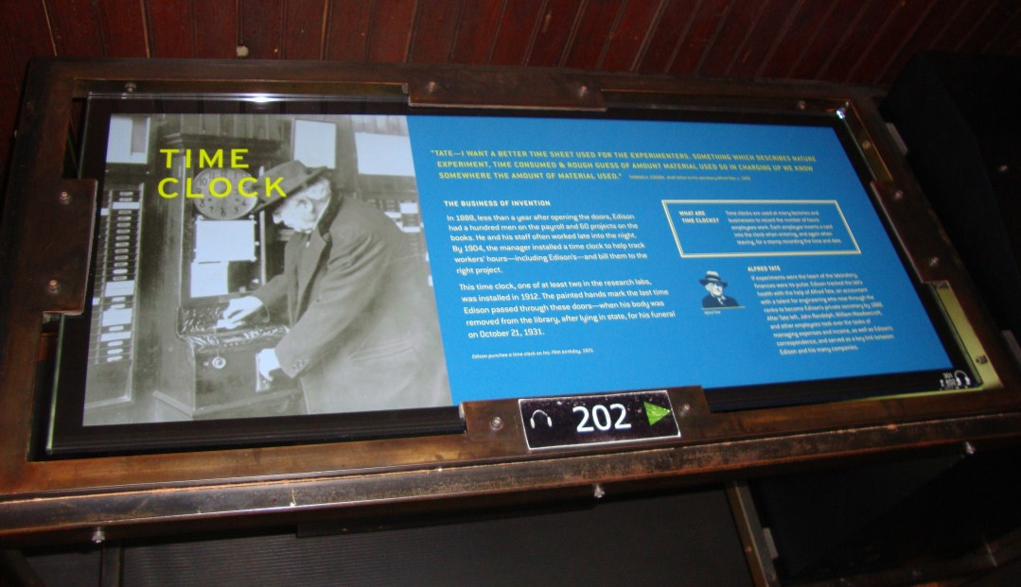
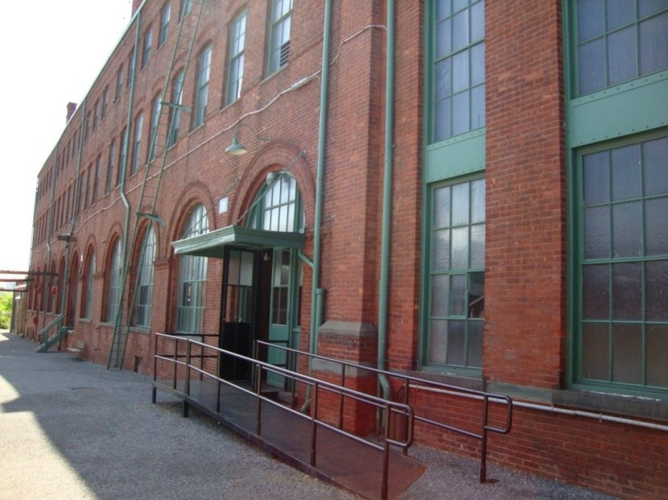

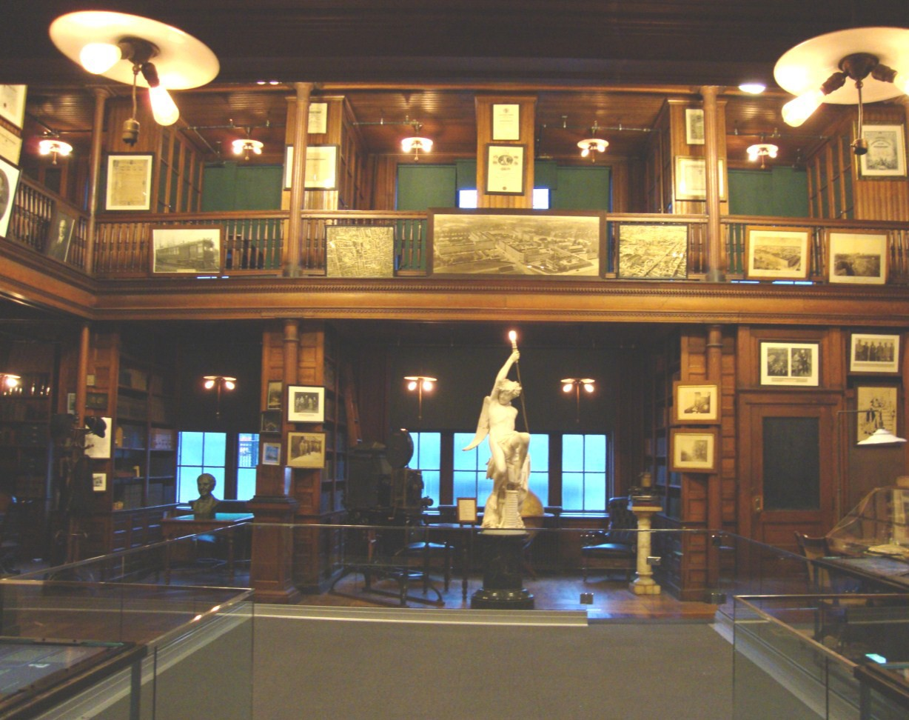
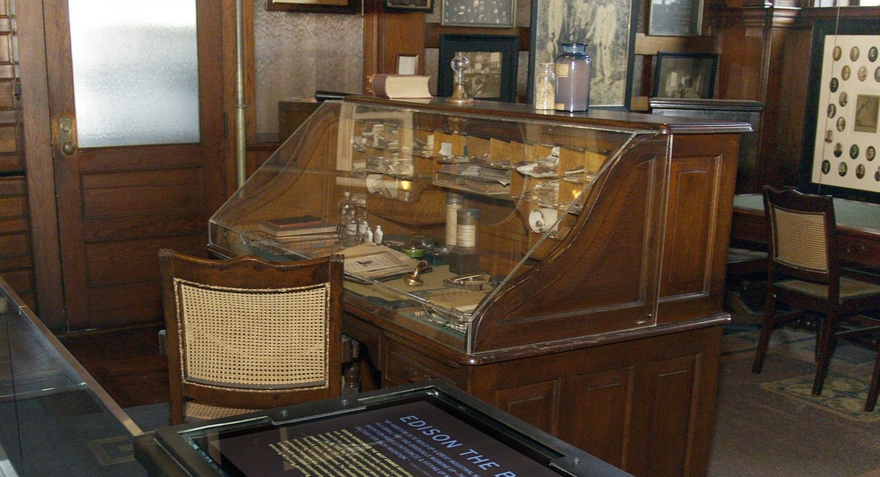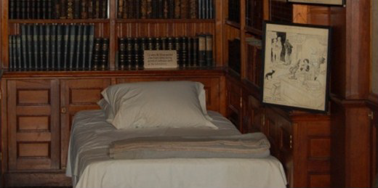

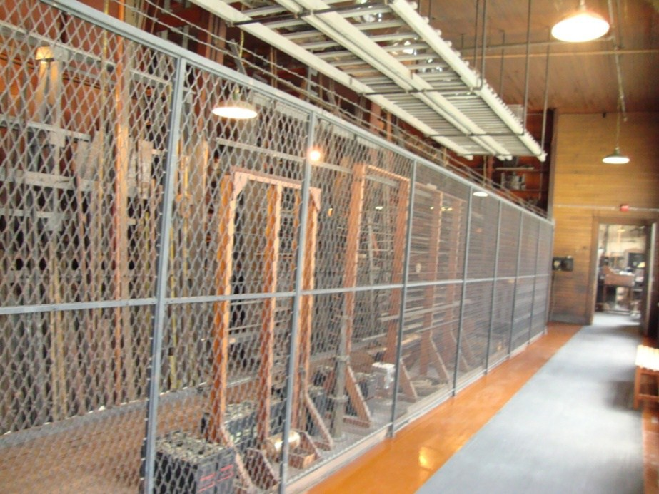
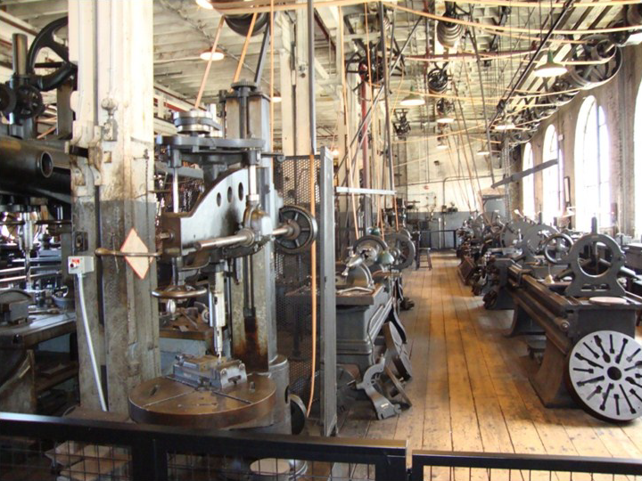

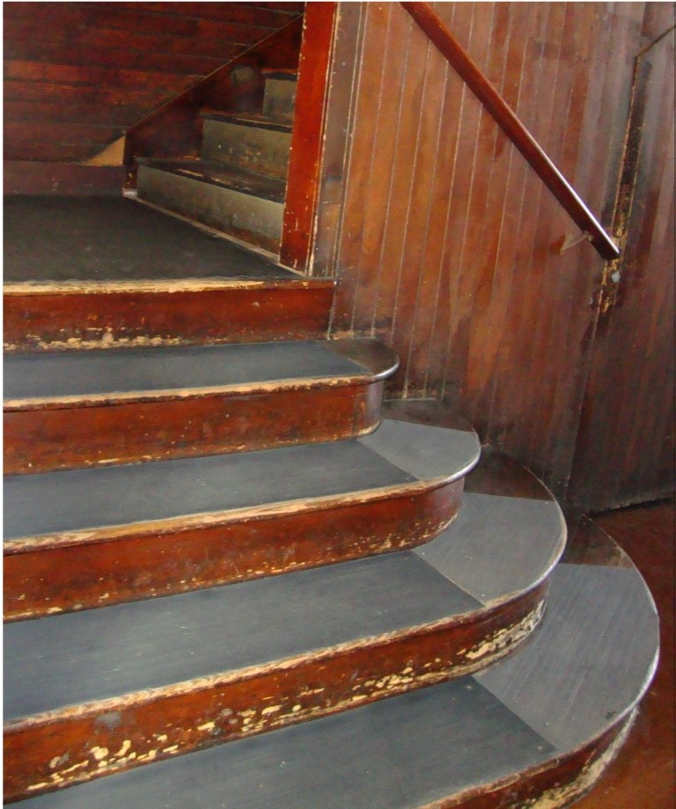
How To Get Upstairs
You have a few options to get upstairs and explore the rest of the building.

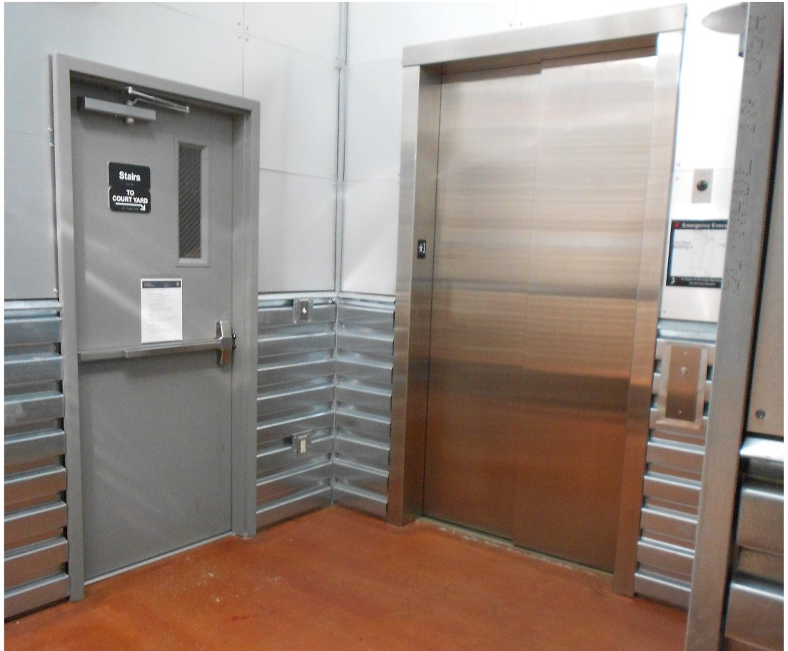
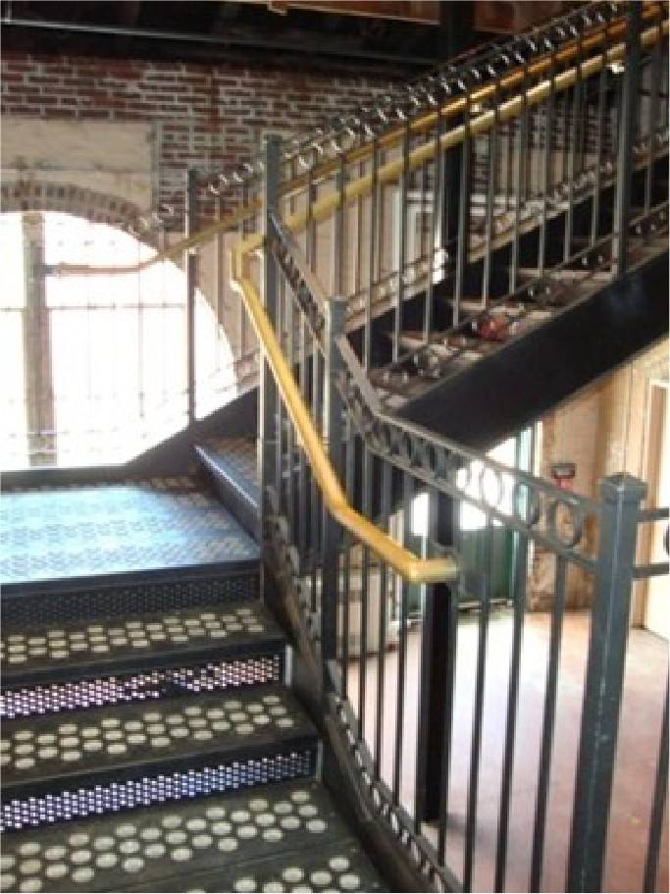
Passing through the door at the end of the Heavy Machine Shop you will find a hallway with an elevator. The door next to the elevator opens to a metal staircase. The elevator and metal staircase are available on all three floors of Building 5. They are located opposite the wooden staircase on each floor.

The wooden staircase on the 1st Floor of Building 5 begins just past the Library. It is available on all three floors .

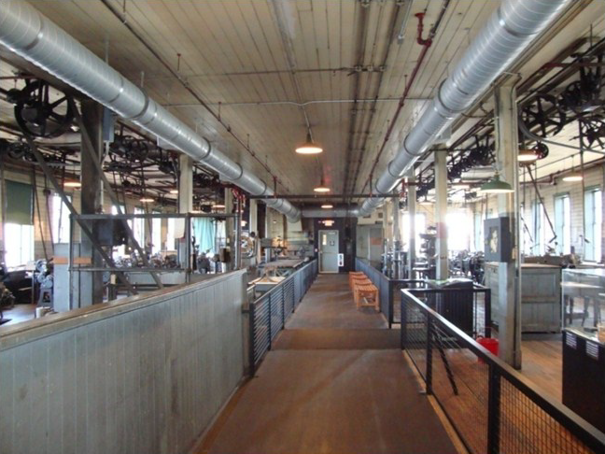
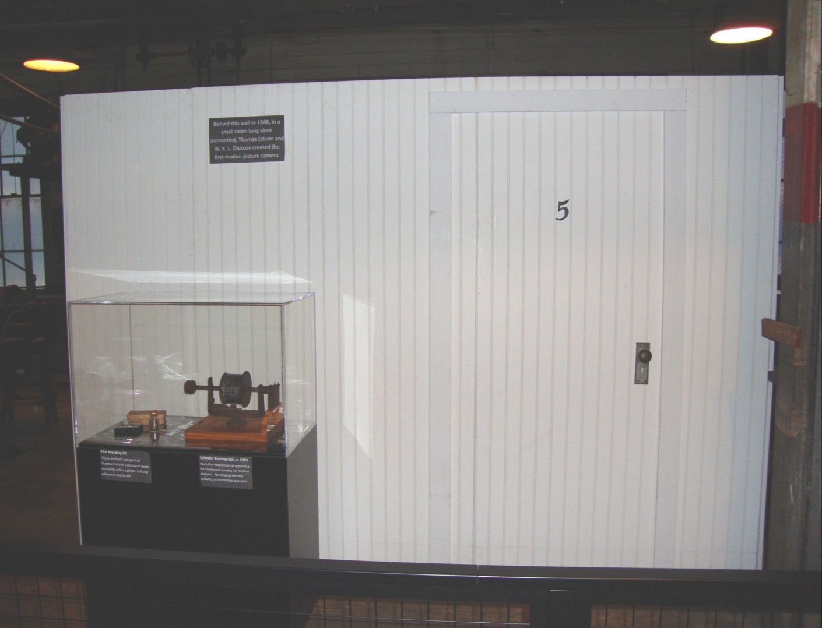
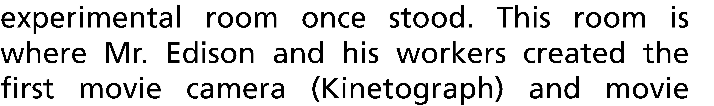

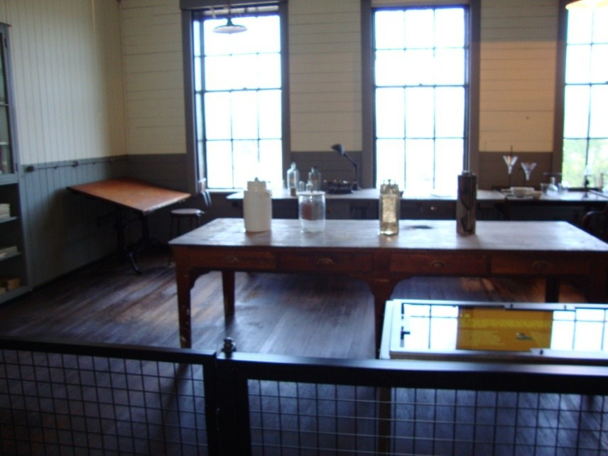

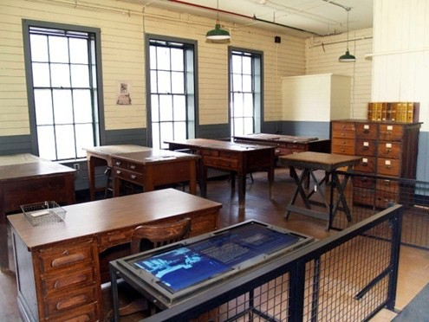

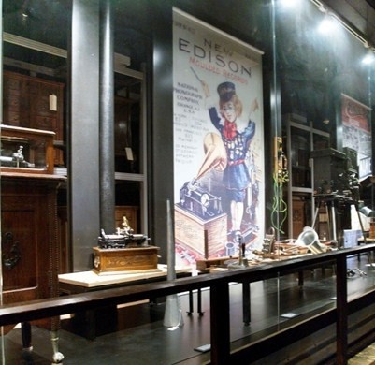
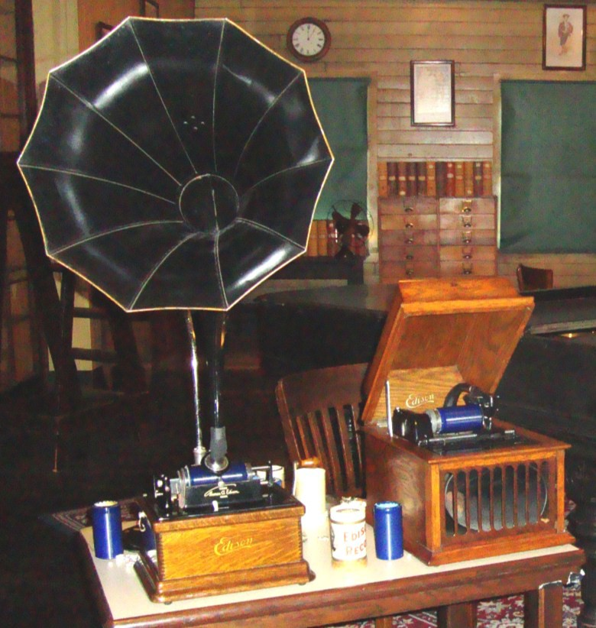
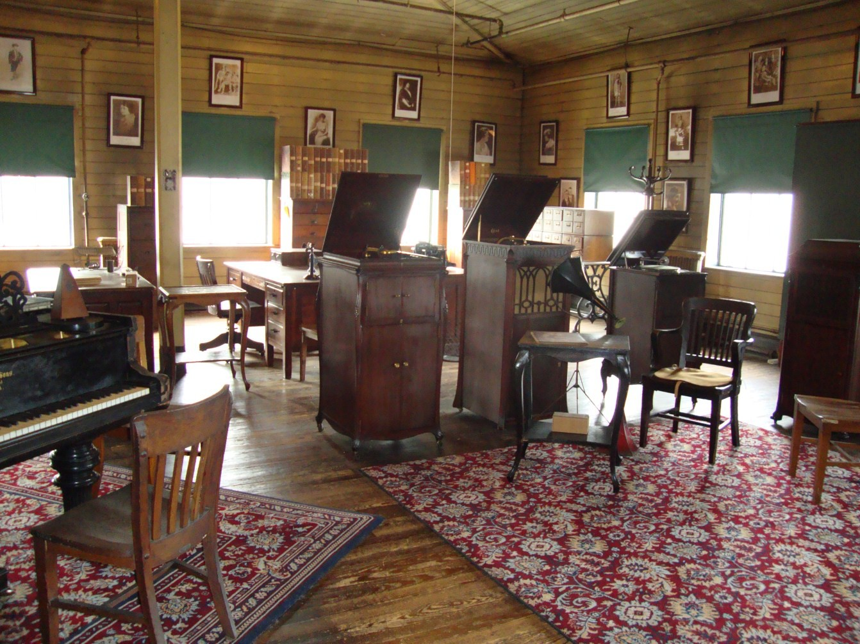

3rd Floor Building 5

Photo Department Exhibits & Storage
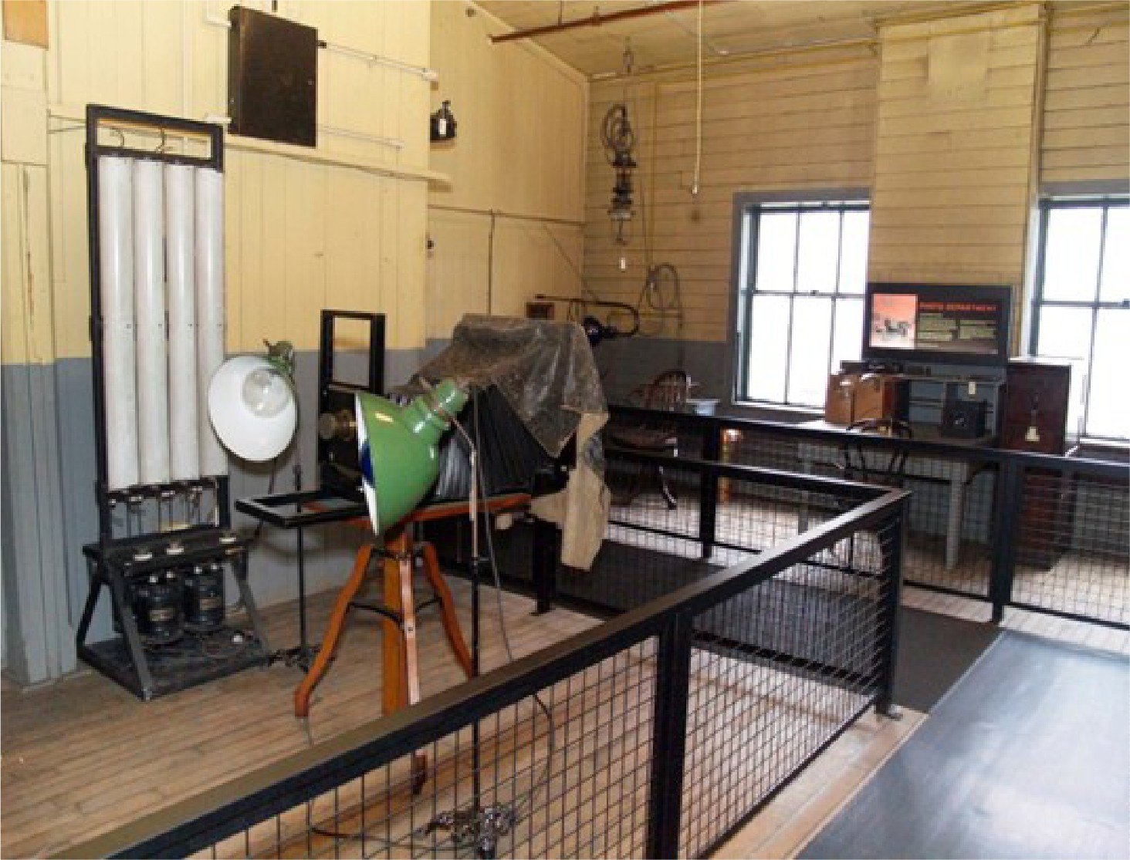
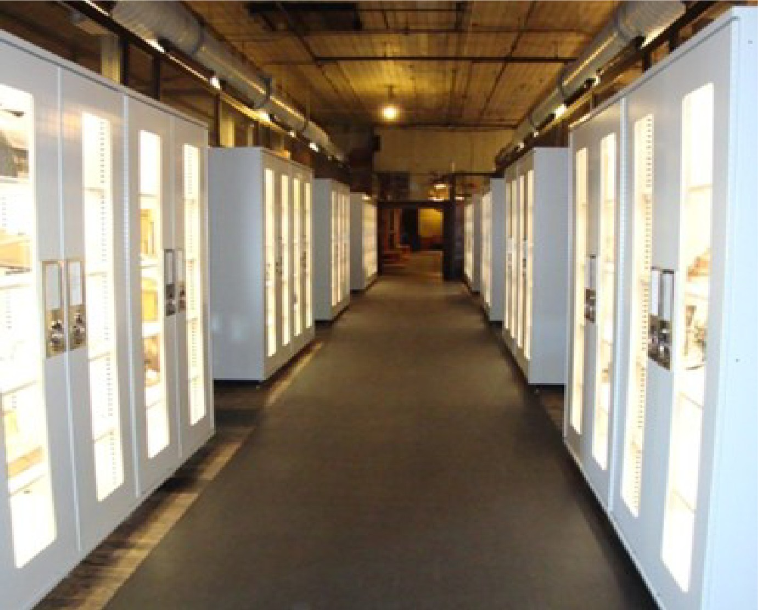

The Photo Department. The people who worked in this room took and prepared pictures of Thomas Edison and his inventions for newspapers and advertisements.
On the 3rd floor there is a section where you will walk through and see a variety of different inventions and artifacts in exhibit cases and in storage. These items were left here by the Edison Company.

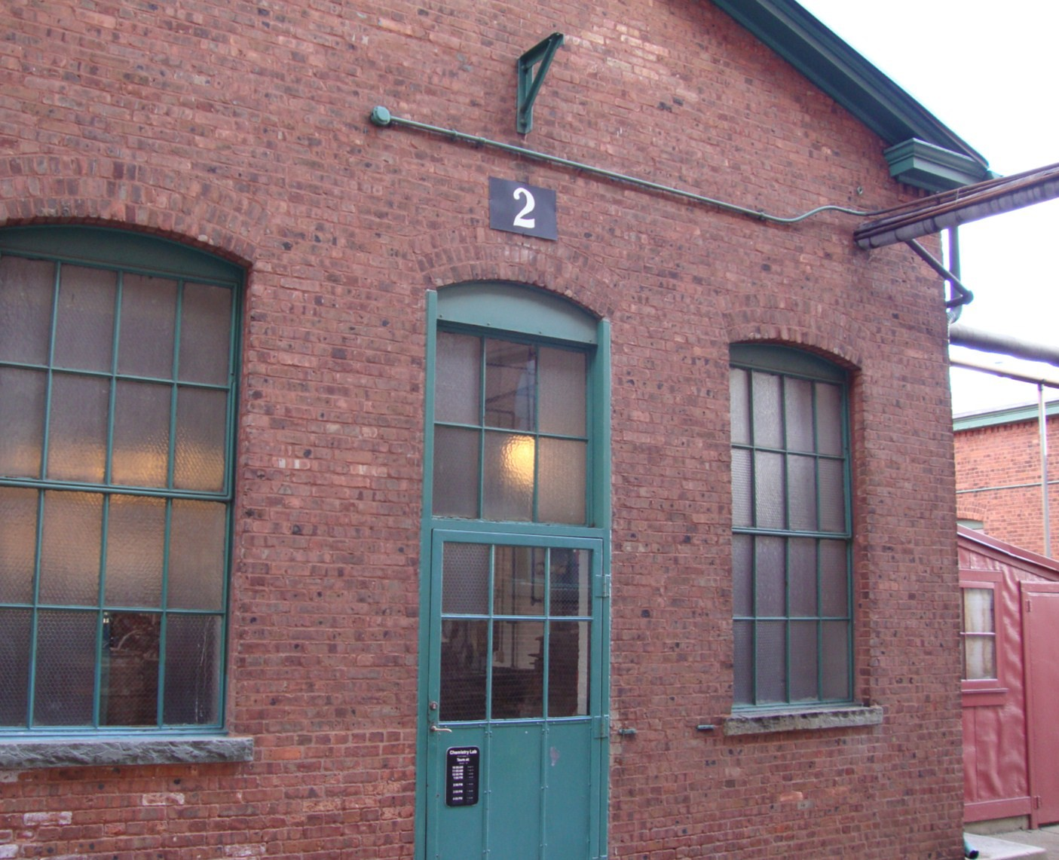
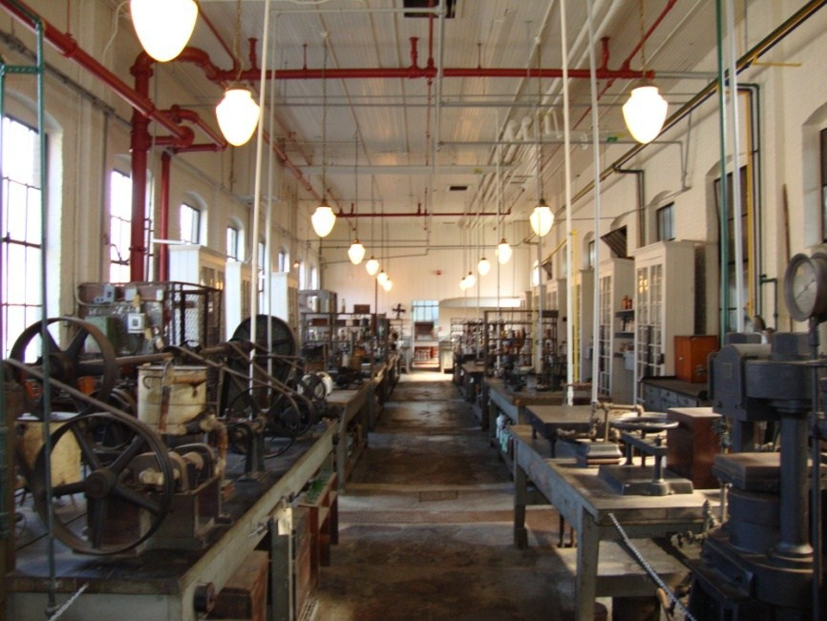

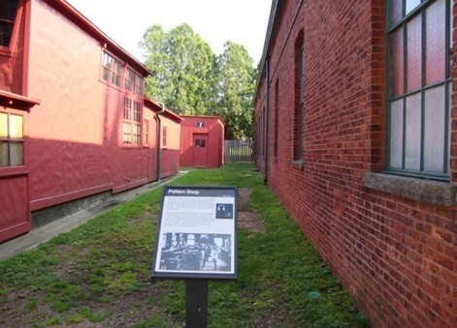
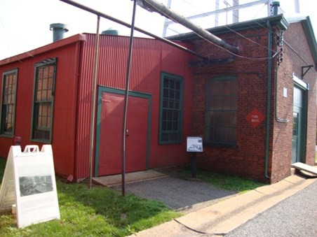
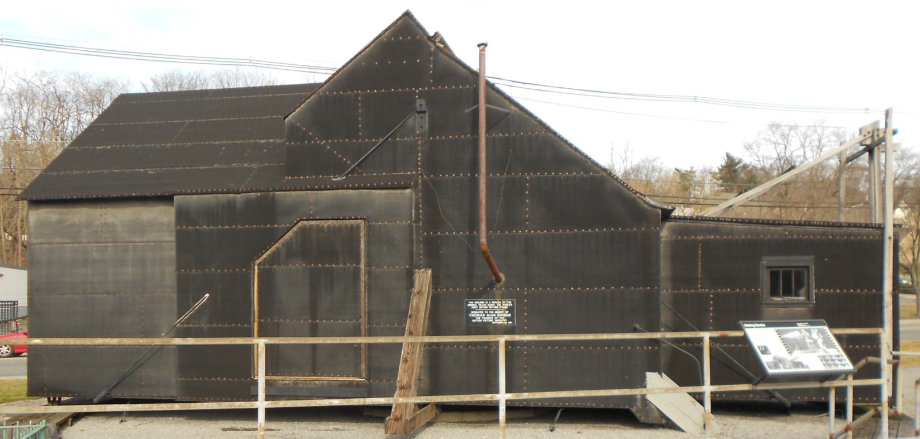

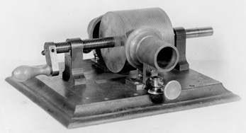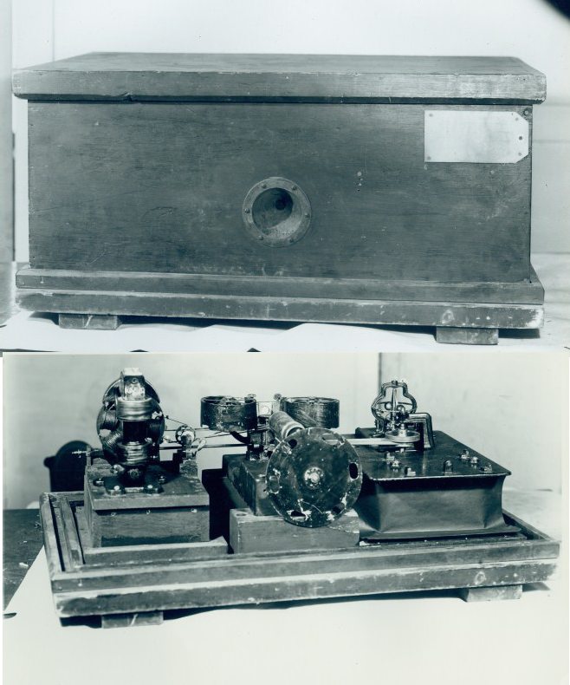
Kinetograph

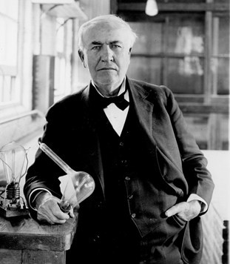
The 1877 Kruesi Model Phonograph

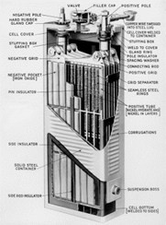

Glossary

Invention- a new useful process, machine or improvement that did not exist before.

Prototype- a working model of your invention.

Artifact- object with historical value.

Laboratory- a building used to conduct experiments. Experiment- a test, or trial to discover something new. Blueprints- a detailed outline or drawing of inventions.
Chemistry- a branch of science where you take chemicals, combine them and create new things.

Workers or Muckers- people who work for Mr. Edison and help him with his experiments and inventions.

Parent/Guardian Recommendations

This is only a guide. Please feel free to explore our site in which ever manner is most convenient and logical for your group and your visit.

When you enter the Visitor Center you may rent an audio tour to use during your visit. These are helpful tools, that give you a more in-depth explanation of the site as you explore. We also have informational panels in almost every room and in front of most our buildings as well, describing what these spaces were traditionally used for.

If during your visit you need a quiet space, we recommend spending time at the far end of the 3rd floor in Building 5. There is a sunny alcove there lined with benches.

We hope this guide is helpful and enhances your whole family's visit. Contact a Park Ranger any time during your visit if you need assistance or have questions. We would also like to encourage you to share feedback on the usefulness of this picture guide and how we can change it to make it even more effective.

We hope you enjoy your visit!
~ The Staff of Thomas Edison National Historical Park

