The restoration of the oval island at the northeast corner of Glenmont has been a possible project since January, 2009, when Mary Jo Patterson and Amy Trimarco of the Rutgers Cooperative Extension (RCE) Master Gardeners of Essex County (MGEC) first approached the park service about completing projects at Glenmont as part of their Master Gardener certification. The “Glenmont Project” was established, and the canna bed behind the mansion was the first project that year. But, the oval was never out of mind, as the Master Gardeners passed it every time they went to work on the canna bed.

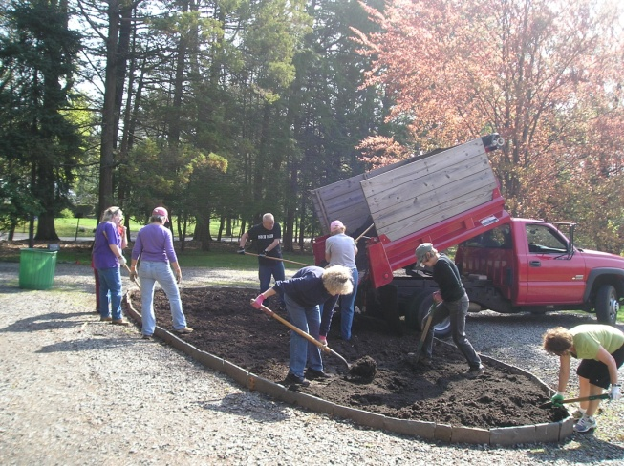
The Master Gardeners hard at work.
Master Gardeners Irene Dunsavage and Jean Grossman presented a design that included a plant budget and work schedule. With approvals in hand and with a generous contribution from the Friends of Thomas Edison NHP, the Glenmont crew made up of students from the 2011 Master Gardener program went to work. They raised the 10” bluestone blocks encircling the oval, uplifted the vinca, turned the soil, worked in topsoil and compost, and re-layed a 12” deep border of vinca. On May 10, the crew began planting with deer resistant perennials and annuals, supplemented with exotics such as cannas, all of which were consistent with the historical vegetation of the period to provide a four-season interest.

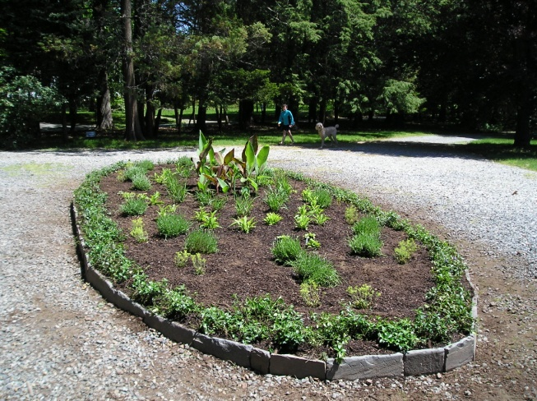
After
Work on the re-established island, as well as the other gardens that make up the Glenmont Project will be ongoing, and it is hoped that they bring as much enjoyment to visitors of Glenmont as they do to the Master Gardeners who helped restore them

