National Park Service  U.S. Department of the Interior | Thomas Edison  National Historical Park |  | 211 Main Street  West Orange, NJ 07052  973 736-0550 phone  973 736-6567 fax
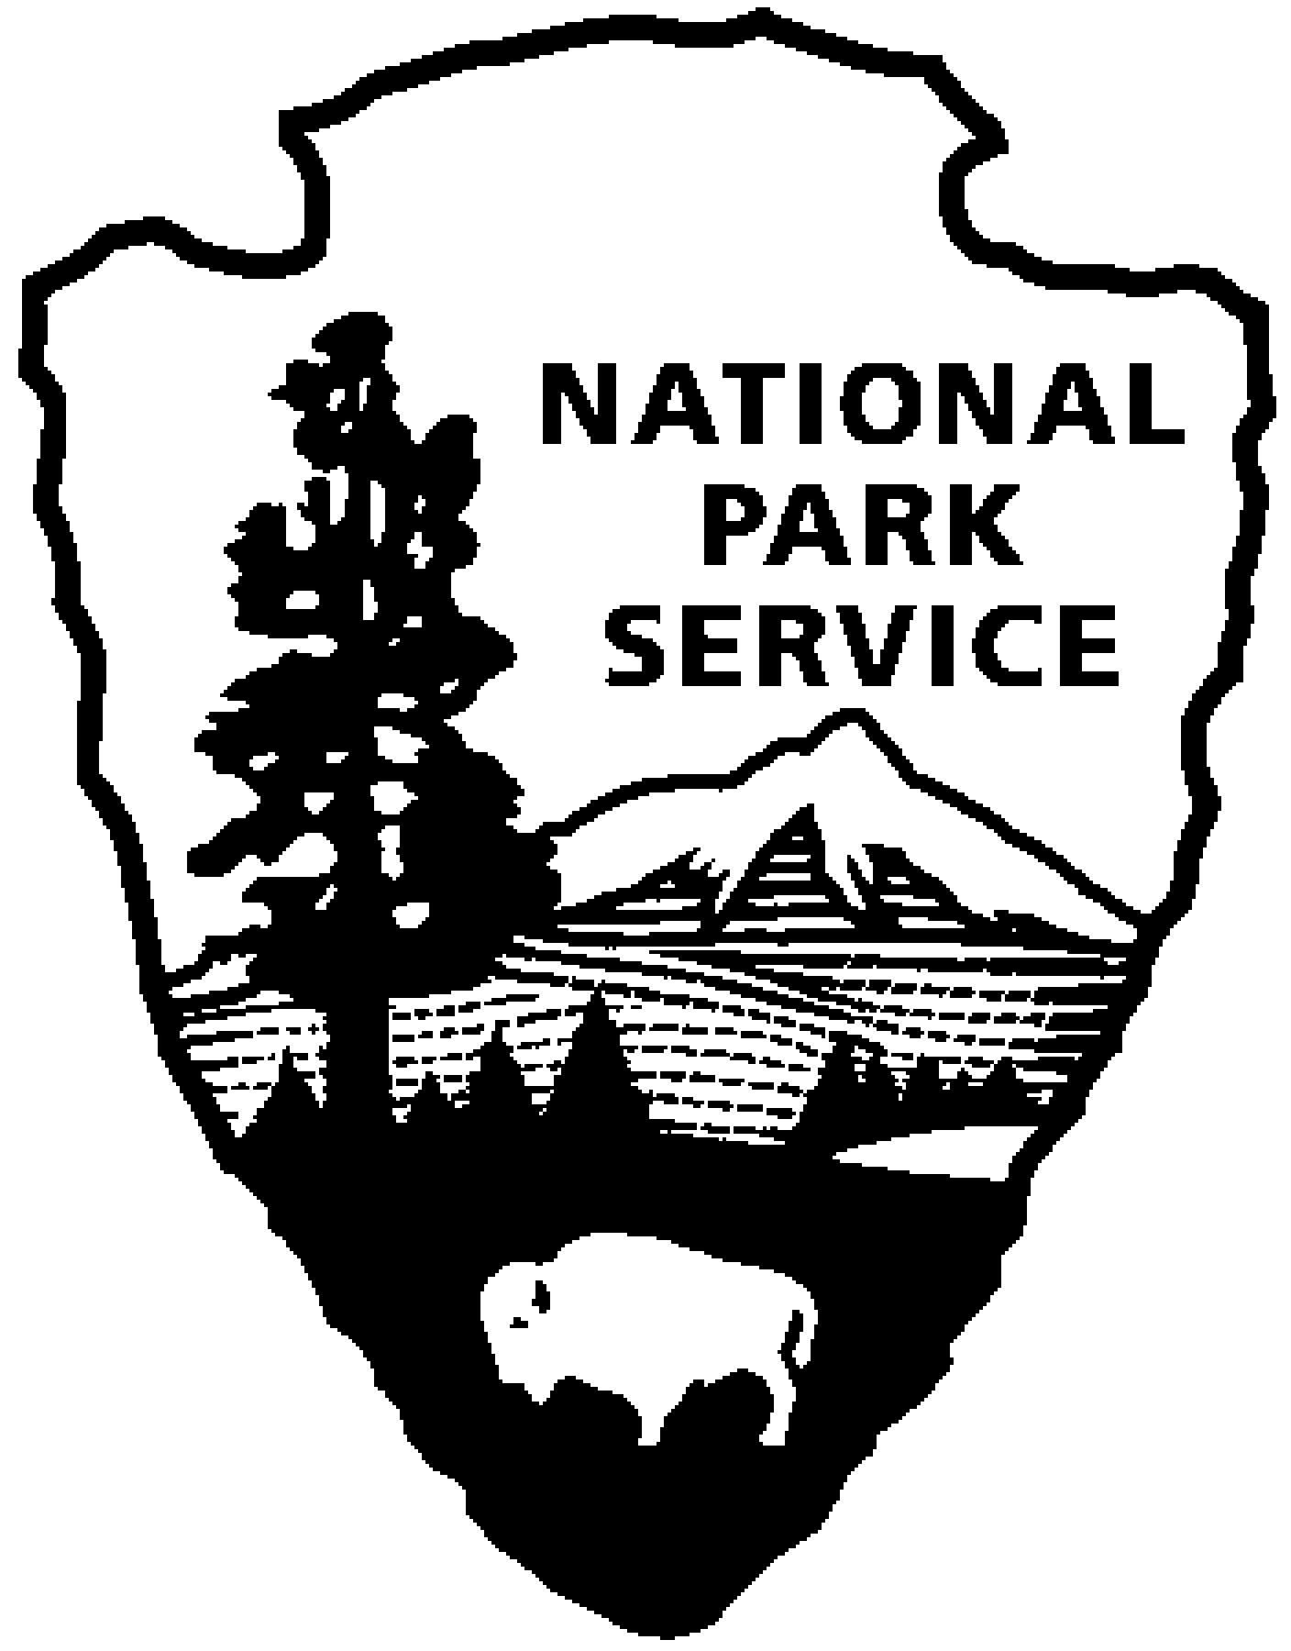
Thomas Edison NHP News Release
For Immediate Release
Contact: Theresa Jung
Phone: 973 736-0550 x50

A PHONOGRAPH IN EVERY HOME - JUNE 2014
Year of Innovation Series Continues

WEST ORANGE, NJ – Turning the tinfoil phonograph from a curiosity into a commercial product became a major project at West Orange. From the late 1880s to the 1920s Edison’s lab designed talking machines for office workers and produced phonographs and records that provided millions of consumers with pre-recorded music. Explore these ideas, attend a program, and see a special exhibit of original artifacts, documents and historic photos during the month of June at Thomas Edison National Historical Park (NHP). The programs are free and will be held at the Laboratory Complex at 211 Main Street unless noted.

1st Friday – June 6th at 2:30 p.m.
Thomas Edison, Chemist
National Historic Chemical Landmark
Thomas Edison’s West Orange Laboratory will be recognized as a National Historic Chemical Landmark by the American Chemical Society. This honor reflects the many aspects of Thomas Edison’s work in chemistry, in particular research into early plastics for phonograph records, improvements to electrical storage batteries, and other developments that took place at the West Orange laboratory. For more information, visit the National Historic Chemical Landmarks website at www.acs.org/landmarks.

2nd Saturday – June 14th at 10:00 a.m. (especially for children)
Can you sell the Edison Phonograph?
Edison often used his own image to sell his products. Join a ranger to design your own advertising poster to put an Edison phonograph in every home.

3rd Thursday – June 19th at 7:00 p.m.
The Rise and Fall of Edison’s West Orange Talking Machine Business
Leonard DeGraaf
Edison pioneered the sound recording industry but by the 1920s his share of the market had declined considerably and he struggled to compete against radio and more agile rivals like the Victor Talking Machine Co. This program looks at how Edison developed the phonograph into a mass consumer product and how he responded to declining sales in the years following World War I. Leonard DeGraaf is an archivist at Thomas Edison National Historical Park and the author of Edison and the Rise of Innovation, (Sterling Signature, 2013).

Continued

Special programs in June:

Saturday, June 7th 10:00 a.m. to 7:00 p.m.
WEST ORANGE CELEBRATES EDISON DAY
The Township of West Orange will host its Downtown Street Fair and Town Picnic together with EDISON DAY this year. The street fair features artists, crafters and vendors with lots of activities for kids. Food and beverages will be sold. There will be music, dance and theater performances all day on the stage.

The National Park Service will host the NJ Hall of Fame Mobile Museum, a video art exhibition, 1890s wax cylinder phonograph demonstrations, an animation film festival, a West Orange archives exhibit and an electric vehicle car show at the Glenmont Garage, just to name a few. Entrance to Thomas Edison NHP is free, no reservations are needed and all are welcome. Visit www.nps.gov/edis for more details. Rain or shine.

June 7 to August 31
DREAM ROCKET ART EXHIBIT
The International Fiber Collaborative (IFC) was formed to create deeper learning experiences through art, collaboration, and cross-curricular themed programming for individuals and their communities. IFC’s current initiative, The Dream Rocket Project (DRP) launched in 2009, is collecting 8,000 works of art that will be stitched together to wrap a Saturn V Moon Rocket replica at the U.S. Space & Rocket Center in Huntsville, Alabama for a public art exhibition.

Organizations like Thomas Edison NHP participate by establishing a local theme and hosting the artwork for two to three months. Since March, 2014 local artists have been submitting 2x2 squares of cloth designed to represent INNOVATION – EDISON AND BEYOND. The artwork might be something that Thomas Edison invented, something related to New Jersey and its many innovators, something that still needs to be invented or something that represents innovation to the artist. Our local theme was chosen for the New Jersey 350th anniversary, celebrating Liberty, Diversity and Innovation. Almost 200 pieces of artwork will be exhibited throughout the Laboratory Complex from June 7 to August 31.

These programs are part of THE YEAR OF INNOVATION celebrating the New Jersey 350th Anniversary in 2014. Since 1664 New Jersey has provided a welcome home for inventors and entrepreneurs like Thomas Edison and there is no better place to learn about the history of innovation than Thomas Edison National Historical Park in West Orange. Special programs each month explore the themes in EDISON AND THE RISE OF INNOVATION a book written by National Park Service archivist Leonard DeGraaf and published by Sterling Signature in October 2013. Another famous innovator – Bill Gates – has written the foreword to this fresh look at Thomas Edison. New programs for all ages will be offered monthly. For more information and updates about THE YEAR OF INNOVATION - First Friday, Second Saturday and Third Thursday events, please visit www.nps.gov/edis monthly. Follow us on Twitter and Facebook.
-NPS-

