National Park Service  U.S. Department of the Interior | Thomas Edison  National Historical Park |  | 211 Main Street  West Orange, NJ 07052  973 736-0550 phone  973 736-6567 fax
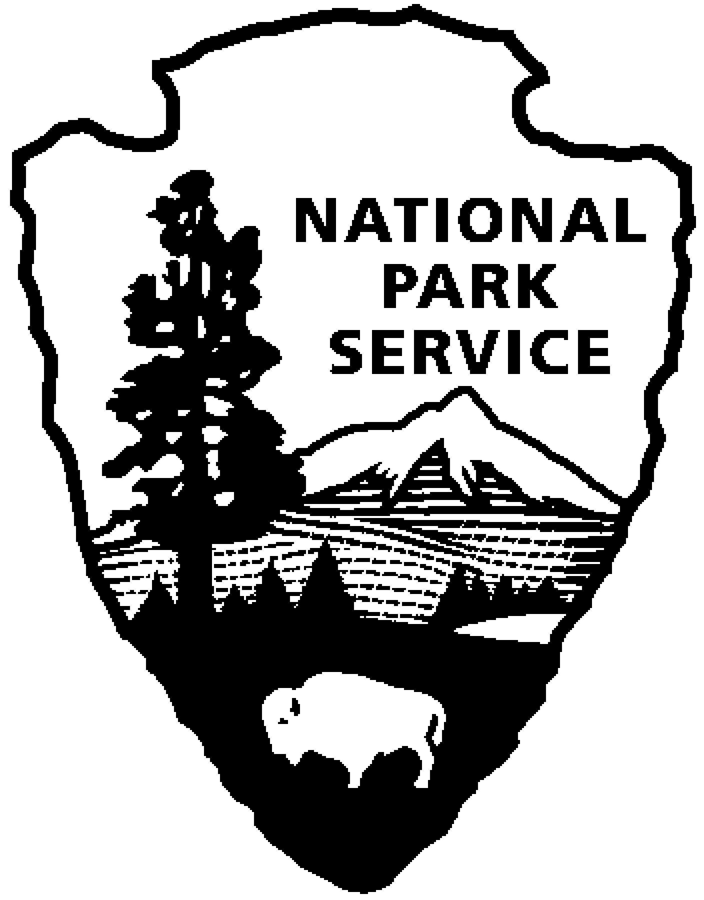
Thomas Edison NHP News Release
For Release: October 13, 2012
Contact: Shemaine McKelvin
Phone: 973-736-0550 x42
Reservations: 973-736-0550 x89

Thomas Edison's Last Moments

WEST ORANGE, NJ - In October 1931, Thomas Alva Edison died at his Glenmont Estate at the age of 84. To commemorate the anniversary of his death, the National Park Service will offer two evening tours of Edison's home, Glenmont, in Llewellyn Park. The "Last Moments" tours will take place on Saturday evening, October 20, 2012 at 7:00pm and 8:00pm. Advance reservations are required and space is limited. Call 973-736-0550 ext. 89 for tickets and important driving information.Admission to the program is free.

After 44 years of innovation and admiration from famous friends and family alike, Thomas Edison died on October 18, 1931. His public profile and global impact lead President Hoover to request a dimming of all lights nationwide in his memory. After his death, his family arranged a public viewing at his Main Street, West Orange laboratory, which lasted two days and was attended by thousands. A private viewing was held at the family's home on October 21, 1931. Learn more about Thomas Edison's last moments. Hear passages from his last will and testament and understand how the world was affected by his passing. Visitors will also have a rare opportunity to view Edison's death mask - an exact copy of the original plaster cast made by James Earle Fraser, a family friend and noted sculptor - and a bronze cast of Edison's right hand.

Thomas Edison moved to West Orange, New Jersey in 1886 at the age of forty, already a successful and wealthy inventor. He was also a newlywed and had bought the Glenmont Estate as a wedding gift for his second wife, Mina Miller. The Edison's spent the rest of their lives in West Orange. Their three children were born in West Orange and almost half of Mr. Edison's patents were generated there.

Thomas Edison National Historical Park is a National Park Service site dedicated to promoting an international understanding and appreciation of the life and extraordinary achievements of Thomas Alva Edison by preserving, protecting, and interpreting the Park’s extensive historic artifact and archive collections at the Edison Laboratory Complex and Glenmont, the Edison family estate. The entrance fee is $7.00. Children under age 16 are free. The Visitor Center is located at 211 Main Street in West Orange, New Jersey. For more information or directions call 973-736-0550 ext. 11 or visit: www.nps.gov/edis
- NPS -

