National Park Service  U.S. Department of the Interior | Thomas Edison  National Historical Park |  | 211 Main Street  West Orange, NJ 07052  973 736-0550 phone  973 736-6567 fax
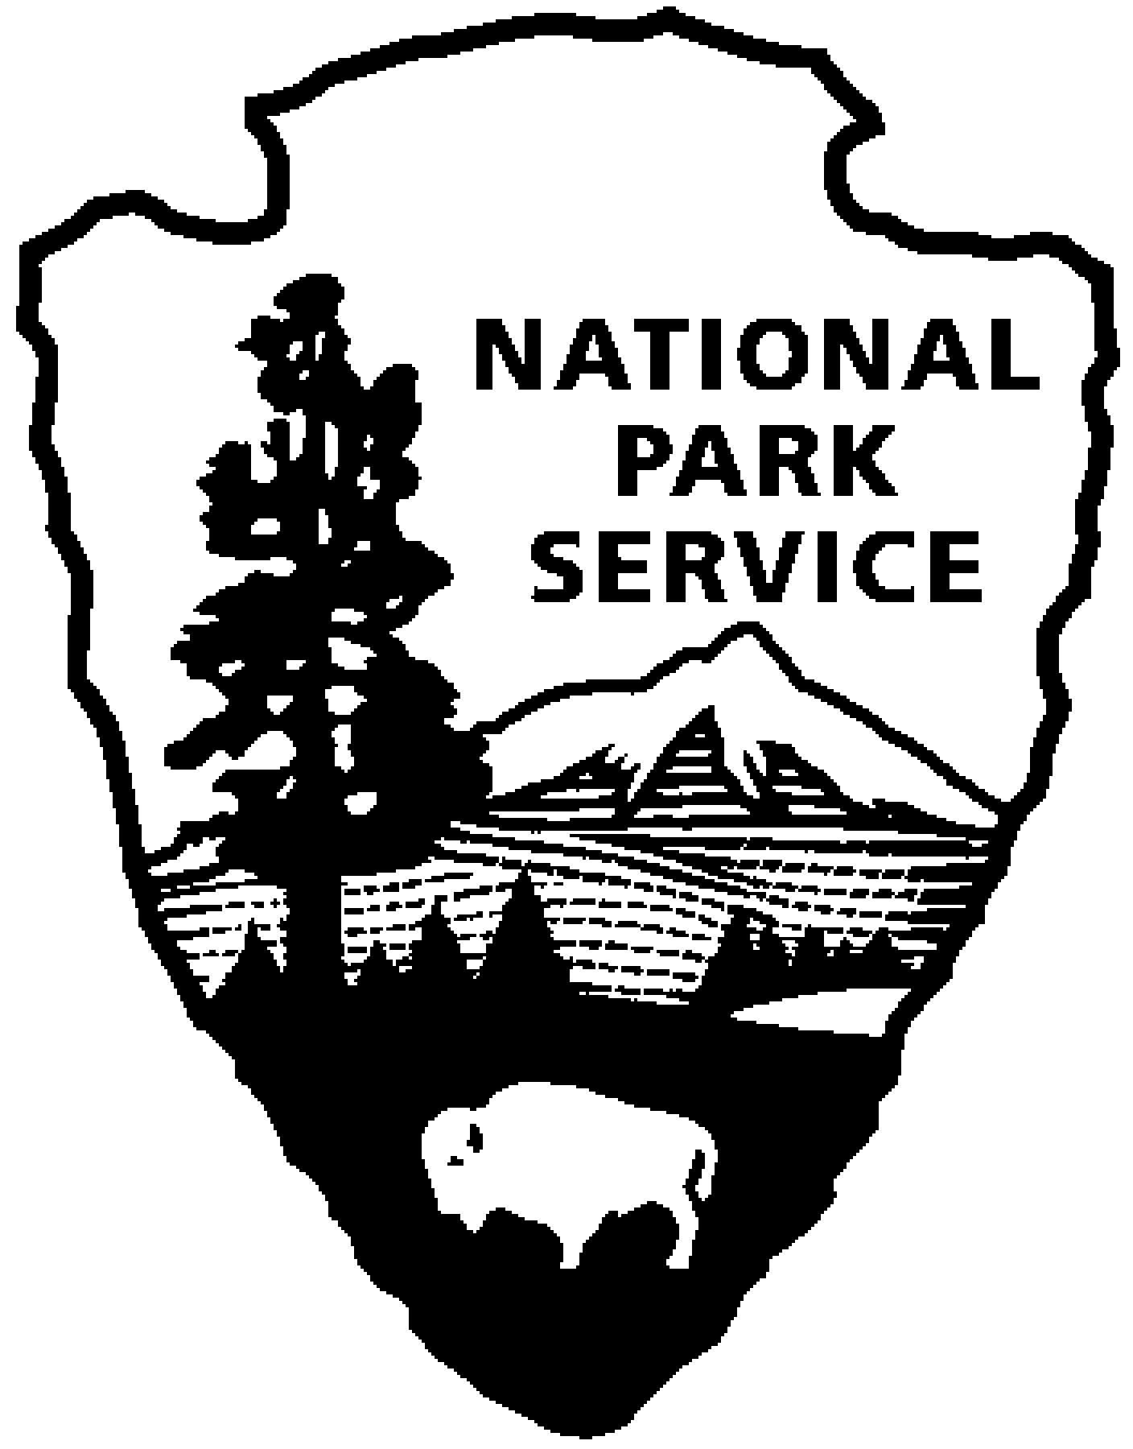
Thomas Edison NHP News Release
For Immediate Release
Contact: Theresa Jung
Phone: 973 736-0550 x50

THOMAS EDISON – REMEMBERING THE WIZARD
October 2014

WEST ORANGE, NJ – The Year of Innovation looks at Thomas Edison’s final days, his role as a cultural icon and the preservation of the Edison legacy. Explore these ideas, attend a program, and see a special exhibit of original artifacts, documents and historic photos during the month of October at Thomas Edison National Historical Park (NHP). The programs are free with admission and will be held at the Laboratory Complex at 211 Main Street unless noted.

Thursday, October 2nd at 7:00 p.m. at the West Orange Public Library, 46 Mt. Pleasant Ave.
How to Preserve Your Personal Digital Collections
Jerry Fabris, Museum Curator
Have you ever lost a large group of your own digital photos, or other important digital files? Most people today need to save digital information – photographs, audio, video, email, documents. Yet, preserving digital files can be problematic, especially on a household budget. Drawing from guidelines developed by the National Digital Information Infrastructure & Preservation Program, this free one-hour presentation will provide basic tips to help make your personal digital collections last long-term, into the future.
As a Museum Curator at Thomas Edison National Historical Park, Jerry Fabris preserves the park’s extensive audio collections and serves on National Park Service’s Digital Information Services Council. He has a Master’s Degree in Library and Information Science from Rutgers University.

2nd Saturday – October 11th at 10:00 a.m. (especially for children)
Leaving a Legacy
Thomas Edison is best known for the phonograph, light bulb and motion pictures, but his legacy is much more. Join a ranger to explore the laboratory complex and discover the many things that make up Edison’s legacy. As part of the program you will make a hand print to leave behind as part of your legacy, just as Edison did.

3rd Thursday – October 16th at 6:00 p.m. and 7:00 p.m.
Last Moments
Thomas Alva Edison died in October 1931 at his Glenmont Estate. He was 84 years old. To commemorate the anniversary of his death, we will offer evening tours of his home in Llewellyn Park. During the Last Moments tours visitors will hear about his final hours and the impact that his passing had on the world. Listen to passages from his last will and testament and view condolence telegrams from around the world. Edison’s death mask and a cast of his right hand will be on exhibit.
Tour tickets are limited and reservations are required. Reservations can be made by calling 973-736-0550, ext.89.

Special programs in October:

Saturday October 25, 5:30 p.m. to 8:30 p.m.
The Friends of Thomas Edison NHP present the First Annual Muckers’ “Ball”
Enjoy local food and drink with vintage music under a tent at the Edison laboratory complex. The event will offer casual fun and camaraderie at the very place Edison and his muckers worked…and ate! The main laboratory building will be open for special evening tours from 5:30 p.m. to 6:30 p.m.
For more information and to order tickets visit www.foedison.org or call 973-736-2916 by October 17th.

Thursday October 30th at 7:00 p.m.
Demolition String Duo to Record on Wax Cylinder
The Demolition String Duo featuring Elena Skye and Boo Reiners will record onto wax cylinders in the same way it was done in Edison's time over a century ago. The method of capturing sound is non-electric. Like the artists who recorded for Edison during the 1890s, the Demolition String Duo will play in front of a large horn that will serve as their microphone.
With a shared passion for country, rock ‘n roll, bluegrass and mountain music, Elena Skye and Boo Reiners lead New York City’s “Demolition String Band”. They are currently celebrating the release of their recording of the Woody Guthrie song “Go Coney Island, Roll on the Sand” on the audio book “My Name is New York, Ramblin’ Around Woody Guthrie’s Town”. This new audio book is a collection of Guthrie’s New York City-inspired stories and music, produced and narrated by daughter Nora Guthrie. The Demolition String Duo can be contacted via email at elenaskye11@gmail.com. Their website address is www.demolitionstringband.com.
Seating is limited and reservations are required. Reservations can be made by calling 973-736-0550, ext.89.

These programs are part of THE YEAR OF INNOVATION celebrating the New Jersey 350th Anniversary in 2014. Since 1664 New Jersey has provided a welcome home for inventors and entrepreneurs like Thomas Edison and there is no better place to learn about the history of innovation than Thomas Edison National Historical Park in West Orange. Special programs each month explore the themes in EDISON AND THE RISE OF INNOVATION a book written by National Park Service archivist Leonard DeGraaf and published by Sterling Signature in October 2013. Another famous innovator – Bill Gates – has written the foreword to this fresh look at Thomas Edison. New programs for all ages will be offered monthly. For more information and updates about THE YEAR OF INNOVATION - First Friday, Second Saturday and Third Thursday events, please visit www.nps.gov/edis monthly. Follow us on Twitter and Facebook.
-NPS-

