National Park Service  U.S. Department of the Interior | Thomas Edison  National Historical Park |  | 211 Main Street  West Orange, NJ 07052  973 736-0550 phone  973 736-6567 fax
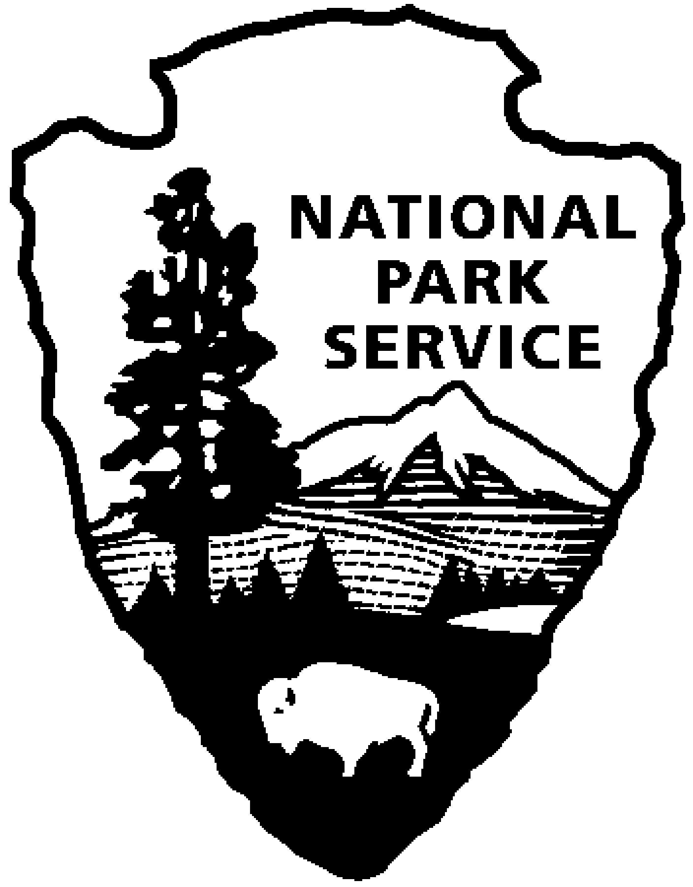
Thomas Edison NHP News Release
For Immediate Release
Contact: Theresa Jung
Phone: 973 736-0550 x50
EDISON LIVES ON
November 2014

WEST ORANGE, NJ – The Year of Innovation looks at Thomas Edison’s legacy and his impact on the world today. Explore these ideas, attend a program, and see a special exhibit of original artifacts, documents and historic photos during the month of November at Thomas Edison National Historical Park (NHP). The programs are free with admission and will be held at the Laboratory Complex at 211 Main Street unless noted.
1st Friday – November 7th at 2:30 p.m.
Edison Lives On … in Ft. Myers, Florida
Mike Cosden and Brent Newman, Edison Ford Winter Estates
Explore Edison’s legacy in Florida. Learn about the time he spent in Florida, his impact on the community, and the current programs at the Edison Ford Winter Estates.
Mike Cosden is the Curator at the Edison & Ford Winter Estates in Fort Myers, Florida, and is responsible for managing the archival collections and research library. He has spent the last 3 years conducting primary research on Thomas Edison’s Botanical Laboratory, which recently received National Historic Chemical Landmark status. Mr. Cosden is currently assisting with the development of a new exhibit about Edison’s quest to find a natural source of rubber. Prior to his work at the Estates, Mr. Cosden earned his Masters degree in Library & Information Science from the University of South Florida.
Brent Newman is the new Assistant Curator at the Edison & Ford Winter Estates after having spent the last year as the Registrar. As Registrar, he was responsible for organizing and managing the historical collections of the Estates, including acquisitions, loans, inventories, and exhibits. He has spent over eight years researching and presenting the history of the state of Florida and its diverse inhabitants to the public. Brent has worked at sites throughout Florida including Mission San Luis Historic Site, Mound House, and AH-Tah-Thi-Ki Seminole Museum.

2nd Saturday – November 8th at 10:00 a.m. (especially for families)
Have you ever just spent time tinkering with technology? Bring the family and spend a morning as a Mucker. Join us as we explore Thomas Edison’s inventive legacy. We will deconstruct a few cell phones and experiment with solar and wind energy. During the experience we will discuss the inventor’s designs and how they impact our modern world. This program is designed with families in mind.

3rd Thursday – November 20th at 7:00 p.m.
A History of Inventing in New Jersey: From Thomas Edison to the Ice Cream Cone
Talk and Book Signing with Author Linda J. Barth
In addition to Thomas Edison’s 1093 patents, many other ideas have grown in the Garden State. New Jerseyans brought sound and music to movies and built the very first drive-in theater. In addition to the first cultivated blueberry, tasty treats like ice cream cones and M&M’s® are also Jersey natives. Iconic aspects of American life, like Bubble Wrap®, the boardwalk, the Band-Aid®, and even professional baseball itself started in New Jersey. Life would be a lot harder without the vacuum cleaner, plastic, and air conditioning, and many other important advances in medicine and surgery were developed here. Join author Linda Barth as she explores groundbreaking, useful, fun, and even silly inventions and their New Jersey roots.
Linda Barth has been a fan of New Jersey for a long time. As a fourth-grade teacher, she tried to focus students’ attention on the positive aspects of our state: its diverse geography, agriculture, industry, and famous firsts and inventions. A lifelong resident of the Garden State, Linda has served on the board of Celebrate NJ!, a grassroots movement that builds pride in and fosters a brighter future for New Jersey through educational programs and promotional initiatives. She has written two books on the D&R Canal for Arcadia Publishing and two children’s picture books. She has also contributed to the Encyclopedia of New Jersey.

Special programs in November:

Fridays, Saturdays and Sundays, November 28th through January 4th
HOLIDAYS AT GLENMONT
The sights and sounds of the season will greet you when you come on a tour of Thomas Edison’s home during “Holidays at Glenmont,” starting on November 28, 2014 and continuing through January 4, 2015. Glenmont will be decorated much as it was while the Edison family lived there. Favorite musical pieces will be playing and greenery and red poinsettias will deck the mantles above the fireplaces. Staircases will be ringed with boughs and red ribbon bows and wreaths will hang in every window. A majestic 10 foot tree will be lit and the presents underneath will be waiting as if the Edison children Madeleine, Theodore and Charles, will soon come running down the stairs from their rooms - after they’ve checked their stockings in the upstairs Living Room!

Harry’s Magic Invention Bag
Sunday November 9 and 23, 1:00 p.m. – 4:00 p.m.
Learn about invention and the important role Edison played in taking invention from a cottage/hobby activity to a full commercial activity- practiced by all major corporations. Hear Harry Roman as he discusses the major role NJ plays in the national invention scene-and all the great inventions NJ inventors have brought into our world.
Harry, a nationally known inventor, was a critical player in establishing the NJ Inventors Hall of Fame in 1989, and later went on to chair the organization from 1996-2004. The Hall of Fame honored him with an Inventor of the Year award in 2005 for his pioneering work in robotics, and honored him again in 2012 with a special achievement award for his dedication to the organization.

The Edison Men and the US Navy
Friday November 28th, 10:00 a.m. – 4:00 p.m.
Bet you did not know that both Thomas Edison and his son Charles played important roles in the US Navy, in WWI and WWII. Come hear Harry Roman tell the exciting story of their involvement and how it affected our nation…and Charles’s ties to the famous battleship New Jersey. Learn also about the two naval vessels that once bore the Edison name!

Alternate Technologies and Their Ties to Thomas Edison and the West Orange Labs Saturday November 29th, 1:00 p.m. – 4:00 p.m.
Many folks consider Thomas Edison an early and staunch supporter of alternate technologies. Hear Harry Roman discuss the different aspects of alternate technologies and Edison’s involvement in them. Lots of really cool and useful facts are to be had. And Harry always brings along toys and stuff from his basement workshop to see and touch! Join the fun.
Harry Roman, volunteer and Edison Innovation Foundation author and advisor, is a retired engineer from PSE&G where he created and managed that company’s solar and alternate energy programs from 1975 through 2006 when he retired.

These programs are part of THE YEAR OF INNOVATION celebrating the New Jersey 350th Anniversary in 2014. Since 1664 New Jersey has provided a welcome home for inventors and entrepreneurs like Thomas Edison and there is no better place to learn about the history of innovation than Thomas Edison National Historical Park in West Orange. Special programs each month explore the themes in EDISON AND THE RISE OF INNOVATION a book written by National Park Service archivist Leonard DeGraaf and published by Sterling Signature in October 2013. Another famous innovator – Bill Gates – has written the foreword to this fresh look at Thomas Edison. For more information and updates about THE YEAR OF INNOVATION - First Friday, Second Saturday and Third Thursday events, please visit www.nps.gov/edis monthly. Follow us on Twitter and Facebook.

-NPS-

