National Park Service  U.S. Department of the Interior | Thomas Edison  National Historical Park |  | 211 Main Street  West Orange, NJ 07052  973 736-0550 phone  973 736-6567 fax
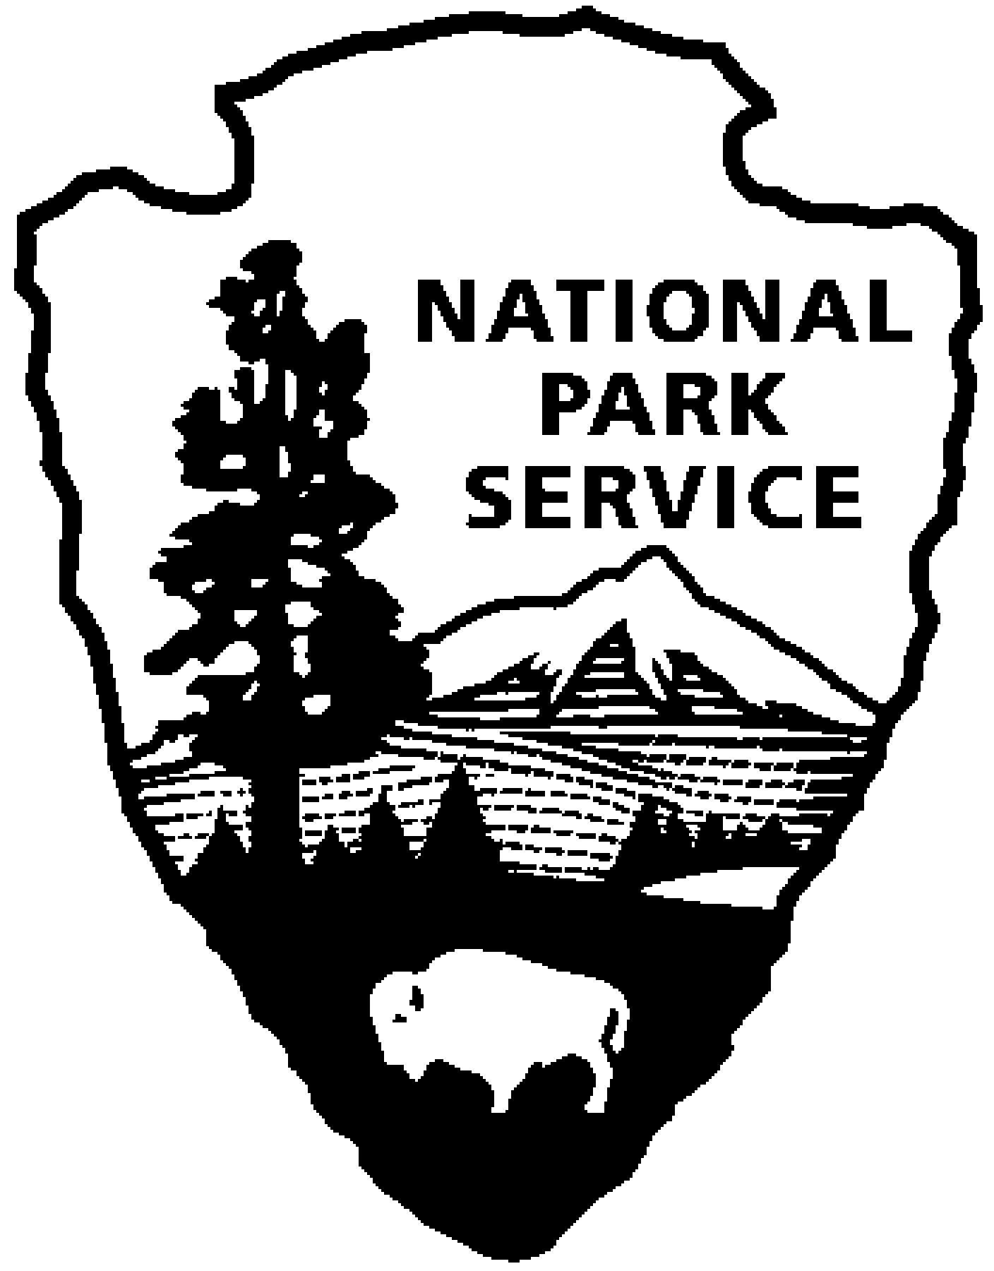
Thomas Edison NHP News Release
For Immediate Release
Contact: Theresa Jung
Phone: 973 736-0550 x50

THE INCANDESCENT BULB
From the 1880s to the 1920s
Mr. Robert Rosenzweig, Aamsco Lighting Company

WEST ORANGE, NJ – On Thursday, January 16, 2014 at 6:00 p.m., Mr. Robert Rosenzweig, President of Aamsco Lighting Company and the Ferrowatt brand of antique reproduction bulbs, will speak on the technical and business history of the incandescent bulb from the 1880s to the 1920s. His presentation will also feature a display of historic advertising and period light bulbs. The program will be held at the Thomas Edison National Historical Park Laboratory Complex at 211 Main Street. Seating is limited and reservations are recommended. Reservations can be made by calling 973-736-0550 ext. 89. There is no fee for the program.

Mr. Rosenzweig’s family owned the Ferrowatt Company in Austria beginning in the late 19th century; it was one of the largest bulb producers in Europe. The Nazi regime forced the Jewish owners to sell the company to the German company Osram/Siemens, and the family largely perished in the Holocaust. Mr. Rosenzweig researched the company history in the 1990s and was able to trademark the name FERROWATT in order to resume manufacturing a range of reproduction antique bulbs worldwide.

He will show that the New Jersey/New York area was a center of innovative bulb production from the 1880s to the 1920s, quite apart from General Electric and its Edison Mazda bulbs. He will shine a light, so to speak, on the fascinating array of companies, players, and lawsuits of the early bulb industry. Mr. Rosenzweig will bring his personal perspective as an insider to this little known part of our industrial history.

During the month of January, the Year of Innovation Series at Thomas Edison National Historical Park looks at the early experiments in electrical lighting as well as new lighting technology. Edison did more than invent a practical incandescent electric lamp; he introduced an entire system of electric lighting. From his first central stations in London and New York’s Pearl Street to his display at the 1889 Paris Exposition, Edison’s companies pioneered the electric utility industry. THE YEAR OF INNOVATION celebrates the New Jersey 350th Anniversary in 2014. Since 1664 New Jersey has provided a welcome home for inventors and entrepreneurs like Thomas Edison and there is no better place to learn about the history of innovation than Thomas Edison National Historical Park in West Orange. Special programs each month will explore the themes in EDISON AND THE RISE OF INNOVATION a recent book written by National Park Service archivist Leonard DeGraaf and published by Sterling Signature in October 2013. Another famous innovator – Bill Gates – has written the foreword to this fresh look at Thomas Edison. New programs for all ages will be offered monthly. For more information and updates about THE YEAR OF INNOVATION - First Friday, Second Saturday and Third Thursday events, please visit www.nps.gov/edis monthly. Follow us on Twitter and Facebook.
-NPS-

