National Park Service  U.S. Department of the Interior | Thomas Edison  National Historical Park |  | 211 Main Street  West Orange, NJ 07052  973 736-0550 phone  973 736-6567 fax
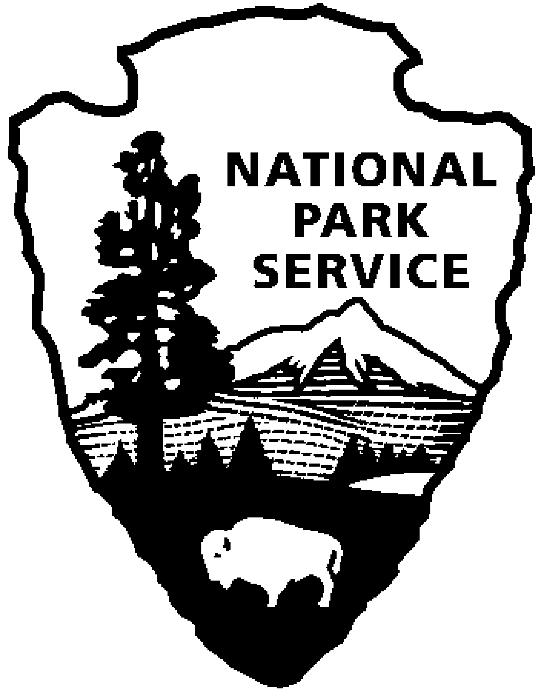

Thomas Edison NHP News Release
For Release: Monday January 30, 2012, 2:00pm Eastern Time
Contact: Jerry Fabris
Phone: 973-736-0550 x48

Early European Edison Phonograph Recordings Released

WEST ORANGE, NJ – Today the National Park Service announces the first-time release of 12 historic sound recordings made by Thomas Edison’s recording engineer Theo Wangemann on wax cylinders during 1889-1890 in Germany, Austria, Prussia, and France. The recordings include the voices of eminent German historical figures Otto von Bismarck and Helmuth von Moltke, and several performances by important musicians of the period. The sounds are available on-line in MP3-format at: http://www.nps.gov/edis/photosmultimedia/theo-wangemann-1889-1890-european-recordings.htm.

On Saturday, February 4, 2012 at 12:00 noon, historian Patrick Feaster, will present a one-hour program about the recordings, titled Theo Wangemann: The Man Who Made the Phonograph Musical. This presentation will explore the life and career of Theo Wangemann, who was arguably the world’s first professional recording engineer. Also at the program, collector Stuart H. Miller, M.D. will exhibit the phonograph used by Wangemann in Europe during 1889-1890. The program will be held in the Laboratory Complex at Thomas Edison National Historical Park, 211 Main Street. The entrance fee to the park is $7.00, children under 16 are free. Seating is limited and reservations are required. Reservations can be made by calling 973-736-0550, ext. 89.

Museum Curators first cataloged the damaged wooden box containing the wax cylinders in 1957, found in the library of the Edison Laboratory. In 2005, the National Park Service completed a multi-year project to individually catalog every historic sound recording in the museum collection. Curators noted that the box contained 17 brown wax cylinders in fair and poor condition, several broken with large pieces missing. No title list or other identification survived in the box with the recordings, so the recordings could not be identified until they were heard. In 2011, the park's Curator of Sound Recordings digitized 12 of Wangemann's 17 cylinders using a French-made Archeophone cylinder playback machine, saving the audio as Broadcast Wave Format files. (Five of the cylinders could not be digitized due to their condition.) Once the audio could be heard, historians Stephan Puille and Patrick Feaster identified the sounds and wrote two scholarly essays, which are included with the recordings on the Thomas Edison National Historical Park website.

Entrusted by Thomas Edison with the task of applying the newly developed wax cylinder phonograph to music, Theo Wangemann oversaw the first regular production of pre-recorded cylinders at the Edison Laboratory in West Orange, New Jersey in 1888-89, ushering in the beginnings of the American musical recording industry. Then, in 1889-90, Wangemann played a prominent role in introducing Edison’s invention to continental Europe.

- more -

Stephan Puille is a conservator of archaeological finds and technical employee at the Hochschule für Technik und Wirtschaft Berlin (HTW Berlin) - University of Applied Sciences. For more than ten years he studies the history of sound recording from the beginning up to 1914, holds lectures and writes articles on the subject. In addition, he is a phonograph and phonogram collector who concentrates on early and historically significant items. Contact: Stephan Puille, Hochschule für Technik und Wirtschaft Berlin, Wilhelminenhofstraße 75A, 12459 Berlin, Germany. E-mail: Stephan.Puille@HTW-Berlin.de

Patrick Feaster (pfeaster@gmail.com, 812-331-0047) is a researcher and educator specializing in the history and culture of sound media. A co-founder of FirstSounds.org and two-time Grammy nominee, he received his doctorate in Folklore and Ethnomusicology in 2007 from Indiana University Bloomington, where he is currently a lecturer in the Department of Communication and Culture, a member of the Media Preservation Initiative, and an instructor for the School of Continuing Studies.

Thomas Edison National Historical Park is a National Park Service site dedicated to promoting an international understanding and appreciation of the life and extraordinary achievements of Thomas Alva Edison by preserving, protecting, and interpreting the Park’s extensive historic artifact and archive collections at the Edison Laboratory Complex and Glenmont, the Edison family estate. The Visitor Center is located at 211 Main Street in West Orange, New Jersey. The Laboratory Complex is open Wednesday through Sunday from 9:00am to 5:00pm. For more information or directions please call 973-736-0550 ext. 11 or visit our website at www.nps.gov/edis .

-NPS-

