National Park Service  U.S. Department of the Interior | Thomas Edison  National Historical Park |  | 211 Main Street  West Orange, NJ 07052  973 736-0550 phone  973 736-6567 fax
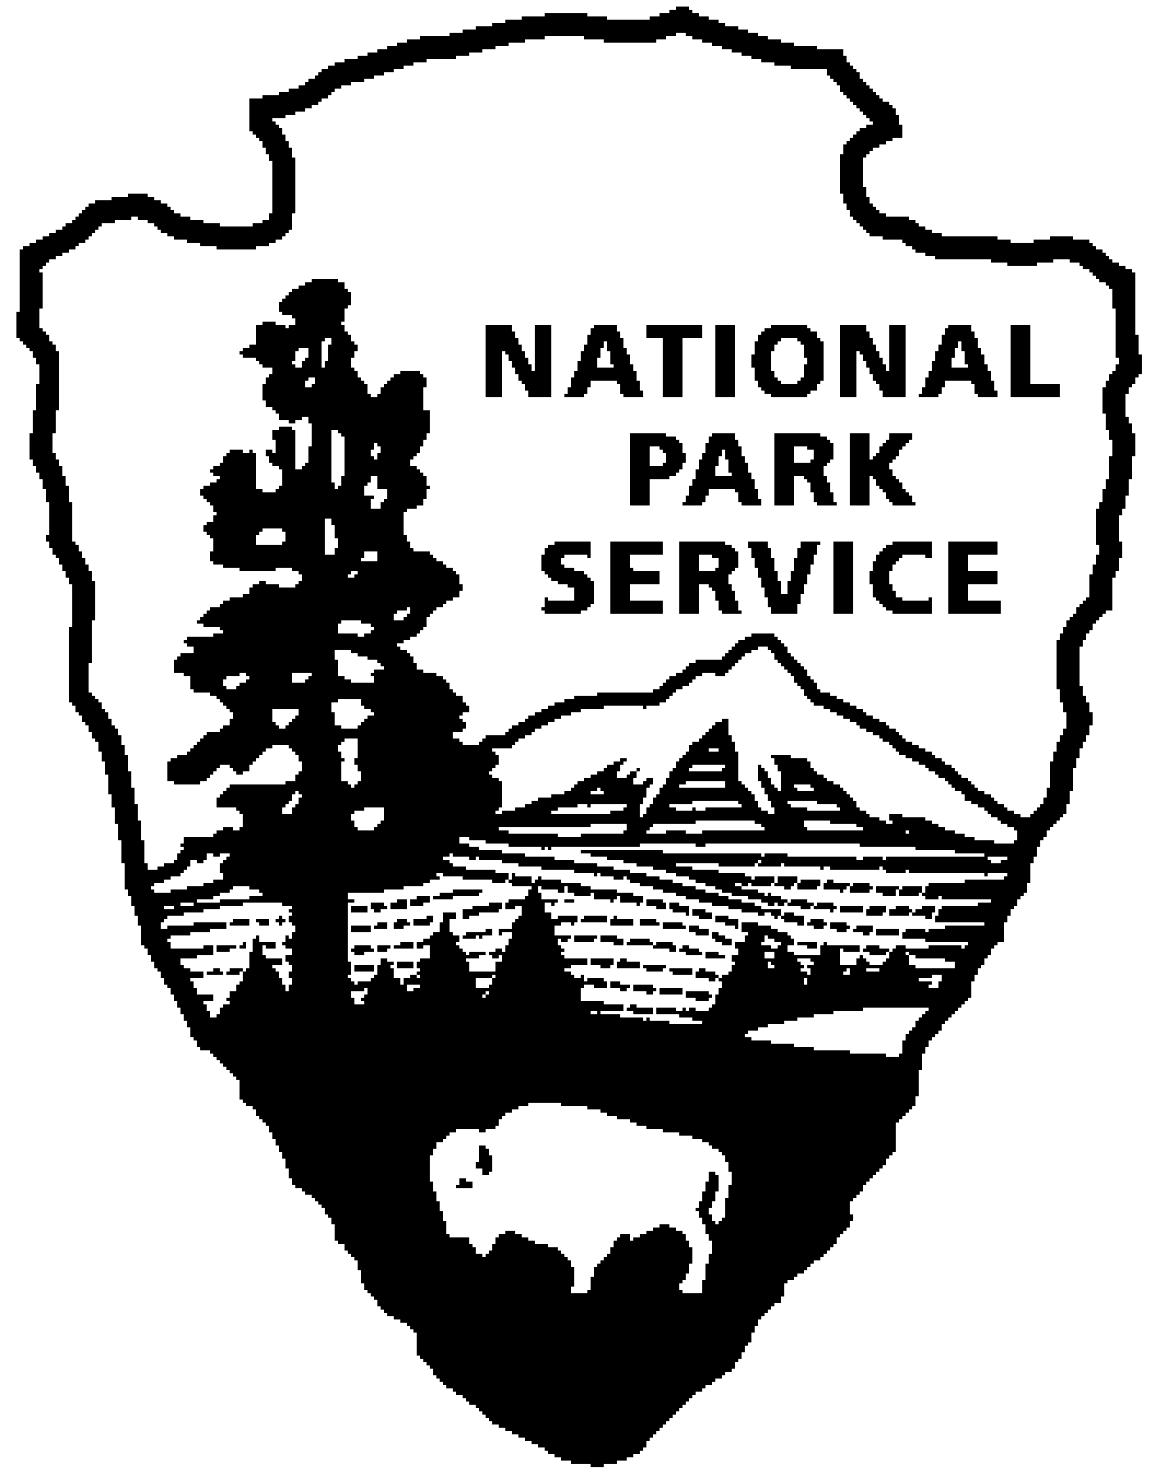

Thomas Edison NHP News Release
For Release: September 29, 2010
Contact: Karen Sloat-Olsen
Phone: 973-736-0550 x17
Reservations: 973-736-0550 x89

Humanity’s First Recordings of its Own Voice
Historian David Giovannoni Presentation

WEST ORANGE, NJ - On Saturday evening, November 6, 2010, at 7:00 pm, Thomas Edison National Historical Park welcomes historian David Giovannoni who will give a 75-minute illustrated presentation titled “Humanity’s First Recordings of its Own Voice.” The program will be held at the Laboratory Complex at 211 Main Street. Admission to the program is free. Seating is limited and reservations are required. Reservations can be made by calling 973-736-0550, ext.89.
Thomas Edison’s tinfoil phonograph of 1877 is rightly considered one of the marvels of the nineteenth century. But in mid-nineteenth-century France, amateur inventor Édouard-Léon Scott de Martinville conceived of a rather similar machine. Between 1854 and 1860 he experimented with focusing airborne sounds of speech and music onto paper. His phonautograph bore a striking resemblance to Edison’s phonograph of 20 years later. But his recordings, unlike Edison’s, were meant to be read by the eye, not heard by the ear.

For a century-and-a-half his experiments lay quietly in the venerable French archives in which he deposited them. Then in 2007 a few audio historians hypothesized there was a real possibility that modern technology could develop these experimental recordings like dormant photographic plates. Instead of exposing images, however, these would bear sounds – perhaps even humanity’s first recordings of its own voice!

In this presentation David Giovannoni recounts how he and his colleagues have identified dozens of these forgotten documents and coaxed several to talk and to sing. A principal in their discovery and recovery, Giovannoni is the first person since Scott de Martinville to personally examine every recording. He’ll explain how they were made and how they are played. He’ll discuss Scott de Martinville experiments, his reception in established scientific circles, and his early descent into an unmarked grave.

For more information or directions please call 973-736-0550 ext. 11 or visit our website at www.nps.gov/edis.

-NPS-

