National Park Service  U.S. Department of the Interior | Thomas Edison  National Historical Park |  | 211 Main Street  West Orange, NJ 07052  973 736-0550 phone  973 736-6567 fax
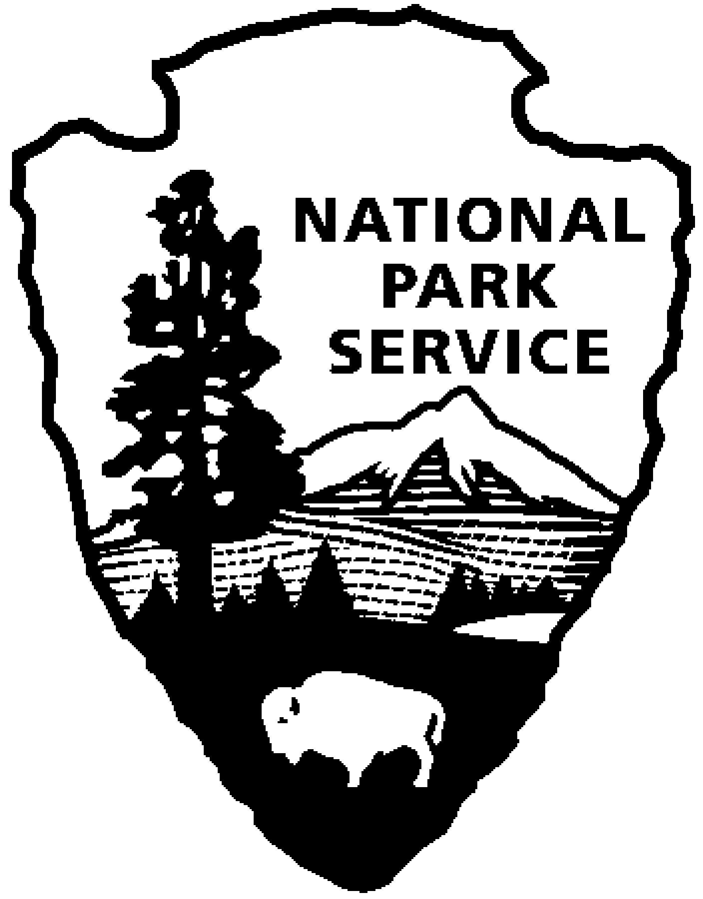
Thomas Edison NHP News Release
For Release: April 20, 2012
Contact: Karen Sloat-Olsen
Phone: 973 736-0550 ext.17

Fee Free at Thomas Edison National Historical Park

West Orange, N.J. – Thomas Edison National Historical Park will be joining national park sites around the country in celebrating National Park Week with fee free days. Entrance fees will be waived for all visitors to the park from Wednesday, April 25 thru Sunday, April 29, 2012. A fee free day is a great opportunity to discover new programs, new stories or for those who have never visited before, discover what the park has to offer.

All 397 national parks will be celebrating National Park Week with the theme of “Picture Yourself in a National Park”. Thomas Edison NHP will offer special programs about the history of the National Park Service, which will feature film clips from the Ken Burns documentary “National Parks: America’s Best Idea”. Programs featuring examples from the park’s historic photography collection will also be offered. Additionally, the Rangers at Thomas Edison NHP have put together a fun video inviting visitors to picture themselves at the park. The video can be viewed on the park’s website (www.nps.gov/edis).

During National Park Week, the National Park Service will also show its appreciation for junior rangers by designating April 28 as Junior Ranger Day. Junior rangers explore, learn, and protect national parks. Children of any age can become a junior ranger by completing a series of activities during their park visit and sharing the answers with a park ranger. After reciting the junior ranger pledge they receive an official patch and certificate.

Thomas Edison NHP is inviting all junior rangers, or budding junior rangers, to take a special tour of the laboratory complex at 11:00 am or 2:00 pm on April 28. Junior rangers can also enjoy learning about Mr. Edison’s work with the telegraph, discover Morse Code and send telegraph messages throughout the day.

Thomas Edison National Historical Park is a National Park Service site dedicated to promoting an international understanding and appreciation of the life and extraordinary achievements of Thomas Alva Edison by preserving, protecting, and interpreting the Park’s extensive historic artifact and archive collections at the Edison Laboratory Complex and Glenmont, the Edison family estate. The entrance fee is $7.00. Children under age 16 are free. The Visitor Center is located at 211 Main Street in West Orange, New Jersey. For more information or directions call 973-736-0550 ext. 11 or visit: www.nps.gov/edis
- NPS -

