United States Department of the Interior
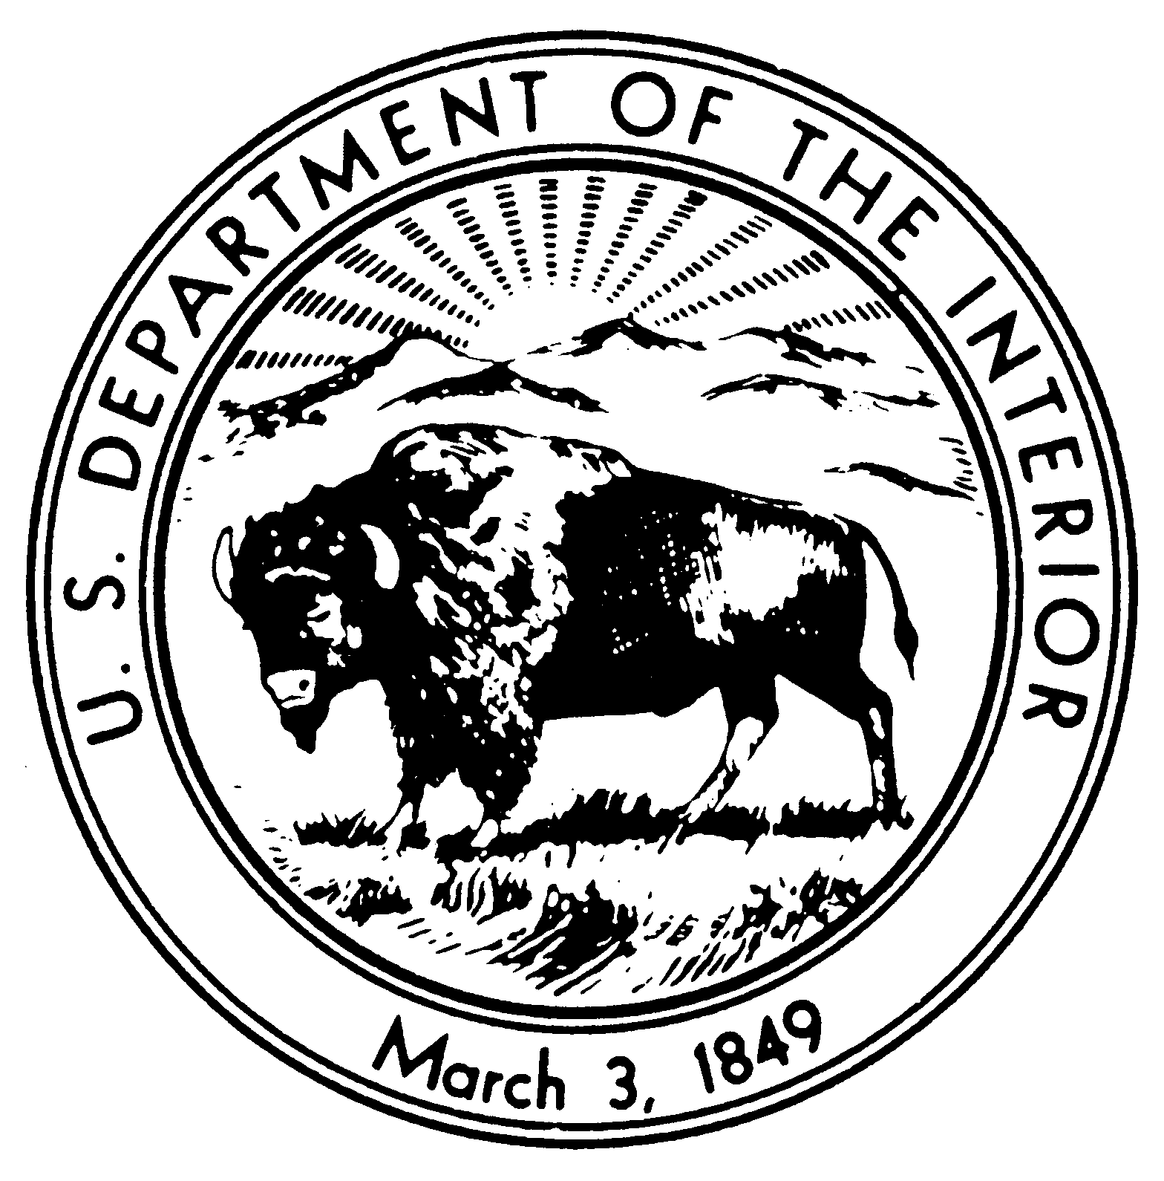

NATIONAL PARK SERVICE
AZTEC RUINS NATIONAL MONUMENT
#84 County Road 2900
Aztec, New Mexico 87410-9715
505 334-6174

IN REPLY REFER TO:

H4217 (AZRU)

December 7, 2001

«FirstName» «LastName»
«Company»
«Address1»
«City», «State» «PostalCode»

Dear «Title» «LastName»,

Reference: Aztec Ruins National Monument, Remodel Visitor Center Interior

Subject: Compliance with Section 106 of the National Historic Preservation Act and National Environmental Policy Act (NEPA)

The National Park Service is developing plans to remodel a portion of the interior of the visitor center at Aztec Ruins National Monument. The visitor center is an historic building listed on the National Register of Historic Places. The action is proposed primarily to serve visitors to the park better. A wall in the lobby will be removed in order to expand the book sales area. Another wall will be built to help segregate office space from the information desk area and reduce noise interference between the two areas. The information desk will be enlarged. Schematics are enclosed that show present conditions and the proposed changes.

In accordance with NEPA and 36 CFR 800 requirements, we are eliciting your comments and invite you to review the project. Please contact us by Jan. 7, 2001 with your initial concerns and comments. An Environmental Assessment will be prepared and will be sent to your for comment after that date.

If you would like to express your concerns, have questions, or need additional information, please contact me by writing at the above address. We would also be happy to arrange a meeting with you at your convenience to discuss this project. Please contact me through my email address, stephanie_dubois@nps.gov, or by telephone at (505) 334-6174 extension 22. You may also contact Chief of Intepretation Terry Nichols at 505 334-6174 ext. 23.

We look forward to consulting with you on this project.

Sincerely,

Stephanie Dubois

Superintendent

Enclosures

Identical letter sent to the following recipients:

Governor Regis Pecos, Cochiti Pueblo
President Roger Vicente, Jicarilla Apache Tribe
Governor Cyrus J. Chino, Pueblo of Acoma
Governor Lawrence Troncosa, Pueblo of San Felipe
Governor Perry Martinez, Pueblo of San Ildefonso
Governor Denny Gutierrez, Pueblo of Santa Clara
Governor William Torivio, Pueblo of Zia
Governor Ramon C. Garcia, Pueblo of Santo Domingo
Chairman Wayne Taylor, Hopi Tribe
Governor Harry Early, Pueblo of Laguna
Governor Alvino Lucero, Pueblo of Isleta
Governor Clarence Chile, Pueblo of Picuris
Governor Stuwart Paisano, Pueblo of Sandia
Governor Nelson J. Cordova, Pueblo of Taos
Acting Chairman Vida Peabody, Southern Ute Indian Tribe
Governor Joe V. Cajero, Jemez Pueblo
President Kelsey Begaye, Navajo Nation
Governor David Perez, Pueblo of Nambe
Governor Jacob Viarrial, Pueblo of Pojoaque
Governor Bruce Sanchez, Pueblo of Santa Ana
Governor Charlie Dorame, Pueblo of Tesuque
Governor Malcolm Bowekaty, Pueblo of Zuni
Chairman Ernest House, Ute Mountain Tribe
Celestino Gachupin, Pueblo of Zia
Rick Quezada, Ysleta del Sur Pueblo
Leigh Kuwanwisiwma, Hopi Cultural Preservation Office
Victor Sarracino, Laguna Pueblo
Herman Agoyo, Pueblo of San Juan
Jenny Holmes, Pueblo of Sandia
Jicarilla Cultural Center, Jicarilla Apache Tribe
Governor Wilfred Garcia, Pueblo of San Juan
Tony Herrera, Cochiti Pueblo
Richard Mermejo, Pueblo of Picuris
Mark Mitchell, Pueblo of Tesuque
William Whatley, Jemez Pueblo
President Sara Misquez, Mescalero Apache Tribe
Petuuche Gilbert, Pueblo of Acoma
Ben Lucero, Pueblo of Isleta
Charlie Tapia, Pueblo of Pojoaque
Myron Gonzales, Pueblo of San Ildefonso
Alan Downer, Navajo Nation HPD
Dan Simplicio, Pueblo of Zuni
Howard Richards, Southern Ute Tribe
Reva Suazo, Pueblo of Taos

