United States Department of the Interior
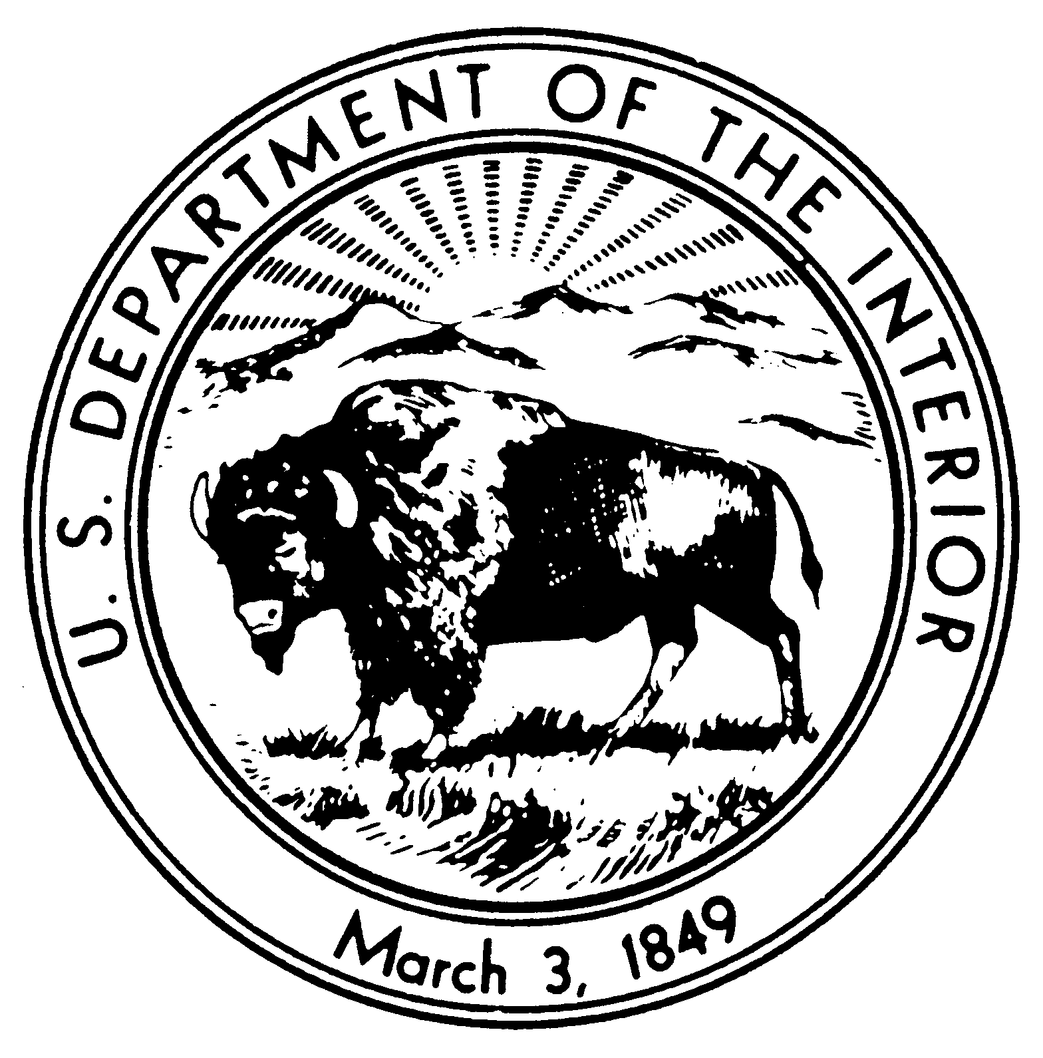
NATIONAL PARK SERVICE
DENVER SERVICE CENTER
12795 W. Alameda Parkway
P.O. Box 25287
Denver, Colorado 80225-0287
IN REPLY REFER TO:
D5217 (DSC)
1443CX_____
PARK-PMIS

Contractor
Address
City, State Zip

Gentlemen:

Reference: Park, _____ County, State, Contract No. 1443CX_____, Developed Area, Project Title, PARK-PMIS

Subject: Pre-Construction Conference Minutes

Attached please find your copy of the minutes from the pre-construction conference held on date.

After reviewing the minutes for errors and omissions, please indicate receipt and approval of the minutes by signing and returning two copies of this letter to this office.

Sincerely,

Name
Contracting Officer

*************************************************************************************

Received: By: Company Name

Title: _________________________________________

Date: _________________________________________

bcc:
DSC-PM, Name
Supt., _____

