PARK NAME
PARK LOCATION
PROJECT DESCRIPTION
PARK Acronym
PMIS Number (Project Management Information System)
PROJECT SPECIFICATIONS
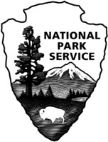
NATIONAL PARK SERVICE (NPS)
DENVER SERVICE CENTER (DSC)

