Contractor Performance Assessment & Reporting System
(CPARS) Information
CPARS training and evaluation process information is available online at www.cpars.gov.
CPARS General Process Flow
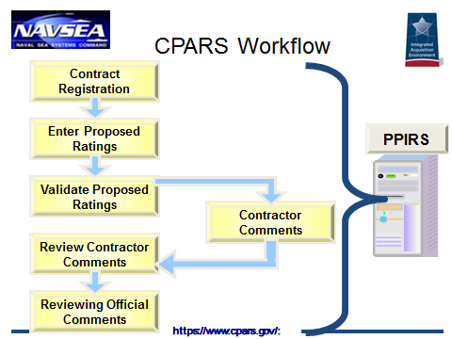
Rating Definitions
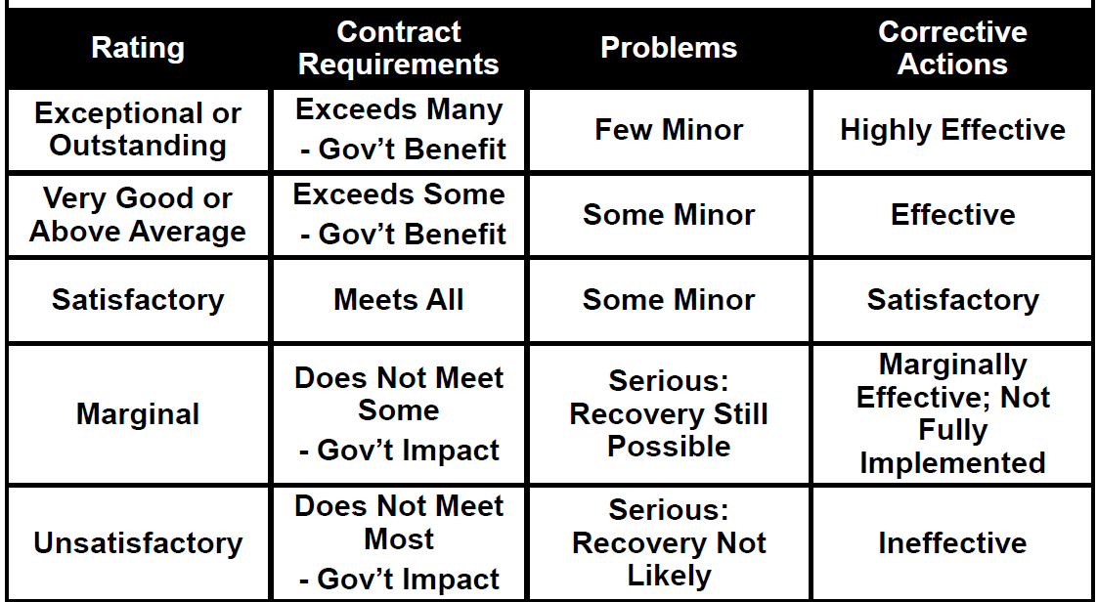
Areas for Evaluation – Construction
The Assessing Official (AO) and AO Representative (AOR) will evaluate Contractor performance for this contract based on the following areas:
- Quality Control
- Effectiveness of Management
- Timely Performance
- Compliance with Labor Standards
- Compliance with Safety Standards

