National Park Service
U. S. Department of the Interior
Cowpens
Invasive Plants at Cowpens National Battlefield

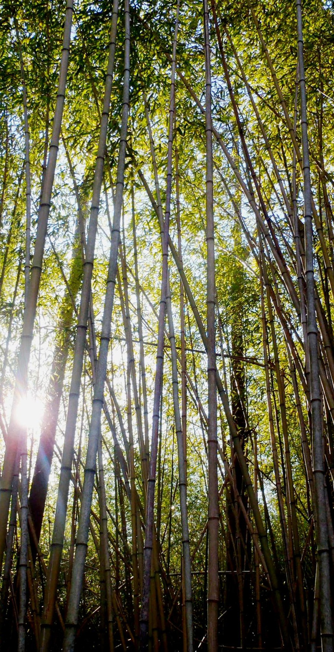
Of the 536 species of plants at Cowpens National Battlefield, 151 are non-native.

Invasive plants are non-native plants whose growth habits are highly threatening to native plant life. Invasive plants lower ecosystem biodiversity by monopolizing soil nutrients, water, and changing habitat types.

Some of the most aggressive, and notable invasive species in the park include Phyllostachys aurea (Golden bamboo), Elaeagnus umbellata (Autumn olive), Lonicera japonica (Japanese honeysuckle), Rosa multiflora (Multiflora rose), Ligustrum spp. (Privet), and Microstegium vimineum (Japanese stiltgrass).

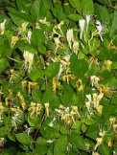
Japanese Honeysuckle
Lonicera japonica

Japanese honeysuckle is one of the most commonly occurring invasive plants in the south. It is identified by its woody vine, opposite leaves, and fragrant flowers.

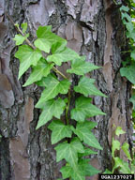
English Ivy
Hedera helix

English ivy is native to most of Europe and western Asia. It is an evergreen climbing plant that grows 20 - 30 feet up vertical surfaces that also grows as a ground cover where there are no suitable surfaces.

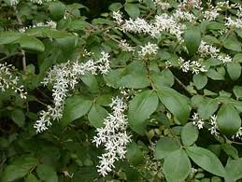
Chinese Privet
Ligustrum sinense

Privet has opposite leaves, white flowers, and berries that range from green to black. It can grow up to 30 ft. in height and forms dense thickets.

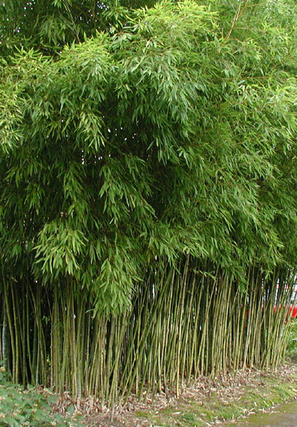
Golden Bamboo
Phyllostachys aurea

Golden bamboo has alternate, grass-like leaves and can reach heights of 24 to 30 ft. It shades out native plants and destroys wildlife habitat.

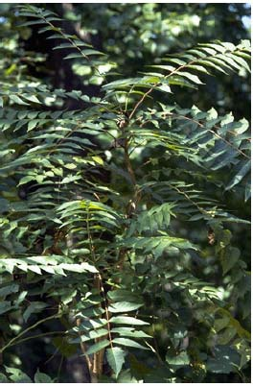
Tree of Heaven
Ailanthus altissima

Tree of heaven spreads rapidly by suckers on its lower trunk or roots in disturbed areas, out-competing native plants.

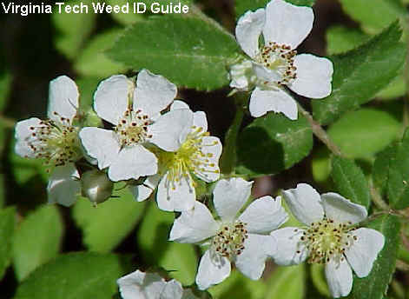
Multiflora Rose
Rosa multiflora

Multiflora rose was originally used as a living fence for livestock. It is identified by its compound leaves, white flowers, and red rose hips in the fall.

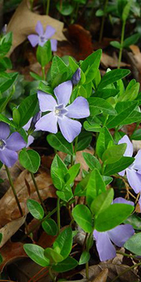
Common Periwinkle
Vinca minor

Periwinkle is commonly grown as a groundcover because of its evergreen foliage and spring and summer flowers. The color “periwinkle” comes from the flower.

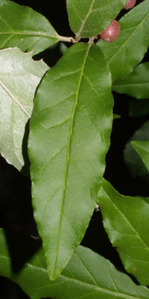
Autumn Olive
Elaeagnus umbellata

Autumn olive is recognizable by its bright green leaves with silver undersides and red berries in the fall. It can grow to a height of 20 feet and forms dense stands.

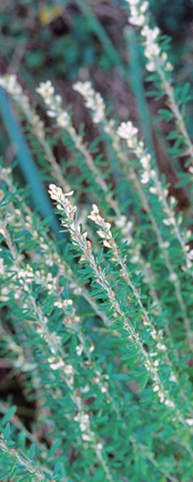
Chinese Lespedeza
Lespedeza cuneata

Chinese lespedeza is native to eastern Asia. Its leaves are divided into three smaller leaflets which are narrow, oblong, and pointed. Once established, it out-competes and displaces native plants.

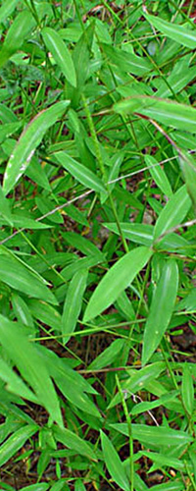
Japanese Stiltgrass
Microstegium vimineum

Japanese stiltgrass is an annual grass with slender stalks that produce tiny flowers in late summer. Japanese stiltgrass may impact other plants by changing soil chemistry and shading other plants.

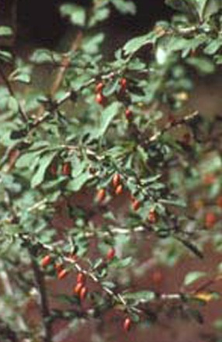
Japanese Barberry
Berberis thunbergii

Japanese barberry is a spiny shrub that grows 2 - 8 feet high. It raises the pH of the soil and replaces native species. This plant spreads by seeds and by roots growing from branches touching the ground.

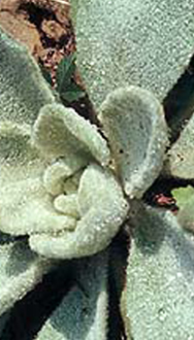
Mullein
Verbascum sp.

Mullein is native to Europe and Asia. It forms a rosette of leaves at ground level and eventually a tall flowering stem. The leaves are often hairy, giving the plant its alternate name, velvet plant.

For more information about plants at Cowpens National Battlefield, go to http://www.nps.gov/cowp/naturescience/index.htm.

EXPERIENCE YOUR AMERICA ™

