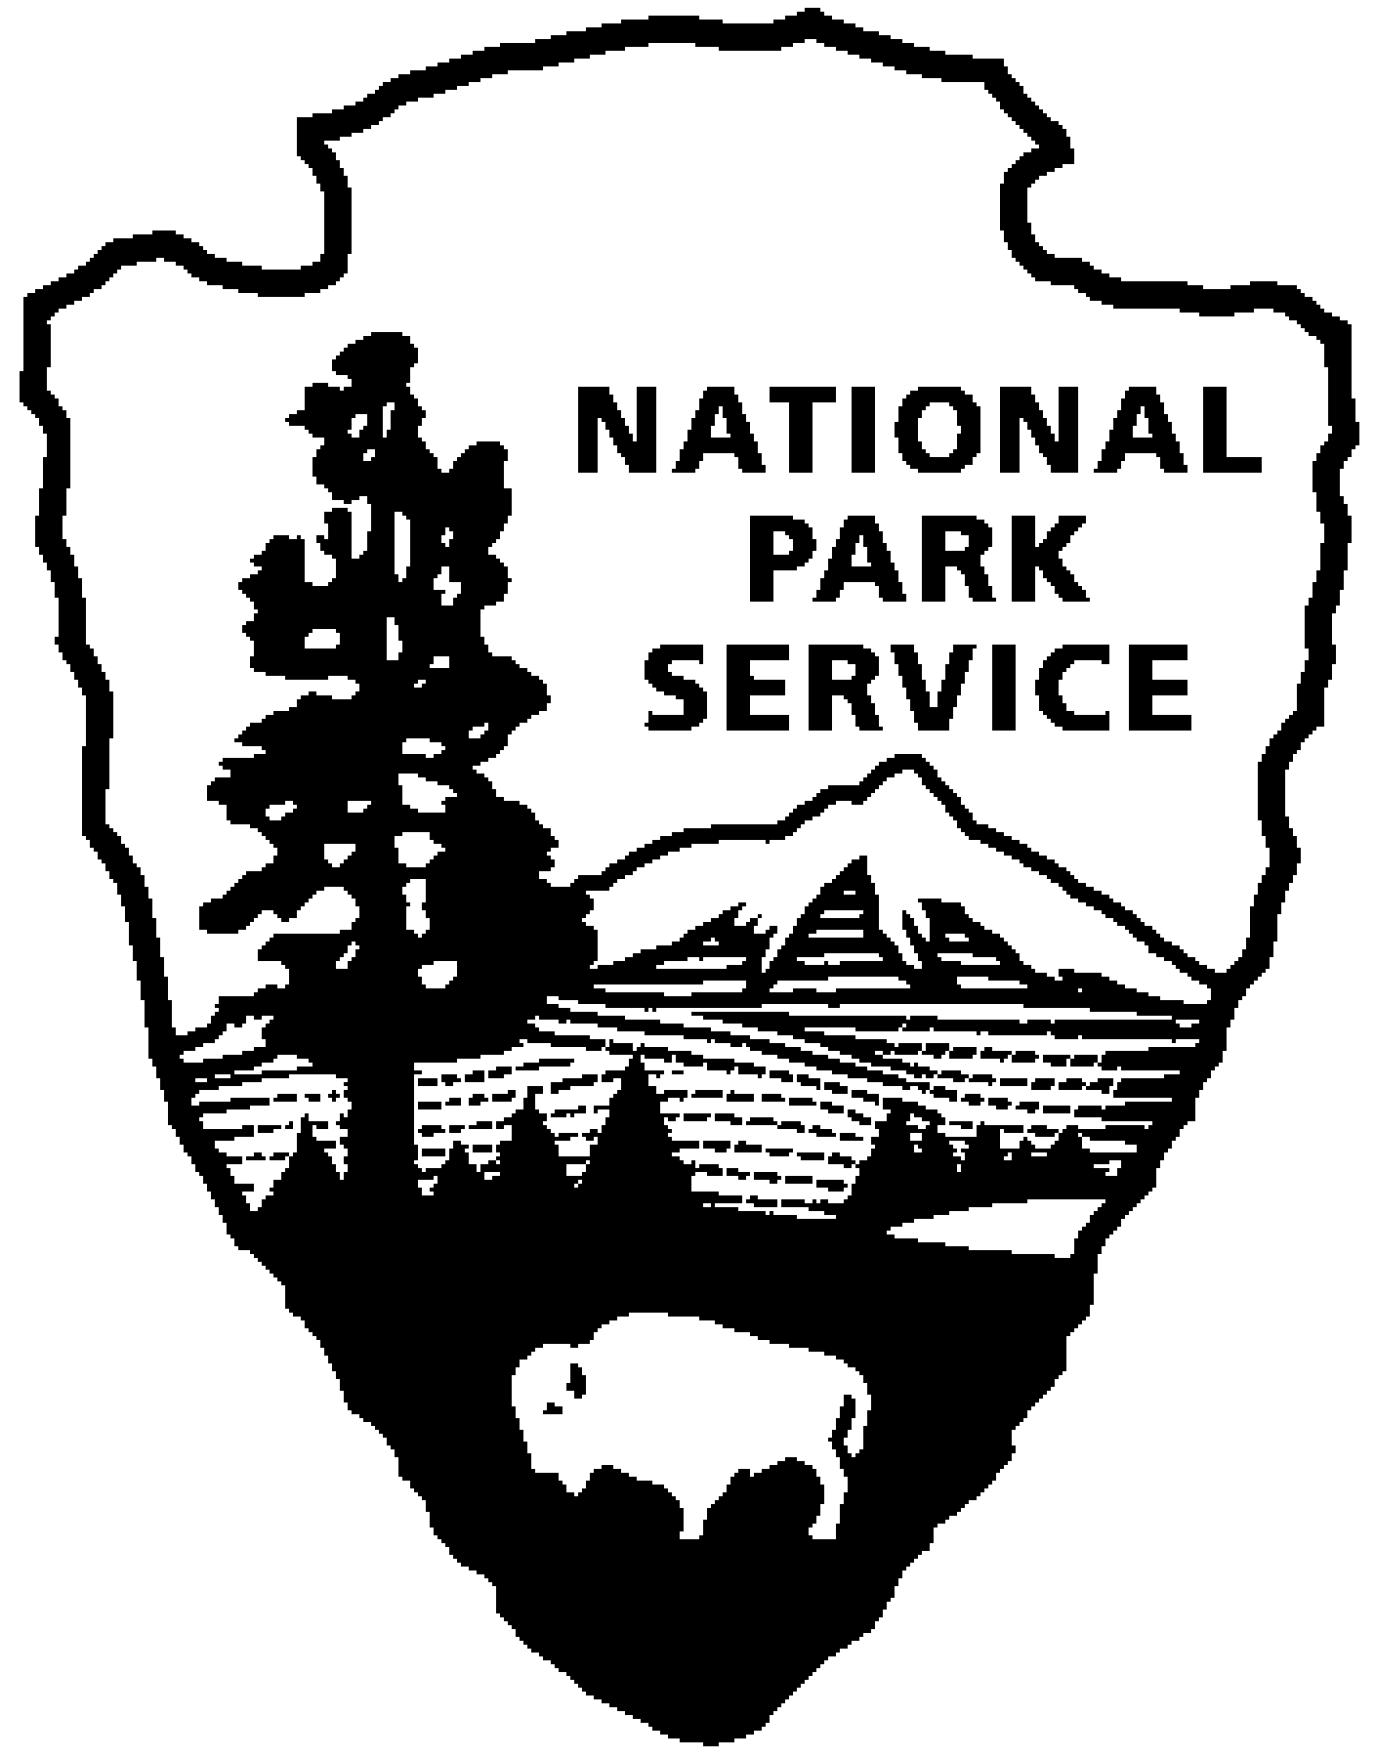  National Park Service  U.S. Department of the Interior | Cowpens National Battlefield |  | 338 New Pleasant Road  Gaffney, SC 29341  864-461-2828 phone  864-461-7795 fax

SPECIAL PARK USE FEE SCHEDULE

I. FEES

A. Types of Fees - Other Than Filming and Photography Fees

1. Administrative Cost
This fee is related to the cost of processing the permit application, which includes reviewing the application, permit preparation, and development of the administrative record. Some requested activities may require considerable additional administrative activities such as environmental, cultural, and other compliance and approval. In such cases, if additional costs are incurred they will be added as a recoverable cost.

Application Fee: Standard, Non-refundable $10.00

2. Location Cost
Two types of fees are associated with location costs:

The land/facility use fee is a one-time charge for use of a specific area. These charges are determined by a cost comparison with county park facilities and the amenities that are offered.

The performance bond acts as a deposit. It represents the permittee's guarantee of compliance with the terms and conditions of the permit. The performance bond is returned to the permittee once the National Park Service (NPS) determines that the area of use has been left in acceptable condition. If a determination is made that the area of use is not left in acceptable condition (for example excessive litter or damage to resources and/or facilities), then the performance bond is retained by the NPS as reimbursement for the cost of recovery. Retention of the performance bond does not preclude the issuance of a Bill for Collection for any recovery costs that exceed the performance bond amount. Performance bonds are accepted as a personal check or money order only.

Park Area: Land/Facility Use Fee: Performance Bond:
(0-50 people) (51-100 people)
Picnic Shelter (for less than 50 people) $25.00 Bond not required for groups under 75 people using shelter for picnic activity/family reunion, appl. fee not incl.)
Picnic Shelter (for 51-75 people) $50.00
Picnic Shelter & Grounds (other than picnics and family reunions)
$300.00 $600.00 $800.00
Scruggs House Grounds (weddings only) $400.00 $300 (no more than 25 people)
Visitor Center Area $500.00 $800.00 $1000.00

3. Recoverable Cost
These fees include all costs associated with the management of a permit, such as costs for personnel, supplies and materials. Management fees generally represent the cost for management of a permitted activity during the activity including, but not limited to, the salary for an employee assigned to the permitted event and the cost of expendable NPS supplies or materials used by the permittee during the event.

Management Fee:
Personnel costs are calculated on an hourly basis and include benefit costs:
 |  |  |  | Hourly Rate
Permanent Employees |  |  |  | Regular | Overtime
 |  | GS 5 |  | 22.95 | 34.43
 |  | GS 7 |  | 28.44 | 42.67
 |  | GS 9 |  | 34.79 | 52.19
 |  | GS 11 |  | 42.08 | 63.13
 |  | WG 10 |  | 38.29 | 57.43

- Fee Exemptions
May be appropriate when - 1. furnishing the service without charge is an appropriate courtesy
to a foreign government or international organization; or
comparable fees are set on a reciprocal basis with a foreign
country; or

2. the permittee is a state, local, or federal government agency or
a tribal government; or

3. the Superintendent determines that the use will promote the
mission of the National Park Service or promote the public
safety, health or welfare.

Is appropriate when - 1. a charge is prohibited by legislation or executive order; or

2. the requested use involves exercise of a right pertaining to
water, property, minerals, access, Native American religious
practices, or the rights guaranteed by the First Amendment to
the Constitution including freedom of assembly, speech,
religion and press.

Exemptions for state and local governments or non-profit groups are not automatic. The permittee must be engaged in an activity designed for the public safety, health or welfare for an exemption to be granted.

General Example: A Red Cross blood drive may be exempted, but a Red Cross banquet
for its workers to celebrate the successful drive would not.

II. SITE SPECIFIC RESTRICTIONS
Due to the grounds in and around Cowpens National Battlefield being designated by the NPS as "commemorative," regulations severely restrict the types of activity allowed. The majority of these park lands are reserved strictly for commemorative events. However, at the Scruggs House area only, small weddings (25 people including the wedding party and no more 5 vehicles) are authorized. The Scruggs House area consists of the porches and grassy area that surround the Scruggs House. Since the Scruggs House is an historic structure, no food/beverages/receptions are allowed in this area. Additional information specific to weddings may be found in section IV. Organized sports activities and/or the use of audio systems must be approved in writing in the permit.

Particular attention must be paid to the logistics of the use of any of the available locations. Carpooling or shuttling is strongly encouraged, and may be required, as parking space is limited in some areas of the park. Please remember the site is not for the exclusive use of your event. Scheduled park programs and activities may be taking place at the same time and in the same general area. Park visitors and neighbors have an expectation of peaceful surroundings, and the park strives for a continuation of that expectation. Additionally, some areas are void of electrical access, lighting and other amenities. Alcoholic beverages are prohibited on park grounds. Parking is limited to designated spaces and the roadway through the area must remain unobstructed. All decorations must be free-standing. Use of adhesives, staples, push-pins etc. on park property is strictly prohibited. All decorations must be removed and properly disposed of immediately after the event. The permitted area must remain clean with all trash placed in cans provided.

III. FILMING AND PHOTOGRAPHY
- Permit Requirements
A permit is not required when:

1. the filming or photography is for personal use and it occurs within normal visitation areas and hours.

2. the filming or photography relates to news media coverage.

A permit is required when:

1. the filming or photography is commercial in nature and/or includes the use of models, props, or sets, which also includes obtaining a release from members of the general public.

2. the filming or photography requires entry into areas restricted from normal visitation.

3. the filming or photography requires access to park locations outside of normal visitation hours.

B. Other Considerations
- The NPS will not sign a location release.
- The NPS can request a credit line.
- The NPS will not censor the content of a filming project, nor require a finished product. However, the NPS may review a story board or other material offered by the applicant to determine:
1. whether a credit line is appropriate; or
2. whether active NPS assistance and authorization of use of the arrowhead symbol is
appropriate.

- The following criteria may justify the denial/rejection of a permit:
1. resource impairment or damage,
2. disruption of visitor use or normal park operations,
3. requested use is within closed areas,
4. management requirements,
5. inability to obtain insurance and/or bonding,
6. illegal portrayals (defacing monuments), and
7. failure to agree to pay assessed cost recovery.

- Fees associated with filming and photography permits are determined in the same manner as fees for other permits, with the exception of land/facility use fees. Filming and Photography land/facility (also called location) fees are established in accordance with P.L. 106-206 and are listed below. The Filming and Photography location fees provided are applicable to all NPS sites.

Motion Picture/Video Filming Commercial Still Photography

1-2 people $0.00 per day 1-10 people $50.00 per day
(camera & tripod only) 11-30 people $150.00 per day
1-10 people $150.00 per day 31 or more people $250.00 per day
11-30 people $250.00 per day
31-49 people $500.00 per day
50 or more people $750.00 per day

IV. WEDDINGS
The areas available for wedding activities are:
- Scruggs House grounds.

The National Park Service is not in the event planning business and cannot provide any equipment, supplies, or materials that might be needed for weddings or any other events. Dates available to accommodate weddings are limited due to conflicts with special events, major holidays, high visitation times, resource protection concerns, etc. No NPS staff will be available for assistance. Applications must be submitted in person six weeks in advance of the upcoming event and must be approved by the Superintendent. This area is available for weddings between 9:30am-2:00pm only and open to the public 9:00am-4:30pm. No activities may be held outside of this time frame unless approved in writing. The maximum size for the ceremony is 25 people. This includes the wedding party, guests, officiate, and photographer. Only the immediate wedding party will be allowed to park at the wedding site. All other guests will park at the Trailhead and walk in. This is a half mile walk, one way.

To protect the historic house, the ceremony is allowed only on grounds surrounding the Scruggs House. The ceremony may not take place on any porch of the Scruggs House. Park visitor center, restrooms, and other buildings may not be used for wedding preparations such as dressing, picture-taking, rehearsals, and waiting areas. These facilities may not be used in the event of inclement weather. Equipment such as tables, chairs, carpets, tents, floral displays, signs, banners, flags, generators and amplifiers cannot be used in the park. Facilities for receptions and parties do not exist in the park. Candles, balloons, throwing and scattering rice, birdseed, flower petals or other materials is prohibited. No horses or horse drawn carriages are allowed.

As stated in Section II above, particular attention must be paid to the logistics of using any available NPS location. The potentially restrictive conditions that exist in these areas include:
- Limited or no available electricity.
- Limited or no available lighting.
- Limited or no available restroom facilities
- Limited or no available shelter in case of inclement weather.
- All areas remain open to visitors during regular park hours.
- Community expectations of peaceful surroundings require limited music and/or noise.

V. GENERAL INFORMATION
- Authorities
Application approval is subject to NPS policy established in Director's Order 53. Additionally, the general authority to regulate park uses and issue permits as a procedure for permitting activities within parks is found in the NPS Organic Act (16 U.S.C. § 1). Park use is further regulated in 36 CFR Part 1.6. The authority to charge a fee and to recover costs is found in 31 U.S.C. § 9701, which outlines the requirements for charging fees for "special services." The authority to charge filming and photography location fees is found in 16 U.S.C. 460l-6d.

B. Review Process
All special park use permit applications are reviewed on an individual basis. The NPS requires receipt of the application at least fourteen working days prior to the date of the event. Generally, a response to an application is provided within these 4 business days; however, this is dependent upon the volume of applications received and the amount of detail provided in the application.

C. Non-Profit Organizations and Government Agencies
Permitted events sponsored by non-profit and government groups are subject to the same fee calculations as any other permitted event, with the exception of the location cost fee.

D. Additional Requirements
The person obtaining this permit must designate a representative who will be responsible for all phases of the event and who will be on site the entire time the event is taking place. Additional information, such as a detailed set-up diagram, contact list, and schedule, will be required by the NPS for large scale events, or for events occurring in environmentally sensitive areas. Liability insurance will also be required for such events (Accord Certificate of Liability Insurance for $1,000,000).

- Contacts
All permit applications are subject to the approval of park Superintendent. Permit applications and information may be obtained by contacting Margo Blewett at (864) 461-2828.

- Checklist
The following checklist may be utilized to ensure adherence to the procedures established in this fee schedule.

  - Request permit application package.

  - Submit application form and application fee. (Application will NOT be processed without receipt of the application fee.)

  - Submit diagram of event layout if required.

  - Upon notification of approval, sign the permit and return the signed pages to park headquarters.

  - Submit liability insurance certificate if indicated on the permit

  - Submit additional fees if indicated on the permit.

