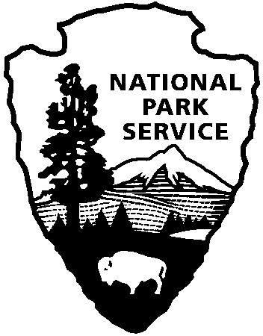 | National Park Service  U.S. Department of the Interior
National Park Service News Release

FOR IMMEDIATE RELEASE – DATE: September 27, 2013
CONTACT: Virginia Fowler, (864) 461-2828

Area History Organizations Present 2nd Annual Upstate Revolutionary War Weekend

To commemorate South Carolina’s vital role in the independence of our country, Cowpens National Battlefield, Kings Mountain National Military Park, the Overmountain Victory National Historic Trail, and Walnut Grove Plantation are teaming up to present An Upstate Revolutionary War Weekend from Friday, October 4 to Monday, October 7, 2013.

Upstate Revolutionary War Weekend begins with the FestiFall at Walnut Grove Plantation in Roebuck, SC. Relive America’s struggle for independence and be transported back to colonial days at this living history festival. Reenactors and artisans camp for the weekend and present battle reenactments and dozens of demonstrations of colonial era crafts and trades. FestiFall begins at 7:00pm on Friday, October 4 with a family-friendly lantern tour to the plantation’s cemetery and past vignettes telling different stories of the Revolutionary period. Lantern tours cost $5 per person and require reservations. FestiFall’s family fun continues from 10:00am to 5:00pm on Saturday, October 5 and from 10:00am to 4:00pm on Sunday, October 6 with the re-enactment of a Revolutionary War skirmish at noon on Saturday and 2:30 on Sunday. Admission to FestiFall is $9 for adults, $5 for ages 6-17, and free for ages 5 and under.

Cowpens National Battlefield near Chesnee, SC will start their events on Saturday, October 5th. Living Historians will be at the park throughout the day, giving special presentations at 11:30 am and 2:30 pm. The 11:30 presentation, given by living historian group Common Knowledge, will discuss colonial life from the female perspective. At 2:30 pm, reenactor Rob Rambo will assume the role of Cherokee Peace Chief Attakullakulla and discuss life as a Native American during the American Revolution. Events resume Sunday at 3:30 pm as actor Ken Johnston gives an hour-long performance as Benedict Arnold. Local author Robert W. Brown Jr.will hold a discussion and book signing at 4:30 pm. The day ends with “The Night before Kings Mountain” drama. Telling the story of the Overmountain Men and their journey from the colonial frontier to the Battle of Kings Mountain, “The Night before Kings Mountain” will begin at 6:00 pm. All activities at Cowpens National Battlefield are free.

Considered by many to be the turning point of the Revolutionary War in the Southern Colonies, Kings Mountain National Military Park in Blacksburg, SC, has a full weekend of events to mark the 233rd anniversary of the Battle of Kings Mountain. Starting on October 5th at 9:00 am, Kings Mountain will hold its Anniversary Encampment including a variety of activities throughout the day, including musket and rifle demonstrations and children's militia drills. Lantern tours will be given on Saturday evening, starting at 7pm and leaving every 10 minutes thereafter. Last tour departs at 8:00 pm. Reservations are required for the tours, please call 864-936-7921 for more information. On Sunday October 6th, the Anniversary Encampment continues. The weekend culminates with the Anniversary of the Battle of Kings Mountain on Monday, October 7th. A commemorative wreath laying ceremony will be held at 11:00 am. That afternoon the Overmountain Victory Trail Marchers will arrive at 3:00 pm, followed by a keynote address from author John Buchannon. All activities at Kings Mountain National Military Park are free.

For more information about any of the activities taking place during the Upstate Revolutionary War Weekend and for a printable schedule, please visit www.RevWarWeekend or contact Ginny Fowler at Virginia_fowler@nps.gov or at 864-461-2828.

Cowpens National Battlefield is part of the National Park Service and has a Visitor Center, movie, bookstore, and a one-mile trail on the battlefield. There is also a picnic area, nature trail and three mile auto tour loop. Visitor Center hours are 9:00 a.m. – 5:00 p.m. daily, closed on Thanksgiving, Christmas, and New Year’s Day. For more information, call (864) 461-2828 or visit the park’s webpage at www.nps.gov/cowp. Find us on Facebook at www.facebook.com/CowpensNationalBattlefield, and follow us on Twitter @CowpensNB.

About the National Park Service. More than 20,000 National Park Service employees care for America’s 401 national parks and work with communities across the nation to help preserve local history and create close-to-home recreational opportunities. Learn more at www.nps.gov.

