Cowpens National Battlefield
PO Box 308
Chesnee, SC 29323

(864) 461-2828 phone
www.nps.gov/cowp/
Cowpens National Battlefield News Release

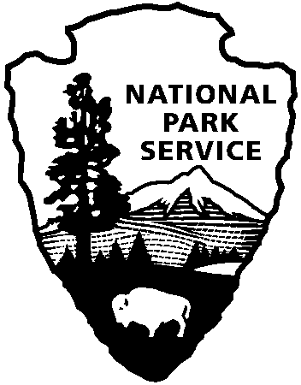
National Park Service
U.S. Department of the Interior

Release Date: August 10, 2012
Contact: Jonathan Riner, Jonathan_Riner@nps.gov, (864) 461-2828

Celebrate the National Park Service’s Birthday at Cowpens National Battlefield on August 25

GAFFNEY, SC – To celebrate the founding of the National Park Service on August 25, 1916, Cowpens National Battlefield will issue free National Park passes for active duty military and disabled servicemen and servicewomen and have reenactors firing 18th Century weapons. Special programs throughout the day feature the South Carolina Rangers, who portray colonists from the Revolutionary War era, demonstrating period muskets and rifles at 10:30am, 11:30am, 1:30pm, and 2:30pm.
Cowpens National Battlefield, for this day only, will be issuing an annual pass offering free entrance to all 397 national parks for active duty military members and their dependents. National parks and the military have strong ties going back to the establishment of Yellowstone as the world's first national park in 1872. The U.S. Cavalry watched over America's national parks and did double duty, serving as the first park rangers until the National Park Service was created 44 years later. During World War II, many parks were set aside for the training and care of military personnel.
In South Carolina alone there are six national parks and a variety of historic trails; most commemorate military battles and achievements. This military version of the America the Beautiful National Parks and Federal Recreational Lands Pass also permits free entrance to sites managed by the U.S. Fish & Wildlife Service, the Bureau of Land Management, the Bureau of Reclamation, and the U.S. Forest Service. Active duty service members and their dependents must show a current, valid military identification card to obtain their pass. Disabled service members are eligible for the Access Pass if they provide proper documentation of a permanent disability that severely limits one or more major life activities. There is no age requirement for the Access pass.
Cowpens National Battlefield, a unit of the National Park Service, is located at 4001 Chesnee Highway, Gaffney, SC 29341. It commemorates a decisive American victory over regular British forces that helped turn the tide of war in the Southern Campaign of the American Revolution. The park is open daily from 9:00-5:00 except for Thanksgiving, Christmas, and New Year's Days. For more information, call (864) 461-2828 or visit us on the Web at www.nps.gov/cowp/.

www.nps.gov

About the National Park Service. More than 20,000 National Park Service employees care for America’s 395 national parks and work with communities across the nation to help preserve local history and create close-to-home recreational opportunities. Learn more at www.nps.gov.

