Cowpens National Battlefield
338 New Pleasant Road
Gaffney, SC 29341

864-461-2828
www.nps.gov/cowp

Cowpens National Battlefield News Release

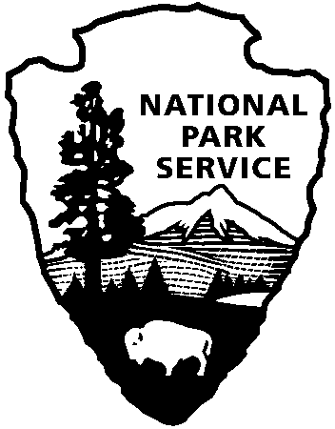
National Park Service
U.S. Department of the Interior

Release Date: October 17, 2013
Contact: John Slaughter (864) 461-2828
Virginia Fowler (864) 461-2828

Cowpens National Battlefield Reopens to Visitors

Gaffney, SC – Cowpens National Battlefield re-opens to visitors today. Visitors can access public areas and roads immediately while facilities and other public services are brought back online. Cowpens National Battlefield has been closed since October 1 due to the lapse in Congressional appropriations.

“We are excited happy to be back at work and welcome visitors to Cowpens National Battlefield,” said Superintendent John Slaughter “Autumn is a particularly special season to enjoy all that the park has to offer.”

The Visitor Center will be open from 9:00 – 5:00, and the loop road and picnic area will be open from 8:00 – 4:30.

NPS

About the National Park Service. National Park Service employees care for America's 401 national parks and work with communities across the nation to help preserve local history and create close-to-home recreational opportunities.

