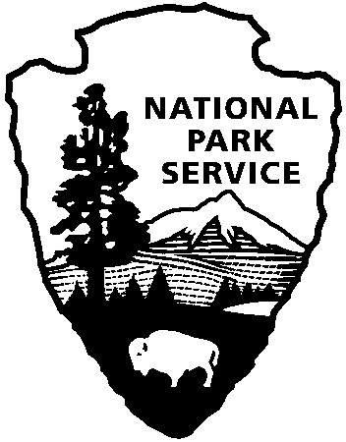 | National Park Service  U.S. Department of the Interior
National Park Service News Release

FOR IMMEDIATE RELEASE – DATE: April 11, 2013
CONTACT: Virginia Fowler 864-461-2828

Highlander Encampment and Junior Ranger Day at Cowpens National Battlefield

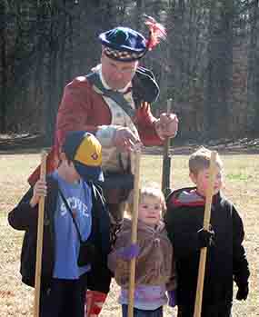
Cowpens National Battlefield is excited to announce that the North Carolina Highland Regiment/71st Highlanders will have a living history encampment on April 27-28. This is the first time that the Highlanders have been the featured group for an encampment at Cowpens. The reenactors will portray Fraser’s 71st Highlanders, who fought for the British at the Battle of Cowpens. Their goal is to educate the public about the American Revolution and the Scottish soldiers and settlers of the Carolinas. Visitors can watch the regiment drill, learn the musket drill, visit their camp, and experience what 18th century soldiers did when they were not fighting a war.

From 10:00 – 3:30 on Saturday, April 27, the first 75 children 6 years and older who pick up a free Junior Ranger Activity Booklet at the Visitor Center, complete the age-appropriate activities, and do one additional activity will earn a special Junior Ranger patch and certificate. The additional activities include attending a living history demonstration by reenactors, or participating in an interactive dummy gun drill, and completing an 18th century craft, such as making sachets. The Junior Ranger program is designed to have children and adults work together to learn more about the history and environment in our national parks.

The Junior Ranger Day program will conclude National Park Week, April 22 – 28. Each year the President proclaims a week to celebrate and recognize the country’s national parks. This is an especially good time for visitors to tour the 401 National Park Service sites because parks that normally charge fees will be free all week.

Save the date for Memorial Day Weekend, May 25-26. On Saturday, May 25, the SC Rangers will give 18th century weapons firing demonstrations. On May 26, the park will continue its Scholar Series with Oregon author, William R. Reynolds, Jr. Mr. Reynolds will give a 45-minute talk on his book, Andrew Pickens: South Carolina Patriot in the Revolutionary War, at 2:30 in the Visitor Center museum/auditorium. This will be followed by a book signing.

Cowpens National Battlefield is the site of the American victory over the British on January 17, 1781 and is located 10 miles west of Gaffney, SC, and 3 miles east of Chesnee, SC at the intersection of Highways 11, 110, and 221-A. Visitor Center hours are 9:00 a.m. – 5:00 p.m. daily. For more information about activities at Cowpens National Battlefield, call (864) 461-2828 or visit the park’s webpage at www.nps.gov/cowp/.
-NPS-

