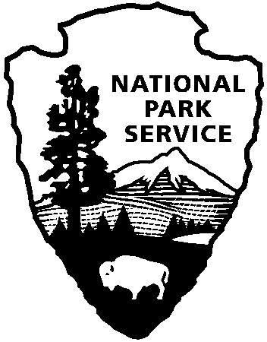 | National Park Service  U.S. Department of the Interior
National Park Service News Release

FOR IMMEDIATE RELEASE – DATE: September 26, 2013
CONTACT: Virginia Fowler, (864) 461-2828

Cowpens National Battlefield to Complete Paving Project in October

Park Superintendent John Slaughter announced today that contractors will be onsite to pave and repair parking lots the week of October 7 – 11, 2013. During this period, pedestrian access in the Picnic Area and the Visitor Center parking lot and vehicular access to the Trailhead Parking Lot will be restricted periodically.

To minimize visitor inconvenience, most of the work will be completed after 5pm while the park is closed. However, the Trailhead Parking Lot will be closed from 3:00 pm – 7:30 am on Monday and Tuesday, October 7 and 8. The park will post any additional closures that may occur due to inclement weather.

Park visitors will continue to have access to the park’s Visitor Center and historic battlefield during normal park hours throughout the project.

Visitors can learn about the Battle of Cowpens at the Visitor Center and museum, where an 18-minute movie about the battle shows on the hour between 9:00 and 4:00. A fiber-optic map explains the battlefield strategy and troop movements, and museum exhibits highlight the opposing soldiers who fought here. The one mile interpretive battlefield trail starts at the visitor center.

Cowpens National Battlefield is part of the National Park Service and has a Visitor Center, movie, bookstore, and a one-mile trail on the battlefield. There is also a picnic area, nature trail and three mile auto tour loop. Visitor Center hours are 9:00 a.m. – 5:00 p.m. daily, closed on Thanksgiving, Christmas, and New Year’s Day. For more information, call (864) 461-2828 or visit the park’s webpage at www.nps.gov/cowp. Find us on Facebook at www.facebook.com/CowpensNationalBattlefield, and follow us on Twitter @CowpensNB.

About the National Park Service. More than 20,000 National Park Service employees care for America’s 401 national parks and work with communities across the nation to help preserve local history and create close-to-home recreational opportunities. Learn more at www.nps.gov.

