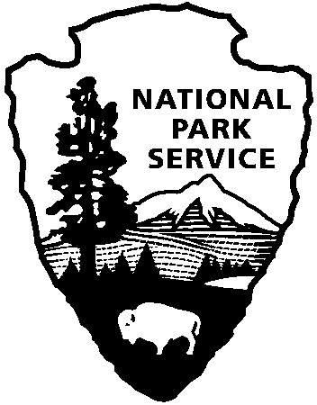 | National Park Service  U.S. Department of the Interior
National Park Service News Release

FOR IMMEDIATE RELEASE – DATE: September 13, 2011
CONTACT: Donna Davis, (864) 461-2828

Start Your Fall with a Bang at Cowpens National Battlefield

Cowpens National Battlefield’s fall schedule is full of free events for the family.

On September 17, the neighboring town of Chesnee will celebrate its 100th Anniversary with events from 10:00 a.m. – 10: p.m. While enjoying the 100th Anniversary festivities, stop by the National Park Service information booth during the day to learn more about upcoming events and programs at the park. Shortly after the Centennial Parade, reenactors will demonstrate the 18th Century Modified Stevens Artillery Drill and will fire the park’s 3-pounder cannon at 11:45, 1:30, and 2:30 in the field to the right of the Cowpens National Battlefield Visitor Center. The NPS is proud to support our “gateway community” of Chesnee in celebrating this monumental occasion.

The park will continue its Sunday in the Park series on September 25 at the Robert Scruggs House. From 1:30 – 4:00, a volunteer will demonstrate and teach 18th century domestic skills.

On October 6, 1780 patriots on their way to fight loyalists at Kings Mountain stopped at a well-known pasturing area known as the Cow Pens. To commemorate the event, the park will host a special evening drama, The Night before Kings Mountain, which depicts the march from Abingdon, Virginia and Sycamore Shoals, Tennessee to Kings Mountain. The 45-minute program will begin at 6:00 p.m. under the tent behind the Visitor Center. Visitors are invited to pack a picnic and enjoy an outdoor dinner theater experience.

Monthly guided bird walks will resume on October 8. The walks will leave from the Visitor Center at 8:00 a.m. Additional bird walks will be on November 5 and December 3.

The popular Backcountry Holiday program will be held at the circa 1828 Robert Scruggs House on November 20. The cabin will be decorated for the season and open to the public. Living historians will demonstrate (and children from 5 – 95 can participate in) backcountry skills such as musket drills, candle dipping, butter churning, and story-telling.

Mark your calendars for January 14 – 15, 2012, when Cowpens National Battlefield will celebrate the 231st anniversary of the Battle of Cowpens, the Revolutionary War battle that help turned the tide of war in favor of the Patriots..

Cowpens National Battlefield is the site of the American victory over the British on January 17, 1781 and is located 10 miles west of Gaffney, SC, and 3 miles east of Chesnee, SC at the intersection of Highways 11, 110, and 221-A. Visitor Center hours are 9:00 a.m. – 5:00 p.m. daily. For more information about the park’s activities, call (864) 461-2828 or visit the park’s web page at www.nps.gov/cowp/.

-NPS-

