Cowpens National Battlefield
PO Box 308
Chesnee, SC 29323

(864) 461-2828 phone
www.nps.gov/cowp/
Cowpens National Battlefield News Release

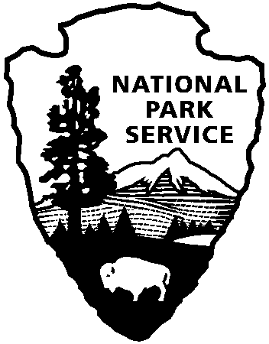
National Park Service
U.S. Department of the Interior

Release Date: November 10, 2012
Contact: Virginia Fowler, Virginia_Fowler@nps.gov, (864) 461-2828

Revolutionize Your Holidays at Cowpens National Battlefield

GAFFNEY, SC – Mark your calendars for Cowpens National Battlefield’s four upcoming events in November and January. The Scholar Series will continue on November 15 at 5:30 pm in the visitor center auditorium. Dr. Paul Thompson, Jr., Chair of History and Political Science at North Greenville University will present a talk on African Americans in the American Revolution.
Looking for a unique Christmas card this year? At our Backcountry Holiday on November 18, children will have an opportunity to dress in colonial clothes for a wonderful holiday photo opportunity. Be sure to bring your cameras. Held on the weekend of November 17-18th, the event will include the American Colonial Civilian Interpreters, who will cook a traditional Christmas meal over an open fire and make period-appropriate wreathes, swags, and other decorations from10:00 – 4:30 on Saturday, November 17 and 9:30 – 11:30 on Sunday, November 18 behind the visitor center. Visitors are invited to participate in making their own Christmas decorations from natural items such as vines and pine cones. From 1:30 – 4:00 on Sunday, November 18, park staff and volunteers will bring the 1828 Robert Scruggs house to life with family activities such as dipping candles and making sachets.
Save the date for January 12, 2013 for the Race for the Grasshopper. This 5k race around the park’s loop road was named for the race between two Battle of Cowpens officers to capture the two British cannons after the battle. For more information, contact the Spartanburg Running Club at http://www.spartanburgrunningclub.com/.
The annual battle anniversary celebration will be January 19-20, 2013. Park staff are planning to offer author lectures and book signings, 18th century weapons firing demonstrations, as well as cavalry and camp life demonstrations.
Cowpens National Battlefield, a unit of the National Park Service, is located at 4001 Chesnee Highway, Gaffney, SC 29341. It commemorates a decisive American victory over regular British forces that helped turn the tide of war in the Southern Campaign of the American Revolution. The park is open daily from 9:00-5:00 except for Thanksgiving, Christmas, and New Year's Days. For more information, call (864) 461-2828 or visit us on the web at www.nps.gov/cowp/.

www.nps.gov

About the National Park Service. More than 20,000 National Park Service employees care for America’s 395 national parks and work with communities across the nation to help preserve local history and create close-to-home recreational opportunities. Learn more at www.nps.gov.

